МИНИСТЕРСТВО ОБРАЗОВАНИЯ И НАУКИ КЫРГЫЗСКОЙ РЕСПУБЛИКИ

КЫРГЫЗСКИЙ ГОСУДАРСТВЕННЫЙ ТЕХНИЧЕСКИЙ УНИВЕРСИТЕТ ИМЕНИ И.РАЗЗАКОВА

ФАКУЛЬТЕТ ИНФОРМАЦИОННЫХ ТЕХНОЛОГИЙ

КАФЕРДА “ПРОГРАММНОЕ ОБЕСПЕЧЕНИЕ КОМПЬЮТЕРНЫХ СИСТЕМ”

КУРСОВАЯ РАБОТА

По дисциплине “Система управления базами данных”

Выполнил: ст. группы ПИ-3-18

Аскербеков А.Н

Проверила: Абалиева А.Д.

Бишкек – 2021

Оглавление

**1)** **Описание предметной области** 3

**2) Требования к системе** 3

2.1 Функциональные требования 3

2.2 Входные данные 4

**3) Архитектура базы данных** 4

3.1 Описание таблиц в базе данных 4

3.2 Диаграмма ERD 10

3.3 Хранимые процедуры 11

3.4 Триггеры 13

**4) Клиентская часть** 25

4.1 **Формы** 25

**5)** **Реализация защищенного режима рабоыт с БД** 142

**6)** **Демонстрация работы программы** 143

**7)** **Заключение** 161

# **Описание предметной области**

**Информационная система** **Пикарня** — предназначенное для изготовления кондитерских изделий. На ИС Пикарня осуществляются следующие технологические операции: приём и хранение материалов для приготовления кондитерских изделий; дробление (при необходимости) и сортировка, складирование, хранение (кратковременное) и отгрузка готовой продукции.

Производственное предприятия занимается производством и продажей кондитерских изделий. Администраторы отвечают за весь процесс в кондитерском во время рабочего дня. Администраторы фиксируют все продажи, приходы сырья на склад. При каждом данном процессе администратору необходимо традиционным методом (ручки и бумаги) вручную заполнять накладные продажи, также накладные приходные товаров, а при заполнении накладной вручную просчитывать все итоговые суммы в накладных. Вести учет сырья на складе приходится, также вручную просчитывая и сохраняя все данные, записанные на бумаге. Однако работа традиционным методом вызывает сложности, так как заполнение накладных и расчет итоговых сумм производится вручную и тратится достаточно большое время на их оформление и есть риски такие как:

- Потеря данных, в связи со сложностью контроля процессов на предпрятии

- Восстановление необходимых данных для подсчета всех продаж и приходов

Поэтому становится актуальной разработка системы, основным назначением которого является автоматизация процесса производства и продаж на предприятии, автоматизация расчета сумм накладных, а также хранение отчетных данных, обеспечение корректности, актуальности, обработки, хранения данных.

# **2) Требования к системе**

## 2.1 Функциональные требования

* Регистрировать справочные данные, а именно действующие должности, единицы измерения сырья и готовой продукции, рецепты кондитерских изделий.
* Производить операции с данными о сотрудниках, учитывать их деятельность в рамках работы завода (все случаи участия в закупках, продажах и производстве), подсчитывать сумму заработной платы сотрудников.
* Регистрировать закупки сырья, при этом увеличивать количество сырья в наличии и уменьшать бюджет при добавлении закупки и производить обратные операции при удалении закупки, а также изменять бюджет и количество сырья при изменении данных о произведенной закупке. При этом система должна проверять бюджет и сообщать об отсутствии возможности закупки.
* Производить операции с данными о применяемом сырье и производимой готовой продукции,
* Регистрировать производство кондитерских изделий, при этом уменьшать количество сырья в соответствии с стандартами и увеличивать количество готовой продукции и производить обратные операции при удалении случая производства. Также система должна изменять количество сырья и готовой продукции при изменении данных о зарегистрированном случае производства. При этом система должна проверить наличие необходимого сырья и сообщить, если производство определенного количества продукции невозможно.
* Регистрировать продажи готовой продукции, при этом уменьшать количество имеющейся готовой продукции и увеличивать бюджет и производить обратные операции при удалении продажи. Система должна изменять бюджет и число готовой продукции при изменении данных о зарегистрированной продаже. Система должна проверять возможность продажи определённого количества продукции и уведомлять пользователя, если такой возможности нет.
* Регистрировать выдачу кредитов банками, регистрировать выплаты по кредитам, подсчитывать сумму выплат в соответствии с датой выплаты. При просрочке система должна подсчитать размер пени и сообщить пользователю. Система должна проверить бюджет и выдать сообщение, если недостаточно бюджета для выплаты по кредиту.

## 2.2 Входные данные

* Справочные данные (единицы измерения, должности, ингредиенты, наименования сырья и готовых продуктов,
* Данные о сотрудниках,
* Данные о закупках,
* Данные о производстве готовой продукции,
* Данные о продажах,
* Данные о кредитах и выплатах по кредитам.

# **3)** **Архитектура базы данных**

## 3.1 Описание таблиц в базе данных

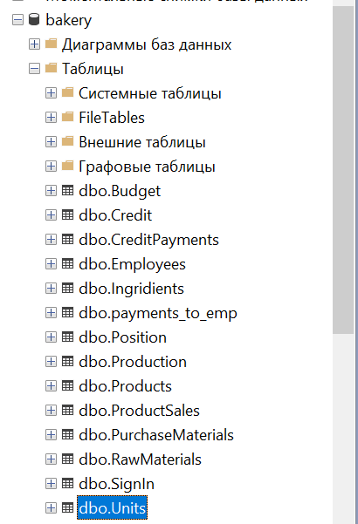

* Таблица **Бюджет**

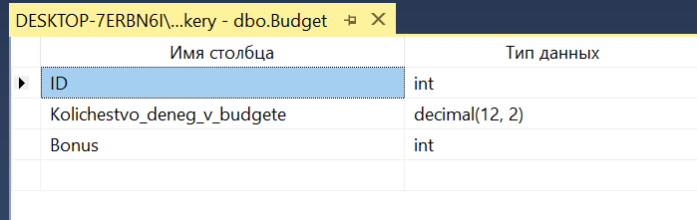

|  |  |  |
| --- | --- | --- |
| **Наименование поля** | **Тип данных** | **Назначение** |
| ID | int | Первичный ключ |
| Kolichestvo_deneg_v_budgete | decimal(12, 2) | Размер бюджета предприятия |
| Bonus |  | Бонусная сумма для сотрудника |

* Таблица **Credit_Repayment**

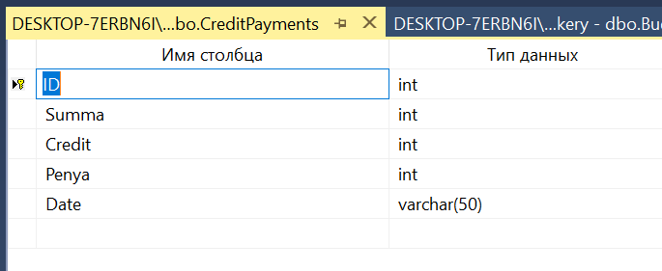

|  |  |  |
| --- | --- | --- |
| **Наименование поля** | **Тип данных** | **Назначение** |
| ID | smallint | Первичный ключ |
| Credit | smallint | ID кредита |
| Date | varchar(50) | Дата выплаты |
| Penya | float | Штрафная сумма выплаты |
| Summa | float | Общая сумма выплаты |

* Таблица **Credit_Info**

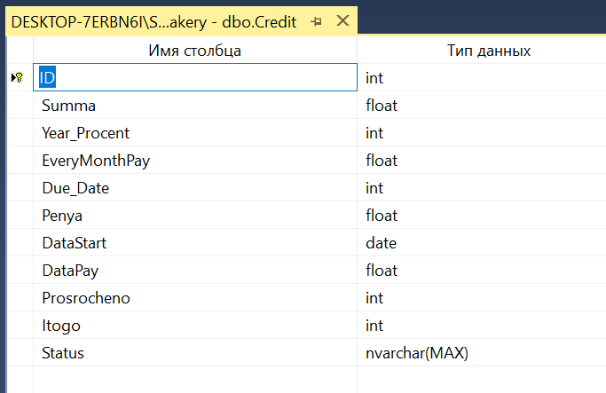

|  |  |  |
| --- | --- | --- |
| **Наименование поля** | **Тип данных** | **Назначение** |
| ID | int | Первичный ключ |
| Year_Procent | int | Годовой процент |
| Summa | Float | Сумма выдачи денежных средств |
| EveryMonthPay | float | Ежемесячный сумма требуемой выплаты по кредиту |
| Due_Date | int | День выплаты |
| Penya | int | Пеня(штраф) |
| DataStart | date | Дата начало кредита |
| DataPay | Float | Дата выплаты |
| Itogo | int | Общая сумма требуемой выплаты по кредиту |
| Status | nvarchar(MAX) | Статус о выплаты кретита |

* Таблица **Ингредиенты**

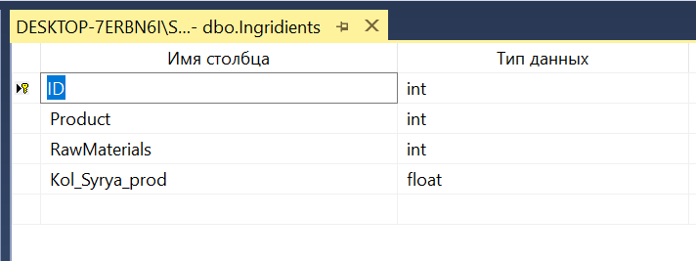

|  |  |  |
| --- | --- | --- |
| **Наименование поля** | **Тип данных** | **Назначение** |
| ID | int | Первичный ключ |
| Product | int | ID продукции |
| RawMaterials | int | ID сырья |
| Kol_Syrya_prod | float | Количество |

* Таблица **Должности**

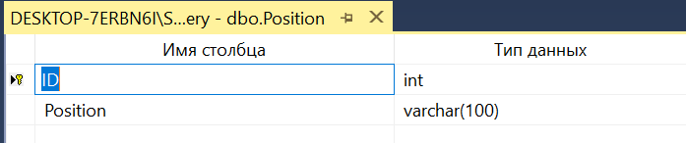

|  |  |  |
| --- | --- | --- |
| **Наименование поля** | **Тип данных** | **Назначение** |
| ID | int | Первичный ключ |
| Position | nvarchar(100) | Наименование должности |

* Таблица **Готовая_продукция**

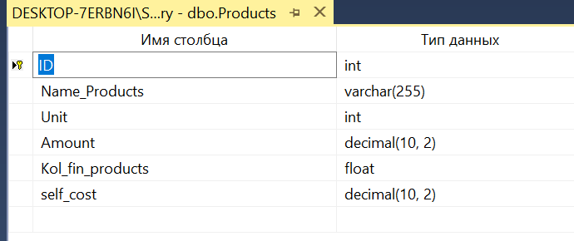

|  |  |  |
| --- | --- | --- |
| **Наименование поля** | **Тип данных** | **Назначение** |
| ID | smallint | Первичный ключ |
| Name_Products | varchar(255) | Наименование продукции |
| Unit | int | Единицы измерения количества продукции |
| Amount | decimal(10, 2) | Общая сумма стоимости продукции |
| Kol_fin_products | float | Количество продукции в наличии |
| Единица_измерения | int | Единицы измерения количества продукции |
| self_cost | decimal(10, 2) | Себестоимость продукции в наличии |

* Таблица **Производство**

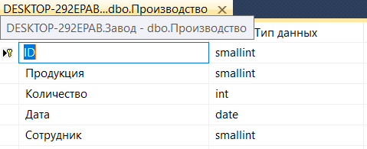

|  |  |  |
| --- | --- | --- |
| **Наименование поля** | **Тип данных** | **Назначение** |
| ID | int | Первичный ключ |
| Product | int | Наименование продукции |
| Kol_Product | int | Количество продукции |
| Date | date | Дата производства продукции |
| Personnel | int | Сотрудник, принявший участие в производстве |

* Таблица **Закупка_сырья**

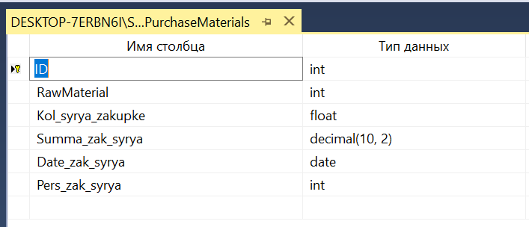

|  |  |  |
| --- | --- | --- |
| **Наименование поля** | **Тип данных** | **Назначение** |
| ID | int | Первичный ключ |
| RawMaterial | int | Наименование сырья |
| Kol_syrya_zakupke | float | Количество сырья |
| Summa_zak_syrya | decimal(10, 2) | Стоимость закупки |
| Date_zak_syrya | Date | Дата закупки |
| Pers_zak_syrya | int | Сотрудник, принявший участие в закупке |

* Таблица **Сырьё**

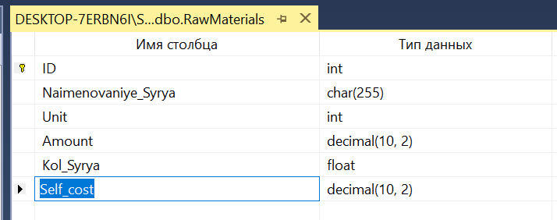

|  |  |  |
| --- | --- | --- |
| **Наименование поля** | **Тип данных** | **Назначение** |
| ID | int | Первичный ключ |
| Naimenovaniye_Syrya | char(255) | Наименование сырья |
| Unit | int | Единица измерения количества |
| Amount | Decimal(10,2) | Стоимость сырья в наличии |
| Kol_Syrya | float | Количество сырья в наличии |
| Self_cost | Decimal(10,2) | Себестоимость продукции в наличии |

* Таблица **Payment_Log**

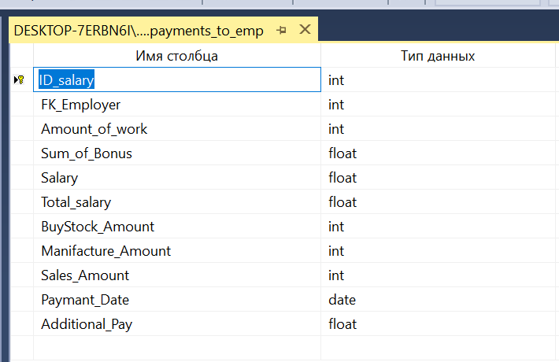

|  |  |  |
| --- | --- | --- |
| **Наименование поля** | **Тип данных** | **Назначение** |
| ID_salary | int | Первичный ключ |
| FK_Employer | int | ID сотрудника |
| Amount_of_work | Int | Общее количество наработок |
| Sum_of_Bonus | float | Бонусная надбавка |
| Salary | float | Фиксированная заработная плата сотрудника |
| Total_salary | float | Итоговая сумма |
| BuyStock_Amount | Int | Количество участий в закупках |
| Manifacture_Amount | Int | Количество участий в производстве |
| Sales_Amount | Int | Количество участий в продажах |
| Payment_Date | Date | Дата выдачи |
| Additional_Pay | float | Доп. оплата |

* Таблица **Продажа_продукции**

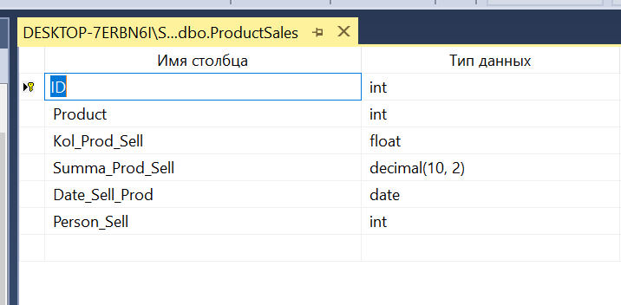

|  |  |  |
| --- | --- | --- |
| **Наименование поля** | **Тип данных** | **Назначение** |
| ID | int | Первичный ключ |
| Product | int | Наименование продукции на продажу |
| Kol_Prod_Sell | float | Количество продаваемой продукции |
| Summa_Prod_Sell | decimal(10, 2) | Общая стоимость продаваемой продукции |
| Date_Sell_Prod | Date | Дата продажи |
| Person_Sell | int | Сотрудник, принявший участие в продаже |

* Таблица **Сотрудники**

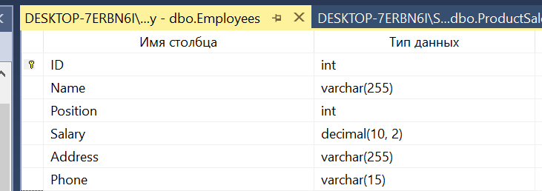

|  |  |  |
| --- | --- | --- |
| **Наименование поля** | **Тип данных** | **Назначение** |
| ID | int | Первичный ключ |
| Name | varchar(255) | ФИО сотрудника |
| Position | int | Занимаемая должность |
| Salary | float | Заработная плата |
| Address | varchar(255) | Адрес жительства |
| Phone | varchar(15) | Номер телефона |

* Таблица **Единицы_измерения**

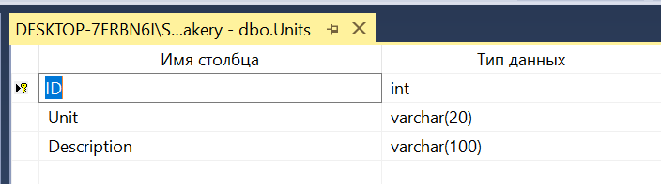

|  |  |  |
| --- | --- | --- |
| **Наименование поля** | **Тип данных** | **Назначение** |
| ID | smallint | Первичный ключ |
| Unit | varchar(20) | Наименование единицы измерения |
| Description | varchar(100) | Описание единицы измерения |

## 3.2 Диаграмма ERD

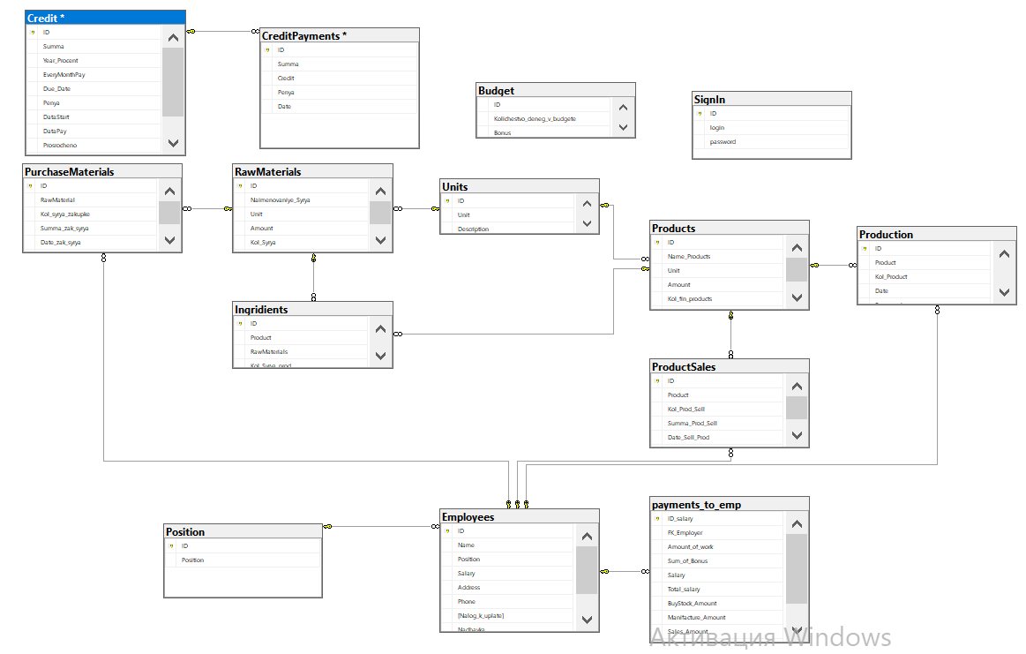

## 3.3 Хранимые процедуры

* Список всех хранимых процедур в базе данных:

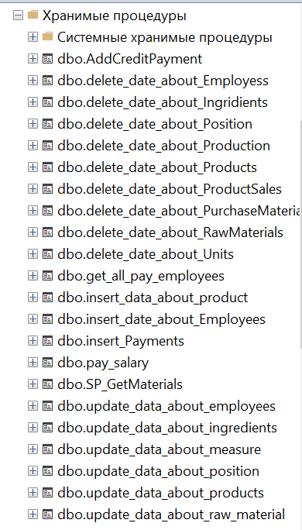

* Хранимые процедуры для удаления записей из таблиц имеют одинаковый синтаксис, таких хранимых процедур 8.

Для примера представлена хранимая процедура [delete_date_about_Ingridients] для удаления записей из таблицы Ингредиенты:

ALTER PROCEDURE [dbo].[delete_date_about_Ingridients]

-- Add the parameters for the stored procedure here

@id int

AS

delete Ingridients WHERE ID=@id

* Хранимые процедуры для изменения записей в таблицах тоже имеют одинаковый синтаксис, таких хранимых процедур 8.

Для примера представлена хранимая процедура [update_data_about_ingredients] для редактирования записей таблицы Ингредиенты:

ALTER PROCEDURE [dbo].[update_data_about_ingredients]

-- Add the parameters for the stored procedure here

@id int,

@marerial int,

@amount int

AS

update Ingridients

set RawMaterials=@marerial,Kol_Syrya_prod=@amount

where ID=@id

* Хранимые процедуры для добавления записей в таблицах тоже имеют одинаковый синтаксис, таких хранимых процедур 6.

Для примера представлена хранимая процедура [insert_data_about_product]

для редактирования записей таблицы Должности:

ALTER PROCEDURE [dbo].[insert_data_about_product]

-- Add the parameters for the stored procedure here

@name varchar(255),

@measure int,

@sum decimal(10,2),

@amount int

AS

insert into Products

(Name_Products, Unit, Amount, Kol_fin_products)

values (@name, @measure, @sum, @amount)

* Хранимая процедура для погащение кредита

ALTER procedure [dbo].[AddCreditPayment]

@Total int,

@Credit int,

@PayDay int,

@Date date,

@Status text output

as

declare @BudgetTotal int,@PayDayCredit int, @FinePercent int, @MonthlyFee int,@CreditItg int,@Fine int,@Prosrochka int

select @PayDayCredit = Credit.DataPay,@FinePercent=Credit.Penya,@MonthlyFee=Credit.EveryMonthPay,@CreditItg=Credit.Itogo,@Fine=Credit.Penya

from Credit

where Credit.ID = @Credit

select @BudgetTotal = Kolichestvo_deneg_v_budgete

from Budget

where Budget.ID=1

if(@PayDay>@PayDayCredit)

begin

set @Fine = @MonthlyFee*(@FinePercent*0.01)*(@PayDay - @PayDayCredit)

set @Total = @Total + @Fine

set @Prosrochka=@PayDay-@PayDayCredit

update Credit

set Credit.Prosrocheno=Credit.Prosrocheno+@Prosrochka

where Credit.ID=@Credit

end

if(@BudgetTotal>=@Total)

begin

insert into CreditPayments(Summa,Credit,Penya,Date)

values(@Total,@Credit,@Fine,@Date)

set @Status = 'Выполнено'

end

else

set @Status = 'Недостаточно средств в бюджете'

update Budget

set Budget.Kolichestvo_deneg_v_budgete=Budget.Kolichestvo_deneg_v_budgete - @Total

update Credit

set Credit.Itogo = Credit.Itogo - @Total

where Credit.ID = @Credit

## 3.4 Триггеры

* Таблица **Производство**
* Триггер **[delete_trigger]**

Триггер срабатывающий вместо удаления, откатывает количество сырья и продукции в случае удаления записи.

USE [bakery]

GO

/****** Object: Trigger [dbo].[delete_trigger] Script Date: 17.05.2021 14:21:57 ******/

SET ANSI_NULLS ON

GO

SET QUOTED_IDENTIFIER ON

GO

ALTER TRIGGER [dbo].[delete_trigger]

ON [dbo].[Production]

AFTER DELETE

AS

BEGIN

SET NOCOUNT ON;

DECLARE @n as int, @i as int,@id as int, @amountStorage as float, @amountIng as float, @canCraft as bit

DECLARE @id_product as int, @amount as float, @emp as int, @id_rm as int

DECLARE @amo as int, @sc as float, @idProduct as int

SET @amo = (SELECT Kol_Product FROM deleted)

SET @idProduct = (SELECT Product FROM deleted)

SET @sc = (SELECT self_cost FROM Products WHERE id = @idProduct)

SET @canCraft = 0

UPDATE dbo.Products

SET dbo.Products.Kol_fin_products=dbo.Products.Kol_fin_products - @amo

--, sum+=@amo*@sc

WHERE id=@idProduct

--UPDATE dbo.budjet

--SET dbo.budjet.budjet_sum = dbo.budjet.budjet_sum - @sc*@amo

--FROM deleted

SET @n = (SELECT COUNT(dbo.RawMaterials.Kol_Syrya)

FROM dbo.Ingridients INNER JOIN

dbo.Products ON dbo.Ingridients.Product = dbo.Products.ID INNER JOIN

dbo.RawMaterials ON dbo.Ingridients.RawMaterials = dbo.RawMaterials.ID

WHERE dbo.Ingridients.Product = @idProduct)

IF(@canCraft = 0) BEGIN

--Inserting new record to table Fabrication

--INSERT INTO production(product,amount,date,employee)

--VALUES(@id_product,@amount,GETDATE(),@emp)

SET @i = 0

WHILE (@i != @n) BEGIN

--Selecting id from dbo.Raw_Materials

SET @id_rm = (SELECT dbo.RawMaterials.ID

FROM dbo.Ingridients INNER JOIN

dbo.RawMaterials ON dbo.Ingridients.RawMaterials = dbo.RawMaterials.ID

WHERE product=@idProduct

ORDER BY dbo.RawMaterials.ID

OFFSET @i ROW FETCH NEXT 1 ROWS ONLY)

--Selecting amount from dbo.Ingredients

SET @amountIng = (SELECT dbo.Ingridients.Kol_Syrya_prod

FROM dbo.Ingridients INNER JOIN

dbo.RawMaterials ON dbo.Ingridients.RawMaterials = dbo.RawMaterials.ID

WHERE dbo.Ingridients.Product=@idProduct

ORDER BY dbo.Ingridients.RawMaterials

OFFSET @i ROW FETCH NEXT 1 ROWS ONLY)

--Updating our found raw_materials

UPDATE RawMaterials

SET Kol_Syrya+=@amo*@amountIng, Amount+=@amo*self_cost

WHERE id=@id_rm

--Next iteration

SET @i=@i+1

END

END

* END
* Триггер **insertTrigger_Production**

Триггер срабатывающий вместо добавления, данный триггер проверяет есть ли нужное количество ингредиентов для создания продукта, если хотя бы 1 не хватает, то нельзя произвести продукт.

USE [bakery]

GO

/****** Object: Trigger [dbo].[insertTrigger_Production] Script Date: 17.05.2021 14:22:53 ******/

SET ANSI_NULLS ON

GO

SET QUOTED_IDENTIFIER ON

GO

ALTER TRIGGER [dbo].[insertTrigger_Production]

ON [dbo].[Production]

INSTEAD OF INSERT

AS

BEGIN

SET NOCOUNT ON;

DECLARE @n as int, @i as int, @amountStorage as float, @amountIng as float, @canCraft as bit

DECLARE @id_product as int, @amount as float, @emp as int, @id_rm as int

SET @id_product = (SELECT Product FROM inserted)

SET @amount = (SELECT Kol_Product FROM inserted)

SET @emp = (SELECT Personnel FROM inserted)

SET @canCraft = 0

SET @i = 0

--Counting how many iterations will

SET @n = (SELECT COUNT(dbo.RawMaterials.Kol_Syrya)

FROM dbo.Ingridients INNER JOIN

dbo.Products ON dbo.Ingridients.Product = dbo.Products.ID INNER JOIN

dbo.RawMaterials ON dbo.Ingridients.RawMaterials = dbo.RawMaterials.ID

WHERE dbo.Ingridients.product = @id_product)

WHILE(@i != @n) BEGIN

--Selecting amount from dbo.Raw_Materials

SET @amountStorage = (SELECT dbo.RawMaterials.Kol_Syrya

FROM dbo.Ingridients INNER JOIN

dbo.RawMaterials ON dbo.Ingridients.RawMaterials = dbo.RawMaterials.ID

WHERE product=@id_product

ORDER BY dbo.RawMaterials.Kol_Syrya

OFFSET @i ROW FETCH NEXT 1 ROWS ONLY)

--Selecting amount from dbo.Ingredients

SET @amountIng = (SELECT dbo.Ingridients.Kol_Syrya_prod

FROM dbo.Ingridients INNER JOIN

dbo.RawMaterials ON dbo.Ingridients.RawMaterials = dbo.RawMaterials.ID

WHERE dbo.Ingridients.product=@id_product

ORDER BY dbo.Ingridients.Kol_Syrya_prod

OFFSET @i ROW FETCH NEXT 1 ROWS ONLY)

IF((@amount*@amountIng) <= @amountStorage)BEGIN

SET @canCraft = 1

END

ELSE BEGIN

SET @canCraft = 0

END

SET @i= @i + 1

IF @canCraft = 0 BEGIN

SET @i = @n

END

END

IF(@canCraft = 1) BEGIN

--Inserting new record to table Fabrication

INSERT INTO Production(Product,Kol_Product,Date,Personnel)

VALUES(@id_product,@amount,GETDATE(),@emp)

SET @i = 0

--Updating our production

UPDATE Products

SET Kol_fin_products+=@amount, Amount+=@amount*self_cost

WHERE id=@id_product

--Searching our ingredients to change their stats

WHILE (@i != @n) BEGIN

--Selecting id from dbo.Raw_Materials

SET @id_rm = (SELECT dbo.RawMaterials.ID

FROM dbo.Ingridients INNER JOIN

dbo.RawMaterials ON dbo.Ingridients.RawMaterials = dbo.RawMaterials.id

WHERE product=@id_product

ORDER BY dbo.RawMaterials.ID

OFFSET @i ROW FETCH NEXT 1 ROWS ONLY)

--Selecting amount from dbo.Ingredients

SET @amountIng = (SELECT dbo.Ingridients.Kol_Syrya_prod

FROM dbo.Ingridients INNER JOIN

dbo.RawMaterials ON dbo.Ingridients.RawMaterials = dbo.RawMaterials.ID

WHERE dbo.Ingridients.product=@id_product

ORDER BY dbo.Ingridients.RawMaterials

OFFSET @i ROW FETCH NEXT 1 ROWS ONLY)

--Updating our found raw_materials

UPDATE RawMaterials

SET Kol_Syrya-=@amount*@amountIng, Amount-=@amount*Self_cost

WHERE id=@id_rm

--Next iteration

SET @i=@i+1

END

END

END

* Таблица **Продажа_продукции**
* Триггер **UpdateAfterDeleteSale**

Триггер срабатывающий после удаления, для отката количества и стоимости, а так же бюджета.

USE [bakery]

GO

/****** Object: Trigger [dbo].[UpdateAfterDeleteSale] Script Date: 17.05.2021 14:24:52 ******/

SET ANSI_NULLS ON

GO

SET QUOTED_IDENTIFIER ON

GO

ALTER TRIGGER [dbo].[UpdateAfterDeleteSale]

ON [dbo].[ProductSales]

AFTER DELETE

AS

BEGIN

SET NOCOUNT ON;

DECLARE @amo as float,@sum as decimal(10,2), @idProduct as int

SET @amo = (SELECT Kol_Prod_Sell FROM deleted)

SET @sum = (SELECT Summa_Prod_Sell FROM deleted)

SET @idProduct = (SELECT product FROM deleted)

UPDATE Products SET Products.Kol_fin_products+=@amo, Products.Amount+=@sum where ID=@idProduct

UPDATE dbo.Budget SET dbo.Budget.Kolichestvo_deneg_v_budgete = dbo.Budget.Kolichestvo_deneg_v_budgete - @sum FROM deleted

END

* Триггер **[TR_Sale]**

Триггер срабатывающий после добавления, для изменения количества сырья его стоимости, а так же бюджета.

USE [bakery]

GO

/****** Object: Trigger [dbo].[TR_Sale] Script Date: 17.05.2021 14:24:23 ******/

SET ANSI_NULLS ON

GO

SET QUOTED_IDENTIFIER ON

GO

ALTER trigger [dbo].[TR_Sale] on [dbo].[ProductSales]

instead of insert as

if ((select Kol_fin_products from Products where ID=(select Product FROM inserted))<(SELECT Kol_Prod_Sell from inserted))

begin

raiserror('Недостаточно продуктов на складе', 16,1)

end

else

begin

declare @Summ MONEY

declare @Quantity int

set @Summ=(select Amount from Products where ID=(select Product from inserted))

set @Quantity=(select Kol_fin_products from Products where ID=(select Product from inserted))

update Products set Amount=Amount-((Amount/Kol_fin_products)*(select Kol_Prod_Sell from inserted)),

Kol_fin_products=Kol_fin_products-(select Kol_Prod_Sell from inserted) WHERE ID=(select Product from inserted)

update Budget set Kolichestvo_deneg_v_budgete=Kolichestvo_deneg_v_budgete+(((@Summ/@Quantity))*(select Kol_Prod_Sell from inserted))

insert into ProductSales(Product,Kol_Prod_Sell,Summa_Prod_Sell,Date_Sell_Prod,Person_Sell)

select Product,Kol_Prod_Sell,((@Summ/@Quantity))*Kol_Prod_Sell,Date_Sell_Prod,Person_Sell from inserted

end

* Триггер [update_trigger_sale]

Триггер срабатывающий после обновления, для того что бы обновить количество и сумму, а так же бюджет в соответствии с новой информацией.

USE [bakery]

GO

/****** Object: Trigger [dbo].[update_trigger_sale] Script Date: 17.05.2021 14:26:29 ******/

SET ANSI_NULLS ON

GO

SET QUOTED_IDENTIFIER ON

GO

-- =============================================

-- Author: <Author,,Name>

-- Create date: <Create Date,,>

-- Description: <Description,,>

-- =============================================

ALTER TRIGGER [dbo].[update_trigger_sale]

ON [dbo].[ProductSales]

AFTER UPDATE

AS

BEGIN

SET NOCOUNT ON;

DECLARE @amo as int

DECLARE @summ as float

DECLARE @n as int, @i as int, @amountStorage as float, @amountIng as float, @canUpdate as bit

DECLARE @new_id_product as int, @new_amount as float,@new_sum as float, @new_emp as int, @id_rm as int

DECLARE @old_id_product as int, @old_amount as float,@old_sum as float, @old_emp as int, @old_id as int

SET @new_amount = (select Kol_Prod_Sell from inserted)

SET @new_sum = (select Summa_Prod_Sell from inserted)

SET @new_emp = (select Person_Sell from inserted)

SET @old_amount = (select Kol_Prod_Sell from deleted)

SET @old_sum = (select Summa_Prod_Sell from deleted)

SET @old_id = (select ID from deleted)

SET @old_id_product = (select Product from deleted)

UPDATE Products

SET Kol_fin_products -= @new_amount - @old_amount, Amount-=(@new_sum-@old_sum), @old_emp=(@new_sum-@old_sum)

WHERE id=@old_id_product

UPDATE Budget

SET Kolichestvo_deneg_v_budgete += @old_emp

END

* Таблица **Закупка_сырья**
* Триггер **Update_AfterDeleteЗакупка**

Триггер срабатывающий после удаления, для изменения количества и стоимости, а так же бюджета.

USE [bakery]

GO

/****** Object: Trigger [dbo].[UpdateAfterDeletePurch] Script Date: 17.05.2021 14:29:38 ******/

SET ANSI_NULLS ON

GO

SET QUOTED_IDENTIFIER ON

GO

ALTER TRIGGER [dbo].[UpdateAfterDeletePurch]

ON [dbo].[PurchaseMaterials]

AFTER DELETE

AS

BEGIN

SET NOCOUNT ON;

DECLARE @amo as int,@sum as int,@idProduct as int

SET @amo = (SELECT Kol_syrya_zakupke FROM deleted)

SET @sum = (SELECT Summa_zak_syrya FROM deleted)

SET @idProduct = (SELECT RawMaterial FROM deleted)

--UPDATE dbo.RawMaterials

--SET dbo.RawMaterials.Kol_Syrya=dbo.RawMaterials.Kol_Syrya - @amo, dbo.RawMaterials.Amount=dbo.RawMaterials.Amount -@sum

--FROM deleted

UPDATE RawMaterials

SET dbo.RawMaterials.Kol_Syrya=Kol_Syrya-@amo, dbo.RawMaterials.Amount=dbo.RawMaterials.Amount -@sum

WHERE id=@idProduct

UPDATE dbo.Budget

SET dbo.Budget.Kolichestvo_deneg_v_budgete = dbo.Budget.Kolichestvo_deneg_v_budgete + @sum

FROM deleted

--Counting how many iterations will

END

* Триггеры **Insert_Закупка_сырья** и **UpdateBudjet**

Триггер срабатывающий после добавления, для обновления количества и стоимости, а так же бюджета.

USE [bakery]

GO

/****** Object: Trigger [dbo].[Insert_Закупка_сырья] Script Date: 17.05.2021 14:30:42 ******/

SET ANSI_NULLS ON

GO

SET QUOTED_IDENTIFIER ON

GO

ALTER TRIGGER [dbo].[Insert_Закупка_сырья] ON [dbo].[PurchaseMaterials]

AFTER INSERT

AS

BEGIN

declare @amount as int

declare @summa as int

select @amount = Kol_syrya_zakupke from PurchaseMaterials where RawMaterial in (select RawMaterial from inserted);

select @summa = Summa_zak_syrya from PurchaseMaterials where RawMaterial in (select RawMaterial from inserted);

UPDATE dbo.RawMaterials

SET dbo.RawMaterials.Kol_Syrya =dbo.RawMaterials.Kol_Syrya + @amount,dbo.RawMaterials.Amount =dbo.RawMaterials.Amount + @summa where ID in (select RawMaterial from inserted)

END

USE [bakery]

GO

/****** Object: Trigger [dbo].[UpdateBudjet] Script Date: 17.05.2021 14:31:14 ******/

SET ANSI_NULLS ON

GO

SET QUOTED_IDENTIFIER ON

GO

ALTER TRIGGER [dbo].[UpdateBudjet]

ON [dbo].[PurchaseMaterials]

AFTER INSERT

AS

DECLARE @summ as float

select @summ = Summa_zak_syrya from PurchaseMaterials

BEGIN

UPDATE dbo.Budget

SET dbo.Budget.Kolichestvo_deneg_v_budgete = dbo.Budget.Kolichestvo_deneg_v_budgete - @summ

FROM inserted

END

* Триггер **update_AfterUpdateЗакупка**

Триггер срабатывающий после обновления, для обновления количества и стоимости, а так же бюджета в соответствии с новой информацией.

USE [bakery]

GO

/****** Object: Trigger [dbo].[update_trigger_purchaseMaterials] Script Date: 17.05.2021 14:31:59 ******/

SET ANSI_NULLS ON

GO

SET QUOTED_IDENTIFIER ON

GO

-- =============================================

-- Author: <Author,,Name>

-- Create date: <Create Date,,>

-- Description: <Description,,>

-- =============================================

ALTER TRIGGER [dbo].[update_trigger_purchaseMaterials]

ON [dbo].[PurchaseMaterials]

AFTER update

AS

BEGIN

SET NOCOUNT ON;

DECLARE @n as int, @i as int, @amountStorage as float, @amountIng as float, @canUpdate as bit

DECLARE @new_id_raw_material as int, @new_amount as float,@new_sum as decimal(10,2), @new_emp as int, @id_rm as int

DECLARE @old_id_raw_material as int, @old_amount as float,@old_sum as decimal(10,2), @old_emp as int, @old_id as int

--New data

SET @new_id_raw_material = (SELECT RawMaterial FROM inserted)

SET @new_amount = (SELECT Kol_syrya_zakupke FROM inserted)

SET @new_sum = (SELECT Summa_zak_syrya FROM inserted)

SET @new_emp = (SELECT Pers_zak_syrya FROM inserted)

--Old data

SET @old_id = (SELECT id FROM deleted)

SET @old_id_raw_material = (SELECT RawMaterial FROM deleted)

SET @old_amount = (SELECT Kol_syrya_zakupke FROM deleted)

SET @old_sum = (SELECT Summa_zak_syrya FROM deleted)

SET @old_emp = (SELECT Pers_zak_syrya FROM deleted)

UPDATE RawMaterials

SET Kol_Syrya += @new_amount - @old_amount, Amount += (@new_sum - @old_sum), @old_emp=(@new_sum - @old_sum)

WHERE id=@old_id_raw_material

UPDATE Budget

SET Kolichestvo_deneg_v_budgete -= @old_emp

END

* Таблица **Credit_Info**
* Триггер [Update_Status], [Insert_Budget]

Триггер срабатывающий после добавления записи в таблице **Credit_Info**, и вычисляет ежемесячную сумму выплаты и годовую сумму выплаты и обновляет бюджет.

USE [bakery]

GO

/****** Object: Trigger [dbo].[Insert_Budget] Script Date: 17.05.2021 14:32:56 ******/

SET ANSI_NULLS ON

GO

SET QUOTED_IDENTIFIER ON

GO

-- =============================================

-- Author: <Author,,Name>

-- Create date: <Create Date,,>

-- Description: <Description,,>

-- =============================================

ALTER TRIGGER [dbo].[Insert_Budget]

ON [dbo].[Credit]

AFTER INSERT

AS

DECLARE @summ as int

select @summ = Summa from Credit

BEGIN

UPDATE dbo.budget

SET dbo.budget.Kolichestvo_deneg_v_budgete = dbo.budget.Kolichestvo_deneg_v_budgete + @summ

FROM inserted

END

USE [bakery]

GO

/****** Object: Trigger [dbo].[Update_Status] Script Date: 17.05.2021 14:33:22 ******/

SET ANSI_NULLS ON

GO

SET QUOTED_IDENTIFIER ON

GO

-- =============================================

-- Author: <Author,,Name>

-- Create date: <Create Date,,>

-- Description: <Description,,>

-- =============================================

ALTER TRIGGER [dbo].[Update_Status]

ON [dbo].[Credit]

AFTER UPDATE

AS

BEGIN

-- SET NOCOUNT ON added to prevent extra result sets from

-- interfering with SELECT statements.

SET NOCOUNT ON;

Declare @itogo as int,@idCredit as int,@Status as NVARCHAR(MAX)

Set @idCredit=(SELECT id FROM deleted)

select @itogo=Itogo from Credit

if(@itogo=0)

begin

set @Status='Deactive'

-- Insert statements for trigger here

end

else

set @Status='Active'

end

UPDATE dbo.Credit

set Credit.Status = @Status

WHERE Credit.ID=@idCredit

* Триггер **UpdateBudjetCredit**

Триггер срабатывающий после добавления записи в таблице **Credit**, и обновляет бюджет.

ALTER TRIGGER [dbo].[UpdateBudjetCredit]

ON [dbo].[Credit_Info]

AFTER INSERT

AS

DECLARE @summ as float

select @summ = Sum_Of_Credit from [Credit_Info]

BEGIN

UPDATE dbo.Бюджет

SET dbo.Бюджет.Сумма_бюджета = dbo.Бюджет.Сумма_бюджета + @summ

FROM inserted

END

* Таблица **Credit**
* Триггер **Credit_Repayment_Insert**

Триггер срабатывающий после добавления записи в таблице **Credit_Repayment**, и вычисляет все необходимые вычислении и записывает в тот же таблицу.

ALTER trigger [dbo].[Credit_Repayment_Insert] on [dbo].[Credit_Repayment]

After insert as

Declare @Date_of_Credit_issue date, -- дата взятия определенного кредита

@Percent_Of_Fine float, -- процент пени

@Sum_of_Month_Repay float, -- сумма ежемесячной оплаты

@Day_of_Credit_Issue int, -- день с кредита

@Date_of_Credit_End date, -- дата конца кредита

@Credit_Term smallint, -- срок кредита

@Date_of_repay date, -- дата взноса за кредит

@FK_Credit_info int, -- информация о конкретном кредите

@Date_of_last_repay date, -- дата последней оплаты по данному кредиту

@Id_of_inserted_repay int, -- id inserted оплаты по кредиту

@Datedifference int, -- разница в днях между последней и текущей оплатой

@Fine_for_days float, -- общая сумма пени за срок отсутствия оплаты

@Date_of_current_payments date, -- даты текущих взносов за кредит

@Year_of_cur_pay int, -- месяцы с текущих взносов

@Month_of_cur_pay int -- годы с текущих взносов

----------------------------------------------------------------------------------------------------------

Select @Date_of_repay = Date_of_Repayment from inserted -- дата взноса

Select @FK_Credit_info = FK_Credit_Information from inserted -- информация о кредите

Select @Id_of_inserted_repay = ID_Repayment from inserted -- id вносимой записи

----------------------------------------------------------------------------------------------------------

Select top(1) @Date_of_last_repay = Date_of_Repayment from dbo.Credit_Repayment

where ID_Repayment != @Id_of_inserted_repay and FK_Credit_Information = @FK_Credit_info

order by Date_of_Repayment desc -- последняя запись об оплате по данному кредиту

----------------------------------------------------------------------------------------------------------

--если дата последнего платежа не имеется в списке, то в качестве неё будет дата открытия кредита

if(@Date_of_last_repay is null) begin

Select @Date_of_last_repay = Date_of_issue from Credit_Info join Credit_Repayment on ID_Credit = FK_Credit_Information

where ID_Credit = @FK_Credit_Info

end

----------------------------------------------------------------------------------------------------------

Select @Date_of_current_payments = Date_of_Repayment from Credit_Repayment join Credit_Info on ID_Credit = FK_Credit_Information

where ID_Credit = @FK_Credit_Info -- даты оплат за конкретный кредит

----------------------------------------------------------------------------------------------------------

Select @Credit_Term = Credit_Term from Credit_Info join Credit_Repayment on ID_Credit = FK_Credit_Information

where ID_Credit = @FK_Credit_Info -- срок кредита

----------------------------------------------------------------------------------------------------------

Select @Date_of_Credit_issue = Date_of_issue from Credit_Info join Credit_Repayment on ID_Credit = FK_Credit_Information

where ID_Credit = @FK_Credit_Info -- Берём информацию о дате открытия кредита

----------------------------------------------------------------------------------------------------------

Select @Percent_Of_Fine = Fine_Sum from Credit_Info join Credit_Repayment on ID_Credit = FK_Credit_Information

where ID_Credit = @FK_Credit_Info -- Берём информацию о пене за 1 день просрочки

----------------------------------------------------------------------------------------------------------

Select @Sum_of_Month_Repay = Sum_Pay_on_Month from Credit_Info join Credit_Repayment on ID_Credit = FK_Credit_Information

where ID_Credit = @FK_Credit_Info -- Берём информацию о платежах за месяц

----------------------------------------------------------------------------------------------------------

Set @Date_of_Credit_End = DATEADD(M, @Credit_Term, @Date_of_Credit_issue) -- Конец срока кредита

Set @Day_of_Credit_Issue = DAY(@Date_of_Credit_issue) -- день открытия кредита

Set @Year_of_cur_pay = Year(@Date_of_current_payments) -- год взносов

Set @Month_of_cur_pay = Month(@Date_of_current_payments) -- месяц взносов

----------------------------------------------------------------------------------------------------------

-- нижнее Если

-- Если месяц взноса равен тому месяцу который должен идти следующим и число месяца меньше или равно

-- чем число месяца открытия кредита, то производится стандартная оплата за месяц

-- если же число месяца превышает число месяца открытия кредита, то высчитываем и начисляем пеню

----------------------------------------------------------------------------------------------------------

if(@Date_of_repay between @Date_of_Credit_issue and @Date_of_Credit_End and DATEDIFF(m,@Date_of_last_repay,@Date_of_repay)=1 )begin

--------------------------------------------------

if(DAY(@Date_of_repay)<= @Day_of_Credit_Issue)begin

Update Credit_Repayment set Fair_Sum = 0 from Credit_Repayment join Credit_Info on ID_Credit = FK_Credit_Information

where ID_Credit = @FK_Credit_info and ID_Repayment = @Id_of_inserted_repay

end

--------------------------------------------------

else if(DAY(@Date_of_repay)> @Day_of_Credit_Issue) begin

Select @Datedifference =ABS(Day(@Date_of_Credit_issue)-Day(@Date_of_repay))-- разница между днем взноса и днём открытия кредита

Set @Fine_for_days = (@Sum_of_Month_Repay*@Datedifference)*(@Percent_Of_Fine/100)

Update Credit_Repayment set Fair_Sum = @Fine_for_days from Credit_Repayment join Credit_Info on ID_Credit = FK_Credit_Information

where ID_Credit = @FK_Credit_info and ID_Repayment = @Id_of_inserted_repay

end

--------------------------------------------------

Update Credit_Repayment set Sum_of_Repayment = Sum_Pay_on_Month from Credit_Repayment join Credit_Info on ID_Credit = FK_Credit_Information

where ID_Credit = @FK_Credit_info and ID_Repayment = @Id_of_inserted_repay

end

----------------------------------------------------------------------------------------------------------

--нижнее если

--если месяц текущего взноса не является следующим, то начисляем пеню и взносы за потерянные месяцы(исключая текущий)

--также если день текущего взноса не равен дню месяца открытия кредита, то еще начисляется пеня за дни

--

----------------------------------------------------------------------------------------------------------

else if(@Date_of_repay between @Date_of_Credit_issue and @Date_of_Credit_End and DATEDIFF(m,@Date_of_last_repay,@Date_of_repay)>1) begin

if(DAY(@Date_of_repay)<= @Day_of_Credit_Issue)begin

Select @Datedifference = ABS(DATEDIFF(D,@Date_of_last_repay,@Date_of_repay))

Set @Fine_for_days = Abs((@Sum_of_Month_Repay*(@Datedifference-30))*(@Percent_Of_Fine/100))

Update Credit_Repayment set Fair_Sum = @Fine_for_days from Credit_Repayment join Credit_Info on ID_Credit = FK_Credit_Information

where ID_Credit = @FK_Credit_info and ID_Repayment = @Id_of_inserted_repay

end

else if(DAY(@Date_of_repay)> @Day_of_Credit_Issue) begin

declare @DayDiff int

Select @DayDiff = ABS(Day(@Date_of_Credit_issue)-Day(@Date_of_repay))

Select @Datedifference = ABS(DATEDIFF(D,@Date_of_last_repay,@Date_of_repay))+@DayDiff

Set @Fine_for_days = Abs((@Sum_of_Month_Repay*(@Datedifference-30))*(@Percent_Of_Fine/100))

Update Credit_Repayment set Fair_Sum = @Fine_for_days from Credit_Repayment join Credit_Info on ID_Credit = FK_Credit_Information

where ID_Credit = @FK_Credit_info and ID_Repayment = @Id_of_inserted_repay

end

Update Credit_Repayment set Sum_of_Repayment = Sum_Pay_on_Month*(DATEDIFF(M,@Date_of_last_repay,@Date_of_repay))

from Credit_Repayment join Credit_Info on ID_Credit = FK_Credit_Information

where ID_Credit = @FK_Credit_info and ID_Repayment = @Id_of_inserted_repay

end

----------------------------------------------------------------------------------------------------------

else if (@Date_of_repay not between @Date_of_Credit_issue and @Date_of_Credit_End) begin

raiserror('Некорректная дата кредита',15,1);rollback

end

----------------------------------------------------------------------------------------------------------

else if(YEAR(@Date_of_repay)=@Year_of_cur_pay and MONTH(@Date_of_repay)=@Month_of_cur_pay)begin

raiserror('Нельзя оплатить два раза за месяц!',16,1);rollback

end

* Таблица **Payment_Log**
* Триггер **Salary_Insert**

Триггер срабатывающий после добавления записи в таблице **Payment_Log**, и вычисляет все наработки и бонусы сотрудника и в тот же таблицу, триггер отнимает от бюджета ту сумму каторый вышел после вычислений.

ALTER trigger [dbo].[Salary_Insert] on [dbo].[payments_to_emp]

after insert as

Declare @Selected_Employer int, -- выбранный сотрудник

@Selected_Date date, -- выбранная дата

@Prize float, -- бонус

@Employer_workout_amount int , -- общее кол-во наработок

@Salary float, -- заработная плата сотрудника

@Total_Pay float, -- общая сумма

@Counter1 int, -- кол-во закупок в которых участвовал сотрудник

@Counter2 int, -- кол-во производств в которых участвовал сотрудник

@Counter3 int, -- кол-во продаж в которых участвовал сотрудник

@Selected_Month_From_Date int, -- месяц с выбранной даты

@Selected_Year_From_Date int, -- год с выбранной даты

@Salary_Markup_sum float, -- Сумма бонуса

@Salary_Markup_percent float, -- 1% Процент от зарплаты

@Addiotional_pay float, -- дополнительная плата

@IDIns int

Select @Addiotional_pay = ISNULL(Additional_Pay, 0) from inserted -- дополнительная плата

Select @Selected_Employer = FK_Employer from inserted

Select @Selected_Date = Paymant_Date from inserted

Select @IDIns = ID_salary from inserted

Set @Selected_Month_From_Date = MONTH(@Selected_Date) -- месяц с выбранной даты

Set @Selected_Year_From_Date = YEAR(@Selected_Date) -- год с выбранной даты

Select @Salary_Markup_percent = Salary/100 From Employees Where(ID = @Selected_Employer) -- вычисление 1% от зарплаты

Set @Employer_workout_amount = 0

Set @Total_Pay = 0

Set @Prize = 0

Set @Salary = 0

Select @Counter1 = Count(Pers_zak_syrya) From PurchaseMaterials Where (Pers_zak_syrya = @Selected_Employer and Month(Date_zak_syrya) = @Selected_Month_From_Date

and Year(Date_zak_syrya) = @Selected_Year_From_Date) -- закупки сырья

Select @Counter2 = Count(Personnel) From Production Where (Personnel = @Selected_Employer and Month(Date) = @Selected_Month_From_Date

and Year(Date) = @Selected_Year_From_Date) -- производство

Select @Counter3 = Count(Person_Sell) From ProductSales Where (Person_Sell = @Selected_Employer and Month(Date_Sell_Prod) = @Selected_Month_From_Date

and Year(Date_Sell_Prod) = @Selected_Year_From_Date) -- продажи

Set @Employer_workout_amount = @Counter1+@Counter2+@Counter3 -- кол-во участий сотрудника в работе с продукцией

Set @Prize = @Employer_workout_amount*@Salary_Markup_percent -- бонус от кол-ва участий в операциях

Select @Salary_Markup_sum = (Bonus*@Salary_Markup_percent) From Budget -- n-% сумма бонуса сотрудника

Set @Prize = @Prize + @Salary_Markup_sum -- прибавление общего бонуса от участий в операциях и бонусах за зп

Select @Salary = Salary From Employees Where(ID=@Selected_Employer) -- определение заработной платы сотрудника

Set @Total_Pay = @Prize + @Salary + @Addiotional_pay -- определение общей платы сотруднику бонусы + заработная плата

Update Budget set Kolichestvo_deneg_v_budgete -= @Total_Pay

Update [payments_to_emp] set Amount_of_work = @Employer_workout_amount from [payments_to_emp] join inserted on [payments_to_emp].ID_salary = inserted.ID_salary

Update [payments_to_emp] set Sum_of_Bonus = @Prize from [payments_to_emp] join inserted on [payments_to_emp].ID_salary = inserted.ID_salary

Update [payments_to_emp] set Salary = @Salary from [payments_to_emp] join inserted on [payments_to_emp].ID_salary = inserted.ID_salary

Update [payments_to_emp] set Total_salary = @Total_Pay from [payments_to_emp] join inserted on [payments_to_emp].ID_salary = inserted.ID_salary

Update [payments_to_emp] set BuyStock_Amount = @Counter1 from [payments_to_emp] join inserted on [payments_to_emp].ID_salary = inserted.ID_salary

Update [payments_to_emp] set Manifacture_Amount = @Counter2 from [payments_to_emp] join inserted on [payments_to_emp].ID_salary = inserted.ID_salary

Update [payments_to_emp] set Sales_Amount = @Counter3 from [payments_to_emp] join inserted on [payments_to_emp].ID_salary = inserted.ID_salary

if((Select Kolichestvo_deneg_v_budgete -@Total_Pay from Budget) < 0 ) Begin

RAISERROR('В бюджете недостаточно средств, для выдачи зарплаты!',16,1);ROLLBACK

End

If(Exists(Select Paymant_Date from [payments_to_emp] where [payments_to_emp].FK_Employer = @Selected_Employer and YEAR(Paymant_Date) = @Selected_Year_From_Date

and MONTH(Paymant_Date) = @Selected_Month_From_Date

and ID_salary != @IDIns))Begin

RAISERROR('Вы не можете выдать сотруднику зарплату за один месяц два раза!',15,1);ROLLBACK

End

# **4) Клиентская часть**

4.1 **Формы**

* Список форм приложения:

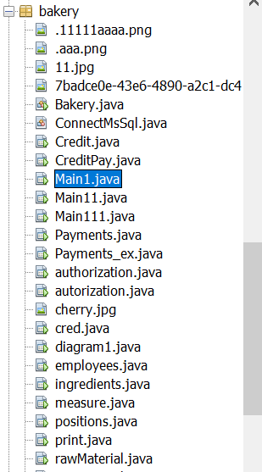

* Форма **Main1.java**

Основная форма администратора, в котором неограничивается доступ к любым действиям, то есть из которой можно переходить по другим формам, для закупа сырья, для производства продукции и для ее продажи. И для просмотра отчётов.

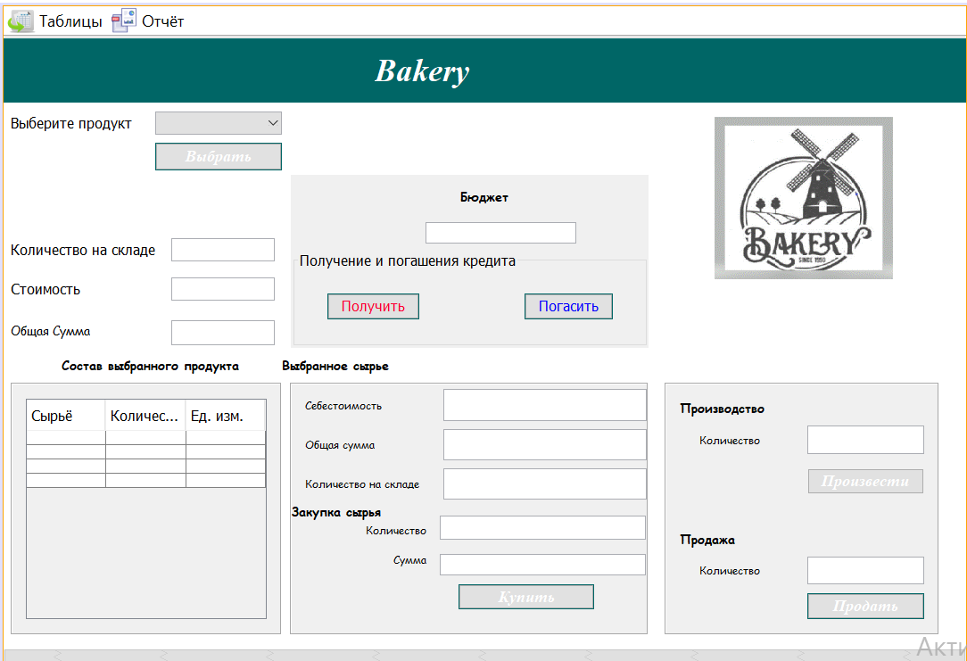

**Код:**

/* /*

* To change this license header, choose License Headers in Project Properties.

* To change this template file, choose Tools | Templates

* and open the template in the editor.

*/

package bakery;

import java.sql.*;

import java.util.Calendar;

import javax.swing.*;

import net.proteanit.sql.DbUtils;

import net.sf.jasperreports.engine.JasperCompileManager;

import net.sf.jasperreports.engine.JasperFillManager;

import net.sf.jasperreports.engine.JasperPrint;

import net.sf.jasperreports.engine.JasperReport;

import net.sf.jasperreports.engine.design.JRDesignQuery;

import net.sf.jasperreports.engine.design.JasperDesign;

import net.sf.jasperreports.engine.xml.JRXmlLoader;

import net.sf.jasperreports.view.JasperViewer;

/**

*

* @author Aidin

*/

public class Main1 extends javax.swing.JFrame {

Connection conn = null;

CallableStatement stored_pro = null;

Statement statement = null;

ResultSet rs = null;

/**

* Creates new form Main

*/

public Main1() {

initComponents();

}

@SuppressWarnings("unchecked")

// <editor-fold defaultstate="collapsed" desc="Generated Code">

private void initComponents() {

bindingGroup = new org.jdesktop.beansbinding.BindingGroup();

jPanel1 = new javax.swing.JPanel();

jComboBox1 = new javax.swing.JComboBox<>();

jLabel2 = new javax.swing.JLabel();

jLabel3 = new javax.swing.JLabel();

jTextField1 = new javax.swing.JTextField();

jTextField2 = new javax.swing.JTextField();

jLabel4 = new javax.swing.JLabel();

jPanel4 = new javax.swing.JPanel();

jLabel7 = new javax.swing.JLabel();

jLabel8 = new javax.swing.JLabel();

jLabel9 = new javax.swing.JLabel();

jTextField3 = new javax.swing.JTextField();

jTextField4 = new javax.swing.JTextField();

jTextField5 = new javax.swing.JTextField();

jLabel10 = new javax.swing.JLabel();

jLabel11 = new javax.swing.JLabel();

jLabel12 = new javax.swing.JLabel();

jTextField6 = new javax.swing.JTextField();

jTextField7 = new javax.swing.JTextField();

jButton2 = new javax.swing.JButton();

jPanel5 = new javax.swing.JPanel();

jLabel14 = new javax.swing.JLabel();

jTextField9 = new javax.swing.JTextField();

jLabel15 = new javax.swing.JLabel();

jToggleButton1 = new javax.swing.JToggleButton();

jLabel17 = new javax.swing.JLabel();

jLabel18 = new javax.swing.JLabel();

jTextField11 = new javax.swing.JTextField();

jButton3 = new javax.swing.JButton();

jLabel6 = new javax.swing.JLabel();

jLabel5 = new javax.swing.JLabel();

jPanel3 = new javax.swing.JPanel();

jScrollPane1 = new javax.swing.JScrollPane();

jTable1 = new javax.swing.JTable();

jButton1 = new javax.swing.JButton();

jLabel21 = new javax.swing.JLabel();

jTextField10 = new javax.swing.JTextField();

jLabel16 = new javax.swing.JLabel();

jPanel2 = new javax.swing.JPanel();

jLabel1 = new javax.swing.JLabel();

jPanel6 = new javax.swing.JPanel();

jLabel20 = new javax.swing.JLabel();

jTextField8 = new javax.swing.JTextField();

jPanel7 = new javax.swing.JPanel();

jButton4 = new javax.swing.JButton();

jButton5 = new javax.swing.JButton();

jMenuBar1 = new javax.swing.JMenuBar();

jMenu1 = new javax.swing.JMenu();

jMenuItem1 = new javax.swing.JMenuItem();

jMenu3 = new javax.swing.JMenu();

jMenu5 = new javax.swing.JMenu();

jMenu4 = new javax.swing.JMenu();

jMenu6 = new javax.swing.JMenu();

jMenuItem3 = new javax.swing.JMenuItem();

jMenu2 = new javax.swing.JMenu();

jMenu8 = new javax.swing.JMenu();

jMenu7 = new javax.swing.JMenu();

jMenuItem2 = new javax.swing.JMenuItem();

setDefaultCloseOperation(javax.swing.WindowConstants.EXIT_ON_CLOSE);

setBackground(new java.awt.Color(0, 153, 153));

addWindowListener(new java.awt.event.WindowAdapter() {

public void windowOpened(java.awt.event.WindowEvent evt) {

formWindowOpened(evt);

}

});

jPanel1.setBackground(new java.awt.Color(255, 255, 255));

org.jdesktop.beansbinding.Binding binding = org.jdesktop.beansbinding.Bindings.createAutoBinding(org.jdesktop.beansbinding.AutoBinding.UpdateStrategy.READ_WRITE, jComboBox1, org.jdesktop.beansbinding.ObjectProperty.create(), jComboBox1, org.jdesktop.beansbinding.BeanProperty.create("selectedItem"));

bindingGroup.addBinding(binding);

jComboBox1.addActionListener(new java.awt.event.ActionListener() {

public void actionPerformed(java.awt.event.ActionEvent evt) {

jComboBox1ActionPerformed(evt);

}

});

jLabel2.setText("Выберите продукт");

jLabel3.setText("Количество на складе");

jLabel4.setText("Стоимость");

jPanel4.setBorder(javax.swing.BorderFactory.createEtchedBorder());

jLabel7.setFont(new java.awt.Font("Comic Sans MS", 0, 12)); // NOI18N

jLabel7.setText("Себестоимость");

jLabel8.setFont(new java.awt.Font("Comic Sans MS", 0, 12)); // NOI18N

jLabel8.setText("Количество на складе");

jLabel9.setFont(new java.awt.Font("Comic Sans MS", 0, 12)); // NOI18N

jLabel9.setText("Общая сумма");

jTextField3.setFont(new java.awt.Font("Comic Sans MS", 0, 12)); // NOI18N

jTextField4.setFont(new java.awt.Font("Comic Sans MS", 0, 12)); // NOI18N

jTextField5.setFont(new java.awt.Font("Comic Sans MS", 0, 12)); // NOI18N

jLabel10.setFont(new java.awt.Font("Comic Sans MS", 1, 14)); // NOI18N

jLabel10.setText("Закупка сырья");

jLabel11.setFont(new java.awt.Font("Comic Sans MS", 0, 12)); // NOI18N

jLabel11.setText("Количество");

jLabel12.setFont(new java.awt.Font("Comic Sans MS", 0, 12)); // NOI18N

jLabel12.setText("Сумма");

jTextField6.setFont(new java.awt.Font("Comic Sans MS", 0, 12)); // NOI18N

jTextField7.setFont(new java.awt.Font("Comic Sans MS", 0, 12)); // NOI18N

jButton2.setBackground(new java.awt.Color(0, 102, 102));

jButton2.setFont(new java.awt.Font("Times New Roman", 3, 18)); // NOI18N

jButton2.setForeground(new java.awt.Color(255, 255, 255));

jButton2.setText("Купить");

jButton2.addActionListener(new java.awt.event.ActionListener() {

public void actionPerformed(java.awt.event.ActionEvent evt) {

jButton2ActionPerformed(evt);

}

});

javax.swing.GroupLayout jPanel4Layout = new javax.swing.GroupLayout(jPanel4);

jPanel4.setLayout(jPanel4Layout);

jPanel4Layout.setHorizontalGroup(

jPanel4Layout.createParallelGroup(javax.swing.GroupLayout.Alignment.LEADING)

.addGroup(jPanel4Layout.createSequentialGroup()

.addContainerGap()

.addGroup(jPanel4Layout.createParallelGroup(javax.swing.GroupLayout.Alignment.LEADING)

.addComponent(jLabel9)

.addComponent(jLabel7)

.addComponent(jLabel8))

.addPreferredGap(javax.swing.LayoutStyle.ComponentPlacement.RELATED, 27, Short.MAX_VALUE)

.addGroup(jPanel4Layout.createParallelGroup(javax.swing.GroupLayout.Alignment.LEADING)

.addGroup(javax.swing.GroupLayout.Alignment.TRAILING, jPanel4Layout.createParallelGroup(javax.swing.GroupLayout.Alignment.TRAILING, false)

.addComponent(jTextField4, javax.swing.GroupLayout.DEFAULT_SIZE, 228, Short.MAX_VALUE)

.addComponent(jTextField5))

.addComponent(jTextField3, javax.swing.GroupLayout.Alignment.TRAILING, javax.swing.GroupLayout.PREFERRED_SIZE, 228, javax.swing.GroupLayout.PREFERRED_SIZE)))

.addGroup(jPanel4Layout.createSequentialGroup()

.addGroup(jPanel4Layout.createParallelGroup(javax.swing.GroupLayout.Alignment.LEADING)

.addGroup(jPanel4Layout.createSequentialGroup()

.addGap(83, 83, 83)

.addGroup(jPanel4Layout.createParallelGroup(javax.swing.GroupLayout.Alignment.TRAILING)

.addComponent(jLabel12)

.addComponent(jLabel11)))

.addComponent(jLabel10))

.addGap(15, 15, 15)

.addGroup(jPanel4Layout.createParallelGroup(javax.swing.GroupLayout.Alignment.LEADING)

.addComponent(jTextField7)

.addComponent(jTextField6, javax.swing.GroupLayout.Alignment.TRAILING)

.addGroup(jPanel4Layout.createSequentialGroup()

.addGap(21, 21, 21)

.addComponent(jButton2, javax.swing.GroupLayout.PREFERRED_SIZE, 152, javax.swing.GroupLayout.PREFERRED_SIZE)

.addGap(0, 0, Short.MAX_VALUE)))

.addGap(1, 1, 1))

);

jPanel4Layout.setVerticalGroup(

jPanel4Layout.createParallelGroup(javax.swing.GroupLayout.Alignment.LEADING)

.addGroup(jPanel4Layout.createSequentialGroup()

.addGap(5, 5, 5)

.addGroup(jPanel4Layout.createParallelGroup(javax.swing.GroupLayout.Alignment.BASELINE)

.addComponent(jTextField3, javax.swing.GroupLayout.PREFERRED_SIZE, 36, javax.swing.GroupLayout.PREFERRED_SIZE)

.addComponent(jLabel7))

.addPreferredGap(javax.swing.LayoutStyle.ComponentPlacement.RELATED)

.addGroup(jPanel4Layout.createParallelGroup(javax.swing.GroupLayout.Alignment.BASELINE)

.addComponent(jTextField4, javax.swing.GroupLayout.PREFERRED_SIZE, 35, javax.swing.GroupLayout.PREFERRED_SIZE)

.addComponent(jLabel9))

.addPreferredGap(javax.swing.LayoutStyle.ComponentPlacement.RELATED)

.addGroup(jPanel4Layout.createParallelGroup(javax.swing.GroupLayout.Alignment.BASELINE)

.addComponent(jTextField5, javax.swing.GroupLayout.PREFERRED_SIZE, 35, javax.swing.GroupLayout.PREFERRED_SIZE)

.addComponent(jLabel8))

.addGroup(jPanel4Layout.createParallelGroup(javax.swing.GroupLayout.Alignment.LEADING)

.addGroup(jPanel4Layout.createSequentialGroup()

.addGap(3, 3, 3)

.addComponent(jLabel10)

.addGap(1, 1, 1)

.addComponent(jLabel11)

.addGap(15, 15, 15)

.addComponent(jLabel12))

.addGroup(jPanel4Layout.createSequentialGroup()

.addGap(18, 18, 18)

.addComponent(jTextField6, javax.swing.GroupLayout.PREFERRED_SIZE, 27, javax.swing.GroupLayout.PREFERRED_SIZE)

.addPreferredGap(javax.swing.LayoutStyle.ComponentPlacement.UNRELATED)

.addComponent(jTextField7, javax.swing.GroupLayout.PREFERRED_SIZE, javax.swing.GroupLayout.DEFAULT_SIZE, javax.swing.GroupLayout.PREFERRED_SIZE)

.addGap(10, 10, 10)

.addComponent(jButton2, javax.swing.GroupLayout.PREFERRED_SIZE, 28, javax.swing.GroupLayout.PREFERRED_SIZE)))

.addContainerGap(javax.swing.GroupLayout.DEFAULT_SIZE, Short.MAX_VALUE))

);

jPanel5.setBorder(javax.swing.BorderFactory.createEtchedBorder());

jLabel14.setFont(new java.awt.Font("Comic Sans MS", 1, 14)); // NOI18N

jLabel14.setText("Производство");

jTextField9.setFont(new java.awt.Font("Comic Sans MS", 0, 12)); // NOI18N

jLabel15.setFont(new java.awt.Font("Comic Sans MS", 0, 12)); // NOI18N

jLabel15.setText("Количество");

jToggleButton1.setBackground(new java.awt.Color(0, 102, 102));

jToggleButton1.setFont(new java.awt.Font("Times New Roman", 3, 18)); // NOI18N

jToggleButton1.setForeground(new java.awt.Color(255, 255, 255));

jToggleButton1.setText("Произвести");

jToggleButton1.addActionListener(new java.awt.event.ActionListener() {

public void actionPerformed(java.awt.event.ActionEvent evt) {

jToggleButton1ActionPerformed(evt);

}

});

jLabel17.setFont(new java.awt.Font("Comic Sans MS", 1, 14)); // NOI18N

jLabel17.setText("Продажа");

jLabel18.setFont(new java.awt.Font("Comic Sans MS", 0, 12)); // NOI18N

jLabel18.setText("Количество");

jTextField11.setFont(new java.awt.Font("Comic Sans MS", 0, 12)); // NOI18N

jButton3.setBackground(new java.awt.Color(0, 102, 102));

jButton3.setFont(new java.awt.Font("Times New Roman", 3, 18)); // NOI18N

jButton3.setForeground(new java.awt.Color(255, 255, 255));

jButton3.setText("Продать");

jButton3.addActionListener(new java.awt.event.ActionListener() {

public void actionPerformed(java.awt.event.ActionEvent evt) {

jButton3ActionPerformed(evt);

}

});

javax.swing.GroupLayout jPanel5Layout = new javax.swing.GroupLayout(jPanel5);

jPanel5.setLayout(jPanel5Layout);

jPanel5Layout.setHorizontalGroup(

jPanel5Layout.createParallelGroup(javax.swing.GroupLayout.Alignment.LEADING)

.addGroup(jPanel5Layout.createSequentialGroup()

.addContainerGap()

.addGroup(jPanel5Layout.createParallelGroup(javax.swing.GroupLayout.Alignment.LEADING)

.addComponent(jLabel14)

.addComponent(jLabel17))

.addContainerGap(javax.swing.GroupLayout.DEFAULT_SIZE, Short.MAX_VALUE))

.addGroup(javax.swing.GroupLayout.Alignment.TRAILING, jPanel5Layout.createSequentialGroup()

.addGap(37, 37, 37)

.addGroup(jPanel5Layout.createParallelGroup(javax.swing.GroupLayout.Alignment.TRAILING)

.addComponent(jLabel15)

.addComponent(jLabel18))

.addPreferredGap(javax.swing.LayoutStyle.ComponentPlacement.RELATED, 53, Short.MAX_VALUE)

.addGroup(jPanel5Layout.createParallelGroup(javax.swing.GroupLayout.Alignment.LEADING, false)

.addComponent(jButton3, javax.swing.GroupLayout.DEFAULT_SIZE, javax.swing.GroupLayout.DEFAULT_SIZE, Short.MAX_VALUE)

.addComponent(jToggleButton1, javax.swing.GroupLayout.DEFAULT_SIZE, javax.swing.GroupLayout.DEFAULT_SIZE, Short.MAX_VALUE)

.addComponent(jTextField9)

.addComponent(jTextField11))

.addContainerGap())

);

jPanel5Layout.setVerticalGroup(

jPanel5Layout.createParallelGroup(javax.swing.GroupLayout.Alignment.LEADING)

.addGroup(jPanel5Layout.createSequentialGroup()

.addContainerGap()

.addComponent(jLabel14)

.addPreferredGap(javax.swing.LayoutStyle.ComponentPlacement.RELATED)

.addGroup(jPanel5Layout.createParallelGroup(javax.swing.GroupLayout.Alignment.BASELINE)

.addComponent(jTextField9, javax.swing.GroupLayout.PREFERRED_SIZE, 32, javax.swing.GroupLayout.PREFERRED_SIZE)

.addComponent(jLabel15))

.addPreferredGap(javax.swing.LayoutStyle.ComponentPlacement.UNRELATED)

.addComponent(jToggleButton1, javax.swing.GroupLayout.PREFERRED_SIZE, 29, javax.swing.GroupLayout.PREFERRED_SIZE)

.addGap(40, 40, 40)

.addComponent(jLabel17)

.addPreferredGap(javax.swing.LayoutStyle.ComponentPlacement.RELATED)

.addGroup(jPanel5Layout.createParallelGroup(javax.swing.GroupLayout.Alignment.BASELINE)

.addComponent(jTextField11, javax.swing.GroupLayout.PREFERRED_SIZE, 31, javax.swing.GroupLayout.PREFERRED_SIZE)

.addComponent(jLabel18))

.addGap(10, 10, 10)

.addComponent(jButton3, javax.swing.GroupLayout.PREFERRED_SIZE, 29, javax.swing.GroupLayout.PREFERRED_SIZE)

.addContainerGap(javax.swing.GroupLayout.DEFAULT_SIZE, Short.MAX_VALUE))

);

jLabel6.setFont(new java.awt.Font("Comic Sans MS", 1, 14)); // NOI18N

jLabel6.setText("Выбранное сырье");

jLabel5.setFont(new java.awt.Font("Comic Sans MS", 1, 14)); // NOI18N

jLabel5.setText("Состав выбранного продукта");

jPanel3.setBorder(javax.swing.BorderFactory.createEtchedBorder());

jTable1.setFont(new java.awt.Font("Comic Sans MS", 0, 12)); // NOI18N

jTable1.setModel(new javax.swing.table.DefaultTableModel(

new Object [][] {

{null, null, null},

{null, null, null},

{null, null, null},

{null, null, null}

},

new String [] {

"Сырьё", "Количество", "Ед. изм."

}

));

jTable1.addMouseListener(new java.awt.event.MouseAdapter() {

public void mouseClicked(java.awt.event.MouseEvent evt) {

jTable1MouseClicked(evt);

}

});

jScrollPane1.setViewportView(jTable1);

javax.swing.GroupLayout jPanel3Layout = new javax.swing.GroupLayout(jPanel3);

jPanel3.setLayout(jPanel3Layout);

jPanel3Layout.setHorizontalGroup(

jPanel3Layout.createParallelGroup(javax.swing.GroupLayout.Alignment.LEADING)

.addGroup(jPanel3Layout.createSequentialGroup()

.addContainerGap()

.addComponent(jScrollPane1, javax.swing.GroupLayout.DEFAULT_SIZE, 270, Short.MAX_VALUE)

.addContainerGap())

);

jPanel3Layout.setVerticalGroup(

jPanel3Layout.createParallelGroup(javax.swing.GroupLayout.Alignment.LEADING)

.addGroup(javax.swing.GroupLayout.Alignment.TRAILING, jPanel3Layout.createSequentialGroup()

.addContainerGap()

.addComponent(jScrollPane1, javax.swing.GroupLayout.PREFERRED_SIZE, 0, Short.MAX_VALUE)

.addContainerGap())

);

jButton1.setBackground(new java.awt.Color(0, 102, 102));

jButton1.setFont(new java.awt.Font("Times New Roman", 3, 18)); // NOI18N

jButton1.setForeground(new java.awt.Color(255, 255, 255));

jButton1.setText("Выбрать");

jButton1.addActionListener(new java.awt.event.ActionListener() {

public void actionPerformed(java.awt.event.ActionEvent evt) {

jButton1ActionPerformed(evt);

}

});

jLabel21.setIcon(new javax.swing.ImageIcon(getClass().getResource("/bakery/Без.gif"))); // NOI18N

jTextField10.setFont(new java.awt.Font("Times New Roman", 0, 11)); // NOI18N

jLabel16.setFont(new java.awt.Font("Comic Sans MS", 0, 14)); // NOI18N

jLabel16.setText("Общая Сумма");

jPanel2.setBackground(new java.awt.Color(0, 102, 102));

jLabel1.setFont(new java.awt.Font("Times New Roman", 3, 36)); // NOI18N

jLabel1.setForeground(new java.awt.Color(255, 255, 255));

jLabel1.setText("Bakery");

javax.swing.GroupLayout jPanel2Layout = new javax.swing.GroupLayout(jPanel2);

jPanel2.setLayout(jPanel2Layout);

jPanel2Layout.setHorizontalGroup(

jPanel2Layout.createParallelGroup(javax.swing.GroupLayout.Alignment.LEADING)

.addGroup(jPanel2Layout.createSequentialGroup()

.addGap(416, 416, 416)

.addComponent(jLabel1, javax.swing.GroupLayout.PREFERRED_SIZE, 129, javax.swing.GroupLayout.PREFERRED_SIZE)

.addContainerGap(javax.swing.GroupLayout.DEFAULT_SIZE, Short.MAX_VALUE))

);

jPanel2Layout.setVerticalGroup(

jPanel2Layout.createParallelGroup(javax.swing.GroupLayout.Alignment.LEADING)

.addGroup(jPanel2Layout.createSequentialGroup()

.addContainerGap()

.addComponent(jLabel1, javax.swing.GroupLayout.PREFERRED_SIZE, 40, javax.swing.GroupLayout.PREFERRED_SIZE)

.addContainerGap(javax.swing.GroupLayout.DEFAULT_SIZE, Short.MAX_VALUE))

);

jLabel20.setFont(new java.awt.Font("Comic Sans MS", 1, 14)); // NOI18N

jLabel20.setText("Бюджет");

jTextField8.setFont(new java.awt.Font("Comic Sans MS", 0, 12)); // NOI18N

jTextField8.setToolTipText("");

jTextField8.addActionListener(new java.awt.event.ActionListener() {

public void actionPerformed(java.awt.event.ActionEvent evt) {

jTextField8ActionPerformed(evt);

}

});

jPanel7.setBorder(javax.swing.BorderFactory.createTitledBorder("Получение и погашения кредита"));

jButton4.setBackground(new java.awt.Color(0, 102, 102));

jButton4.setForeground(new java.awt.Color(255, 0, 51));

jButton4.setText("Получить");

jButton4.addActionListener(new java.awt.event.ActionListener() {

public void actionPerformed(java.awt.event.ActionEvent evt) {

jButton4ActionPerformed(evt);

}

});

jButton5.setBackground(new java.awt.Color(0, 102, 102));

jButton5.setForeground(new java.awt.Color(0, 0, 255));

jButton5.setText("Погасить");

jButton5.addActionListener(new java.awt.event.ActionListener() {

public void actionPerformed(java.awt.event.ActionEvent evt) {

jButton5ActionPerformed(evt);

}

});

javax.swing.GroupLayout jPanel7Layout = new javax.swing.GroupLayout(jPanel7);

jPanel7.setLayout(jPanel7Layout);

jPanel7Layout.setHorizontalGroup(

jPanel7Layout.createParallelGroup(javax.swing.GroupLayout.Alignment.LEADING)

.addGroup(jPanel7Layout.createSequentialGroup()

.addGap(34, 34, 34)

.addComponent(jButton4)

.addGap(118, 118, 118)

.addComponent(jButton5)

.addContainerGap(javax.swing.GroupLayout.DEFAULT_SIZE, Short.MAX_VALUE))

);

jPanel7Layout.setVerticalGroup(

jPanel7Layout.createParallelGroup(javax.swing.GroupLayout.Alignment.LEADING)

.addGroup(jPanel7Layout.createSequentialGroup()

.addGap(25, 25, 25)

.addGroup(jPanel7Layout.createParallelGroup(javax.swing.GroupLayout.Alignment.BASELINE)

.addComponent(jButton4)

.addComponent(jButton5))

.addContainerGap(25, Short.MAX_VALUE))

);

javax.swing.GroupLayout jPanel6Layout = new javax.swing.GroupLayout(jPanel6);

jPanel6.setLayout(jPanel6Layout);

jPanel6Layout.setHorizontalGroup(

jPanel6Layout.createParallelGroup(javax.swing.GroupLayout.Alignment.LEADING)

.addGroup(jPanel6Layout.createSequentialGroup()

.addGap(1, 1, 1)

.addGroup(jPanel6Layout.createParallelGroup(javax.swing.GroupLayout.Alignment.LEADING)

.addGroup(jPanel6Layout.createSequentialGroup()

.addGap(0, 0, Short.MAX_VALUE)

.addGroup(jPanel6Layout.createParallelGroup(javax.swing.GroupLayout.Alignment.LEADING)

.addGroup(javax.swing.GroupLayout.Alignment.TRAILING, jPanel6Layout.createSequentialGroup()

.addComponent(jLabel20)

.addGap(157, 157, 157))

.addGroup(javax.swing.GroupLayout.Alignment.TRAILING, jPanel6Layout.createSequentialGroup()

.addComponent(jTextField8, javax.swing.GroupLayout.PREFERRED_SIZE, 169, javax.swing.GroupLayout.PREFERRED_SIZE)

.addGap(81, 81, 81))))

.addComponent(jPanel7, javax.swing.GroupLayout.DEFAULT_SIZE, javax.swing.GroupLayout.DEFAULT_SIZE, Short.MAX_VALUE)))

);

jPanel6Layout.setVerticalGroup(

jPanel6Layout.createParallelGroup(javax.swing.GroupLayout.Alignment.LEADING)

.addGroup(jPanel6Layout.createSequentialGroup()

.addGap(14, 14, 14)

.addComponent(jLabel20)

.addGap(18, 18, 18)

.addComponent(jTextField8, javax.swing.GroupLayout.PREFERRED_SIZE, javax.swing.GroupLayout.DEFAULT_SIZE, javax.swing.GroupLayout.PREFERRED_SIZE)

.addPreferredGap(javax.swing.LayoutStyle.ComponentPlacement.RELATED, javax.swing.GroupLayout.DEFAULT_SIZE, Short.MAX_VALUE)

.addComponent(jPanel7, javax.swing.GroupLayout.PREFERRED_SIZE, javax.swing.GroupLayout.DEFAULT_SIZE, javax.swing.GroupLayout.PREFERRED_SIZE))

);

javax.swing.GroupLayout jPanel1Layout = new javax.swing.GroupLayout(jPanel1);

jPanel1.setLayout(jPanel1Layout);

jPanel1Layout.setHorizontalGroup(

jPanel1Layout.createParallelGroup(javax.swing.GroupLayout.Alignment.LEADING)

.addGroup(jPanel1Layout.createSequentialGroup()

.addGap(8, 8, 8)

.addGroup(jPanel1Layout.createParallelGroup(javax.swing.GroupLayout.Alignment.TRAILING)

.addGroup(javax.swing.GroupLayout.Alignment.LEADING, jPanel1Layout.createSequentialGroup()

.addComponent(jLabel2)

.addGap(26, 26, 26)

.addGroup(jPanel1Layout.createParallelGroup(javax.swing.GroupLayout.Alignment.LEADING)

.addComponent(jButton1, javax.swing.GroupLayout.DEFAULT_SIZE, javax.swing.GroupLayout.DEFAULT_SIZE, Short.MAX_VALUE)

.addComponent(jComboBox1, 0, javax.swing.GroupLayout.DEFAULT_SIZE, Short.MAX_VALUE)))

.addGroup(jPanel1Layout.createSequentialGroup()

.addGap(0, 0, Short.MAX_VALUE)

.addGroup(jPanel1Layout.createParallelGroup(javax.swing.GroupLayout.Alignment.TRAILING)

.addGroup(jPanel1Layout.createSequentialGroup()

.addComponent(jLabel5)

.addGap(48, 48, 48))

.addComponent(jPanel3, javax.swing.GroupLayout.PREFERRED_SIZE, javax.swing.GroupLayout.DEFAULT_SIZE, javax.swing.GroupLayout.PREFERRED_SIZE)))

.addGroup(javax.swing.GroupLayout.Alignment.LEADING, jPanel1Layout.createSequentialGroup()

.addGroup(jPanel1Layout.createParallelGroup(javax.swing.GroupLayout.Alignment.TRAILING, false)

.addGroup(javax.swing.GroupLayout.Alignment.LEADING, jPanel1Layout.createSequentialGroup()

.addGroup(jPanel1Layout.createParallelGroup(javax.swing.GroupLayout.Alignment.LEADING)

.addComponent(jLabel4)

.addComponent(jLabel16))

.addGap(91, 91, 91)

.addGroup(jPanel1Layout.createParallelGroup(javax.swing.GroupLayout.Alignment.LEADING)

.addComponent(jTextField2)

.addComponent(jTextField10)))

.addGroup(javax.swing.GroupLayout.Alignment.LEADING, jPanel1Layout.createSequentialGroup()

.addComponent(jLabel3)

.addGap(18, 18, 18)

.addComponent(jTextField1, javax.swing.GroupLayout.PREFERRED_SIZE, 116, javax.swing.GroupLayout.PREFERRED_SIZE)))

.addGap(0, 0, Short.MAX_VALUE)))

.addGroup(jPanel1Layout.createParallelGroup(javax.swing.GroupLayout.Alignment.LEADING)

.addGroup(jPanel1Layout.createSequentialGroup()

.addPreferredGap(javax.swing.LayoutStyle.ComponentPlacement.RELATED)

.addComponent(jPanel4, javax.swing.GroupLayout.PREFERRED_SIZE, javax.swing.GroupLayout.DEFAULT_SIZE, javax.swing.GroupLayout.PREFERRED_SIZE)

.addGap(18, 18, 18)

.addComponent(jPanel5, javax.swing.GroupLayout.PREFERRED_SIZE, javax.swing.GroupLayout.DEFAULT_SIZE, javax.swing.GroupLayout.PREFERRED_SIZE)

.addContainerGap(30, Short.MAX_VALUE))

.addGroup(jPanel1Layout.createSequentialGroup()

.addGroup(jPanel1Layout.createParallelGroup(javax.swing.GroupLayout.Alignment.LEADING)

.addGroup(jPanel1Layout.createSequentialGroup()

.addComponent(jLabel6)

.addPreferredGap(javax.swing.LayoutStyle.ComponentPlacement.RELATED, javax.swing.GroupLayout.DEFAULT_SIZE, Short.MAX_VALUE))

.addGroup(jPanel1Layout.createSequentialGroup()

.addGap(10, 10, 10)

.addComponent(jPanel6, javax.swing.GroupLayout.DEFAULT_SIZE, javax.swing.GroupLayout.DEFAULT_SIZE, Short.MAX_VALUE)

.addGap(74, 74, 74)))

.addComponent(jLabel21)

.addGap(82, 82, 82))))

.addComponent(jPanel2, javax.swing.GroupLayout.DEFAULT_SIZE, javax.swing.GroupLayout.DEFAULT_SIZE, Short.MAX_VALUE)

);

jPanel1Layout.setVerticalGroup(

jPanel1Layout.createParallelGroup(javax.swing.GroupLayout.Alignment.LEADING)

.addGroup(jPanel1Layout.createSequentialGroup()

.addGroup(jPanel1Layout.createParallelGroup(javax.swing.GroupLayout.Alignment.LEADING)

.addGroup(jPanel1Layout.createSequentialGroup()

.addGap(1, 1, 1)

.addComponent(jPanel2, javax.swing.GroupLayout.PREFERRED_SIZE, javax.swing.GroupLayout.DEFAULT_SIZE, javax.swing.GroupLayout.PREFERRED_SIZE)

.addGroup(jPanel1Layout.createParallelGroup(javax.swing.GroupLayout.Alignment.LEADING)

.addGroup(javax.swing.GroupLayout.Alignment.TRAILING, jPanel1Layout.createSequentialGroup()

.addGap(175, 175, 175)

.addGroup(jPanel1Layout.createParallelGroup(javax.swing.GroupLayout.Alignment.BASELINE)

.addComponent(jLabel16)

.addComponent(jTextField10, javax.swing.GroupLayout.PREFERRED_SIZE, 28, javax.swing.GroupLayout.PREFERRED_SIZE))

.addGap(12, 12, 12))

.addGroup(jPanel1Layout.createSequentialGroup()

.addGroup(jPanel1Layout.createParallelGroup(javax.swing.GroupLayout.Alignment.LEADING)

.addGroup(jPanel1Layout.createSequentialGroup()

.addGap(10, 10, 10)

.addGroup(jPanel1Layout.createParallelGroup(javax.swing.GroupLayout.Alignment.BASELINE)

.addComponent(jComboBox1, javax.swing.GroupLayout.PREFERRED_SIZE, javax.swing.GroupLayout.DEFAULT_SIZE, javax.swing.GroupLayout.PREFERRED_SIZE)

.addComponent(jLabel2))

.addPreferredGap(javax.swing.LayoutStyle.ComponentPlacement.RELATED)

.addComponent(jButton1)

.addGap(76, 76, 76)

.addGroup(jPanel1Layout.createParallelGroup(javax.swing.GroupLayout.Alignment.BASELINE)

.addComponent(jLabel3)

.addComponent(jTextField1, javax.swing.GroupLayout.PREFERRED_SIZE, javax.swing.GroupLayout.DEFAULT_SIZE, javax.swing.GroupLayout.PREFERRED_SIZE))

.addGap(18, 18, 18)

.addGroup(jPanel1Layout.createParallelGroup(javax.swing.GroupLayout.Alignment.BASELINE)

.addComponent(jLabel4)

.addComponent(jTextField2, javax.swing.GroupLayout.PREFERRED_SIZE, javax.swing.GroupLayout.DEFAULT_SIZE, javax.swing.GroupLayout.PREFERRED_SIZE)))

.addGroup(jPanel1Layout.createSequentialGroup()

.addGap(81, 81, 81)

.addComponent(jPanel6, javax.swing.GroupLayout.PREFERRED_SIZE, javax.swing.GroupLayout.DEFAULT_SIZE, javax.swing.GroupLayout.PREFERRED_SIZE)))

.addPreferredGap(javax.swing.LayoutStyle.ComponentPlacement.RELATED))))

.addGroup(jPanel1Layout.createSequentialGroup()

.addGap(25, 25, 25)

.addComponent(jLabel21, javax.swing.GroupLayout.PREFERRED_SIZE, 311, javax.swing.GroupLayout.PREFERRED_SIZE)))

.addGroup(jPanel1Layout.createParallelGroup(javax.swing.GroupLayout.Alignment.TRAILING)

.addGroup(jPanel1Layout.createSequentialGroup()

.addComponent(jLabel5)

.addPreferredGap(javax.swing.LayoutStyle.ComponentPlacement.RELATED)

.addComponent(jPanel3, javax.swing.GroupLayout.DEFAULT_SIZE, javax.swing.GroupLayout.DEFAULT_SIZE, Short.MAX_VALUE))

.addGroup(jPanel1Layout.createSequentialGroup()

.addComponent(jLabel6)

.addPreferredGap(javax.swing.LayoutStyle.ComponentPlacement.RELATED)

.addGroup(jPanel1Layout.createParallelGroup(javax.swing.GroupLayout.Alignment.LEADING)

.addComponent(jPanel4, javax.swing.GroupLayout.DEFAULT_SIZE, javax.swing.GroupLayout.DEFAULT_SIZE, Short.MAX_VALUE)

.addComponent(jPanel5, javax.swing.GroupLayout.DEFAULT_SIZE, javax.swing.GroupLayout.DEFAULT_SIZE, Short.MAX_VALUE))))

.addContainerGap())

);

jMenu1.setIcon(new javax.swing.ImageIcon(getClass().getResource("/bakery/.11111aaaa.png"))); // NOI18N

jMenu1.setText("Таблицы");

jMenuItem1.setText("Должность");

jMenuItem1.addActionListener(new java.awt.event.ActionListener() {

public void actionPerformed(java.awt.event.ActionEvent evt) {

jMenuItem1ActionPerformed(evt);

}

});

jMenu1.add(jMenuItem1);

jMenu3.setText("Сырье");

jMenu3.addMouseListener(new java.awt.event.MouseAdapter() {

public void mouseClicked(java.awt.event.MouseEvent evt) {

jMenu3MouseClicked(evt);

}

});

jMenu1.add(jMenu3);

jMenu5.setText("Единица измерения");

jMenu5.addMouseListener(new java.awt.event.MouseAdapter() {

public void mouseClicked(java.awt.event.MouseEvent evt) {

jMenu5MouseClicked(evt);

}

});

jMenu1.add(jMenu5);

jMenu4.setText("Ингридиент");

jMenu4.addMouseListener(new java.awt.event.MouseAdapter() {

public void mouseClicked(java.awt.event.MouseEvent evt) {

jMenu4MouseClicked(evt);

}

});

jMenu1.add(jMenu4);

jMenu6.setText("Сотрудники");

jMenu6.addMouseListener(new java.awt.event.MouseAdapter() {

public void mouseClicked(java.awt.event.MouseEvent evt) {

jMenu6MouseClicked(evt);

}

});

jMenu1.add(jMenu6);

jMenuItem3.setText("Готовая продукция");

jMenuItem3.addActionListener(new java.awt.event.ActionListener() {

public void actionPerformed(java.awt.event.ActionEvent evt) {

jMenuItem3ActionPerformed(evt);

}

});

jMenu1.add(jMenuItem3);

jMenuBar1.add(jMenu1);

jMenu2.setIcon(new javax.swing.ImageIcon(getClass().getResource("/bakery/.aaa.png"))); // NOI18N

jMenu2.setText("Отчёт");

jMenu8.setText("Закуп сырья");

jMenu8.addMouseListener(new java.awt.event.MouseAdapter() {

public void mouseClicked(java.awt.event.MouseEvent evt) {

jMenu8MouseClicked(evt);

}

});

jMenu2.add(jMenu8);

jMenu7.setText("Отчёт продажи продукции");

jMenu7.addMouseListener(new java.awt.event.MouseAdapter() {

public void mouseClicked(java.awt.event.MouseEvent evt) {

jMenu7MouseClicked(evt);

}

});

jMenu2.add(jMenu7);

jMenuItem2.setText("Отчёт производство продукции");

jMenuItem2.addMouseListener(new java.awt.event.MouseAdapter() {

public void mouseClicked(java.awt.event.MouseEvent evt) {

jMenuItem2MouseClicked(evt);

}

});

jMenuItem2.addActionListener(new java.awt.event.ActionListener() {

public void actionPerformed(java.awt.event.ActionEvent evt) {

jMenuItem2ActionPerformed(evt);

}

});

jMenu2.add(jMenuItem2);

jMenuBar1.add(jMenu2);

setJMenuBar(jMenuBar1);

javax.swing.GroupLayout layout = new javax.swing.GroupLayout(getContentPane());

getContentPane().setLayout(layout);

layout.setHorizontalGroup(

layout.createParallelGroup(javax.swing.GroupLayout.Alignment.LEADING)

.addGroup(layout.createSequentialGroup()

.addComponent(jPanel1, javax.swing.GroupLayout.PREFERRED_SIZE, javax.swing.GroupLayout.DEFAULT_SIZE, javax.swing.GroupLayout.PREFERRED_SIZE)

.addGap(0, 0, Short.MAX_VALUE))

);

layout.setVerticalGroup(

layout.createParallelGroup(javax.swing.GroupLayout.Alignment.LEADING)

.addGroup(layout.createSequentialGroup()

.addGap(1, 1, 1)

.addComponent(jPanel1, javax.swing.GroupLayout.PREFERRED_SIZE, javax.swing.GroupLayout.DEFAULT_SIZE, javax.swing.GroupLayout.PREFERRED_SIZE)

.addContainerGap(javax.swing.GroupLayout.DEFAULT_SIZE, Short.MAX_VALUE))

);

bindingGroup.bind();

pack();

}// </editor-fold>

private void jButton2ActionPerformed(java.awt.event.ActionEvent evt) {

// TODO add your handling code here:

try{

Class.forName("com.microsoft.sqlserver.jdbc.SQLServerDriver");

String url="jdbc:sqlserver://localhost:1433;databaseName=bakery;user=aidin007;password=123";

Connection conn = DriverManager.getConnection(url);

int row = jTable1.getSelectedRow();

String id = (jTable1.getModel().getValueAt(row,1).toString());

String sql = "SELECT ID FROM RawMaterials WHERE Naimenovaniye_Syrya ='" + id + "'";

PreparedStatement pst=conn.prepareStatement(sql);

ResultSet rs = pst.executeQuery();

int temp = 0;

while(rs.next()){

temp=Integer.parseInt(rs.getString("ID")) ;

}

Calendar calendar = Calendar.getInstance();

java.sql.Date startDate = new java.sql.Date(calendar.getTime().getTime());

int amount=Integer.parseInt(jTextField6.getText());

int summ=Integer.parseInt(jTextField7.getText());

int person=3;

String dobavlenie = "INSERT INTO PurchaseMaterials(RawMaterial, Kol_syrya_zakupke, Summa_zak_syrya, Date_zak_syrya, Pers_zak_syrya) VALUES(?, ?, ?, ?, ?)";

PreparedStatement pst1=conn.prepareStatement(dobavlenie);

pst1.setInt(1, temp);

pst1.setInt(2, amount);

pst1.setInt(3, summ);

pst1.setDate(4, startDate);

pst1.setInt(5,person);

JOptionPane.showMessageDialog(null, "Закуплено");

pst1.executeUpdate();

String update = "SELECT Kol_Syrya,Amount FROM RawMaterials WHERE ID ='" + temp + "'";

pst=conn.prepareStatement(update);

ResultSet res = pst.executeQuery();

statement = conn.createStatement();

res = statement.executeQuery(update);

while(res.next()){

jTextField5.setText(res.getString("Kol_Syrya"));

jTextField4.setText(res.getString("Amount"));

}

String insert = "SELECT Kolichestvo_deneg_v_budgete FROM Budget";

pst=conn.prepareStatement(insert);

ResultSet ress = pst.executeQuery();

statement = conn.createStatement();

ress = statement.executeQuery(insert);

while(ress.next()){

jTextField8.setText(ress.getString("Kolichestvo_deneg_v_budgete"));

}

}

catch(Exception e){

JOptionPane.showMessageDialog(null, "no Data added");

System.out.println("Error");

}

}

private void jToggleButton1ActionPerformed(java.awt.event.ActionEvent evt) {

// TODO add your handling code here:

try{

Class.forName("com.microsoft.sqlserver.jdbc.SQLServerDriver");

String url="jdbc:sqlserver://localhost:1433;databaseName=bakery;user=aidin007;password=123";

Connection conn = DriverManager.getConnection(url);

Statement st=conn.createStatement();

String name=jComboBox1.getSelectedItem().toString();

int ID = 0;

ResultSet id = st.executeQuery("select ID from Products where Name_Products = '" + name + "'");

while(id.next()){

ID = Integer.parseInt(id.getString("ID"));

}

Calendar calendar = Calendar.getInstance();

java.sql.Date startDate = new java.sql.Date(calendar.getTime().getTime());

int amount=Integer.parseInt(jTextField9.getText());

//

String dobavlenie = "INSERT INTO Production (Product, Kol_Product, Date, Personnel) VALUES(?,?,?,?)";

PreparedStatement pst=conn.prepareStatement(dobavlenie);

pst.setInt(1, ID);

pst.setInt(2, amount);

pst.setDate(3, startDate);

pst.setInt(4, 2);

JOptionPane.showMessageDialog(null, "Произведено");

pst.executeUpdate();

String update = "SELECT Kol_fin_products,self_cost,Amount FROM Products WHERE ID ='" + ID + "'";

pst=conn.prepareStatement(update);

ResultSet res = pst.executeQuery();

statement = conn.createStatement();

res = statement.executeQuery(update);

while(res.next()){

jTextField1.setText(res.getString("Kol_fin_products"));

jTextField2.setText(res.getString("self_cost"));

jTextField10.setText(res.getString("Amount"));

}

String insert = "SELECT Kolichestvo_deneg_v_budgete FROM Budget";

pst=conn.prepareStatement(insert);

ResultSet ress = pst.executeQuery();

statement = conn.createStatement();

ress = statement.executeQuery(insert);

while(ress.next()){

jTextField8.setText(ress.getString("Kolichestvo_deneg_v_budgete"));

}

}

catch(Exception e){

JOptionPane.showMessageDialog(null, "'недостаточно сырья на складе '");

System.out.println("raiserror('недостаточно сырья на складе ',16,1)");

}

}

private void jButton3ActionPerformed(java.awt.event.ActionEvent evt) {

//TODO add your handling code here:

try{

Class.forName("com.microsoft.sqlserver.jdbc.SQLServerDriver");

String url="jdbc:sqlserver://localhost:1433;databaseName=bakery;user=aidin007;password=123";

Connection conn = DriverManager.getConnection(url);

Statement st=conn.createStatement();

String name=jComboBox1.getSelectedItem().toString();

int ID = 0;

ResultSet id = st.executeQuery("select ID from Products where Name_Products = '" + name + "'");

while(id.next()){

ID = Integer.parseInt(id.getString("ID"));

}

Calendar calendar = Calendar.getInstance();

java.sql.Date startDate = new java.sql.Date(calendar.getTime().getTime());

int amount=Integer.parseInt(jTextField11.getText());

String dobavlenie = "INSERT INTO ProductSales (Product,Kol_Prod_Sell,Date_Sell_Prod,Person_Sell) VALUES(?,?,?,?)";

PreparedStatement pst=conn.prepareStatement(dobavlenie);

pst.setInt(1, ID);

pst.setInt(2, amount);

pst.setDate(3, startDate);

pst.setInt(4, 2);

JOptionPane.showMessageDialog(null, "Товар продан");

pst.executeUpdate();

String update = "SELECT Kol_fin_products,self_cost,Amount FROM Products WHERE ID ='" + ID + "'";

pst=conn.prepareStatement(update);

ResultSet res = pst.executeQuery();

statement = conn.createStatement();

res = statement.executeQuery(update);

while(res.next()){

jTextField1.setText(res.getString("Kol_fin_products"));

jTextField2.setText(res.getString("self_cost"));

jTextField10.setText(res.getString("Amount"));

}

String insert = "SELECT Kolichestvo_deneg_v_budgete FROM Budget";

pst=conn.prepareStatement(insert);

ResultSet ress = pst.executeQuery();

statement = conn.createStatement();

ress = statement.executeQuery(insert);

while(ress.next()){

jTextField8.setText(ress.getString("Kolichestvo_deneg_v_budgete"));

}

}

catch(Exception e){

JOptionPane.showMessageDialog(null, "недостаточно продукции на складе");

//

}

}

private void jTable1MouseClicked(java.awt.event.MouseEvent evt) {

// TODO add your handling code here:

try{

jTextField6.setText("");

jTextField7.setText("");

Class.forName("com.microsoft.sqlserver.jdbc.SQLServerDriver");

String url="jdbc:sqlserver://localhost:1433;databaseName=bakery;user=aidin007;password=123";

Connection con = DriverManager.getConnection(url);

int row = jTable1.getSelectedRow();

String name = (jTable1.getModel().getValueAt(row,1).toString());

String sql = "SELECT Self_cost, Amount, Kol_Syrya FROM RawMaterials WHERE Naimenovaniye_Syrya ='" + name + "'";

PreparedStatement pst=con.prepareStatement(sql);

ResultSet rs = pst.executeQuery();

statement = con.createStatement();

rs = statement.executeQuery(sql);

while(rs.next()){

jTextField3.setText(rs.getString("Self_cost"));

jTextField4.setText(rs.getString("Amount"));

jTextField5.setText(rs.getString("Kol_Syrya"));

}

}

catch(Exception e){

System.out.println("Error");

}

}

private void jButton1ActionPerformed(java.awt.event.ActionEvent evt) {

// TODO add your handling code here:

try{

jTextField3.setText("");

jTextField4.setText("");

jTextField5.setText("");

jTextField9.setText("");

// jTextField10.setText("");

jTextField11.setText("");

Class.forName("com.microsoft.sqlserver.jdbc.SQLServerDriver");

String url="jdbc:sqlserver://localhost:1433;databaseName=bakery;user=aidin007;password=123";

Connection con = DriverManager.getConnection(url);

Statement st=con.createStatement();

String test=jComboBox1.getSelectedItem().toString();

ResultSet amount = st.executeQuery("select Kol_fin_products from Products where Name_Products = '" + test + "'");

while(amount.next()){

jTextField1.setText(amount.getString("Kol_fin_products"));

}

ResultSet sum = st.executeQuery("select self_cost from Products where Name_Products = '" + test + "'");

while(sum.next()){

jTextField2.setText(sum.getString("self_cost"));

}

ResultSet summ = st.executeQuery("select Amount from Products where Name_Products = '" + test + "'");

while(summ.next()){

jTextField10.setText(summ.getString("Amount"));

}

String insert = "SELECT Kolichestvo_deneg_v_budgete FROM Budget";

PreparedStatement pst = conn.prepareStatement(insert);

ResultSet ress = pst.executeQuery();

statement = conn.createStatement();

ress = statement.executeQuery(insert);

while(ress.next()){

jTextField8.setText(ress.getString("Kolichestvo_deneg_v_budgete"));

}

////

int ID=0;

ResultSet id = st.executeQuery("select ID from Products where Name_Products = '" + test + "'");

while(id.next()){

ID=Integer.parseInt(id.getString("ID"));

}

String sql = "SELECT RawMaterials.ID, RawMaterials.Naimenovaniye_Syrya,Ingridients.Kol_Syrya_prod,Units.Unit\n" +

"from Products inner join\n" +

"Ingridients on Products.ID=Ingridients.Product INNER JOIN\n" +

" RawMaterials ON Ingridients.RawMaterials = RawMaterials.ID\n" +

" inner Join\n" +

" Units ON RawMaterials.Unit = Units.ID\n" +

"WHERE Products.ID ='" + ID + "'";

statement = con.createStatement();

rs = statement.executeQuery(sql);

this.jTable1.setModel(DbUtils.resultSetToTableModel(rs));

jTable1.getColumnModel().getColumn(0).setHeaderValue("ID");

jTable1.getColumnModel().getColumn(1).setHeaderValue("Сырьё");

jTable1.getColumnModel().getColumn(2).setHeaderValue("Количество");

jTable1.getColumnModel().getColumn(3).setHeaderValue("Ед. изм.");

con.close();

}

catch(Exception e){

e.printStackTrace();

JOptionPane.showMessageDialog(null, e);

}

}

private void jTextField8ActionPerformed(java.awt.event.ActionEvent evt) {

// TODO add your handling code here:

}

private void jComboBox1ActionPerformed(java.awt.event.ActionEvent evt) {

// TODO add your handling code here:

}

private void jMenuItem1ActionPerformed(java.awt.event.ActionEvent evt) {

// TODO add your handling code here:

positions field= new positions();

field.setVisible(true);

setVisible(false);

}

private void formWindowOpened(java.awt.event.WindowEvent evt) {

// TODO add your handling code here:

Fillcombo();

}

private void jMenu3MouseClicked(java.awt.event.MouseEvent evt) {

// TODO add your handling code here:

rawMaterial field= new rawMaterial();

field.setVisible(true);

setVisible(false);

}

private void jMenu5MouseClicked(java.awt.event.MouseEvent evt) {

// TODO add your handling code here:

measure field= new measure();

field.setVisible(true);

setVisible(false);

}

private void jMenu4MouseClicked(java.awt.event.MouseEvent evt) {

// TODO add your handling code here:

ingredients field= new ingredients();

field.setVisible(true);

setVisible(false);

}

private void jMenu6MouseClicked(java.awt.event.MouseEvent evt) {

// TODO add your handling code here:

employees field= new employees();

field.setVisible(true);

setVisible(false);

}

private void showMeAllReportsell(){

try{

conn = ConnectMsSql.ConnectDB();

JasperDesign jasperDesign = JRXmlLoader.load("C:\\Users\\Aidin\\Documents\\3 курс\\Осенний семестр\\Клиент сервер\\MsSqlConnection\\src\\bakery\\repSell.jrxml");

String sql = "SELECT\n" +

" ProductSales.\"ID\" AS ProductSales_ID,\n" +

" ProductSales.\"Kol_Prod_Sell\" AS ProductSales_Kol_Prod_Sell,\n" +

" ProductSales.\"Summa_Prod_Sell\" AS ProductSales_Summa_Prod_Sell,\n" +

" ProductSales.\"Date_Sell_Prod\" AS ProductSales_Date_Sell_Prod,\n" +

" Products.\"Name_Products\" AS Products_Name_Products,\n" +

" Employees.\"Name\" AS Employees_Name\n" +

"FROM\n" +

" \"dbo\".\"Products\" Products INNER JOIN \"dbo\".\"ProductSales\" ProductSales ON Products.\"ID\" = ProductSales.\"Product\"\n" +

" INNER JOIN \"dbo\".\"Employees\" Employees ON ProductSales.\"Person_Sell\" = Employees.\"ID\"";

//String sql ="SELECT [id],[name],[surname],[address],[email],[birth_date] FROM [student_info]";

JRDesignQuery newQuery = new JRDesignQuery();

newQuery.setText(sql);

jasperDesign.setQuery(newQuery);

JasperReport jasperReport = JasperCompileManager.compileReport(jasperDesign);

JasperPrint jasperPrint = JasperFillManager.fillReport(jasperReport, null, conn);

JasperViewer.viewReport(jasperPrint,false);

}

catch(Exception e){

e.printStackTrace();

}

}

private void showMeAllReportprod(){

try{

conn = ConnectMsSql.ConnectDB();

JasperDesign jasperDesign = JRXmlLoader.load("C:\\Users\\Aidin\\Documents\\3 курс\\осений семестр\\Клиент сервер\\MsSqlConnection\\src\\bakery\\report4.jrxml");

String sql = "SELECT\n" +

" PurchaseMaterials.\"ID\" AS PurchaseMaterials_ID,\n" +

" PurchaseMaterials.\"Kol_syrya_zakupke\" AS PurchaseMaterials_Kol_syrya_zakupke,\n" +

" PurchaseMaterials.\"Summa_zak_syrya\" AS PurchaseMaterials_Summa_zak_syrya,\n" +

" PurchaseMaterials.\"Date_zak_syrya\" AS PurchaseMaterials_Date_zak_syrya,\n" +

" RawMaterials.\"Naimenovaniye_Syrya\" AS RawMaterials_Naimenovaniye_Syrya,\n" +

" Employees.\"Name\" AS Employees_Name\n" +

"FROM\n" +

" \"dbo\".\"RawMaterials\" RawMaterials INNER JOIN \"dbo\".\"PurchaseMaterials\" PurchaseMaterials ON RawMaterials.\"ID\" = PurchaseMaterials.\"RawMaterial\"\n" +

" INNER JOIN \"dbo\".\"Employees\" Employees ON PurchaseMaterials.\"Pers_zak_syrya\" = Employees.\"ID\"";

//String sql ="SELECT [id],[name],[surname],[address],[email],[birth_date] FROM [student_info]";

JRDesignQuery newQuery = new JRDesignQuery();

newQuery.setText(sql);

jasperDesign.setQuery(newQuery);

JasperReport jasperReport = JasperCompileManager.compileReport(jasperDesign);

JasperPrint jasperPrint = JasperFillManager.fillReport(jasperReport, null, conn);

JasperViewer.viewReport(jasperPrint,false);

}

catch(Exception e){

e.printStackTrace();

}

}

private void showMeAllReportpruch(){

try{

conn = ConnectMsSql.ConnectDB();

JasperDesign jasperDesign = JRXmlLoader.load("C:\\Users\\Aidin\\Documents\\3 курс\\Осенний семестр\\Клиент сервер\\MsSqlConnection\\src\\bakery\\report4.jrxml");

String sql = "SELECT\n" +

" Production.\"ID\" AS Production_ID,\n" +

" Production.\"Kol_Product\" AS Production_Kol_Product,\n" +

" Production.\"Date\" AS Production_Date,\n" +

" Products.\"Name_Products\" AS Products_Name_Products,\n" +

" Employees.\"Name\" AS Employees_Name\n" +

"FROM\n" +

" \"dbo\".\"Products\" Products INNER JOIN \"dbo\".\"Production\" Production ON Products.\"ID\" = Production.\"Product\"\n" +

" INNER JOIN \"dbo\".\"Employees\" Employees ON Production.\"Personnel\" = Employees.\"ID\"";

//String sql ="SELECT [id],[name],[surname],[address],[email],[birth_date] FROM [student_info]";

JRDesignQuery newQuery = new JRDesignQuery();

newQuery.setText(sql);

jasperDesign.setQuery(newQuery);

JasperReport jasperReport = JasperCompileManager.compileReport(jasperDesign);

JasperPrint jasperPrint = JasperFillManager.fillReport(jasperReport, null, conn);

JasperViewer.viewReport(jasperPrint,false);

}

catch(Exception e){

e.printStackTrace();

}

}

private void jMenu7MouseClicked(java.awt.event.MouseEvent evt) {

// TODO add your handling code here:

showMeAllReportsell();

}

private void jMenuItem2ActionPerformed(java.awt.event.ActionEvent evt) {

// TODO add your handling code here:

showMeAllReportpruch();

}

private void jMenuItem2MouseClicked(java.awt.event.MouseEvent evt) {

// TODO add your handling code here:

showMeAllReportpruch();

}

private void jMenu8MouseClicked(java.awt.event.MouseEvent evt) {

// TODO add your handling code here:

showMeAllReportprod();

}

private void jMenuItem3ActionPerformed(java.awt.event.ActionEvent evt) {

// TODO add your handling code here:

rawMaterial1 field= new rawMaterial1();

field.setVisible(true);

setVisible(false);

}

private void jButton4ActionPerformed(java.awt.event.ActionEvent evt) {

// TODO add your handling code here:

new Credit().setVisible(true);

this.dispose();

}

private void jButton5ActionPerformed(java.awt.event.ActionEvent evt) {

// TODO add your handling code here:

new CreditPay().setVisible(true);

this.dispose();

}

private void Fillcombo(){

try{

conn=ConnectMsSql.ConnectDB();

String sql="select Name_Products from Products";

statement = conn.createStatement();

rs = statement.executeQuery(sql);

while(rs.next()){

String nme=rs.getString("Name_Products");

this.jComboBox1.addItem(nme);

}

}

catch(Exception e){

JOptionPane.showMessageDialog(null, "Ошибка, что то пошло не так c rjv :(");

}

}

/**

* @param args the command line arguments

*/

public static void main(String args[]) {

/* Set the Nimbus look and feel */

//<editor-fold defaultstate="collapsed" desc=" Look and feel setting code (optional) ">

/* If Nimbus (introduced in Java SE 6) is not available, stay with the default look and feel.

* For details see http://download.oracle.com/javase/tutorial/uiswing/lookandfeel/plaf.html

*/

try {

for (javax.swing.UIManager.LookAndFeelInfo info : javax.swing.UIManager.getInstalledLookAndFeels()) {

if ("Nimbus".equals(info.getName())) {

javax.swing.UIManager.setLookAndFeel(info.getClassName());

break;

}

}

} catch (ClassNotFoundException ex) {

java.util.logging.Logger.getLogger(Main1.class.getName()).log(java.util.logging.Level.SEVERE, null, ex);

} catch (InstantiationException ex) {

java.util.logging.Logger.getLogger(Main1.class.getName()).log(java.util.logging.Level.SEVERE, null, ex);

} catch (IllegalAccessException ex) {

java.util.logging.Logger.getLogger(Main1.class.getName()).log(java.util.logging.Level.SEVERE, null, ex);

} catch (javax.swing.UnsupportedLookAndFeelException ex) {

java.util.logging.Logger.getLogger(Main1.class.getName()).log(java.util.logging.Level.SEVERE, null, ex);

}

//</editor-fold>

//</editor-fold>

/* Create and display the form */

java.awt.EventQueue.invokeLater(new Runnable() {

public void run() {

new Main1().setVisible(true);

}

});

}

// Variables declaration - do not modify

private javax.swing.JButton jButton1;

private javax.swing.JButton jButton2;

private javax.swing.JButton jButton3;

private javax.swing.JButton jButton4;

private javax.swing.JButton jButton5;

private javax.swing.JComboBox<String> jComboBox1;

private javax.swing.JLabel jLabel1;

private javax.swing.JLabel jLabel10;

private javax.swing.JLabel jLabel11;

private javax.swing.JLabel jLabel12;

private javax.swing.JLabel jLabel14;

private javax.swing.JLabel jLabel15;

private javax.swing.JLabel jLabel16;

private javax.swing.JLabel jLabel17;

private javax.swing.JLabel jLabel18;

private javax.swing.JLabel jLabel2;

private javax.swing.JLabel jLabel20;

private javax.swing.JLabel jLabel21;

private javax.swing.JLabel jLabel3;

private javax.swing.JLabel jLabel4;

private javax.swing.JLabel jLabel5;

private javax.swing.JLabel jLabel6;

private javax.swing.JLabel jLabel7;

private javax.swing.JLabel jLabel8;

private javax.swing.JLabel jLabel9;

private javax.swing.JMenu jMenu1;

private javax.swing.JMenu jMenu2;

private javax.swing.JMenu jMenu3;

private javax.swing.JMenu jMenu4;

private javax.swing.JMenu jMenu5;

private javax.swing.JMenu jMenu6;

private javax.swing.JMenu jMenu7;

private javax.swing.JMenu jMenu8;

private javax.swing.JMenuBar jMenuBar1;

private javax.swing.JMenuItem jMenuItem1;

private javax.swing.JMenuItem jMenuItem2;

private javax.swing.JMenuItem jMenuItem3;

private javax.swing.JPanel jPanel1;

private javax.swing.JPanel jPanel2;

private javax.swing.JPanel jPanel3;

private javax.swing.JPanel jPanel4;

private javax.swing.JPanel jPanel5;

private javax.swing.JPanel jPanel6;

private javax.swing.JPanel jPanel7;

private javax.swing.JScrollPane jScrollPane1;

private javax.swing.JTable jTable1;

private javax.swing.JTextField jTextField1;

private javax.swing.JTextField jTextField10;

private javax.swing.JTextField jTextField11;

private javax.swing.JTextField jTextField2;

private javax.swing.JTextField jTextField3;

private javax.swing.JTextField jTextField4;

private javax.swing.JTextField jTextField5;

private javax.swing.JTextField jTextField6;

private javax.swing.JTextField jTextField7;

private javax.swing.JTextField jTextField8;

private javax.swing.JTextField jTextField9;

private javax.swing.JToggleButton jToggleButton1;

private org.jdesktop.beansbinding.BindingGroup bindingGroup;

// End of variables declaration

}

* Форма **Credit.java**

Для операций получения кредита.

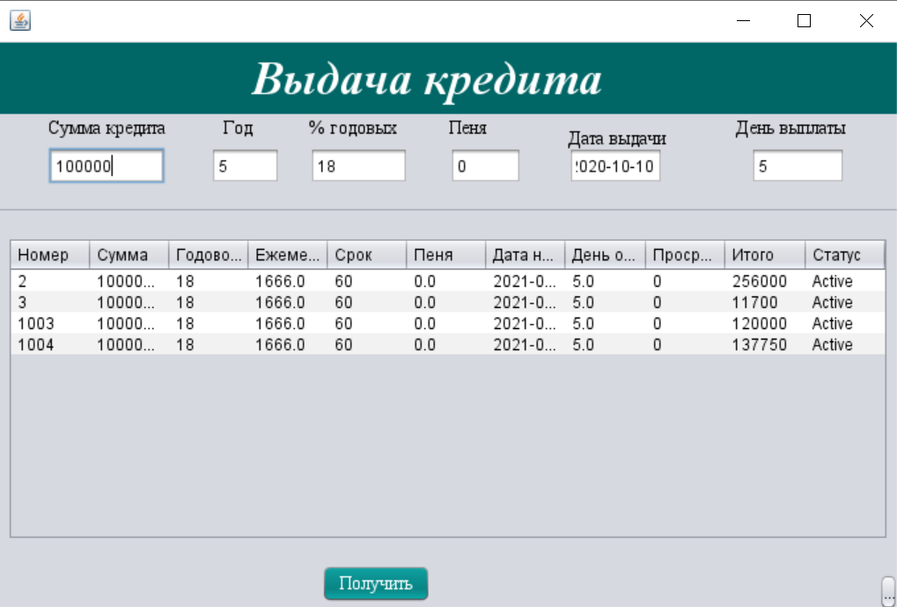

**Код:**

/*

/*

* To change this license header, choose License Headers in Project Properties.

* To change this template file, choose Tools | Templates

* and open the template in the editor.

*/

package bakery;

import java.sql.CallableStatement;

import java.sql.Connection;

import java.sql.DriverManager;

import java.sql.PreparedStatement;

import java.sql.ResultSet;

import java.sql.Statement;

import java.util.Calendar;

import javax.swing.JOptionPane;

import net.proteanit.sql.DbUtils;

/**

*

* @author User

*/

public class Credit extends javax.swing.JFrame {

ResultSet rs = null;

CallableStatement stored_pro = null;

Statement statement = null;

Connection conn = null;

/**

* Creates new form Credit

*/

public Credit() {

initComponents();

}

@SuppressWarnings("unchecked")

// <editor-fold defaultstate="collapsed" desc="Generated Code">

private void initComponents() {

jLabel1 = new javax.swing.JLabel();

CreditSum = new javax.swing.JTextField();

jLabel2 = new javax.swing.JLabel();

Year = new javax.swing.JTextField();

jLabel3 = new javax.swing.JLabel();

Procent = new javax.swing.JTextField();

jLabel4 = new javax.swing.JLabel();

Penya = new javax.swing.JTextField();

jButton1 = new javax.swing.JButton();

jSeparator1 = new javax.swing.JSeparator();

jLabel6 = new javax.swing.JLabel();

DateCredit = new javax.swing.JTextField();

jLabel7 = new javax.swing.JLabel();

dad = new javax.swing.JTextField();

jScrollPane1 = new javax.swing.JScrollPane();

jTable1 = new javax.swing.JTable();

jPanel1 = new javax.swing.JPanel();

jLabel5 = new javax.swing.JLabel();

jButton2 = new javax.swing.JButton();

addWindowListener(new java.awt.event.WindowAdapter() {

public void windowActivated(java.awt.event.WindowEvent evt) {

formWindowActivated(evt);

}

public void windowClosing(java.awt.event.WindowEvent evt) {

formWindowClosing(evt);

}

});

jLabel1.setFont(new java.awt.Font("Times New Roman", 0, 14)); // NOI18N

jLabel1.setText("Сумма кредита");

CreditSum.setText("100000");

jLabel2.setFont(new java.awt.Font("Times New Roman", 0, 14)); // NOI18N

jLabel2.setText("Год");

Year.setText("5");

jLabel3.setFont(new java.awt.Font("Times New Roman", 0, 14)); // NOI18N

jLabel3.setText("% годовых");

Procent.setText("18");

jLabel4.setFont(new java.awt.Font("Times New Roman", 0, 14)); // NOI18N

jLabel4.setText("Пеня");

Penya.setText("0");

jButton1.setBackground(new java.awt.Color(0, 102, 102));

jButton1.setFont(new java.awt.Font("Times New Roman", 0, 14)); // NOI18N

jButton1.setForeground(new java.awt.Color(255, 255, 255));

jButton1.setText("Получить");

jButton1.addActionListener(new java.awt.event.ActionListener() {

public void actionPerformed(java.awt.event.ActionEvent evt) {

jButton1ActionPerformed(evt);

}

});

jLabel6.setFont(new java.awt.Font("Times New Roman", 0, 14)); // NOI18N

jLabel6.setText("Дата выдачи");

DateCredit.setText("2020-10-10");

jLabel7.setFont(new java.awt.Font("Times New Roman", 0, 14)); // NOI18N

jLabel7.setText("День выплаты");

dad.setText("5");

jTable1.setModel(new javax.swing.table.DefaultTableModel(

new Object [][] {

{null, null, null, null},

{null, null, null, null},

{null, null, null, null},

{null, null, null, null}

},

new String [] {

"Title 1", "Title 2", "Title 3", "Title 4"

}

));

jScrollPane1.setViewportView(jTable1);

jPanel1.setBackground(new java.awt.Color(0, 102, 102));

jLabel5.setFont(new java.awt.Font("Times New Roman", 3, 36)); // NOI18N

jLabel5.setForeground(new java.awt.Color(255, 255, 255));

jLabel5.setText("Выдача кредита");

javax.swing.GroupLayout jPanel1Layout = new javax.swing.GroupLayout(jPanel1);

jPanel1.setLayout(jPanel1Layout);

jPanel1Layout.setHorizontalGroup(

jPanel1Layout.createParallelGroup(javax.swing.GroupLayout.Alignment.LEADING)

.addGroup(jPanel1Layout.createSequentialGroup()

.addGap(191, 191, 191)

.addComponent(jLabel5)

.addContainerGap(javax.swing.GroupLayout.DEFAULT_SIZE, Short.MAX_VALUE))

);

jPanel1Layout.setVerticalGroup(

jPanel1Layout.createParallelGroup(javax.swing.GroupLayout.Alignment.LEADING)

.addGroup(jPanel1Layout.createSequentialGroup()

.addContainerGap()

.addComponent(jLabel5)

.addContainerGap(javax.swing.GroupLayout.DEFAULT_SIZE, Short.MAX_VALUE))

);

jButton2.setText("jButton2");

jButton2.addActionListener(new java.awt.event.ActionListener() {

public void actionPerformed(java.awt.event.ActionEvent evt) {

jButton2ActionPerformed(evt);

}

});

javax.swing.GroupLayout layout = new javax.swing.GroupLayout(getContentPane());

getContentPane().setLayout(layout);

layout.setHorizontalGroup(

layout.createParallelGroup(javax.swing.GroupLayout.Alignment.LEADING)

.addComponent(jSeparator1)

.addGroup(layout.createSequentialGroup()

.addGap(244, 244, 244)

.addComponent(jButton1)

.addPreferredGap(javax.swing.LayoutStyle.ComponentPlacement.RELATED, javax.swing.GroupLayout.DEFAULT_SIZE, Short.MAX_VALUE)

.addComponent(jButton2, javax.swing.GroupLayout.PREFERRED_SIZE, 13, javax.swing.GroupLayout.PREFERRED_SIZE))

.addGroup(layout.createSequentialGroup()

.addContainerGap()

.addComponent(jScrollPane1)

.addContainerGap())

.addGroup(javax.swing.GroupLayout.Alignment.TRAILING, layout.createSequentialGroup()

.addGap(37, 37, 37)

.addGroup(layout.createParallelGroup(javax.swing.GroupLayout.Alignment.LEADING, false)

.addComponent(CreditSum)

.addComponent(jLabel1))

.addGroup(layout.createParallelGroup(javax.swing.GroupLayout.Alignment.LEADING)

.addGroup(layout.createSequentialGroup()

.addGap(44, 44, 44)

.addComponent(jLabel2))

.addGroup(layout.createSequentialGroup()

.addGap(34, 34, 34)

.addComponent(Year, javax.swing.GroupLayout.PREFERRED_SIZE, 53, javax.swing.GroupLayout.PREFERRED_SIZE)))

.addGap(22, 22, 22)

.addGroup(layout.createParallelGroup(javax.swing.GroupLayout.Alignment.LEADING, false)

.addComponent(jLabel3, javax.swing.GroupLayout.DEFAULT_SIZE, 75, Short.MAX_VALUE)

.addComponent(Procent))

.addGap(31, 31, 31)

.addGroup(layout.createParallelGroup(javax.swing.GroupLayout.Alignment.LEADING)

.addComponent(jLabel4)

.addComponent(Penya, javax.swing.GroupLayout.PREFERRED_SIZE, 55, javax.swing.GroupLayout.PREFERRED_SIZE))

.addGap(35, 35, 35)

.addGroup(layout.createParallelGroup(javax.swing.GroupLayout.Alignment.LEADING)

.addComponent(jLabel6)

.addComponent(DateCredit, javax.swing.GroupLayout.PREFERRED_SIZE, 72, javax.swing.GroupLayout.PREFERRED_SIZE))

.addGap(39, 53, Short.MAX_VALUE)

.addGroup(layout.createParallelGroup(javax.swing.GroupLayout.Alignment.TRAILING)

.addComponent(jLabel7)

.addComponent(dad, javax.swing.GroupLayout.PREFERRED_SIZE, 72, javax.swing.GroupLayout.PREFERRED_SIZE))

.addGap(39, 39, 39))

.addComponent(jPanel1, javax.swing.GroupLayout.DEFAULT_SIZE, javax.swing.GroupLayout.DEFAULT_SIZE, Short.MAX_VALUE)

);

layout.setVerticalGroup(

layout.createParallelGroup(javax.swing.GroupLayout.Alignment.LEADING)

.addGroup(layout.createSequentialGroup()

.addGap(1, 1, 1)

.addComponent(jPanel1, javax.swing.GroupLayout.PREFERRED_SIZE, javax.swing.GroupLayout.DEFAULT_SIZE, javax.swing.GroupLayout.PREFERRED_SIZE)

.addGap(2, 2, 2)

.addGroup(layout.createParallelGroup(javax.swing.GroupLayout.Alignment.LEADING)

.addGroup(layout.createParallelGroup(javax.swing.GroupLayout.Alignment.TRAILING)

.addGroup(layout.createSequentialGroup()

.addGroup(layout.createParallelGroup(javax.swing.GroupLayout.Alignment.BASELINE)

.addComponent(jLabel1)

.addComponent(jLabel2)

.addComponent(jLabel3))

.addPreferredGap(javax.swing.LayoutStyle.ComponentPlacement.RELATED)

.addGroup(layout.createParallelGroup(javax.swing.GroupLayout.Alignment.BASELINE)

.addComponent(CreditSum, javax.swing.GroupLayout.PREFERRED_SIZE, javax.swing.GroupLayout.DEFAULT_SIZE, javax.swing.GroupLayout.PREFERRED_SIZE)

.addComponent(Year, javax.swing.GroupLayout.PREFERRED_SIZE, javax.swing.GroupLayout.DEFAULT_SIZE, javax.swing.GroupLayout.PREFERRED_SIZE)

.addComponent(Procent, javax.swing.GroupLayout.PREFERRED_SIZE, javax.swing.GroupLayout.DEFAULT_SIZE, javax.swing.GroupLayout.PREFERRED_SIZE)

.addComponent(Penya, javax.swing.GroupLayout.PREFERRED_SIZE, javax.swing.GroupLayout.DEFAULT_SIZE, javax.swing.GroupLayout.PREFERRED_SIZE)

.addComponent(DateCredit, javax.swing.GroupLayout.PREFERRED_SIZE, javax.swing.GroupLayout.DEFAULT_SIZE, javax.swing.GroupLayout.PREFERRED_SIZE)))

.addGroup(layout.createSequentialGroup()

.addComponent(jLabel6)

.addGap(26, 26, 26)))

.addGroup(layout.createSequentialGroup()

.addGap(23, 23, 23)

.addComponent(dad, javax.swing.GroupLayout.PREFERRED_SIZE, javax.swing.GroupLayout.DEFAULT_SIZE, javax.swing.GroupLayout.PREFERRED_SIZE))

.addComponent(jLabel7)

.addComponent(jLabel4))

.addGap(18, 18, 18)

.addComponent(jSeparator1, javax.swing.GroupLayout.PREFERRED_SIZE, 10, javax.swing.GroupLayout.PREFERRED_SIZE)

.addPreferredGap(javax.swing.LayoutStyle.ComponentPlacement.UNRELATED)

.addGroup(layout.createParallelGroup(javax.swing.GroupLayout.Alignment.LEADING)

.addGroup(layout.createSequentialGroup()

.addComponent(jScrollPane1, javax.swing.GroupLayout.PREFERRED_SIZE, 230, javax.swing.GroupLayout.PREFERRED_SIZE)

.addGap(18, 18, 18)

.addComponent(jButton1)

.addContainerGap())

.addGroup(javax.swing.GroupLayout.Alignment.TRAILING, layout.createSequentialGroup()

.addGap(0, 0, Short.MAX_VALUE)

.addComponent(jButton2))))

);

pack();

}// </editor-fold>

private void jButton1ActionPerformed(java.awt.event.ActionEvent evt) {

// TODO add your handling code here:

double partOfCredit= Double.parseDouble(CreditSum.getText())/Double.parseDouble(Year.getText())/12;

double procent=Double.parseDouble(CreditSum.getText())* Double.parseDouble(Procent.getText())/12/100;

// System.out.println(Integer.parseInt(CreditSum.getText())* Integer.parseInt(Procent.getText())/12/100);

int Proc=Integer.parseInt(Procent.getText());

double TotalSum=partOfCredit+procent;

double restOfCredit=Double.parseDouble(CreditSum.getText())-partOfCredit;

int penya=0;

double Summative=TotalSum+Proc;

double SumOfCredit=partOfCredit;

double SumOfProcent=procent;

double SumAll=TotalSum;

double Itogo=Summative;

int CreditYear=Integer.parseInt(Year.getText())*12;

// System.out.println((int)partOfCredit+"\t"+(int)procent+"\t"+(int)TotalSum+"\t"+(int)restOfCredit+"\t"+(int)Summative);

for(int i=1;i<=CreditYear-1;i++){

//System.out.print(partOfCredit);

procent=restOfCredit/100*Proc/12;

restOfCredit=restOfCredit-partOfCredit;

//1500/100

TotalSum=partOfCredit+procent;

Summative=TotalSum+Proc;

// System.out.println((int)partOfCredit+"\t"+(int)procent+"\t"+(int)TotalSum+"\t"+(int)restOfCredit+"\t"+(int)Summative);

SumOfCredit+=partOfCredit;

SumOfProcent+=procent;

SumAll+=TotalSum;

}

//System.out.println("_____________________________");

//System.out.println((int)SumOfCredit+" "+(int)SumOfProcent+" "+(int)SumAll+" "+(int)SumAll);

try {

conn = ConnectMsSql.ConnectDB();

Statement st = conn.createStatement();

Calendar calendar = Calendar.getInstance();

java.sql.Date startDate = new java.sql.Date(calendar.getTime().getTime());

//{call select_login(?,?)}

String query = "INSERT INTO Credit(Summa, Year_Procent,EveryMonthPay,Due_Date,Penya,DataStart,DataPay,Prosrocheno,Itogo,Status) values (?, ?, ?, ?,?,?,?,?,?,?)";

//"{?=call insert_credit (?,?,?,?,?,?,?,?,?)}"

//insert into Credit(Summa, Year_Procent,EveryMonthPay,Due_Date,Penya,DataStart,DataPay,Prosrocheno,Itogo) values (@summa, @Year_Procent, @everymothpay, @duedata,@penya,@datastart,@datapay,@prosrocheno,@itogo)

PreparedStatement lol = conn.prepareStatement(query);

//

lol.setDouble(1,Double.parseDouble(CreditSum.getText()));

lol.setInt(2,Integer.parseInt(Procent.getText()));

lol.setDouble(3, (int)partOfCredit);

lol.setInt(4, Integer.parseInt(Year.getText())*12);

lol.setDouble(5, Double.parseDouble(Penya.getText()));

lol.setDate(6, startDate);

lol.setDouble(7, Integer.parseInt(dad.getText()));

lol.setDouble(8, 0);

lol.setInt(9, (int)Math.round(SumAll));

lol.setString(10,"Active");

lol.executeUpdate();

JOptionPane.showMessageDialog(null, "Кредит успешно добавлен");

// lol.setDouble(10, SumAll);

// rs = lol.executeUpdate();

}catch (Exception e) {

}

}

private void formWindowActivated(java.awt.event.WindowEvent evt) {

// TODO add your handling code here:

UpdateJTable();

}

private void formWindowClosing(java.awt.event.WindowEvent evt) {

// TODO add your handling code here:

new Main1().setVisible(true);

this.dispose();

}

private void jButton2ActionPerformed(java.awt.event.ActionEvent evt) {

// TODO add your handling code here:

new cred().setVisible(true);

this.dispose();

}

private void UpdateJTable(){

try{

Connection conn = ConnectMsSql.ConnectDB();

String sql = "SELECT [ID],[Summa], [Year_Procent],[EveryMonthPay],[Due_Date],[Penya],[DataStart],[DataPay],[Prosrocheno],[Itogo],[Status] FROM [Credit]";

statement = conn.createStatement();

rs = statement.executeQuery(sql);

this.jTable1.setModel(DbUtils.resultSetToTableModel(rs));

jTable1.getColumnModel().getColumn(0).setHeaderValue("Номер");

jTable1.getColumnModel().getColumn(1).setHeaderValue("Сумма");

jTable1.getColumnModel().getColumn(2).setHeaderValue("Годовой процент");

jTable1.getColumnModel().getColumn(3).setHeaderValue("Ежемесячная оплата");

jTable1.getColumnModel().getColumn(4).setHeaderValue("Срок");

jTable1.getColumnModel().getColumn(5).setHeaderValue("Пеня");

jTable1.getColumnModel().getColumn(6).setHeaderValue("Дата начала");

jTable1.getColumnModel().getColumn(7).setHeaderValue("День оплаты");

jTable1.getColumnModel().getColumn(8).setHeaderValue("Просрочено");

jTable1.getColumnModel().getColumn(9).setHeaderValue("Итого");

jTable1.getColumnModel().getColumn(10).setHeaderValue("Статус");

}

catch(Exception e){

e.printStackTrace();

}

}

/**

* @param args the command line arguments

*/

public static void main(String args[]) {

/* Set the Nimbus look and feel */

//<editor-fold defaultstate="collapsed" desc=" Look and feel setting code (optional) ">

/* If Nimbus (introduced in Java SE 6) is not available, stay with the default look and feel.

* For details see http://download.oracle.com/javase/tutorial/uiswing/lookandfeel/plaf.html

*/

try {

for (javax.swing.UIManager.LookAndFeelInfo info : javax.swing.UIManager.getInstalledLookAndFeels()) {

if ("Nimbus".equals(info.getName())) {

javax.swing.UIManager.setLookAndFeel(info.getClassName());

break;

}

}

} catch (ClassNotFoundException ex) {

java.util.logging.Logger.getLogger(Credit.class.getName()).log(java.util.logging.Level.SEVERE, null, ex);

} catch (InstantiationException ex) {

java.util.logging.Logger.getLogger(Credit.class.getName()).log(java.util.logging.Level.SEVERE, null, ex);

} catch (IllegalAccessException ex) {

java.util.logging.Logger.getLogger(Credit.class.getName()).log(java.util.logging.Level.SEVERE, null, ex);

} catch (javax.swing.UnsupportedLookAndFeelException ex) {

java.util.logging.Logger.getLogger(Credit.class.getName()).log(java.util.logging.Level.SEVERE, null, ex);

}

//</editor-fold>

//</editor-fold>

//</editor-fold>

//</editor-fold>

/* Create and display the form */

java.awt.EventQueue.invokeLater(new Runnable() {

public void run() {

new Credit().setVisible(true);

}

});

}

// Variables declaration - do not modify

private javax.swing.JTextField CreditSum;

private javax.swing.JTextField DateCredit;

private javax.swing.JTextField Penya;

private javax.swing.JTextField Procent;

private javax.swing.JTextField Year;

private javax.swing.JTextField dad;

private javax.swing.JButton jButton1;

private javax.swing.JButton jButton2;

private javax.swing.JLabel jLabel1;

private javax.swing.JLabel jLabel2;

private javax.swing.JLabel jLabel3;

private javax.swing.JLabel jLabel4;

private javax.swing.JLabel jLabel5;

private javax.swing.JLabel jLabel6;

private javax.swing.JLabel jLabel7;

private javax.swing.JPanel jPanel1;

private javax.swing.JScrollPane jScrollPane1;

private javax.swing.JSeparator jSeparator1;

private javax.swing.JTable jTable1;

// End of variables declaration

}

* Форма **PayCredit.java**

Для операций погашения кредита.

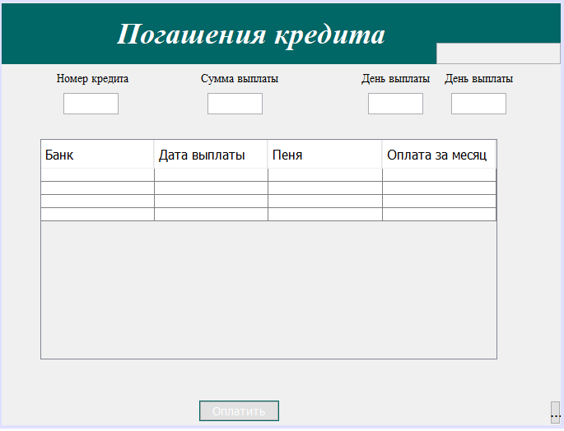

**Код:**

/*

/*

* To change this license header, choose License Headers in Project Properties.

* To change this template file, choose Tools | Templates

* and open the template in the editor.

*/

package bakery;

import java.text.SimpleDateFormat;

import java.util.Date;

import java.sql.CallableStatement;

import java.sql.Connection;

import java.sql.DriverManager;

import java.sql.PreparedStatement;

import java.sql.ResultSet;

import java.sql.SQLException;

import java.sql.Statement;

import java.text.ParseException;

import java.text.SimpleDateFormat;

import java.util.Calendar;

import java.util.logging.Level;

import java.util.logging.Logger;

//import static javaapplication18.Login.text;

import javax.swing.JOptionPane;

import net.proteanit.sql.DbUtils;

/**

*

* @author User

*/

public class CreditPay extends javax.swing.JFrame {

Connection conn = null;

ResultSet rs = null;

CallableStatement stored_pro = null;

Statement statement = null;

/**

* Creates new form CreditPay

*/

public CreditPay() {

initComponents();

}

@SuppressWarnings("unchecked")

// <editor-fold defaultstate="collapsed" desc="Generated Code">

private void initComponents() {

jPanel1 = new javax.swing.JPanel();

jLabel1 = new javax.swing.JLabel();

CreditNumber = new javax.swing.JTextField();

jLabel2 = new javax.swing.JLabel();

CreditSumma = new javax.swing.JTextField();

jLabel3 = new javax.swing.JLabel();

CreditPayDay = new javax.swing.JTextField();

jButton1 = new javax.swing.JButton();

jScrollPane1 = new javax.swing.JScrollPane();

jTable1 = new javax.swing.JTable();

jPanel2 = new javax.swing.JPanel();

txtBudget = new javax.swing.JTextField();

jLabel4 = new javax.swing.JLabel();

jButton2 = new javax.swing.JButton();

CreditPayDay1 = new javax.swing.JTextField();

jLabel5 = new javax.swing.JLabel();

javax.swing.GroupLayout jPanel1Layout = new javax.swing.GroupLayout(jPanel1);

jPanel1.setLayout(jPanel1Layout);

jPanel1Layout.setHorizontalGroup(

jPanel1Layout.createParallelGroup(javax.swing.GroupLayout.Alignment.LEADING)

.addGap(0, 100, Short.MAX_VALUE)

);

jPanel1Layout.setVerticalGroup(

jPanel1Layout.createParallelGroup(javax.swing.GroupLayout.Alignment.LEADING)

.addGap(0, 100, Short.MAX_VALUE)

);

addWindowListener(new java.awt.event.WindowAdapter() {

public void windowActivated(java.awt.event.WindowEvent evt) {

formWindowActivated(evt);

}

public void windowClosing(java.awt.event.WindowEvent evt) {

formWindowClosing(evt);

}

});

jLabel1.setFont(new java.awt.Font("Times New Roman", 0, 14)); // NOI18N

jLabel1.setText("Номер кредита");

jLabel2.setFont(new java.awt.Font("Times New Roman", 0, 14)); // NOI18N

jLabel2.setText("Сумма выплаты");

jLabel3.setFont(new java.awt.Font("Times New Roman", 0, 14)); // NOI18N

jLabel3.setText("День выплаты");

jButton1.setBackground(new java.awt.Color(0, 102, 102));

jButton1.setFont(new java.awt.Font("Tahoma", 0, 14)); // NOI18N

jButton1.setForeground(new java.awt.Color(255, 255, 255));

jButton1.setText("Оплатить");

jButton1.addActionListener(new java.awt.event.ActionListener() {

public void actionPerformed(java.awt.event.ActionEvent evt) {

jButton1ActionPerformed(evt);

}

});

jTable1.setModel(new javax.swing.table.DefaultTableModel(

new Object [][] {

{null, null, null, null},

{null, null, null, null},

{null, null, null, null},

{null, null, null, null}

},

new String [] {

"Банк", "Дата выплаты", "Пеня", "Оплата за месяц"

}

));

jScrollPane1.setViewportView(jTable1);

jPanel2.setBackground(new java.awt.Color(0, 102, 102));

jPanel2.setToolTipText("");

txtBudget.setEnabled(false);

jLabel4.setFont(new java.awt.Font("Times New Roman", 3, 36)); // NOI18N

jLabel4.setForeground(new java.awt.Color(255, 255, 255));

jLabel4.setText("Погашения кредита");

javax.swing.GroupLayout jPanel2Layout = new javax.swing.GroupLayout(jPanel2);

jPanel2.setLayout(jPanel2Layout);

jPanel2Layout.setHorizontalGroup(

jPanel2Layout.createParallelGroup(javax.swing.GroupLayout.Alignment.LEADING)

.addGroup(javax.swing.GroupLayout.Alignment.TRAILING, jPanel2Layout.createSequentialGroup()

.addContainerGap(javax.swing.GroupLayout.DEFAULT_SIZE, Short.MAX_VALUE)

.addComponent(jLabel4, javax.swing.GroupLayout.PREFERRED_SIZE, 370, javax.swing.GroupLayout.PREFERRED_SIZE)

.addGap(18, 18, 18)

.addComponent(txtBudget, javax.swing.GroupLayout.PREFERRED_SIZE, 151, javax.swing.GroupLayout.PREFERRED_SIZE))

);

jPanel2Layout.setVerticalGroup(

jPanel2Layout.createParallelGroup(javax.swing.GroupLayout.Alignment.LEADING)

.addGroup(javax.swing.GroupLayout.Alignment.TRAILING, jPanel2Layout.createSequentialGroup()

.addGap(0, 0, Short.MAX_VALUE)

.addComponent(txtBudget, javax.swing.GroupLayout.PREFERRED_SIZE, 26, javax.swing.GroupLayout.PREFERRED_SIZE))

.addGroup(jPanel2Layout.createSequentialGroup()

.addContainerGap()

.addComponent(jLabel4)

.addContainerGap(javax.swing.GroupLayout.DEFAULT_SIZE, Short.MAX_VALUE))

);

jButton2.setText("jButton2");

jButton2.addActionListener(new java.awt.event.ActionListener() {

public void actionPerformed(java.awt.event.ActionEvent evt) {

jButton2ActionPerformed(evt);

}

});

jLabel5.setFont(new java.awt.Font("Times New Roman", 0, 14)); // NOI18N

jLabel5.setText("День выплаты");

javax.swing.GroupLayout layout = new javax.swing.GroupLayout(getContentPane());

getContentPane().setLayout(layout);

layout.setHorizontalGroup(

layout.createParallelGroup(javax.swing.GroupLayout.Alignment.LEADING)

.addComponent(jPanel2, javax.swing.GroupLayout.Alignment.TRAILING, javax.swing.GroupLayout.DEFAULT_SIZE, javax.swing.GroupLayout.DEFAULT_SIZE, Short.MAX_VALUE)

.addGroup(layout.createSequentialGroup()

.addGroup(layout.createParallelGroup(javax.swing.GroupLayout.Alignment.LEADING)

.addGroup(layout.createSequentialGroup()

.addGap(67, 67, 67)

.addGroup(layout.createParallelGroup(javax.swing.GroupLayout.Alignment.LEADING)

.addGroup(layout.createSequentialGroup()

.addComponent(jLabel1)

.addGap(88, 88, 88)

.addGroup(layout.createParallelGroup(javax.swing.GroupLayout.Alignment.LEADING)

.addGroup(layout.createSequentialGroup()

.addGap(8, 8, 8)

.addComponent(CreditSumma, javax.swing.GroupLayout.PREFERRED_SIZE, 67, javax.swing.GroupLayout.PREFERRED_SIZE))

.addComponent(jLabel2))

.addGap(101, 101, 101)

.addGroup(layout.createParallelGroup(javax.swing.GroupLayout.Alignment.LEADING)

.addGroup(layout.createSequentialGroup()

.addGap(8, 8, 8)

.addComponent(CreditPayDay, javax.swing.GroupLayout.PREFERRED_SIZE, 67, javax.swing.GroupLayout.PREFERRED_SIZE))

.addComponent(jLabel3)))

.addGroup(layout.createSequentialGroup()

.addGap(8, 8, 8)

.addComponent(CreditNumber, javax.swing.GroupLayout.PREFERRED_SIZE, 67, javax.swing.GroupLayout.PREFERRED_SIZE)))

.addGap(18, 18, 18)

.addGroup(layout.createParallelGroup(javax.swing.GroupLayout.Alignment.LEADING)

.addGroup(layout.createSequentialGroup()

.addGap(8, 8, 8)

.addComponent(CreditPayDay1, javax.swing.GroupLayout.PREFERRED_SIZE, 67, javax.swing.GroupLayout.PREFERRED_SIZE))

.addComponent(jLabel5)))

.addGroup(layout.createSequentialGroup()

.addGap(47, 47, 47)

.addComponent(jScrollPane1, javax.swing.GroupLayout.PREFERRED_SIZE, 555, javax.swing.GroupLayout.PREFERRED_SIZE)))

.addContainerGap(58, Short.MAX_VALUE))

.addGroup(layout.createSequentialGroup()

.addGap(240, 240, 240)

.addComponent(jButton1)

.addPreferredGap(javax.swing.LayoutStyle.ComponentPlacement.RELATED, javax.swing.GroupLayout.DEFAULT_SIZE, Short.MAX_VALUE)

.addComponent(jButton2, javax.swing.GroupLayout.PREFERRED_SIZE, 13, javax.swing.GroupLayout.PREFERRED_SIZE))

);

layout.setVerticalGroup(

layout.createParallelGroup(javax.swing.GroupLayout.Alignment.LEADING)

.addGroup(layout.createSequentialGroup()

.addGap(1, 1, 1)

.addComponent(jPanel2, javax.swing.GroupLayout.PREFERRED_SIZE, javax.swing.GroupLayout.DEFAULT_SIZE, javax.swing.GroupLayout.PREFERRED_SIZE)

.addPreferredGap(javax.swing.LayoutStyle.ComponentPlacement.RELATED)

.addGroup(layout.createParallelGroup(javax.swing.GroupLayout.Alignment.TRAILING)

.addGroup(layout.createParallelGroup(javax.swing.GroupLayout.Alignment.LEADING)

.addGroup(layout.createSequentialGroup()

.addComponent(jLabel3)

.addPreferredGap(javax.swing.LayoutStyle.ComponentPlacement.RELATED)

.addComponent(CreditPayDay, javax.swing.GroupLayout.PREFERRED_SIZE, javax.swing.GroupLayout.DEFAULT_SIZE, javax.swing.GroupLayout.PREFERRED_SIZE))

.addGroup(layout.createSequentialGroup()

.addComponent(jLabel2)

.addPreferredGap(javax.swing.LayoutStyle.ComponentPlacement.RELATED)

.addComponent(CreditSumma, javax.swing.GroupLayout.PREFERRED_SIZE, javax.swing.GroupLayout.DEFAULT_SIZE, javax.swing.GroupLayout.PREFERRED_SIZE))

.addGroup(layout.createSequentialGroup()

.addComponent(jLabel1)

.addPreferredGap(javax.swing.LayoutStyle.ComponentPlacement.RELATED)

.addComponent(CreditNumber, javax.swing.GroupLayout.PREFERRED_SIZE, javax.swing.GroupLayout.DEFAULT_SIZE, javax.swing.GroupLayout.PREFERRED_SIZE)))

.addGroup(layout.createSequentialGroup()

.addComponent(jLabel5)

.addPreferredGap(javax.swing.LayoutStyle.ComponentPlacement.RELATED)

.addComponent(CreditPayDay1, javax.swing.GroupLayout.PREFERRED_SIZE, javax.swing.GroupLayout.DEFAULT_SIZE, javax.swing.GroupLayout.PREFERRED_SIZE)))

.addGap(30, 30, 30)

.addComponent(jScrollPane1, javax.swing.GroupLayout.PREFERRED_SIZE, 268, javax.swing.GroupLayout.PREFERRED_SIZE)

.addPreferredGap(javax.swing.LayoutStyle.ComponentPlacement.RELATED, 50, Short.MAX_VALUE)

.addGroup(layout.createParallelGroup(javax.swing.GroupLayout.Alignment.LEADING)

.addComponent(jButton1)

.addComponent(jButton2))

.addGap(1, 1, 1))

);

pack();

}// </editor-fold>

private void jButton1ActionPerformed(java.awt.event.ActionEvent evt) {

// TODO add your handling code here:

String budget=txtBudget.getText();

double number=Double.parseDouble(budget);

double number1=Double.parseDouble(CreditSumma.getText());

if(number<number1){

JOptionPane.showMessageDialog(null, "Ошибка, нехватает средств в бюджете.");

}

else{

try {

conn = ConnectMsSql.ConnectDB();

stored_pro = conn.prepareCall("{call AddCreditPayment(?,?,?,?,?)}");

stored_pro.setInt(1,Integer.parseInt(this.CreditSumma.getText()));

stored_pro.setInt(2, Integer.parseInt(this.CreditNumber.getText()));

stored_pro.setInt(3, Integer.parseInt(this.CreditPayDay.getText()) );

Calendar calendar1 = Calendar.getInstance();

java.sql.Date startDate1 = new java.sql.Date(calendar1.getTime().getTime());

stored_pro.setDate(4, startDate1);

stored_pro.setString(5, "");

stored_pro.execute();

JOptionPane.showMessageDialog(null, "Выплата по кредиту прошла успешно.");

if(rs.next()){

JOptionPane.showMessageDialog(null, "Выплата по кредиту прошла успешно.");

}

else{

//JOptionPane.showMessageDialog(null, "Ошибка");

//System.exit(0);

}

}catch (Exception e) {

// Logger.getLogger(CreditPay.class.getName()).log(Level.SEVERE,null,e);

//JOptionPane.showMessageDialog(null,"Ошибка");

}

}

}

private void UpdateJTable(){

try{

Connection conn = ConnectMsSql.ConnectDB();

String sql = "SELECT [ID],[Summa], [Credit],[Penya],[Date] FROM [CreditPayments]";

statement = conn.createStatement();

rs = statement.executeQuery(sql);

this.jTable1.setModel(DbUtils.resultSetToTableModel(rs));

jTable1.getColumnModel().getColumn(0).setHeaderValue("Номер");

jTable1.getColumnModel().getColumn(1).setHeaderValue("Сумма");

jTable1.getColumnModel().getColumn(2).setHeaderValue("Кредит");

jTable1.getColumnModel().getColumn(3).setHeaderValue("Пеня");

jTable1.getColumnModel().getColumn(4).setHeaderValue("Дата");

}

catch(Exception e){

e.printStackTrace();

}

}

private void formWindowActivated(java.awt.event.WindowEvent evt) {

// TODO add your handling code here:

String insert = "SELECT Kolichestvo_deneg_v_budgete FROM Budget";

try {

conn = ConnectMsSql.ConnectDB();

Statement pst = conn.createStatement();

ResultSet ress = pst.executeQuery(insert);

while (ress.next()) {

//txtBudget.setText(String.format("%.2f", ress.getFloat("Summa")));

txtBudget.setText(ress.getString("Kolichestvo_deneg_v_budgete"));

}

} catch (SQLException ex) {

Logger.getLogger(CreditPay.class.getName()).log(Level.SEVERE, null, ex);

}

UpdateJTable();

}

private void formWindowClosing(java.awt.event.WindowEvent evt) {

// TODO add your handling code here:

new Main1().setVisible(true);

this.dispose();

}

private void jButton2ActionPerformed(java.awt.event.ActionEvent evt) {

// TODO add your handling code here:

new cred().setVisible(true);

this.dispose();

}

/**

* @param args the command line arguments

*/

public static void main(String args[]) {

/* Set the Nimbus look and feel */

//<editor-fold defaultstate="collapsed" desc=" Look and feel setting code (optional) ">

/* If Nimbus (introduced in Java SE 6) is not available, stay with the default look and feel.

* For details see http://download.oracle.com/javase/tutorial/uiswing/lookandfeel/plaf.html

*/

try {

for (javax.swing.UIManager.LookAndFeelInfo info : javax.swing.UIManager.getInstalledLookAndFeels()) {

if ("Nimbus".equals(info.getName())) {

javax.swing.UIManager.setLookAndFeel(info.getClassName());

break;

}

}

} catch (ClassNotFoundException ex) {

java.util.logging.Logger.getLogger(CreditPay.class.getName()).log(java.util.logging.Level.SEVERE, null, ex);

} catch (InstantiationException ex) {

java.util.logging.Logger.getLogger(CreditPay.class.getName()).log(java.util.logging.Level.SEVERE, null, ex);

} catch (IllegalAccessException ex) {

java.util.logging.Logger.getLogger(CreditPay.class.getName()).log(java.util.logging.Level.SEVERE, null, ex);

} catch (javax.swing.UnsupportedLookAndFeelException ex) {

java.util.logging.Logger.getLogger(CreditPay.class.getName()).log(java.util.logging.Level.SEVERE, null, ex);

}

//</editor-fold>

//</editor-fold>

//</editor-fold>

//</editor-fold>

/* Create and display the form */

java.awt.EventQueue.invokeLater(new Runnable() {

public void run() {

new CreditPay().setVisible(true);

}

});

}

// Variables declaration - do not modify

private javax.swing.JTextField CreditNumber;

private javax.swing.JTextField CreditPayDay;

private javax.swing.JTextField CreditPayDay1;

private javax.swing.JTextField CreditSumma;

private javax.swing.JButton jButton1;

private javax.swing.JButton jButton2;

private javax.swing.JLabel jLabel1;

private javax.swing.JLabel jLabel2;

private javax.swing.JLabel jLabel3;

private javax.swing.JLabel jLabel4;

private javax.swing.JLabel jLabel5;

private javax.swing.JPanel jPanel1;

private javax.swing.JPanel jPanel2;

private javax.swing.JScrollPane jScrollPane1;

private javax.swing.JTable jTable1;

private javax.swing.JTextField txtBudget;

// End of variables declaration

}

* Форма **employees.java**

Для управление сотрудниками и выдачи зарплаты.

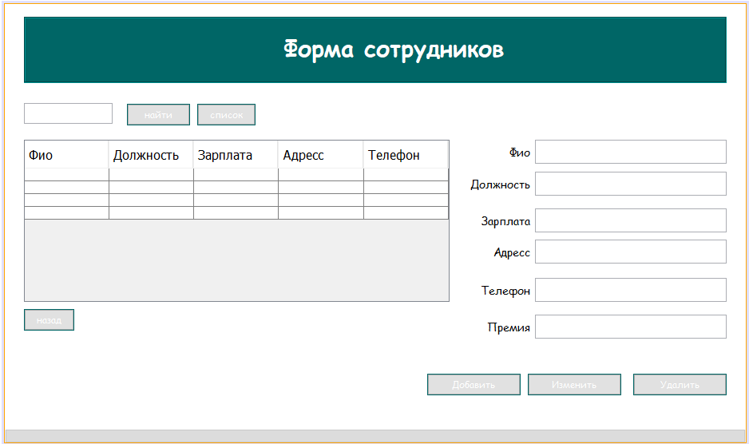

**Код:**

/*

* /*
* * To change this license header, choose License Headers in Project Properties.
* * To change this template file, choose Tools | Templates
* * and open the template in the editor.
* */
* package bakery;
* import java.sql.*;
* import java.util.Calendar;
* import javax.swing.*;
* import javax.swing.table.TableModel;
* import net.proteanit.sql.DbUtils;
* /**
* *
* * @author aidin
* */
* public class employees extends javax.swing.JFrame {
* Connection conn = null;
* CallableStatement stored_pro = null;
* Statement statement = null;
* ResultSet rs = null;
* /**
* * Creates new form measure
* */
* public employees() {
* initComponents();
* }
* @SuppressWarnings("unchecked")
* // <editor-fold defaultstate="collapsed" desc="Generated Code">
* private void initComponents() {
* jLabel2 = new javax.swing.JLabel();
* jPanel1 = new javax.swing.JPanel();
* jScrollPane1 = new javax.swing.JScrollPane();
* jTable1 = new javax.swing.JTable();
* MeasureInsertButton = new javax.swing.JButton();
* MeasureUpdateButton = new javax.swing.JButton();
* MeasureDeleteButton = new javax.swing.JButton();
* NameTxt = new javax.swing.JTextField();
* jLabel1 = new javax.swing.JLabel();
* back = new javax.swing.JButton();
* jPanel2 = new javax.swing.JPanel();
* jLabel3 = new javax.swing.JLabel();
* jButton1 = new javax.swing.JButton();
* SearchTxt = new javax.swing.JTextField();
* SalaryTxt = new javax.swing.JTextField();
* adressTxt = new javax.swing.JTextField();
* jLabel4 = new javax.swing.JLabel();
* jLabel6 = new javax.swing.JLabel();
* jLabel7 = new javax.swing.JLabel();
* PositionTxt = new javax.swing.JTextField();
* jButton2 = new javax.swing.JButton();
* phoneTxt = new javax.swing.JTextField();
* jLabel8 = new javax.swing.JLabel();
* phoneTxt1 = new javax.swing.JTextField();
* jLabel9 = new javax.swing.JLabel();
* jLabel2.setText("jLabel2");
* setDefaultCloseOperation(javax.swing.WindowConstants.EXIT_ON_CLOSE);
* addWindowListener(new java.awt.event.WindowAdapter() {
* public void windowActivated(java.awt.event.WindowEvent evt) {
* formWindowActivated(evt);
* }
* });
* jPanel1.setBackground(new java.awt.Color(255, 255, 255));
* jTable1.setFont(new java.awt.Font("Comic Sans MS", 0, 14)); // NOI18N
* jTable1.setModel(new javax.swing.table.DefaultTableModel(
* new Object [][] {
* {null, null, null, null, null},
* {null, null, null, null, null},
* {null, null, null, null, null},
* {null, null, null, null, null}
* },
* new String [] {
* "Фио", "Должность", "Зарплата", "Адресс", "Телефон"
* }
* ));
* jTable1.addMouseListener(new java.awt.event.MouseAdapter() {
* public void mouseClicked(java.awt.event.MouseEvent evt) {
* jTable1MouseClicked(evt);
* }
* });
* jScrollPane1.setViewportView(jTable1);
* MeasureInsertButton.setBackground(new java.awt.Color(0, 102, 102));
* MeasureInsertButton.setFont(new java.awt.Font("Comic Sans MS", 0, 12)); // NOI18N
* MeasureInsertButton.setForeground(new java.awt.Color(255, 255, 255));
* MeasureInsertButton.setText("Добавить");
* MeasureInsertButton.addActionListener(new java.awt.event.ActionListener() {
* public void actionPerformed(java.awt.event.ActionEvent evt) {
* MeasureInsertButtonActionPerformed(evt);
* }
* });
* MeasureUpdateButton.setBackground(new java.awt.Color(0, 102, 102));
* MeasureUpdateButton.setFont(new java.awt.Font("Comic Sans MS", 0, 12)); // NOI18N
* MeasureUpdateButton.setForeground(new java.awt.Color(255, 255, 255));
* MeasureUpdateButton.setText("Изменить");
* MeasureUpdateButton.addActionListener(new java.awt.event.ActionListener() {
* public void actionPerformed(java.awt.event.ActionEvent evt) {
* MeasureUpdateButtonActionPerformed(evt);
* }
* });
* MeasureDeleteButton.setBackground(new java.awt.Color(0, 102, 102));
* MeasureDeleteButton.setFont(new java.awt.Font("Comic Sans MS", 0, 12)); // NOI18N
* MeasureDeleteButton.setForeground(new java.awt.Color(255, 255, 255));
* MeasureDeleteButton.setText("Удалить");
* MeasureDeleteButton.addActionListener(new java.awt.event.ActionListener() {
* public void actionPerformed(java.awt.event.ActionEvent evt) {
* MeasureDeleteButtonActionPerformed(evt);
* }
* });
* jLabel1.setFont(new java.awt.Font("Comic Sans MS", 0, 14)); // NOI18N
* jLabel1.setText("Фио");
* back.setBackground(new java.awt.Color(0, 102, 102));
* back.setFont(new java.awt.Font("Comic Sans MS", 0, 12)); // NOI18N
* back.setForeground(new java.awt.Color(255, 255, 255));
* back.setText("назад");
* back.addActionListener(new java.awt.event.ActionListener() {
* public void actionPerformed(java.awt.event.ActionEvent evt) {
* backActionPerformed(evt);
* }
* });
* jPanel2.setBackground(new java.awt.Color(0, 102, 102));
* jPanel2.setBorder(javax.swing.BorderFactory.createEtchedBorder());
* jLabel3.setFont(new java.awt.Font("Comic Sans MS", 1, 29)); // NOI18N
* jLabel3.setForeground(new java.awt.Color(255, 255, 255));
* jLabel3.setText("Форма сотрудников");
* javax.swing.GroupLayout jPanel2Layout = new javax.swing.GroupLayout(jPanel2);
* jPanel2.setLayout(jPanel2Layout);
* jPanel2Layout.setHorizontalGroup(
* jPanel2Layout.createParallelGroup(javax.swing.GroupLayout.Alignment.LEADING)
* .addGroup(jPanel2Layout.createSequentialGroup()
* .addGap(323, 323, 323)
* .addComponent(jLabel3)
* .addContainerGap(javax.swing.GroupLayout.DEFAULT_SIZE, Short.MAX_VALUE))
* );
* jPanel2Layout.setVerticalGroup(
* jPanel2Layout.createParallelGroup(javax.swing.GroupLayout.Alignment.LEADING)
* .addGroup(jPanel2Layout.createSequentialGroup()
* .addContainerGap()
* .addComponent(jLabel3)
* .addContainerGap(22, Short.MAX_VALUE))
* );
* jButton1.setBackground(new java.awt.Color(0, 102, 102));
* jButton1.setFont(new java.awt.Font("Comic Sans MS", 0, 12)); // NOI18N
* jButton1.setForeground(new java.awt.Color(255, 255, 255));
* jButton1.setText("найти");
* jButton1.addActionListener(new java.awt.event.ActionListener() {
* public void actionPerformed(java.awt.event.ActionEvent evt) {
* jButton1ActionPerformed(evt);
* }
* });
* SearchTxt.addMouseListener(new java.awt.event.MouseAdapter() {
* public void mousePressed(java.awt.event.MouseEvent evt) {
* SearchTxtMousePressed(evt);
* }
* });
* adressTxt.setToolTipText("");
* jLabel4.setFont(new java.awt.Font("Comic Sans MS", 0, 14)); // NOI18N
* jLabel4.setText("Должность");
* jLabel6.setFont(new java.awt.Font("Comic Sans MS", 0, 14)); // NOI18N
* jLabel6.setText("Зарплата");
* jLabel7.setFont(new java.awt.Font("Comic Sans MS", 0, 14)); // NOI18N
* jLabel7.setText("Адресс");
* jButton2.setBackground(new java.awt.Color(0, 102, 102));
* jButton2.setFont(new java.awt.Font("Comic Sans MS", 0, 12)); // NOI18N
* jButton2.setForeground(new java.awt.Color(255, 255, 255));
* jButton2.setText("список");
* jButton2.addActionListener(new java.awt.event.ActionListener() {
* public void actionPerformed(java.awt.event.ActionEvent evt) {
* jButton2ActionPerformed(evt);
* }
* });
* phoneTxt.setToolTipText("");
* jLabel8.setFont(new java.awt.Font("Comic Sans MS", 0, 14)); // NOI18N
* jLabel8.setText("Премия");
* phoneTxt1.setToolTipText("");
* jLabel9.setFont(new java.awt.Font("Comic Sans MS", 0, 14)); // NOI18N
* jLabel9.setText("Телефон");
* javax.swing.GroupLayout jPanel1Layout = new javax.swing.GroupLayout(jPanel1);
* jPanel1.setLayout(jPanel1Layout);
* jPanel1Layout.setHorizontalGroup(
* jPanel1Layout.createParallelGroup(javax.swing.GroupLayout.Alignment.LEADING)
* .addGroup(javax.swing.GroupLayout.Alignment.TRAILING, jPanel1Layout.createSequentialGroup()
* .addGroup(jPanel1Layout.createParallelGroup(javax.swing.GroupLayout.Alignment.TRAILING)
* .addGroup(jPanel1Layout.createSequentialGroup()
* .addContainerGap(javax.swing.GroupLayout.DEFAULT_SIZE, Short.MAX_VALUE)
* .addComponent(MeasureInsertButton, javax.swing.GroupLayout.PREFERRED_SIZE, 117, javax.swing.GroupLayout.PREFERRED_SIZE)
* .addPreferredGap(javax.swing.LayoutStyle.ComponentPlacement.RELATED)
* .addComponent(MeasureUpdateButton, javax.swing.GroupLayout.PREFERRED_SIZE, 117, javax.swing.GroupLayout.PREFERRED_SIZE)
* .addPreferredGap(javax.swing.LayoutStyle.ComponentPlacement.UNRELATED)
* .addComponent(MeasureDeleteButton, javax.swing.GroupLayout.PREFERRED_SIZE, 117, javax.swing.GroupLayout.PREFERRED_SIZE))
* .addGroup(jPanel1Layout.createSequentialGroup()
* .addGap(24, 24, 24)
* .addGroup(jPanel1Layout.createParallelGroup(javax.swing.GroupLayout.Alignment.TRAILING)
* .addComponent(jPanel2, javax.swing.GroupLayout.Alignment.LEADING, javax.swing.GroupLayout.DEFAULT_SIZE, javax.swing.GroupLayout.DEFAULT_SIZE, Short.MAX_VALUE)
* .addGroup(jPanel1Layout.createSequentialGroup()
* .addComponent(jScrollPane1, javax.swing.GroupLayout.PREFERRED_SIZE, 533, javax.swing.GroupLayout.PREFERRED_SIZE)
* .addGroup(jPanel1Layout.createParallelGroup(javax.swing.GroupLayout.Alignment.LEADING)
* .addGroup(jPanel1Layout.createSequentialGroup()
* .addGap(39, 39, 39)
* .addGroup(jPanel1Layout.createParallelGroup(javax.swing.GroupLayout.Alignment.TRAILING)
* .addComponent(jLabel6)
* .addComponent(jLabel7)
* .addComponent(jLabel9))
* .addPreferredGap(javax.swing.LayoutStyle.ComponentPlacement.RELATED, javax.swing.GroupLayout.DEFAULT_SIZE, Short.MAX_VALUE))
* .addGroup(jPanel1Layout.createSequentialGroup()
* .addPreferredGap(javax.swing.LayoutStyle.ComponentPlacement.RELATED, javax.swing.GroupLayout.DEFAULT_SIZE, Short.MAX_VALUE)
* .addGroup(jPanel1Layout.createParallelGroup(javax.swing.GroupLayout.Alignment.LEADING)
* .addComponent(jLabel4, javax.swing.GroupLayout.Alignment.TRAILING)
* .addComponent(jLabel1, javax.swing.GroupLayout.Alignment.TRAILING))
* .addPreferredGap(javax.swing.LayoutStyle.ComponentPlacement.RELATED)))
* .addGroup(jPanel1Layout.createParallelGroup(javax.swing.GroupLayout.Alignment.LEADING, false)
* .addComponent(adressTxt, javax.swing.GroupLayout.Alignment.TRAILING)
* .addComponent(SalaryTxt)
* .addComponent(NameTxt)
* .addComponent(PositionTxt)
* .addComponent(phoneTxt, javax.swing.GroupLayout.PREFERRED_SIZE, 240, javax.swing.GroupLayout.PREFERRED_SIZE)))
* .addGroup(javax.swing.GroupLayout.Alignment.LEADING, jPanel1Layout.createSequentialGroup()
* .addComponent(SearchTxt, javax.swing.GroupLayout.PREFERRED_SIZE, 111, javax.swing.GroupLayout.PREFERRED_SIZE)
* .addGap(18, 18, 18)
* .addComponent(jButton1, javax.swing.GroupLayout.PREFERRED_SIZE, 79, javax.swing.GroupLayout.PREFERRED_SIZE)
* .addPreferredGap(javax.swing.LayoutStyle.ComponentPlacement.RELATED)
* .addComponent(jButton2)
* .addGap(0, 0, Short.MAX_VALUE))
* .addGroup(jPanel1Layout.createSequentialGroup()
* .addComponent(back)
* .addGap(517, 517, 517)
* .addComponent(jLabel8)
* .addPreferredGap(javax.swing.LayoutStyle.ComponentPlacement.RELATED)
* .addComponent(phoneTxt1, javax.swing.GroupLayout.PREFERRED_SIZE, 240, javax.swing.GroupLayout.PREFERRED_SIZE)))))
* .addGap(206, 206, 206))
* );
* jPanel1Layout.setVerticalGroup(
* jPanel1Layout.createParallelGroup(javax.swing.GroupLayout.Alignment.LEADING)
* .addGroup(javax.swing.GroupLayout.Alignment.TRAILING, jPanel1Layout.createSequentialGroup()
* .addContainerGap()
* .addComponent(jPanel2, javax.swing.GroupLayout.PREFERRED_SIZE, javax.swing.GroupLayout.DEFAULT_SIZE, javax.swing.GroupLayout.PREFERRED_SIZE)
* .addGap(25, 25, 25)
* .addGroup(jPanel1Layout.createParallelGroup(javax.swing.GroupLayout.Alignment.BASELINE)
* .addComponent(SearchTxt, javax.swing.GroupLayout.PREFERRED_SIZE, javax.swing.GroupLayout.DEFAULT_SIZE, javax.swing.GroupLayout.PREFERRED_SIZE)
* .addComponent(jButton1)
* .addComponent(jButton2, javax.swing.GroupLayout.PREFERRED_SIZE, 27, javax.swing.GroupLayout.PREFERRED_SIZE))
* .addGap(18, 18, 18)
* .addGroup(jPanel1Layout.createParallelGroup(javax.swing.GroupLayout.Alignment.LEADING)
* .addGroup(jPanel1Layout.createSequentialGroup()
* .addComponent(jScrollPane1, javax.swing.GroupLayout.PREFERRED_SIZE, 203, javax.swing.GroupLayout.PREFERRED_SIZE)
* .addPreferredGap(javax.swing.LayoutStyle.ComponentPlacement.RELATED)
* .addComponent(back))
* .addGroup(jPanel1Layout.createSequentialGroup()
* .addGroup(jPanel1Layout.createParallelGroup(javax.swing.GroupLayout.Alignment.BASELINE)
* .addComponent(jLabel1)
* .addComponent(NameTxt, javax.swing.GroupLayout.PREFERRED_SIZE, 30, javax.swing.GroupLayout.PREFERRED_SIZE))
* .addGap(10, 10, 10)
* .addGroup(jPanel1Layout.createParallelGroup(javax.swing.GroupLayout.Alignment.BASELINE)
* .addComponent(jLabel4)
* .addComponent(PositionTxt, javax.swing.GroupLayout.PREFERRED_SIZE, 30, javax.swing.GroupLayout.PREFERRED_SIZE))
* .addPreferredGap(javax.swing.LayoutStyle.ComponentPlacement.UNRELATED)
* .addGroup(jPanel1Layout.createParallelGroup(javax.swing.GroupLayout.Alignment.BASELINE)
* .addComponent(SalaryTxt, javax.swing.GroupLayout.PREFERRED_SIZE, 30, javax.swing.GroupLayout.PREFERRED_SIZE)
* .addComponent(jLabel6))
* .addPreferredGap(javax.swing.LayoutStyle.ComponentPlacement.RELATED)
* .addGroup(jPanel1Layout.createParallelGroup(javax.swing.GroupLayout.Alignment.BASELINE)
* .addComponent(adressTxt, javax.swing.GroupLayout.PREFERRED_SIZE, 30, javax.swing.GroupLayout.PREFERRED_SIZE)
* .addComponent(jLabel7))
* .addGap(18, 18, 18)
* .addGroup(jPanel1Layout.createParallelGroup(javax.swing.GroupLayout.Alignment.BASELINE)
* .addComponent(phoneTxt, javax.swing.GroupLayout.PREFERRED_SIZE, 30, javax.swing.GroupLayout.PREFERRED_SIZE)
* .addComponent(jLabel9))
* .addPreferredGap(javax.swing.LayoutStyle.ComponentPlacement.UNRELATED)
* .addGroup(jPanel1Layout.createParallelGroup(javax.swing.GroupLayout.Alignment.BASELINE)
* .addComponent(phoneTxt1, javax.swing.GroupLayout.PREFERRED_SIZE, 30, javax.swing.GroupLayout.PREFERRED_SIZE)
* .addComponent(jLabel8))))
* .addGap(44, 44, 44)
* .addGroup(jPanel1Layout.createParallelGroup(javax.swing.GroupLayout.Alignment.BASELINE)
* .addComponent(MeasureInsertButton)
* .addComponent(MeasureUpdateButton)
* .addComponent(MeasureDeleteButton))
* .addGap(43, 43, 43))
* );
* javax.swing.GroupLayout layout = new javax.swing.GroupLayout(getContentPane());
* getContentPane().setLayout(layout);
* layout.setHorizontalGroup(
* layout.createParallelGroup(javax.swing.GroupLayout.Alignment.LEADING)
* .addComponent(jPanel1, javax.swing.GroupLayout.PREFERRED_SIZE, 928, Short.MAX_VALUE)
* );
* layout.setVerticalGroup(
* layout.createParallelGroup(javax.swing.GroupLayout.Alignment.LEADING)
* .addGroup(layout.createSequentialGroup()
* .addComponent(jPanel1, javax.swing.GroupLayout.DEFAULT_SIZE, javax.swing.GroupLayout.DEFAULT_SIZE, Short.MAX_VALUE)
* .addContainerGap())
* );
* pack();
* }// </editor-fold>
* private void jTable1MouseClicked(java.awt.event.MouseEvent evt) {
* // TODO add your handling code here:
* try{
* conn = ConnectMsSql.ConnectDB();
* // int row = jTable1.getSelectedRow();
* // String name = (jTable1.getModel().getValueAt(row,0).toString());
* int i=jTable1.getSelectedRow();
* TableModel model=jTable1.getModel();
* NameTxt.setText(model.getValueAt(i,0).toString());
* PositionTxt.setText(model.getValueAt(i,1).toString());
* SalaryTxt.setText(model.getValueAt(i,2).toString());
* adressTxt.setText(model.getValueAt(i,3).toString());
* phoneTxt.setText(model.getValueAt(i,4).toString());
* phoneTxt1.setText(model.getValueAt(i,6).toString());

* //
* }
* catch(Exception e){
* System.out.println("Error");
* }
* }
* private void formWindowActivated(java.awt.event.WindowEvent evt) {
* // TODO add your handling code here:
* try{
* conn = ConnectMsSql.ConnectDB();
* //String sql = "SELECT Employees.Name,Position.Position as pos,Employees.Final_sallary, Employees.Address, Employees.Phone FROM Employees INNER JOIN Position ON Employees.Position = Position.ID WHERE Employees.Name ='" + name + "'";
* String sql = "SELECT Employees.Name, Position.Position, Employees.Salary, Employees.Address, Employees.Phone,Employees.[Nalog_k​_uplate],Employees.Nadbavka, Employees.Final_sallary FROM Employees INNER JOIN Position ON Employees.Position = Position.ID";
* statement = conn.createStatement();
* rs = statement.executeQuery(sql);
* this.jTable1.setModel(DbUtils.resultSetToTableModel(rs));
* jTable1.getColumnModel().getColumn(0).setHeaderValue("Фио");
* jTable1.getColumnModel().getColumn(1).setHeaderValue("Должность");
* jTable1.getColumnModel().getColumn(2).setHeaderValue("Зарплата");
* jTable1.getColumnModel().getColumn(3).setHeaderValue("Адресс");
* jTable1.getColumnModel().getColumn(4).setHeaderValue("Телефон");
* jTable1.getColumnModel().getColumn(5).setHeaderValue("Nalog_k​_uplate");
* jTable1.getColumnModel().getColumn(6).setHeaderValue("Nadbavka");
* jTable1.getColumnModel().getColumn(7).setHeaderValue("Final_sallary");
* conn.close();
* }
* catch(Exception e){
* e.printStackTrace();
* JOptionPane.showMessageDialog(null, e);
* }
* }
* private void MeasureInsertButtonActionPerformed(java.awt.event.ActionEvent evt) {
* // TODO add your handling code here:
* try{
* conn = ConnectMsSql.ConnectDB();
* Statement st=conn.createStatement();
* String txt = PositionTxt.getText();
* int pos = 0;
* ResultSet measure = st.executeQuery("select ID from Position where Position = '" + txt + "'");
* while(measure.next()){
* pos = measure.getInt("ID");
* }
* String name=NameTxt.getText();
* String salary=SalaryTxt.getText();
* String adress=adressTxt.getText();
* String phone=phoneTxt.getText();
* String phone1=phoneTxt1.getText();
* String dobavlenie = "INSERT INTO Employees(Name,Position,Salary,Address,Phone,Nadbavka) VALUES(?,?,?,?,?,?)";
* PreparedStatement pst=conn.prepareStatement(dobavlenie);
* pst.setString(1, name);
* pst.setInt(2, pos);
* pst.setString(3, salary);
* pst.setString(4, adress);
* pst.setString(5, phone);
* pst.setString(6, phone1);
* JOptionPane.showMessageDialog(null, "Данные успешно добавленны.");
* pst.executeUpdate();
* }
* catch(Exception e){
* JOptionPane.showMessageDialog(null, "Ошибка, что то пошло не так :(");
* }
* }
* private void MeasureDeleteButtonActionPerformed(java.awt.event.ActionEvent evt) {
* // TODO add your handling code here:
* try{
* conn = ConnectMsSql.ConnectDB();
* JFrame frame = new JFrame("Sure");
* if (JOptionPane.showConfirmDialog(frame, "Вы действительно хотите удалить данные?",
* "Удаление данных", JOptionPane.YES_NO_OPTION) == JOptionPane.YES_NO_OPTION)
* {
* stored_pro = conn.prepareCall("{call delete_date_about_Employess (?)}");
* stored_pro.setString(1, this.NameTxt.getText());
* stored_pro.execute();
* JOptionPane.showMessageDialog(null, "Данные успешно удалены.");
* NameTxt.setText("");
* PositionTxt.setText("");
* SalaryTxt.setText("");
* adressTxt.setText("");
* phoneTxt.setText("");
* }
* }
* catch(Exception e){
* JOptionPane.showMessageDialog(null, "Ошибка, что то пошло не так :(");
* }
* }
* private void MeasureUpdateButtonActionPerformed(java.awt.event.ActionEvent evt) {
* // TODO add your handling code here:
* try{
* conn = ConnectMsSql.ConnectDB();
* Statement st=conn.createStatement();
* int row = jTable1.getSelectedRow();
* String id = (jTable1.getModel().getValueAt(row,0).toString());
* String sql = "SELECT ID FROM Employees WHERE Name ='" + id + "'";
* PreparedStatement pst=conn.prepareStatement(sql);
* ResultSet rs = pst.executeQuery();
* int ID=0;
* while(rs.next()){
* ID=Integer.parseInt(rs.getString("ID")) ;
* }
* String txt = PositionTxt.getText();
* int pos = 0;
* ResultSet measure = st.executeQuery("select ID from Position where Position = '" + txt + "'");
* while(measure.next()){
* pos = measure.getInt("ID");
* }
* double sum=Double.parseDouble(SalaryTxt.getText());
* double nad=Double.parseDouble(phoneTxt1.getText());
* String adress=adressTxt.getText();
* String phone = phoneTxt.getText();
* String name = NameTxt.getText();
* stored_pro = conn.prepareCall("{call update_data_about_employees (?,?,?,?,?,?,?)}");
* stored_pro.setInt(1, ID);
* stored_pro.setString(2, name);
* stored_pro.setInt(3, pos);
* stored_pro.setDouble(4, sum);
* stored_pro.setString(5, adress);
* stored_pro.setString(6, phone);
* stored_pro.setDouble(7, nad);
* stored_pro.execute();
* JOptionPane.showMessageDialog(null, "Данные успешно обновлены.");
* }
* catch(Exception e){
* JOptionPane.showMessageDialog(null, "Ошибка, что то пошло не так :(");
* }
* }
* private void backActionPerformed(java.awt.event.ActionEvent evt) {
* // TODO add your handling code here:
* Main1 field= new Main1();
* field.setVisible(true);
* setVisible(false);
* }
* private void jButton1ActionPerformed(java.awt.event.ActionEvent evt) {
* // TODO add your handling code here:
* try{
* conn = ConnectMsSql.ConnectDB();
* //String sql = "SELECT Employees.Name, Position.Position, Employees.Final_sallary, Employees.Address, Employees.Phone FROM Employees INNER JOIN Position ON Employees.Position = Position.ID";
* String perem = SearchTxt.getText();
* String sql = "SELECT Employees.Name, Position.Position, Employees.Final_sallary, Employees.Address, Employees.Phone FROM Employees INNER JOIN Position ON Employees.Position = Position.ID WHERE Employees.Name like '%" + perem + "%'";
* statement = conn.createStatement();
* rs = statement.executeQuery(sql);
* this.jTable1.setModel(DbUtils.resultSetToTableModel(rs));
* jTable1.getColumnModel().getColumn(0).setHeaderValue("Фио");
* jTable1.getColumnModel().getColumn(1).setHeaderValue("Должность");
* jTable1.getColumnModel().getColumn(2).setHeaderValue("Зарплата");
* jTable1.getColumnModel().getColumn(3).setHeaderValue("Адресс");
* jTable1.getColumnModel().getColumn(4).setHeaderValue("Телефон");
* }
* catch(Exception e){
* JOptionPane.showMessageDialog(null, "Ошибка, что то пошло не так :(");
* }
* }
* private void SearchTxtMousePressed(java.awt.event.MouseEvent evt) {
* // TODO add your handling code here:
* }
* private void jButton2ActionPerformed(java.awt.event.ActionEvent evt) {
* // TODO add your handling code here:
* try{
* conn = ConnectMsSql.ConnectDB();
* //String sql = "SELECT Employees.Name, Position.Position, Employees.Final_sallary, Employees.Address, Employees.Phone FROM Employees INNER JOIN Position ON Employees.Position = Position.ID WHERE Employees.Name like '%" + perem + "%'";
* String sql = "SELECT Employees.Name, Position.Position, Employees.Final_sallary, Employees.Address, Employees.Phone FROM Employees INNER JOIN Position ON Employees.Position = Position.ID";
* statement = conn.createStatement();
* rs = statement.executeQuery(sql);
* this.jTable1.setModel(DbUtils.resultSetToTableModel(rs));
* jTable1.getColumnModel().getColumn(0).setHeaderValue("Фио");
* jTable1.getColumnModel().getColumn(1).setHeaderValue("Должность");
* jTable1.getColumnModel().getColumn(2).setHeaderValue("Зарплата");
* jTable1.getColumnModel().getColumn(3).setHeaderValue("Адресс");
* jTable1.getColumnModel().getColumn(4).setHeaderValue("Телефон");
* conn.close();
* }
* catch(Exception e){
* e.printStackTrace();
* JOptionPane.showMessageDialog(null, e);
* }
* }
* /**
* * @param args the command line arguments
* */
* public static void main(String args[]) {
* /* Set the Nimbus look and feel */
* //<editor-fold defaultstate="collapsed" desc=" Look and feel setting code (optional) ">
* /* If Nimbus (introduced in Java SE 6) is not available, stay with the default look and feel.
* * For details see http://download.oracle.com/javase/tutorial/uiswing/lookandfeel/plaf.html
* */
* try {
* for (javax.swing.UIManager.LookAndFeelInfo info : javax.swing.UIManager.getInstalledLookAndFeels()) {
* if ("Nimbus".equals(info.getName())) {
* javax.swing.UIManager.setLookAndFeel(info.getClassName());
* break;
* }
* }
* } catch (ClassNotFoundException ex) {
* java.util.logging.Logger.getLogger(employees.class.getName()).log(java.util.logging.Level.SEVERE, null, ex);
* } catch (InstantiationException ex) {
* java.util.logging.Logger.getLogger(employees.class.getName()).log(java.util.logging.Level.SEVERE, null, ex);
* } catch (IllegalAccessException ex) {
* java.util.logging.Logger.getLogger(employees.class.getName()).log(java.util.logging.Level.SEVERE, null, ex);
* } catch (javax.swing.UnsupportedLookAndFeelException ex) {
* java.util.logging.Logger.getLogger(employees.class.getName()).log(java.util.logging.Level.SEVERE, null, ex);
* }
* //</editor-fold>
* //</editor-fold>
* //</editor-fold>
* //</editor-fold>
* //</editor-fold>
* //</editor-fold>
* //</editor-fold>
* //</editor-fold>
* //</editor-fold>
* //</editor-fold>
* //</editor-fold>
* //</editor-fold>
* //</editor-fold>
* //</editor-fold>
* //</editor-fold>
* //</editor-fold>
* /* Create and display the form */
* java.awt.EventQueue.invokeLater(new Runnable() {
* public void run() {
* new employees().setVisible(true);
* }
* });
* }
* // Variables declaration - do not modify
* private javax.swing.JButton MeasureDeleteButton;
* private javax.swing.JButton MeasureInsertButton;
* private javax.swing.JButton MeasureUpdateButton;
* private javax.swing.JTextField NameTxt;
* private javax.swing.JTextField PositionTxt;
* private javax.swing.JTextField SalaryTxt;
* private javax.swing.JTextField SearchTxt;
* private javax.swing.JTextField adressTxt;
* private javax.swing.JButton back;
* private javax.swing.JButton jButton1;
* private javax.swing.JButton jButton2;
* private javax.swing.JLabel jLabel1;
* private javax.swing.JLabel jLabel2;
* private javax.swing.JLabel jLabel3;
* private javax.swing.JLabel jLabel4;
* private javax.swing.JLabel jLabel6;
* private javax.swing.JLabel jLabel7;
* private javax.swing.JLabel jLabel8;
* private javax.swing.JLabel jLabel9;
* private javax.swing.JPanel jPanel1;
* private javax.swing.JPanel jPanel2;
* private javax.swing.JScrollPane jScrollPane1;
* private javax.swing.JTable jTable1;
* private javax.swing.JTextField phoneTxt;
* private javax.swing.JTextField phoneTxt1;
* // End of variables declaration
* }
* Форма **Payments.java**

Для выдачи заработной платы

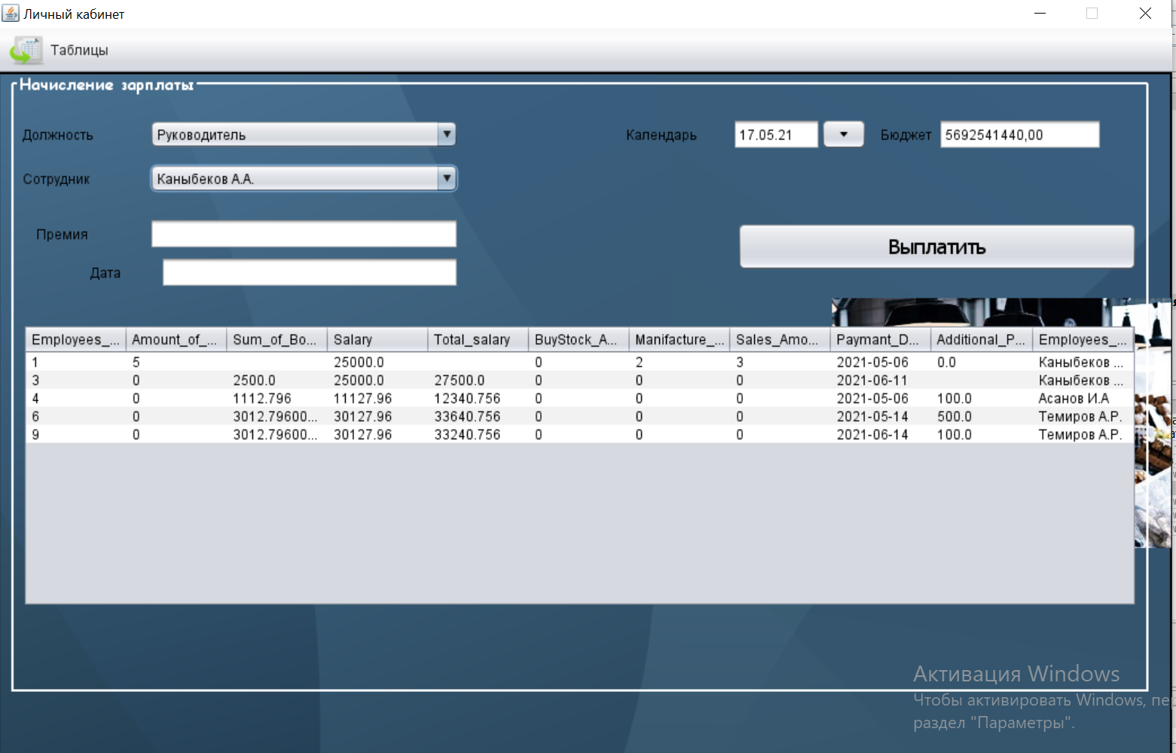

**Код:**

/*

package bakery;

import javax.swing.table.DefaultTableModel;

//import ketchupproduction.*;

import java.awt.Color;

import java.awt.Font;

import java.awt.Toolkit;

import java.sql.CallableStatement;

import java.sql.Connection;

import java.sql.PreparedStatement;

import java.sql.ResultSet;

import java.sql.Statement;

import java.text.SimpleDateFormat;

import java.time.LocalDate;

import java.util.Date;

import javafx.scene.control.DatePicker;

import javax.swing.ImageIcon;

import javax.swing.JOptionPane;

import javax.swing.table.TableModel;

import net.proteanit.sql.DbUtils;

import net.sf.jasperreports.engine.JasperCompileManager;

import net.sf.jasperreports.engine.JasperFillManager;

import net.sf.jasperreports.engine.JasperPrint;

import net.sf.jasperreports.engine.JasperReport;

import net.sf.jasperreports.engine.design.JRDesignQuery;

import net.sf.jasperreports.engine.design.JasperDesign;

import net.sf.jasperreports.engine.xml.JRXmlLoader;

import net.sf.jasperreports.view.JasperViewer;

/**

*

* @author Mirik

*/

public class Payments_ex extends javax.swing.JFrame {

Connection conn = null;

Statement st = null;

ResultSet rs = null;

String id_buyer = "";

boolean customizeWpnTable = false;

boolean customizeAccountTable = false;

boolean customizeDocumentTable = false;

boolean customizeOrderTable = false;

CallableStatement stored_pro = null;

private void UpdateBudjet(){

try{

conn = ConnectMsSql.ConnectDB();

String insert = "SELECT Kolichestvo_deneg_v_budgete FROM Budget";

PreparedStatement pst = conn.prepareStatement(insert);

ResultSet res = pst.executeQuery();

st = conn.createStatement();

res = st.executeQuery(insert);

while(res.next()){

BudjetTxt.setText(String.format("%.2f", res.getFloat("Kolichestvo_deneg_v_budgete")));

}

conn.close();

}

catch(Exception e){

JOptionPane.showMessageDialog(null, e);

}

}

private void GetEmloyee(){

// try{

// conn = ConnectMsSql.ConnectDB();

// //String query = "SELECT full_name FROM Employees WHERE login=" + KetchupProduction.id;

// // PreparedStatement pst = conn.prepareStatement(query);

// // rs = pst.executeQuery();

//

// while(rs.next()){

// BuhNameTxt.setText(rs.getString("Name"));

// }

//

// conn.close();

// }

// catch(Exception e){

// JOptionPane.showMessageDialog(null, e);

// }

}

private void UpdateJTable(){

}

void DefaultValues(){

LocalDate date = LocalDate.now(); // получаем текущую дату

int year = date.getYear();

// YearTxt.setText(String.valueOf(year));

SimpleDateFormat formatter = new SimpleDateFormat("dd.MM.yyyy");

Date pickerDate = new Date();

JDatePicker.setDate(pickerDate);

conn = ConnectMsSql.ConnectDB();

// String sql = "SELECT full_name FROM employees WHERE id ='"+KetchupProduction.id+"'";

try

{

st = conn.createStatement();

// ResultSet rs = st.executeQuery(sql);

while (rs.next())

{

BuhNameTxt.setText(rs.getString(1));

}

//MonthComboBox.setSelectedIndex(-1);

}

catch (Exception e)

{

e.printStackTrace();

}

}

void ComboboxMonth() {

conn = ConnectMsSql.ConnectDB();

String sql = "SELECT name FROM month";

try {

st = conn.createStatement();

ResultSet rs = st.executeQuery(sql);

while (rs.next())

{

//MonthComboBox.addItem(rs.getString(1));

}

// MonthComboBox.setSelectedIndex(-1);

}

catch (Exception e) {

e.printStackTrace();

}

}

/**

* Creates new form client_main_form

*/

public Payments_ex() {

initComponents();

UpdateBudjet();

GetEmloyee();

ComboboxPos();

ComboboxMonth();

DefaultValues();

//UpdateJTable();

// setIconImage(Toolkit.getDefaultToolkit().getImage(getClass().getResource("tomato-sauce.png")));

}

/**

* This method is called from within the constructor to initialize the form.

* WARNING: Do NOT modify this code. The content of this method is always

* regenerated by the Form Editor.

*/

@SuppressWarnings("unchecked")

// <editor-fold defaultstate="collapsed" desc="Generated Code">

private void initComponents() {

desktopPane = new javax.swing.JDesktopPane();

statusBar = new javax.swing.JLabel();

wpnTableborder = new javax.swing.JPanel();

jLabel3 = new javax.swing.JLabel();

JDatePicker = new org.jdesktop.swingx.JXDatePicker();

PosComboBox = new javax.swing.JComboBox<>();

jLabel5 = new javax.swing.JLabel();

jLabel6 = new javax.swing.JLabel();

EmpComboBox = new javax.swing.JComboBox<>();

jScrollPane1 = new javax.swing.JScrollPane();

EmployeeTable = new javax.swing.JTable();

PaySumTxt = new javax.swing.JTextField();

jLabel8 = new javax.swing.JLabel();

BudjetTxt = new javax.swing.JTextField();

jLabel9 = new javax.swing.JLabel();

jLabel11 = new javax.swing.JLabel();

BuhNameTxt = new javax.swing.JTextField();

PayBtn = new javax.swing.JButton();

background = new javax.swing.JLabel();

jMenuBar1 = new javax.swing.JMenuBar();

jMenu1 = new javax.swing.JMenu();

jMenuItem1 = new javax.swing.JMenuItem();

jMenu4 = new javax.swing.JMenu();

jMenu6 = new javax.swing.JMenu();

setDefaultCloseOperation(javax.swing.WindowConstants.DISPOSE_ON_CLOSE);

setTitle("Личный кабинет");

setResizable(false);

addWindowListener(new java.awt.event.WindowAdapter() {

public void windowActivated(java.awt.event.WindowEvent evt) {

formWindowActivated(evt);

}

public void windowClosing(java.awt.event.WindowEvent evt) {

formWindowClosing(evt);

}

});

desktopPane.setBackground(new java.awt.Color(51, 51, 51));

desktopPane.setBorder(javax.swing.BorderFactory.createLineBorder(new java.awt.Color(0, 0, 0), 2));

statusBar.setFont(new java.awt.Font("Comic Sans MS", 1, 12)); // NOI18N

statusBar.setForeground(new java.awt.Color(255, 0, 0));

statusBar.setBorder(javax.swing.BorderFactory.createLineBorder(new java.awt.Color(0, 0, 0)));

desktopPane.add(statusBar);

statusBar.setBounds(0, 620, 1040, 20);

wpnTableborder.setBorder(javax.swing.BorderFactory.createTitledBorder(new javax.swing.border.LineBorder(new java.awt.Color(255, 255, 255), 2, true), "Начисление зарплаты", javax.swing.border.TitledBorder.LEFT, javax.swing.border.TitledBorder.TOP, new java.awt.Font("Comic Sans MS", 1, 14), new java.awt.Color(255, 255, 255))); // NOI18N

wpnTableborder.setFont(new java.awt.Font("Comic Sans MS", 1, 14)); // NOI18N

wpnTableborder.setOpaque(false);

jLabel3.setText("Календарь");

JDatePicker.addActionListener(new java.awt.event.ActionListener() {

public void actionPerformed(java.awt.event.ActionEvent evt) {

JDatePickerActionPerformed(evt);

}

});

PosComboBox.addActionListener(new java.awt.event.ActionListener() {

public void actionPerformed(java.awt.event.ActionEvent evt) {

PosComboBoxActionPerformed(evt);

}

});

jLabel5.setText("Сотрудник");

jLabel6.setText("Премия");

EmpComboBox.addActionListener(new java.awt.event.ActionListener() {

public void actionPerformed(java.awt.event.ActionEvent evt) {

EmpComboBoxActionPerformed(evt);

}

});

EmployeeTable.addMouseListener(new java.awt.event.MouseAdapter() {

public void mouseClicked(java.awt.event.MouseEvent evt) {

EmployeeTableMouseClicked(evt);

}

});

jScrollPane1.setViewportView(EmployeeTable);

jLabel8.setText("Бюджет");

jLabel9.setText("Должность");

jLabel11.setText("Дата");

PayBtn.setFont(new java.awt.Font("Tahoma", 0, 18)); // NOI18N

PayBtn.setText("Выплатить");

PayBtn.addActionListener(new java.awt.event.ActionListener() {

public void actionPerformed(java.awt.event.ActionEvent evt) {

PayBtnActionPerformed(evt);

}

});

javax.swing.GroupLayout wpnTableborderLayout = new javax.swing.GroupLayout(wpnTableborder);

wpnTableborder.setLayout(wpnTableborderLayout);

wpnTableborderLayout.setHorizontalGroup(

wpnTableborderLayout.createParallelGroup(javax.swing.GroupLayout.Alignment.LEADING)

.addGroup(wpnTableborderLayout.createSequentialGroup()

.addContainerGap()

.addGroup(wpnTableborderLayout.createParallelGroup(javax.swing.GroupLayout.Alignment.LEADING)

.addComponent(jScrollPane1)

.addGroup(wpnTableborderLayout.createSequentialGroup()

.addGroup(wpnTableborderLayout.createParallelGroup(javax.swing.GroupLayout.Alignment.LEADING, false)

.addGroup(wpnTableborderLayout.createSequentialGroup()

.addGap(60, 60, 60)

.addComponent(jLabel11)

.addGap(35, 35, 35)

.addComponent(BuhNameTxt))

.addGroup(wpnTableborderLayout.createSequentialGroup()

.addGroup(wpnTableborderLayout.createParallelGroup(javax.swing.GroupLayout.Alignment.LEADING)

.addComponent(jLabel5)

.addGroup(wpnTableborderLayout.createSequentialGroup()

.addGap(12, 12, 12)

.addComponent(jLabel6))

.addComponent(jLabel9))

.addGap(49, 49, 49)

.addGroup(wpnTableborderLayout.createParallelGroup(javax.swing.GroupLayout.Alignment.LEADING)

.addComponent(PaySumTxt, javax.swing.GroupLayout.Alignment.TRAILING, javax.swing.GroupLayout.PREFERRED_SIZE, 274, javax.swing.GroupLayout.PREFERRED_SIZE)

.addGroup(wpnTableborderLayout.createParallelGroup(javax.swing.GroupLayout.Alignment.TRAILING)

.addComponent(PosComboBox, javax.swing.GroupLayout.PREFERRED_SIZE, 274, javax.swing.GroupLayout.PREFERRED_SIZE)

.addComponent(EmpComboBox, javax.swing.GroupLayout.PREFERRED_SIZE, 274, javax.swing.GroupLayout.PREFERRED_SIZE)))))

.addGroup(wpnTableborderLayout.createParallelGroup(javax.swing.GroupLayout.Alignment.LEADING)

.addGroup(wpnTableborderLayout.createSequentialGroup()

.addPreferredGap(javax.swing.LayoutStyle.ComponentPlacement.RELATED, javax.swing.GroupLayout.DEFAULT_SIZE, Short.MAX_VALUE)

.addComponent(PayBtn, javax.swing.GroupLayout.DEFAULT_SIZE, javax.swing.GroupLayout.DEFAULT_SIZE, Short.MAX_VALUE))

.addGroup(wpnTableborderLayout.createSequentialGroup()

.addGap(148, 148, 148)

.addComponent(jLabel3)

.addPreferredGap(javax.swing.LayoutStyle.ComponentPlacement.RELATED, javax.swing.GroupLayout.DEFAULT_SIZE, Short.MAX_VALUE)

.addComponent(JDatePicker, javax.swing.GroupLayout.PREFERRED_SIZE, 119, javax.swing.GroupLayout.PREFERRED_SIZE)

.addPreferredGap(javax.swing.LayoutStyle.ComponentPlacement.UNRELATED)

.addComponent(jLabel8)

.addPreferredGap(javax.swing.LayoutStyle.ComponentPlacement.RELATED)

.addComponent(BudjetTxt, javax.swing.GroupLayout.PREFERRED_SIZE, 145, javax.swing.GroupLayout.PREFERRED_SIZE)

.addGap(31, 31, 31)))))

.addContainerGap())

);

wpnTableborderLayout.setVerticalGroup(

wpnTableborderLayout.createParallelGroup(javax.swing.GroupLayout.Alignment.LEADING)

.addGroup(wpnTableborderLayout.createSequentialGroup()

.addGap(18, 18, 18)

.addGroup(wpnTableborderLayout.createParallelGroup(javax.swing.GroupLayout.Alignment.BASELINE)

.addComponent(JDatePicker, javax.swing.GroupLayout.PREFERRED_SIZE, javax.swing.GroupLayout.DEFAULT_SIZE, javax.swing.GroupLayout.PREFERRED_SIZE)

.addComponent(jLabel3)

.addComponent(BudjetTxt, javax.swing.GroupLayout.PREFERRED_SIZE, javax.swing.GroupLayout.DEFAULT_SIZE, javax.swing.GroupLayout.PREFERRED_SIZE)

.addComponent(jLabel8)

.addComponent(PosComboBox, javax.swing.GroupLayout.PREFERRED_SIZE, javax.swing.GroupLayout.DEFAULT_SIZE, javax.swing.GroupLayout.PREFERRED_SIZE)

.addComponent(jLabel9))

.addGroup(wpnTableborderLayout.createParallelGroup(javax.swing.GroupLayout.Alignment.LEADING)

.addGroup(wpnTableborderLayout.createSequentialGroup()

.addGap(64, 64, 64)

.addComponent(PayBtn, javax.swing.GroupLayout.PREFERRED_SIZE, 43, javax.swing.GroupLayout.PREFERRED_SIZE))

.addGroup(wpnTableborderLayout.createSequentialGroup()

.addPreferredGap(javax.swing.LayoutStyle.ComponentPlacement.UNRELATED)

.addGroup(wpnTableborderLayout.createParallelGroup(javax.swing.GroupLayout.Alignment.BASELINE)

.addComponent(EmpComboBox, javax.swing.GroupLayout.PREFERRED_SIZE, javax.swing.GroupLayout.DEFAULT_SIZE, javax.swing.GroupLayout.PREFERRED_SIZE)

.addComponent(jLabel5))

.addGap(22, 22, 22)

.addGroup(wpnTableborderLayout.createParallelGroup(javax.swing.GroupLayout.Alignment.BASELINE)

.addComponent(PaySumTxt, javax.swing.GroupLayout.PREFERRED_SIZE, javax.swing.GroupLayout.DEFAULT_SIZE, javax.swing.GroupLayout.PREFERRED_SIZE)

.addComponent(jLabel6))

.addPreferredGap(javax.swing.LayoutStyle.ComponentPlacement.RELATED)

.addGroup(wpnTableborderLayout.createParallelGroup(javax.swing.GroupLayout.Alignment.BASELINE)

.addComponent(jLabel11)

.addComponent(BuhNameTxt, javax.swing.GroupLayout.PREFERRED_SIZE, javax.swing.GroupLayout.DEFAULT_SIZE, javax.swing.GroupLayout.PREFERRED_SIZE))))

.addGap(32, 32, 32)

.addComponent(jScrollPane1, javax.swing.GroupLayout.DEFAULT_SIZE, 249, Short.MAX_VALUE)

.addGap(71, 71, 71))

);

desktopPane.add(wpnTableborder);

wpnTableborder.setBounds(10, 0, 1010, 550);

background.setFont(new java.awt.Font("Comic Sans MS", 1, 14)); // NOI18N

background.setHorizontalAlignment(javax.swing.SwingConstants.RIGHT);

background.setIcon(new javax.swing.ImageIcon(getClass().getResource("/bakery/7badce0e-43e6-4890-a2c1-dc414048b270.jpg"))); // NOI18N

background.setBorder(javax.swing.BorderFactory.createLineBorder(new java.awt.Color(0, 0, 0), 2));

desktopPane.add(background);

background.setBounds(0, 0, 1040, 620);

jMenu1.setIcon(new javax.swing.ImageIcon(getClass().getResource("/bakery/.11111aaaa.png"))); // NOI18N

jMenu1.setText("Таблицы");

jMenuItem1.setText("Должность");

jMenuItem1.addActionListener(new java.awt.event.ActionListener() {

public void actionPerformed(java.awt.event.ActionEvent evt) {

jMenuItem1ActionPerformed(evt);

}

});

jMenu1.add(jMenuItem1);

jMenu4.setText("Банк");

jMenu4.addMouseListener(new java.awt.event.MouseAdapter() {

public void mouseClicked(java.awt.event.MouseEvent evt) {

jMenu4MouseClicked(evt);

}

});

jMenu1.add(jMenu4);

jMenu6.setText("Сотрудники");

jMenu6.addMouseListener(new java.awt.event.MouseAdapter() {

public void mouseClicked(java.awt.event.MouseEvent evt) {

jMenu6MouseClicked(evt);

}

});

jMenu1.add(jMenu6);

jMenuBar1.add(jMenu1);

setJMenuBar(jMenuBar1);

javax.swing.GroupLayout layout = new javax.swing.GroupLayout(getContentPane());

getContentPane().setLayout(layout);

layout.setHorizontalGroup(

layout.createParallelGroup(javax.swing.GroupLayout.Alignment.LEADING)

.addComponent(desktopPane, javax.swing.GroupLayout.DEFAULT_SIZE, 1039, Short.MAX_VALUE)

);

layout.setVerticalGroup(

layout.createParallelGroup(javax.swing.GroupLayout.Alignment.LEADING)

.addComponent(desktopPane, javax.swing.GroupLayout.DEFAULT_SIZE, 641, Short.MAX_VALUE)

);

pack();

setLocationRelativeTo(null);

}// </editor-fold>

private void formWindowClosing(java.awt.event.WindowEvent evt) {

// new Main1().setVisible(true);

// this.dispose();

}

private void PayBtnActionPerformed(java.awt.event.ActionEvent evt) {

// TODO add your handling code here:

try {

conn = ConnectMsSql.ConnectDB();

Statement st = conn.createStatement();

String test = EmpComboBox.getSelectedItem().toString();

double amount = Double.parseDouble(PaySumTxt.getText());

String date=BuhNameTxt.getText();

// phone=JDatePicker.getText();

int idProduct = 0;

ResultSet id = st.executeQuery("select ID from Employees where Name = '" + test + "'");

while (id.next()) {

idProduct = Integer.parseInt(id.getString("ID"));

}

String dobavlenie = "INSERT INTO payments_to_emp (FK_Employer, Additional_Pay, Paymant_Date) VALUES(?,?,?)";

PreparedStatement pst = conn.prepareStatement(dobavlenie);

pst.setInt(1, idProduct);

pst.setDouble(2, amount);

pst.setString(3, date);

JOptionPane.showMessageDialog(null, "Данные успешно добавленны.");

pst.executeUpdate();

} catch (Exception e) {

JOptionPane.showMessageDialog(null, e);

}

/*Регистрация гражданина в БД*/

}

private void EmployeeTableMouseClicked(java.awt.event.MouseEvent evt) {

// TODO add your handling code here:

try{

conn = ConnectMsSql.ConnectDB();

// int row = jTable1.getSelectedRow();

// String name = (jTable1.getModel().getValueAt(row,0).toString());

int i=EmployeeTable.getSelectedRow();

TableModel model=EmployeeTable.getModel();

// NameTxt.setText(model.getValueAt(i,0).toString());

// PositionTxt.setText(model.getValueAt(i,1).toString());

// SalaryTxt.setText(model.getValueAt(i,2).toString());

// adressTxt.setText(model.getValueAt(i,3).toString());

// phoneTxt.setText(model.getValueAt(i,4).toString());

// phoneTxt1.setText(model.getValueAt(i,6).toString());

// String sql = "SELECT Employees.Name,Position.Position as pos,Employees.Final_sallary, Employees.Address, Employees.Phone,Employees.Nadbavka FROM Employees INNER JOIN Position ON Employees.Position = Position.ID WHERE Employees.Name ='" + name + "'";

// PreparedStatement pst=conn.prepareStatement(sql);

// ResultSet rs = pst.executeQuery();

// statement = conn.createStatement();

// rs = statement.executeQuery(sql);

//

// while(rs.next()){

// NameTxt.setText(rs.getString("Name"));

// PositionTxt.setText(rs.getString("pos"));

// SalaryTxt.setText(rs.getString("Final_sallary"));

// adressTxt.setText(rs.getString("Address"));

// phoneTxt.setText(rs.getString("Phone"));

// phoneTxt1.setText(rs.getString("Nadbavka"));

// }

}

catch(Exception e){

System.out.println("Error");

}

}

private void formWindowActivated(java.awt.event.WindowEvent evt) {

// TODO add your handling code here:

try{

conn = ConnectMsSql.ConnectDB();

//String sql = "SELECT Employees.Name,Position.Position as pos,Employees.Final_sallary, Employees.Address, Employees.Phone FROM Employees INNER JOIN Position ON Employees.Position = Position.ID WHERE Employees.Name ='" + name + "'";

String sql = "SELECT\n" +

" payments_to_emp.\"ID_salary\" AS payments_to_emp_ID_salary,\n" +

" payments_to_emp.\"Amount_of_work\" AS payments_to_emp_Amount_of_work,\n" +

" payments_to_emp.\"Sum_of_Bonus\" AS payments_to_emp_Sum_of_Bonus,\n" +

" payments_to_emp.\"Salary\" AS payments_to_emp_Salary,\n" +

" payments_to_emp.\"Total_salary\" AS payments_to_emp_Total_salary,\n" +

" payments_to_emp.\"BuyStock_Amount\" AS payments_to_emp_BuyStock_Amount,\n" +

" payments_to_emp.\"Manifacture_Amount\" AS payments_to_emp_Manifacture_Amount,\n" +

" payments_to_emp.\"Sales_Amount\" AS payments_to_emp_Sales_Amount,\n" +

" payments_to_emp.\"Paymant_Date\" AS payments_to_emp_Paymant_Date,\n" +

" payments_to_emp.\"Additional_Pay\" AS payments_to_emp_Additional_Pay,\n" +

" Employees.\"Name\" AS Employees_Name\n" +

"FROM\n" +

" \"dbo\".\"Employees\" Employees INNER JOIN \"dbo\".\"payments_to_emp\" payments_to_emp ON Employees.\"ID\" = payments_to_emp.\"FK_Employer\"";

Statement statement = conn.createStatement();

rs = statement.executeQuery(sql);

this.EmployeeTable.setModel(DbUtils.resultSetToTableModel(rs));

EmployeeTable.getColumnModel().getColumn(0).setHeaderValue("Employees_Name");

EmployeeTable.getColumnModel().getColumn(1).setHeaderValue("Amount_of_work");

EmployeeTable.getColumnModel().getColumn(2).setHeaderValue("Sum_of_Bonus");

EmployeeTable.getColumnModel().getColumn(3).setHeaderValue("Salary");

EmployeeTable.getColumnModel().getColumn(4).setHeaderValue("Total_salary");

EmployeeTable.getColumnModel().getColumn(5).setHeaderValue("BuyStock_Amount");

EmployeeTable.getColumnModel().getColumn(6).setHeaderValue("Manifacture_Amount");

EmployeeTable.getColumnModel().getColumn(7).setHeaderValue("Sales_Amount");

EmployeeTable.getColumnModel().getColumn(8).setHeaderValue("Paymant_Date");

EmployeeTable.getColumnModel().getColumn(9).setHeaderValue("Additional_Pay");

conn.close();

}

catch(Exception e){

e.printStackTrace();

JOptionPane.showMessageDialog(null, e);

}

}

private void EmpComboBoxActionPerformed(java.awt.event.ActionEvent evt) {

// TODO add your handling code here:

}

void ComboboxPos() {

conn = ConnectMsSql.ConnectDB();

String sql = "SELECT Position FROM Position";

try {

st = conn.createStatement();

ResultSet rs = st.executeQuery(sql);

while (rs.next())

{

PosComboBox.addItem(rs.getString(1));

}

PosComboBox.setSelectedIndex(-1);

}

catch (Exception e) {

e.printStackTrace();

}

}

private void PosComboBoxActionPerformed(java.awt.event.ActionEvent evt) {

// TODO add your handling code here:

EmpComboBox.removeAllItems();

conn = ConnectMsSql.ConnectDB();

try {

String query = "SELECT ID FROM Position WHERE Position = '" + PosComboBox.getSelectedItem() + "'";

PreparedStatement pst = conn.prepareStatement(query);

rs = pst.executeQuery();

int id_pos = 0;

while(rs.next()){

id_pos = rs.getInt("id");

}

String sql = "SELECT Name FROM Employees WHERE Position = '" + id_pos + "'";

st = conn.createStatement();

ResultSet res = st.executeQuery(sql);

while (res.next())

{

EmpComboBox.addItem(res.getString(1));

}

EmpComboBox.setSelectedIndex(-1);

}

catch (Exception e) {

e.printStackTrace();

}

}

private void JDatePickerActionPerformed(java.awt.event.ActionEvent evt) {

// TODO add your handling code here:

}

private void jMenuItem1ActionPerformed(java.awt.event.ActionEvent evt) {

// TODO add your handling code here:

positions field= new positions();

field.setVisible(true);

setVisible(false);

}

private void jMenu4MouseClicked(java.awt.event.MouseEvent evt) {

// TODO add your handling code here:

cred field= new cred();

field.setVisible(true);

setVisible(false);

}

private void jMenu6MouseClicked(java.awt.event.MouseEvent evt) {

// TODO add your handling code here:

employees field= new employees();

field.setVisible(true);

setVisible(false);

}

/**

* @param args the command line arguments

*/

public static void main(String args[]) {

/* Set the Nimbus look and feel */

//<editor-fold defaultstate="collapsed" desc=" Look and feel setting code (optional) ">

/* If Nimbus (introduced in Java SE 6) is not available, stay with the default look and feel.

* For details see http://download.oracle.com/javase/tutorial/uiswing/lookandfeel/plaf.html

*/

try {

for (javax.swing.UIManager.LookAndFeelInfo info : javax.swing.UIManager.getInstalledLookAndFeels()) {

if ("Nimbus".equals(info.getName())) {

javax.swing.UIManager.setLookAndFeel(info.getClassName());

break;

}

}

} catch (ClassNotFoundException ex) {

java.util.logging.Logger.getLogger(Payments_ex.class.getName()).log(java.util.logging.Level.SEVERE, null, ex);

} catch (InstantiationException ex) {

java.util.logging.Logger.getLogger(Payments_ex.class.getName()).log(java.util.logging.Level.SEVERE, null, ex);

} catch (IllegalAccessException ex) {

java.util.logging.Logger.getLogger(Payments_ex.class.getName()).log(java.util.logging.Level.SEVERE, null, ex);

} catch (javax.swing.UnsupportedLookAndFeelException ex) {

java.util.logging.Logger.getLogger(Payments_ex.class.getName()).log(java.util.logging.Level.SEVERE, null, ex);

}

//</editor-fold>

//</editor-fold>

//</editor-fold>

//</editor-fold>

//</editor-fold>

//</editor-fold>

//</editor-fold>

//</editor-fold>

//</editor-fold>

//</editor-fold>

//</editor-fold>

//</editor-fold>

//</editor-fold>

//</editor-fold>

//</editor-fold>

//</editor-fold>

//</editor-fold>

//</editor-fold>

//</editor-fold>

//</editor-fold>

//</editor-fold>

//</editor-fold>

//</editor-fold>

//</editor-fold>

//</editor-fold>

//</editor-fold>

//</editor-fold>

//</editor-fold>

//</editor-fold>

//</editor-fold>

//</editor-fold>

//</editor-fold>

/* Create and display the form */

java.awt.EventQueue.invokeLater(new Runnable() {

public void run() {

new Payments_ex().setVisible(true);

}

});

}

// Variables declaration - do not modify

private javax.swing.JTextField BudjetTxt;

private javax.swing.JTextField BuhNameTxt;

private javax.swing.JComboBox<String> EmpComboBox;

private javax.swing.JTable EmployeeTable;

private org.jdesktop.swingx.JXDatePicker JDatePicker;

private javax.swing.JButton PayBtn;

private javax.swing.JTextField PaySumTxt;

private javax.swing.JComboBox<String> PosComboBox;

private javax.swing.JLabel background;

private javax.swing.JDesktopPane desktopPane;

private javax.swing.JLabel jLabel11;

private javax.swing.JLabel jLabel3;

private javax.swing.JLabel jLabel5;

private javax.swing.JLabel jLabel6;

private javax.swing.JLabel jLabel8;

private javax.swing.JLabel jLabel9;

private javax.swing.JMenu jMenu1;

private javax.swing.JMenu jMenu4;

private javax.swing.JMenu jMenu6;

private javax.swing.JMenuBar jMenuBar1;

private javax.swing.JMenuItem jMenuItem1;

private javax.swing.JScrollPane jScrollPane1;

private javax.swing.JLabel statusBar;

private javax.swing.JPanel wpnTableborder;

// End of variables declaration

}

* Форма **ingredients.java**

Для просмотра рецептов продукции, какое количество нужно для приготовления и т.д.

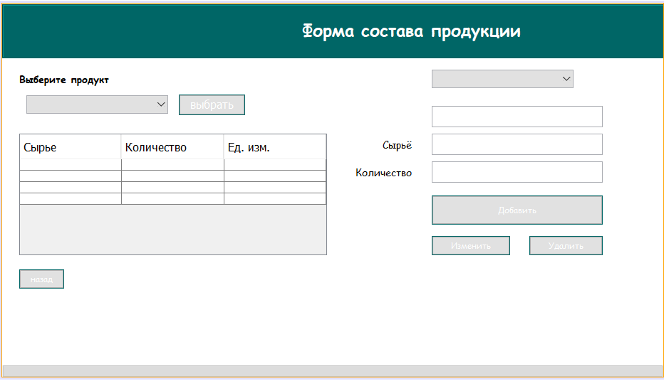

**Код:**

/*

package bakery;

import java.sql.*;

import java.util.Calendar;

import javax.swing.*;

import javax.swing.table.TableModel;

import net.proteanit.sql.DbUtils;

/**

*

* @author aidin

*/

public class ingredients extends javax.swing.JFrame {

Connection conn = null;

CallableStatement stored_pro = null;

Statement statement = null;

ResultSet rs = null;

/**

* Creates new form measure

*/

public ingredients() {

initComponents();

}

/**

* This method is called from within the constructor to initialize the form.

* WARNING: Do NOT modify this code. The content of this method is always

* regenerated by the Form Editor.

*/

@SuppressWarnings("unchecked")

// <editor-fold defaultstate="collapsed" desc="Generated Code">

private void initComponents() {

jLabel2 = new javax.swing.JLabel();

jPanel1 = new javax.swing.JPanel();

jScrollPane1 = new javax.swing.JScrollPane();

jTable1 = new javax.swing.JTable();

MeasureInsertButton = new javax.swing.JButton();

MeasureUpdateButton = new javax.swing.JButton();

MeasureDeleteButton = new javax.swing.JButton();

IDTxt = new javax.swing.JTextField();

jLabel1 = new javax.swing.JLabel();

back = new javax.swing.JButton();

jPanel2 = new javax.swing.JPanel();

jLabel3 = new javax.swing.JLabel();

AmountTxt = new javax.swing.JTextField();

jLabel7 = new javax.swing.JLabel();

jLabel5 = new javax.swing.JLabel();

jComboBox1 = new javax.swing.JComboBox<>();

jButton3 = new javax.swing.JButton();

jComboBox2 = new javax.swing.JComboBox<>();

IDTxt1 = new javax.swing.JTextField();

jLabel2.setText("jLabel2");

setDefaultCloseOperation(javax.swing.WindowConstants.EXIT_ON_CLOSE);

addWindowListener(new java.awt.event.WindowAdapter() {

public void windowActivated(java.awt.event.WindowEvent evt) {

formWindowActivated(evt);

}

public void windowClosing(java.awt.event.WindowEvent evt) {

formWindowClosing(evt);

}

});

jPanel1.setBackground(new java.awt.Color(255, 255, 255));

jTable1.setFont(new java.awt.Font("Comic Sans MS", 0, 14)); // NOI18N

jTable1.setModel(new javax.swing.table.DefaultTableModel(

new Object [][] {

{null, null, null},

{null, null, null},

{null, null, null},

{null, null, null}

},

new String [] {

"Сырье", "Количество", "Ед. изм."

}

));

jTable1.addMouseListener(new java.awt.event.MouseAdapter() {

public void mouseClicked(java.awt.event.MouseEvent evt) {

jTable1MouseClicked(evt);

}

});

jScrollPane1.setViewportView(jTable1);

MeasureInsertButton.setBackground(new java.awt.Color(0, 102, 102));

MeasureInsertButton.setFont(new java.awt.Font("Comic Sans MS", 0, 12)); // NOI18N

MeasureInsertButton.setForeground(new java.awt.Color(255, 255, 255));

MeasureInsertButton.setText("Добавить");

MeasureInsertButton.addActionListener(new java.awt.event.ActionListener() {

public void actionPerformed(java.awt.event.ActionEvent evt) {

MeasureInsertButtonActionPerformed(evt);

}

});

MeasureUpdateButton.setBackground(new java.awt.Color(0, 102, 102));

MeasureUpdateButton.setFont(new java.awt.Font("Comic Sans MS", 0, 12)); // NOI18N

MeasureUpdateButton.setForeground(new java.awt.Color(255, 255, 255));

MeasureUpdateButton.setText("Изменить");

MeasureUpdateButton.addActionListener(new java.awt.event.ActionListener() {

public void actionPerformed(java.awt.event.ActionEvent evt) {

MeasureUpdateButtonActionPerformed(evt);

}

});

MeasureDeleteButton.setBackground(new java.awt.Color(0, 102, 102));

MeasureDeleteButton.setFont(new java.awt.Font("Comic Sans MS", 0, 12)); // NOI18N

MeasureDeleteButton.setForeground(new java.awt.Color(255, 255, 255));

MeasureDeleteButton.setText("Удалить");

MeasureDeleteButton.addActionListener(new java.awt.event.ActionListener() {

public void actionPerformed(java.awt.event.ActionEvent evt) {

MeasureDeleteButtonActionPerformed(evt);

}

});

jLabel1.setFont(new java.awt.Font("Comic Sans MS", 0, 14)); // NOI18N

jLabel1.setText("Сырьё");

back.setBackground(new java.awt.Color(0, 102, 102));

back.setFont(new java.awt.Font("Comic Sans MS", 0, 12)); // NOI18N

back.setForeground(new java.awt.Color(255, 255, 255));

back.setText("назад");

back.addActionListener(new java.awt.event.ActionListener() {

public void actionPerformed(java.awt.event.ActionEvent evt) {

backActionPerformed(evt);

}

});

jPanel2.setBackground(new java.awt.Color(0, 102, 102));

jPanel2.setBorder(javax.swing.BorderFactory.createEtchedBorder());

jPanel2.setForeground(new java.awt.Color(255, 255, 255));

jLabel3.setFont(new java.awt.Font("Comic Sans MS", 1, 24)); // NOI18N

jLabel3.setForeground(new java.awt.Color(255, 255, 255));

jLabel3.setText("Форма состава продукции");

javax.swing.GroupLayout jPanel2Layout = new javax.swing.GroupLayout(jPanel2);

jPanel2.setLayout(jPanel2Layout);

jPanel2Layout.setHorizontalGroup(

jPanel2Layout.createParallelGroup(javax.swing.GroupLayout.Alignment.LEADING)

.addGroup(javax.swing.GroupLayout.Alignment.TRAILING, jPanel2Layout.createSequentialGroup()

.addContainerGap(javax.swing.GroupLayout.DEFAULT_SIZE, Short.MAX_VALUE)

.addComponent(jLabel3)

.addGap(378, 378, 378))

);

jPanel2Layout.setVerticalGroup(

jPanel2Layout.createParallelGroup(javax.swing.GroupLayout.Alignment.LEADING)

.addGroup(jPanel2Layout.createSequentialGroup()

.addContainerGap()

.addComponent(jLabel3)

.addContainerGap(22, Short.MAX_VALUE))

);

AmountTxt.setToolTipText("");

jLabel7.setFont(new java.awt.Font("Comic Sans MS", 0, 14)); // NOI18N

jLabel7.setText("Количество");

jLabel5.setFont(new java.awt.Font("Comic Sans MS", 1, 14)); // NOI18N

jLabel5.setText("Выберите продукт");

jComboBox1.addMouseListener(new java.awt.event.MouseAdapter() {

public void mouseClicked(java.awt.event.MouseEvent evt) {

jComboBox1MouseClicked(evt);

}

});

jButton3.setBackground(new java.awt.Color(0, 102, 102));

jButton3.setForeground(new java.awt.Color(255, 255, 255));

jButton3.setText("выбрать");

jButton3.addActionListener(new java.awt.event.ActionListener() {

public void actionPerformed(java.awt.event.ActionEvent evt) {

jButton3ActionPerformed(evt);

}

});

jComboBox2.addPopupMenuListener(new javax.swing.event.PopupMenuListener() {

public void popupMenuCanceled(javax.swing.event.PopupMenuEvent evt) {

}

public void popupMenuWillBecomeInvisible(javax.swing.event.PopupMenuEvent evt) {

jComboBox2PopupMenuWillBecomeInvisible(evt);

}

public void popupMenuWillBecomeVisible(javax.swing.event.PopupMenuEvent evt) {

}

});

jComboBox2.addMouseListener(new java.awt.event.MouseAdapter() {

public void mouseClicked(java.awt.event.MouseEvent evt) {

jComboBox2MouseClicked(evt);

}

});

javax.swing.GroupLayout jPanel1Layout = new javax.swing.GroupLayout(jPanel1);

jPanel1.setLayout(jPanel1Layout);

jPanel1Layout.setHorizontalGroup(

jPanel1Layout.createParallelGroup(javax.swing.GroupLayout.Alignment.LEADING)

.addGroup(jPanel1Layout.createSequentialGroup()

.addGap(24, 24, 24)

.addGroup(jPanel1Layout.createParallelGroup(javax.swing.GroupLayout.Alignment.LEADING)

.addGroup(jPanel1Layout.createSequentialGroup()

.addGroup(jPanel1Layout.createParallelGroup(javax.swing.GroupLayout.Alignment.LEADING)

.addGroup(jPanel1Layout.createSequentialGroup()

.addGap(10, 10, 10)

.addComponent(jComboBox1, javax.swing.GroupLayout.PREFERRED_SIZE, 199, javax.swing.GroupLayout.PREFERRED_SIZE)

.addPreferredGap(javax.swing.LayoutStyle.ComponentPlacement.UNRELATED)

.addComponent(jButton3))

.addComponent(jScrollPane1, javax.swing.GroupLayout.PREFERRED_SIZE, 432, javax.swing.GroupLayout.PREFERRED_SIZE))

.addGroup(jPanel1Layout.createParallelGroup(javax.swing.GroupLayout.Alignment.LEADING)

.addGroup(jPanel1Layout.createSequentialGroup()

.addPreferredGap(javax.swing.LayoutStyle.ComponentPlacement.RELATED, javax.swing.GroupLayout.DEFAULT_SIZE, Short.MAX_VALUE)

.addGroup(jPanel1Layout.createParallelGroup(javax.swing.GroupLayout.Alignment.TRAILING)

.addComponent(jLabel1)

.addComponent(jLabel7))

.addGap(28, 28, 28)

.addGroup(jPanel1Layout.createParallelGroup(javax.swing.GroupLayout.Alignment.LEADING)

.addGroup(jPanel1Layout.createParallelGroup(javax.swing.GroupLayout.Alignment.LEADING, false)

.addComponent(AmountTxt, javax.swing.GroupLayout.PREFERRED_SIZE, 240, javax.swing.GroupLayout.PREFERRED_SIZE)

.addComponent(MeasureInsertButton, javax.swing.GroupLayout.PREFERRED_SIZE, 240, javax.swing.GroupLayout.PREFERRED_SIZE)

.addGroup(jPanel1Layout.createSequentialGroup()

.addComponent(MeasureUpdateButton, javax.swing.GroupLayout.PREFERRED_SIZE, 110, javax.swing.GroupLayout.PREFERRED_SIZE)

.addPreferredGap(javax.swing.LayoutStyle.ComponentPlacement.RELATED, javax.swing.GroupLayout.DEFAULT_SIZE, Short.MAX_VALUE)

.addComponent(MeasureDeleteButton, javax.swing.GroupLayout.PREFERRED_SIZE, 103, javax.swing.GroupLayout.PREFERRED_SIZE)))

.addComponent(IDTxt1, javax.swing.GroupLayout.PREFERRED_SIZE, 240, javax.swing.GroupLayout.PREFERRED_SIZE))

.addGap(265, 265, 265))

.addGroup(jPanel1Layout.createSequentialGroup()

.addGap(147, 147, 147)

.addComponent(IDTxt, javax.swing.GroupLayout.PREFERRED_SIZE, 240, javax.swing.GroupLayout.PREFERRED_SIZE)

.addContainerGap(javax.swing.GroupLayout.DEFAULT_SIZE, Short.MAX_VALUE))))

.addGroup(javax.swing.GroupLayout.Alignment.TRAILING, jPanel1Layout.createSequentialGroup()

.addGap(0, 0, Short.MAX_VALUE)

.addComponent(back)

.addGap(1021, 1021, 1021))

.addGroup(jPanel1Layout.createSequentialGroup()

.addComponent(jLabel5)

.addPreferredGap(javax.swing.LayoutStyle.ComponentPlacement.RELATED, javax.swing.GroupLayout.DEFAULT_SIZE, Short.MAX_VALUE)

.addComponent(jComboBox2, javax.swing.GroupLayout.PREFERRED_SIZE, 199, javax.swing.GroupLayout.PREFERRED_SIZE)

.addGap(306, 306, 306))))

.addComponent(jPanel2, javax.swing.GroupLayout.DEFAULT_SIZE, javax.swing.GroupLayout.DEFAULT_SIZE, Short.MAX_VALUE)

);

jPanel1Layout.setVerticalGroup(

jPanel1Layout.createParallelGroup(javax.swing.GroupLayout.Alignment.LEADING)

.addGroup(javax.swing.GroupLayout.Alignment.TRAILING, jPanel1Layout.createSequentialGroup()

.addGap(1, 1, 1)

.addComponent(jPanel2, javax.swing.GroupLayout.PREFERRED_SIZE, javax.swing.GroupLayout.DEFAULT_SIZE, javax.swing.GroupLayout.PREFERRED_SIZE)

.addPreferredGap(javax.swing.LayoutStyle.ComponentPlacement.UNRELATED)

.addGroup(jPanel1Layout.createParallelGroup(javax.swing.GroupLayout.Alignment.BASELINE)

.addComponent(jLabel5)

.addComponent(jComboBox2, javax.swing.GroupLayout.PREFERRED_SIZE, javax.swing.GroupLayout.DEFAULT_SIZE, javax.swing.GroupLayout.PREFERRED_SIZE))

.addGroup(jPanel1Layout.createParallelGroup(javax.swing.GroupLayout.Alignment.LEADING)

.addGroup(jPanel1Layout.createSequentialGroup()

.addPreferredGap(javax.swing.LayoutStyle.ComponentPlacement.RELATED)

.addGroup(jPanel1Layout.createParallelGroup(javax.swing.GroupLayout.Alignment.BASELINE)

.addComponent(jComboBox1, javax.swing.GroupLayout.PREFERRED_SIZE, javax.swing.GroupLayout.DEFAULT_SIZE, javax.swing.GroupLayout.PREFERRED_SIZE)

.addComponent(jButton3)))

.addGroup(jPanel1Layout.createSequentialGroup()

.addGap(25, 25, 25)

.addComponent(IDTxt, javax.swing.GroupLayout.PREFERRED_SIZE, 30, javax.swing.GroupLayout.PREFERRED_SIZE)))

.addPreferredGap(javax.swing.LayoutStyle.ComponentPlacement.RELATED)

.addGroup(jPanel1Layout.createParallelGroup(javax.swing.GroupLayout.Alignment.LEADING, false)

.addGroup(jPanel1Layout.createSequentialGroup()

.addGroup(jPanel1Layout.createParallelGroup(javax.swing.GroupLayout.Alignment.BASELINE)

.addComponent(jLabel1)

.addComponent(IDTxt1, javax.swing.GroupLayout.PREFERRED_SIZE, 30, javax.swing.GroupLayout.PREFERRED_SIZE))

.addGap(9, 9, 9)

.addGroup(jPanel1Layout.createParallelGroup(javax.swing.GroupLayout.Alignment.BASELINE)

.addComponent(jLabel7)

.addComponent(AmountTxt, javax.swing.GroupLayout.PREFERRED_SIZE, 30, javax.swing.GroupLayout.PREFERRED_SIZE))

.addGap(18, 18, 18)

.addComponent(MeasureInsertButton, javax.swing.GroupLayout.DEFAULT_SIZE, javax.swing.GroupLayout.DEFAULT_SIZE, Short.MAX_VALUE)

.addPreferredGap(javax.swing.LayoutStyle.ComponentPlacement.UNRELATED)

.addGroup(jPanel1Layout.createParallelGroup(javax.swing.GroupLayout.Alignment.BASELINE)

.addComponent(MeasureUpdateButton)

.addComponent(MeasureDeleteButton)))

.addComponent(jScrollPane1, javax.swing.GroupLayout.PREFERRED_SIZE, 171, javax.swing.GroupLayout.PREFERRED_SIZE))

.addGap(20, 20, 20)

.addComponent(back)

.addContainerGap(108, Short.MAX_VALUE))

);

javax.swing.GroupLayout layout = new javax.swing.GroupLayout(getContentPane());

getContentPane().setLayout(layout);

layout.setHorizontalGroup(

layout.createParallelGroup(javax.swing.GroupLayout.Alignment.LEADING)

.addComponent(jPanel1, javax.swing.GroupLayout.PREFERRED_SIZE, 928, Short.MAX_VALUE)

);

layout.setVerticalGroup(

layout.createParallelGroup(javax.swing.GroupLayout.Alignment.LEADING)

.addGroup(layout.createSequentialGroup()

.addComponent(jPanel1, javax.swing.GroupLayout.DEFAULT_SIZE, javax.swing.GroupLayout.DEFAULT_SIZE, Short.MAX_VALUE)

.addContainerGap())

);

pack();

}// </editor-fold>

private void formWindowActivated(java.awt.event.WindowEvent evt) {

// TODO add your handling code here:

Fillcombo();

try {

conn = ConnectMsSql.ConnectDB();

Statement st = conn.createStatement();

ResultSet rs = st.executeQuery("select Name_Products from Products");

while (rs.next()) {

String name = rs.getString("Name_Products");

jComboBox1.addItem(name);

}

String test = jComboBox1.getSelectedItem().toString();

int ID = 0;

ResultSet id = st.executeQuery("select ID from Products where Name_Products = '" + test + "'");

while (id.next()) {

ID = Integer.parseInt(id.getString("ID"));

}

String sql = "SELECT Ingridients.ID, RawMaterials.Naimenovaniye_Syrya,Ingridients.Kol_Syrya_prod,Units.Unit FROM Ingridients INNER JOIN RawMaterials ON Ingridients.RawMaterials = RawMaterials.ID INNER JOIN Units ON RawMaterials.Unit = Units.ID WHERE Ingridients.Product ='" + ID + "'";

statement = conn.createStatement();

rs = statement.executeQuery(sql);

this.jTable1.setModel(DbUtils.resultSetToTableModel(rs));

jTable1.getColumnModel().getColumn(0).setHeaderValue("ID");

jTable1.getColumnModel().getColumn(1).setHeaderValue("Сырьё");

jTable1.getColumnModel().getColumn(2).setHeaderValue("Количество");

jTable1.getColumnModel().getColumn(3).setHeaderValue("Ед. изм.");

conn.close();

} catch (Exception e) {

JOptionPane.showMessageDialog(null, e);

}

}

private void jComboBox1MouseClicked(java.awt.event.MouseEvent evt) {

// TODO add your handling code here:

}

private void backActionPerformed(java.awt.event.ActionEvent evt) {

// TODO add your handling code here:

Main111 field = new Main111();

field.setVisible(true);

setVisible(false);

}

private void MeasureDeleteButtonActionPerformed(java.awt.event.ActionEvent evt) {

// TODO add your handling code here:

try {

conn = ConnectMsSql.ConnectDB();

Statement st = conn.createStatement();

// String name = IDTxt.getText();

// int idMaterial = 0;

// ResultSet id = st.executeQuery("select ID from Ingridients where ID = '" + name + "'");

// while (id.next()) {

// idMaterial = id.getInt("ID");

// }

int idMaterial = Integer.parseInt(IDTxt.getText());

JFrame frame = new JFrame("Sure");

if (JOptionPane.showConfirmDialog(frame, "Вы действительно хотите удалить данные?",

"Удаление данных", JOptionPane.YES_NO_OPTION) == JOptionPane.YES_NO_OPTION) {

stored_pro = conn.prepareCall("{call delete_date_about_Ingridients(?)}");

stored_pro.setInt(1, idMaterial);

stored_pro.execute();

JOptionPane.showMessageDialog(null, "Данные успешно удалены.");

IDTxt.setText("");

IDTxt1.setText("");

AmountTxt.setText("");

}

} catch (Exception e) {

JOptionPane.showMessageDialog(null, "Ошибка, что то пошло не так");

}

}

private void MeasureUpdateButtonActionPerformed(java.awt.event.ActionEvent evt) {

// TODO add your handling code here:

try {

int row = jTable1.getSelectedRow();

String name = (jTable1.getModel().getValueAt(row,1).toString());

conn = ConnectMsSql.ConnectDB();

Statement st = conn.createStatement();

String test = jComboBox1.getSelectedItem().toString();

// String name = IDTxt.getText();

int idProduct = 0;

ResultSet id = st.executeQuery("select ID from Products where Name_Products = '" + test + "'");

while (id.next()) {

idProduct = Integer.parseInt(id.getString("ID"));

}

int idMaterial = 0;

ResultSet id1 = st.executeQuery("select ID from RawMaterials where Naimenovaniye_Syrya = '" + name + "'");

while (id1.next()) {

idMaterial = id1.getInt("ID");

}

int ID = 0;

ResultSet krest = st.executeQuery("select ID from Ingridients where Product = '" + idProduct + "' and RawMaterials = '" + idMaterial + "'");

while (krest.next()) {

ID = krest.getInt("ID");

}

double amount = Double.parseDouble(IDTxt1.getText());

stored_pro = conn.prepareCall("{call update_data_about_ingredients (?,?,?)}");

stored_pro.setInt(1, ID);

stored_pro.setInt(2, idMaterial);

stored_pro.setDouble(3, amount);

stored_pro.execute();

JOptionPane.showMessageDialog(null, "Данные успешно обновлены.");

}

catch (Exception e) {

JOptionPane.showMessageDialog(null, "Ошибка, что то пошло не так :(");

}

}

private void MeasureInsertButtonActionPerformed(java.awt.event.ActionEvent evt) {

// TODO add your handling code here:

try {

conn = ConnectMsSql.ConnectDB();

Statement st = conn.createStatement();

String test = jComboBox1.getSelectedItem().toString();

String name = jComboBox2.getSelectedItem().toString();

double amount = Double.parseDouble(IDTxt1.getText());

int idProduct = 0;

ResultSet id = st.executeQuery("select ID from Products where Name_Products = '" + test + "'");

while (id.next()) {

idProduct = Integer.parseInt(id.getString("ID"));

}

int idMaterial = 0;

ResultSet id1 = st.executeQuery("select ID from RawMaterials where Naimenovaniye_Syrya = '" + name + "'");

while (id1.next()) {

idMaterial = id1.getInt("ID");

}

String dobavlenie = "INSERT INTO Ingridients (Product,RawMaterials,Kol_Syrya_prod) VALUES(?,?,?)";

PreparedStatement pst = conn.prepareStatement(dobavlenie);

pst.setInt(1, idProduct);

pst.setInt(2, idMaterial);

pst.setDouble(3, amount);

JOptionPane.showMessageDialog(null, "Данные успешно добавленны.");

pst.executeUpdate();

} catch (Exception e) {

JOptionPane.showMessageDialog(null, "Ошибка, что то пошло не так :(");

}

//int i=jTable1.getSelectedRow();

// TableModel model=jTable1.getModel();

// IDTxt.setText(model.getValueAt(i,0).toString());

// IDTxt1.setText(model.getValueAt(i,0).toString());

// //jComboBox2.setSelectedItem(model.getValueAt(i,1).toString());

// AmountTxt.setText(model.getValueAt(i,2).toString());

//

}

private void Fillcombo(){

try{

conn=ConnectMsSql.ConnectDB();

String sql="select Naimenovaniye_Syrya from RawMaterials";

statement = conn.createStatement();

rs = statement.executeQuery(sql);

while(rs.next()){

String nme=rs.getString("Naimenovaniye_Syrya");

this.jComboBox2.addItem(nme);

}

}

catch(Exception e){

JOptionPane.showMessageDialog(null, "Ошибка, что то пошло не так");

}

}

private void jTable1MouseClicked(java.awt.event.MouseEvent evt) {

// TODO add your handling code here:

// try {

// conn = ConnectMsSql.ConnectDB();

// int row = jTable1.getSelectedRow();

// String name = (jTable1.getModel().getValueAt(row, 1).toString());

// Statement st = conn.createStatement();

//

// int ID1 = 0;

// ResultSet id = st.executeQuery("select ID from RawMaterials where Naimenovaniye_Syrya = '" + name + "'");

// while (id.next()) {

// ID1 = id.getInt("ID");

// }

//

// String sql = "SELECT Ingridients.ID, RawMaterials.Naimenovaniye_Syrya, Ingridients.Kol_Syrya_prod FROM Ingridients INNER JOIN RawMaterials ON Ingridients.RawMaterials = RawMaterials.ID WHERE Ingridients.RawMaterials ='" + ID1 + "'";

// PreparedStatement pst = conn.prepareStatement(sql);

// ResultSet rs = pst.executeQuery();

// statement = conn.createStatement();

// rs = statement.executeQuery(sql);

//

// while (rs.next()) {

// IDTxt.setText(rs.getString("ID"));

// jComboBox2.addItem(rs.getString("Naimenovaniye_Syrya"));

//

// AmountTxt.setText(rs.getString("Kol_Syrya_prod"));

// // MeasureTxt.setText(rs.getString("meas"));

// }

//

// } catch (Exception e) {

// System.out.println("Error");

// }

int i=jTable1.getSelectedRow();

TableModel model=jTable1.getModel();

IDTxt.setText(model.getValueAt(i,0).toString());

jComboBox2.setSelectedItem(model.getValueAt(i,1).toString());

IDTxt1.setText(model.getValueAt(i,2).toString());

AmountTxt.setText(model.getValueAt(i,3).toString());

}

private void jButton3ActionPerformed(java.awt.event.ActionEvent evt) {

// TODO add your handling code here:

try {

conn = ConnectMsSql.ConnectDB();

String test = jComboBox1.getSelectedItem().toString();

Statement st = conn.createStatement();

int ID = 0;

ResultSet id = st.executeQuery("select ID from Products where Name_Products = '" + test + "'");

while (id.next()) {

ID = Integer.parseInt(id.getString("ID"));

}

String sql = "SELECT Ingridients.ID, RawMaterials.Naimenovaniye_Syrya,Ingridients.Kol_Syrya_prod,Units.Unit FROM Ingridients INNER JOIN RawMaterials ON Ingridients.RawMaterials = RawMaterials.ID INNER JOIN Units ON RawMaterials.Unit = Units.ID WHERE Ingridients.Product ='" + ID + "'";

statement = conn.createStatement();

rs = statement.executeQuery(sql);

this.jTable1.setModel(DbUtils.resultSetToTableModel(rs));

jTable1.getColumnModel().getColumn(0).setHeaderValue("ID");

jTable1.getColumnModel().getColumn(1).setHeaderValue("Сырьё");

jTable1.getColumnModel().getColumn(2).setHeaderValue("Количество");

jTable1.getColumnModel().getColumn(3).setHeaderValue("Ед. изм.");

conn.close();

} catch (Exception e) {

e.printStackTrace();

JOptionPane.showMessageDialog(null, e);

}

}

private void jComboBox2MouseClicked(java.awt.event.MouseEvent evt) {

// TODO add your handling code here:

}

private void jComboBox2PopupMenuWillBecomeInvisible(javax.swing.event.PopupMenuEvent evt) {

// TODO add your handling code here:

// Fillcombo();

String tmp=(String)jComboBox2.getSelectedItem();

String sql = "SELECT RawMaterials.Naimenovaniye_Syrya, Ingridients.Kol_Syrya_prod FROM Ingridients INNER JOIN RawMaterials ON Ingridients.RawMaterials = RawMaterials.ID WHERE Ingridients.RawMaterials =?";

// try {

//

// //String sql = "SELECT RawMaterials.Naimenovaniye_Syrya, Ingridients.Kol_Syrya_prod FROM Ingridients INNER JOIN RawMaterials ON Ingridients.RawMaterials = RawMaterials.ID WHERE Ingridients.RawMaterials ='" + ID + "'";

// PreparedStatement pst = conn.prepareStatement(sql);

// pst.setString(1,tmp);

// rs=pst.executeQuery();

//

// while (rs.next()) {

// String add1= rs.getString("Naimenovaniye_Syrya");

// IDTxt.setText(add1);

// String add2=(rs.getString("Kol_Syrya_prod"));

// // MeasureTxt.setText(rs.getString("meas"));

// AmountTxt.setText(add2);

// }

//

// } catch (Exception e) {

// System.out.println("Error");

// }

}

private void formWindowClosing(java.awt.event.WindowEvent evt) {

// TODO add your handling code here:

new Main111().setVisible(true);

this.dispose();

}

/**

* @param args the command line arguments

*/

public static void main(String args[]) {

/* Set the Nimbus look and feel */

//<editor-fold defaultstate="collapsed" desc=" Look and feel setting code (optional) ">

/* If Nimbus (introduced in Java SE 6) is not available, stay with the default look and feel.

* For details see http://download.oracle.com/javase/tutorial/uiswing/lookandfeel/plaf.html

*/

try {

for (javax.swing.UIManager.LookAndFeelInfo info : javax.swing.UIManager.getInstalledLookAndFeels()) {

if ("Nimbus".equals(info.getName())) {

javax.swing.UIManager.setLookAndFeel(info.getClassName());

break;

}

}

} catch (ClassNotFoundException ex) {

java.util.logging.Logger.getLogger(ingredients.class.getName()).log(java.util.logging.Level.SEVERE, null, ex);

} catch (InstantiationException ex) {

java.util.logging.Logger.getLogger(ingredients.class.getName()).log(java.util.logging.Level.SEVERE, null, ex);

} catch (IllegalAccessException ex) {

java.util.logging.Logger.getLogger(ingredients.class.getName()).log(java.util.logging.Level.SEVERE, null, ex);

} catch (javax.swing.UnsupportedLookAndFeelException ex) {

java.util.logging.Logger.getLogger(ingredients.class.getName()).log(java.util.logging.Level.SEVERE, null, ex);

}

//</editor-fold>

//</editor-fold>

//</editor-fold>

//</editor-fold>

//</editor-fold>

//</editor-fold>

//</editor-fold>

//</editor-fold>

/* Create and display the form */

java.awt.EventQueue.invokeLater(new Runnable() {

public void run() {

new ingredients().setVisible(true);

}

});

}

// Variables declaration - do not modify

private javax.swing.JTextField AmountTxt;

private javax.swing.JTextField IDTxt;

private javax.swing.JTextField IDTxt1;

private javax.swing.JButton MeasureDeleteButton;

private javax.swing.JButton MeasureInsertButton;

private javax.swing.JButton MeasureUpdateButton;

private javax.swing.JButton back;

private javax.swing.JButton jButton3;

private javax.swing.JComboBox<String> jComboBox1;

private javax.swing.JComboBox<String> jComboBox2;

private javax.swing.JLabel jLabel1;

private javax.swing.JLabel jLabel2;

private javax.swing.JLabel jLabel3;

private javax.swing.JLabel jLabel5;

private javax.swing.JLabel jLabel7;

private javax.swing.JPanel jPanel1;

private javax.swing.JPanel jPanel2;

private javax.swing.JScrollPane jScrollPane1;

private javax.swing.JTable jTable1;

// End of variables declaration

}

Форма **main11.java**

Главная окно для кондитера, в котором можно осуществлять производство кондитерских изделий, добавление новой ингредиенты.

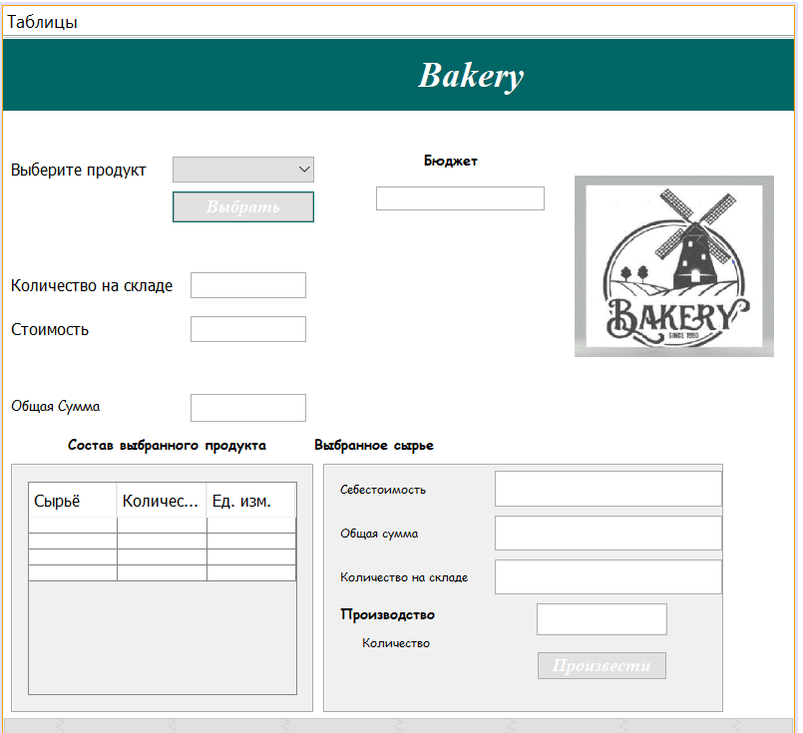

**Код:**

/*

package bakery;

import java.sql.*;

import java.util.Calendar;

import javax.swing.*;

import net.proteanit.sql.DbUtils;

import net.sf.jasperreports.engine.JasperCompileManager;

import net.sf.jasperreports.engine.JasperFillManager;

import net.sf.jasperreports.engine.JasperPrint;

import net.sf.jasperreports.engine.JasperReport;

import net.sf.jasperreports.engine.design.JRDesignQuery;

import net.sf.jasperreports.engine.design.JasperDesign;

import net.sf.jasperreports.engine.xml.JRXmlLoader;

import net.sf.jasperreports.view.JasperViewer;

/**

*

* @author Aidin

*/

public class Main111 extends javax.swing.JFrame {

Connection conn = null;

CallableStatement stored_pro = null;

Statement statement = null;

ResultSet rs = null;

/**

* Creates new form Main

*/

public Main111() {

initComponents();

}

/**

* This method is called from within the constructor to initialize the form.

* WARNING: Do NOT modify this code. The content of this method is always

* regenerated by the Form Editor.

*/

@SuppressWarnings("unchecked")

// <editor-fold defaultstate="collapsed" desc="Generated Code">

private void initComponents() {

bindingGroup = new org.jdesktop.beansbinding.BindingGroup();

jPanel1 = new javax.swing.JPanel();

jComboBox1 = new javax.swing.JComboBox<>();

jLabel2 = new javax.swing.JLabel();

jLabel3 = new javax.swing.JLabel();

jTextField1 = new javax.swing.JTextField();

jTextField2 = new javax.swing.JTextField();

jLabel4 = new javax.swing.JLabel();

jPanel4 = new javax.swing.JPanel();

jLabel7 = new javax.swing.JLabel();

jLabel8 = new javax.swing.JLabel();

jLabel9 = new javax.swing.JLabel();

jTextField3 = new javax.swing.JTextField();

jTextField4 = new javax.swing.JTextField();

jTextField5 = new javax.swing.JTextField();

jLabel14 = new javax.swing.JLabel();

jLabel15 = new javax.swing.JLabel();

jTextField9 = new javax.swing.JTextField();

jToggleButton1 = new javax.swing.JToggleButton();

jLabel6 = new javax.swing.JLabel();

jLabel5 = new javax.swing.JLabel();

jPanel3 = new javax.swing.JPanel();

jScrollPane1 = new javax.swing.JScrollPane();

jTable1 = new javax.swing.JTable();

jButton1 = new javax.swing.JButton();

jTextField8 = new javax.swing.JTextField();

jLabel20 = new javax.swing.JLabel();

jLabel21 = new javax.swing.JLabel();

jTextField10 = new javax.swing.JTextField();

jLabel16 = new javax.swing.JLabel();

jPanel2 = new javax.swing.JPanel();

jLabel1 = new javax.swing.JLabel();

jMenuBar1 = new javax.swing.JMenuBar();

jMenu1 = new javax.swing.JMenu();

jMenu4 = new javax.swing.JMenu();

jMenuItem3 = new javax.swing.JMenuItem();

setDefaultCloseOperation(javax.swing.WindowConstants.EXIT_ON_CLOSE);

setBackground(new java.awt.Color(0, 153, 153));

addWindowListener(new java.awt.event.WindowAdapter() {

public void windowOpened(java.awt.event.WindowEvent evt) {

formWindowOpened(evt);

}

});

jPanel1.setBackground(new java.awt.Color(255, 255, 255));

org.jdesktop.beansbinding.Binding binding = org.jdesktop.beansbinding.Bindings.createAutoBinding(org.jdesktop.beansbinding.AutoBinding.UpdateStrategy.READ_WRITE, jComboBox1, org.jdesktop.beansbinding.ObjectProperty.create(), jComboBox1, org.jdesktop.beansbinding.BeanProperty.create("selectedItem"));

bindingGroup.addBinding(binding);

jComboBox1.addActionListener(new java.awt.event.ActionListener() {

public void actionPerformed(java.awt.event.ActionEvent evt) {

jComboBox1ActionPerformed(evt);

}

});

jLabel2.setText("Выберите продукт");

jLabel3.setText("Количество на складе");

jLabel4.setText("Стоимость");

jPanel4.setBorder(javax.swing.BorderFactory.createEtchedBorder());

jLabel7.setFont(new java.awt.Font("Comic Sans MS", 0, 12)); // NOI18N

jLabel7.setText("Себестоимость");

jLabel8.setFont(new java.awt.Font("Comic Sans MS", 0, 12)); // NOI18N

jLabel8.setText("Количество на складе");

jLabel9.setFont(new java.awt.Font("Comic Sans MS", 0, 12)); // NOI18N

jLabel9.setText("Общая сумма");

jTextField3.setFont(new java.awt.Font("Comic Sans MS", 0, 12)); // NOI18N

jTextField4.setFont(new java.awt.Font("Comic Sans MS", 0, 12)); // NOI18N

jTextField5.setFont(new java.awt.Font("Comic Sans MS", 0, 12)); // NOI18N

jLabel14.setFont(new java.awt.Font("Comic Sans MS", 1, 14)); // NOI18N

jLabel14.setText("Производство");

jLabel15.setFont(new java.awt.Font("Comic Sans MS", 0, 12)); // NOI18N

jLabel15.setText("Количество");

jTextField9.setFont(new java.awt.Font("Comic Sans MS", 0, 12)); // NOI18N

jToggleButton1.setBackground(new java.awt.Color(0, 102, 102));

jToggleButton1.setFont(new java.awt.Font("Times New Roman", 3, 18)); // NOI18N

jToggleButton1.setForeground(new java.awt.Color(255, 255, 255));

jToggleButton1.setText("Произвести");

jToggleButton1.addActionListener(new java.awt.event.ActionListener() {

public void actionPerformed(java.awt.event.ActionEvent evt) {

jToggleButton1ActionPerformed(evt);

}

});

javax.swing.GroupLayout jPanel4Layout = new javax.swing.GroupLayout(jPanel4);

jPanel4.setLayout(jPanel4Layout);

jPanel4Layout.setHorizontalGroup(

jPanel4Layout.createParallelGroup(javax.swing.GroupLayout.Alignment.LEADING)

.addGroup(jPanel4Layout.createSequentialGroup()

.addContainerGap()

.addGroup(jPanel4Layout.createParallelGroup(javax.swing.GroupLayout.Alignment.LEADING)

.addGroup(jPanel4Layout.createSequentialGroup()

.addGroup(jPanel4Layout.createParallelGroup(javax.swing.GroupLayout.Alignment.LEADING)

.addComponent(jLabel9)

.addComponent(jLabel7)

.addComponent(jLabel8))

.addPreferredGap(javax.swing.LayoutStyle.ComponentPlacement.RELATED, 27, Short.MAX_VALUE)

.addGroup(jPanel4Layout.createParallelGroup(javax.swing.GroupLayout.Alignment.LEADING)

.addGroup(javax.swing.GroupLayout.Alignment.TRAILING, jPanel4Layout.createParallelGroup(javax.swing.GroupLayout.Alignment.TRAILING, false)

.addComponent(jTextField4, javax.swing.GroupLayout.DEFAULT_SIZE, 228, Short.MAX_VALUE)

.addComponent(jTextField5))

.addComponent(jTextField3, javax.swing.GroupLayout.Alignment.TRAILING, javax.swing.GroupLayout.PREFERRED_SIZE, 228, javax.swing.GroupLayout.PREFERRED_SIZE)))

.addGroup(jPanel4Layout.createSequentialGroup()

.addGroup(jPanel4Layout.createParallelGroup(javax.swing.GroupLayout.Alignment.LEADING)

.addComponent(jLabel14)

.addGroup(jPanel4Layout.createSequentialGroup()

.addGap(22, 22, 22)

.addComponent(jLabel15)))

.addPreferredGap(javax.swing.LayoutStyle.ComponentPlacement.RELATED, javax.swing.GroupLayout.DEFAULT_SIZE, Short.MAX_VALUE)

.addGroup(jPanel4Layout.createParallelGroup(javax.swing.GroupLayout.Alignment.LEADING, false)

.addComponent(jToggleButton1, javax.swing.GroupLayout.DEFAULT_SIZE, javax.swing.GroupLayout.DEFAULT_SIZE, Short.MAX_VALUE)

.addComponent(jTextField9, javax.swing.GroupLayout.PREFERRED_SIZE, 131, javax.swing.GroupLayout.PREFERRED_SIZE))

.addGap(55, 55, 55))))

);

jPanel4Layout.setVerticalGroup(

jPanel4Layout.createParallelGroup(javax.swing.GroupLayout.Alignment.LEADING)

.addGroup(jPanel4Layout.createSequentialGroup()

.addGap(5, 5, 5)

.addGroup(jPanel4Layout.createParallelGroup(javax.swing.GroupLayout.Alignment.BASELINE)

.addComponent(jTextField3, javax.swing.GroupLayout.PREFERRED_SIZE, 36, javax.swing.GroupLayout.PREFERRED_SIZE)

.addComponent(jLabel7))

.addPreferredGap(javax.swing.LayoutStyle.ComponentPlacement.RELATED)

.addGroup(jPanel4Layout.createParallelGroup(javax.swing.GroupLayout.Alignment.BASELINE)

.addComponent(jTextField4, javax.swing.GroupLayout.PREFERRED_SIZE, 35, javax.swing.GroupLayout.PREFERRED_SIZE)

.addComponent(jLabel9))

.addPreferredGap(javax.swing.LayoutStyle.ComponentPlacement.RELATED)

.addGroup(jPanel4Layout.createParallelGroup(javax.swing.GroupLayout.Alignment.BASELINE)

.addComponent(jTextField5, javax.swing.GroupLayout.PREFERRED_SIZE, 35, javax.swing.GroupLayout.PREFERRED_SIZE)

.addComponent(jLabel8))

.addPreferredGap(javax.swing.LayoutStyle.ComponentPlacement.RELATED)

.addGroup(jPanel4Layout.createParallelGroup(javax.swing.GroupLayout.Alignment.LEADING)

.addGroup(jPanel4Layout.createSequentialGroup()

.addComponent(jLabel14)

.addPreferredGap(javax.swing.LayoutStyle.ComponentPlacement.RELATED)

.addComponent(jLabel15))

.addGroup(jPanel4Layout.createSequentialGroup()

.addComponent(jTextField9, javax.swing.GroupLayout.PREFERRED_SIZE, 32, javax.swing.GroupLayout.PREFERRED_SIZE)

.addPreferredGap(javax.swing.LayoutStyle.ComponentPlacement.UNRELATED)

.addComponent(jToggleButton1, javax.swing.GroupLayout.PREFERRED_SIZE, 29, javax.swing.GroupLayout.PREFERRED_SIZE)))

.addContainerGap(31, Short.MAX_VALUE))

);

jLabel6.setFont(new java.awt.Font("Comic Sans MS", 1, 14)); // NOI18N

jLabel6.setText("Выбранное сырье");

jLabel5.setFont(new java.awt.Font("Comic Sans MS", 1, 14)); // NOI18N

jLabel5.setText("Состав выбранного продукта");

jPanel3.setBorder(javax.swing.BorderFactory.createEtchedBorder());

jTable1.setFont(new java.awt.Font("Comic Sans MS", 0, 12)); // NOI18N

jTable1.setModel(new javax.swing.table.DefaultTableModel(

new Object [][] {

{null, null, null},

{null, null, null},

{null, null, null},

{null, null, null}

},

new String [] {

"Сырьё", "Количество", "Ед. изм."

}

));

jTable1.addMouseListener(new java.awt.event.MouseAdapter() {

public void mouseClicked(java.awt.event.MouseEvent evt) {

jTable1MouseClicked(evt);

}

});

jScrollPane1.setViewportView(jTable1);

javax.swing.GroupLayout jPanel3Layout = new javax.swing.GroupLayout(jPanel3);

jPanel3.setLayout(jPanel3Layout);

jPanel3Layout.setHorizontalGroup(

jPanel3Layout.createParallelGroup(javax.swing.GroupLayout.Alignment.LEADING)

.addGroup(jPanel3Layout.createSequentialGroup()

.addContainerGap()

.addComponent(jScrollPane1, javax.swing.GroupLayout.DEFAULT_SIZE, 270, Short.MAX_VALUE)

.addContainerGap())

);

jPanel3Layout.setVerticalGroup(

jPanel3Layout.createParallelGroup(javax.swing.GroupLayout.Alignment.LEADING)

.addGroup(javax.swing.GroupLayout.Alignment.TRAILING, jPanel3Layout.createSequentialGroup()

.addContainerGap()

.addComponent(jScrollPane1, javax.swing.GroupLayout.PREFERRED_SIZE, 0, Short.MAX_VALUE)

.addContainerGap())

);

jButton1.setBackground(new java.awt.Color(0, 102, 102));

jButton1.setFont(new java.awt.Font("Times New Roman", 3, 18)); // NOI18N

jButton1.setForeground(new java.awt.Color(255, 255, 255));

jButton1.setText("Выбрать");

jButton1.addActionListener(new java.awt.event.ActionListener() {

public void actionPerformed(java.awt.event.ActionEvent evt) {

jButton1ActionPerformed(evt);

}

});

jTextField8.setFont(new java.awt.Font("Comic Sans MS", 0, 12)); // NOI18N

jTextField8.setToolTipText("");

jTextField8.addActionListener(new java.awt.event.ActionListener() {

public void actionPerformed(java.awt.event.ActionEvent evt) {

jTextField8ActionPerformed(evt);

}

});

jLabel20.setFont(new java.awt.Font("Comic Sans MS", 1, 14)); // NOI18N

jLabel20.setText("Бюджет");

jLabel21.setIcon(new javax.swing.ImageIcon(getClass().getResource("/bakery/Без.gif"))); // NOI18N

jTextField10.setFont(new java.awt.Font("Times New Roman", 0, 11)); // NOI18N

jLabel16.setFont(new java.awt.Font("Comic Sans MS", 0, 14)); // NOI18N

jLabel16.setText("Общая Сумма");

jPanel2.setBackground(new java.awt.Color(0, 102, 102));

jLabel1.setFont(new java.awt.Font("Times New Roman", 3, 36)); // NOI18N

jLabel1.setForeground(new java.awt.Color(255, 255, 255));

jLabel1.setText("Bakery");

javax.swing.GroupLayout jPanel2Layout = new javax.swing.GroupLayout(jPanel2);

jPanel2.setLayout(jPanel2Layout);

jPanel2Layout.setHorizontalGroup(

jPanel2Layout.createParallelGroup(javax.swing.GroupLayout.Alignment.LEADING)

.addGroup(jPanel2Layout.createSequentialGroup()

.addGap(416, 416, 416)

.addComponent(jLabel1, javax.swing.GroupLayout.PREFERRED_SIZE, 129, javax.swing.GroupLayout.PREFERRED_SIZE)

.addContainerGap(javax.swing.GroupLayout.DEFAULT_SIZE, Short.MAX_VALUE))

);

jPanel2Layout.setVerticalGroup(

jPanel2Layout.createParallelGroup(javax.swing.GroupLayout.Alignment.LEADING)

.addGroup(jPanel2Layout.createSequentialGroup()

.addContainerGap()

.addComponent(jLabel1, javax.swing.GroupLayout.PREFERRED_SIZE, 40, javax.swing.GroupLayout.PREFERRED_SIZE)

.addContainerGap(javax.swing.GroupLayout.DEFAULT_SIZE, Short.MAX_VALUE))

);

javax.swing.GroupLayout jPanel1Layout = new javax.swing.GroupLayout(jPanel1);

jPanel1.setLayout(jPanel1Layout);

jPanel1Layout.setHorizontalGroup(

jPanel1Layout.createParallelGroup(javax.swing.GroupLayout.Alignment.LEADING)

.addGroup(jPanel1Layout.createSequentialGroup()

.addGap(8, 8, 8)

.addGroup(jPanel1Layout.createParallelGroup(javax.swing.GroupLayout.Alignment.TRAILING)

.addGroup(javax.swing.GroupLayout.Alignment.LEADING, jPanel1Layout.createSequentialGroup()

.addComponent(jLabel2)

.addGap(26, 26, 26)

.addGroup(jPanel1Layout.createParallelGroup(javax.swing.GroupLayout.Alignment.LEADING)

.addComponent(jButton1, javax.swing.GroupLayout.DEFAULT_SIZE, javax.swing.GroupLayout.DEFAULT_SIZE, Short.MAX_VALUE)

.addComponent(jComboBox1, 0, javax.swing.GroupLayout.DEFAULT_SIZE, Short.MAX_VALUE)))

.addGroup(jPanel1Layout.createSequentialGroup()

.addGap(0, 0, Short.MAX_VALUE)

.addGroup(jPanel1Layout.createParallelGroup(javax.swing.GroupLayout.Alignment.TRAILING)

.addGroup(jPanel1Layout.createSequentialGroup()

.addComponent(jLabel5)

.addGap(48, 48, 48))

.addComponent(jPanel3, javax.swing.GroupLayout.PREFERRED_SIZE, javax.swing.GroupLayout.DEFAULT_SIZE, javax.swing.GroupLayout.PREFERRED_SIZE)))

.addGroup(javax.swing.GroupLayout.Alignment.LEADING, jPanel1Layout.createSequentialGroup()

.addGroup(jPanel1Layout.createParallelGroup(javax.swing.GroupLayout.Alignment.TRAILING, false)

.addGroup(javax.swing.GroupLayout.Alignment.LEADING, jPanel1Layout.createSequentialGroup()

.addGroup(jPanel1Layout.createParallelGroup(javax.swing.GroupLayout.Alignment.LEADING)

.addComponent(jLabel4)

.addComponent(jLabel16))

.addGap(91, 91, 91)

.addGroup(jPanel1Layout.createParallelGroup(javax.swing.GroupLayout.Alignment.LEADING)

.addComponent(jTextField2)

.addComponent(jTextField10)))

.addGroup(javax.swing.GroupLayout.Alignment.LEADING, jPanel1Layout.createSequentialGroup()

.addComponent(jLabel3)

.addGap(18, 18, 18)

.addComponent(jTextField1, javax.swing.GroupLayout.PREFERRED_SIZE, 116, javax.swing.GroupLayout.PREFERRED_SIZE)))

.addGap(0, 0, Short.MAX_VALUE)))

.addGroup(jPanel1Layout.createParallelGroup(javax.swing.GroupLayout.Alignment.LEADING)

.addGroup(jPanel1Layout.createSequentialGroup()

.addPreferredGap(javax.swing.LayoutStyle.ComponentPlacement.RELATED)

.addComponent(jPanel4, javax.swing.GroupLayout.PREFERRED_SIZE, javax.swing.GroupLayout.DEFAULT_SIZE, javax.swing.GroupLayout.PREFERRED_SIZE))

.addComponent(jLabel6)

.addGroup(jPanel1Layout.createSequentialGroup()

.addGroup(jPanel1Layout.createParallelGroup(javax.swing.GroupLayout.Alignment.LEADING)

.addGroup(jPanel1Layout.createSequentialGroup()

.addGap(62, 62, 62)

.addComponent(jTextField8, javax.swing.GroupLayout.PREFERRED_SIZE, 169, javax.swing.GroupLayout.PREFERRED_SIZE))

.addGroup(jPanel1Layout.createSequentialGroup()

.addGap(110, 110, 110)

.addComponent(jLabel20)))

.addGap(30, 30, 30)

.addComponent(jLabel21)))

.addContainerGap(20, Short.MAX_VALUE))

.addComponent(jPanel2, javax.swing.GroupLayout.DEFAULT_SIZE, javax.swing.GroupLayout.DEFAULT_SIZE, Short.MAX_VALUE)

);

jPanel1Layout.setVerticalGroup(

jPanel1Layout.createParallelGroup(javax.swing.GroupLayout.Alignment.LEADING)

.addGroup(jPanel1Layout.createSequentialGroup()

.addGap(1, 1, 1)

.addComponent(jPanel2, javax.swing.GroupLayout.PREFERRED_SIZE, javax.swing.GroupLayout.DEFAULT_SIZE, javax.swing.GroupLayout.PREFERRED_SIZE)

.addGroup(jPanel1Layout.createParallelGroup(javax.swing.GroupLayout.Alignment.LEADING)

.addGroup(jPanel1Layout.createSequentialGroup()

.addGap(39, 39, 39)

.addGroup(jPanel1Layout.createParallelGroup(javax.swing.GroupLayout.Alignment.LEADING)

.addGroup(jPanel1Layout.createSequentialGroup()

.addComponent(jLabel20)

.addPreferredGap(javax.swing.LayoutStyle.ComponentPlacement.UNRELATED)

.addComponent(jTextField8, javax.swing.GroupLayout.PREFERRED_SIZE, javax.swing.GroupLayout.DEFAULT_SIZE, javax.swing.GroupLayout.PREFERRED_SIZE))

.addGroup(jPanel1Layout.createSequentialGroup()

.addGap(7, 7, 7)

.addGroup(jPanel1Layout.createParallelGroup(javax.swing.GroupLayout.Alignment.BASELINE)

.addComponent(jComboBox1, javax.swing.GroupLayout.PREFERRED_SIZE, javax.swing.GroupLayout.DEFAULT_SIZE, javax.swing.GroupLayout.PREFERRED_SIZE)

.addComponent(jLabel2))

.addPreferredGap(javax.swing.LayoutStyle.ComponentPlacement.RELATED)

.addComponent(jButton1)))

.addGap(50, 50, 50)

.addGroup(jPanel1Layout.createParallelGroup(javax.swing.GroupLayout.Alignment.BASELINE)

.addComponent(jLabel3)

.addComponent(jTextField1, javax.swing.GroupLayout.PREFERRED_SIZE, javax.swing.GroupLayout.DEFAULT_SIZE, javax.swing.GroupLayout.PREFERRED_SIZE))

.addGap(18, 18, 18)

.addGroup(jPanel1Layout.createParallelGroup(javax.swing.GroupLayout.Alignment.BASELINE)

.addComponent(jLabel4)

.addComponent(jTextField2, javax.swing.GroupLayout.PREFERRED_SIZE, javax.swing.GroupLayout.DEFAULT_SIZE, javax.swing.GroupLayout.PREFERRED_SIZE))

.addGap(50, 50, 50))

.addGroup(javax.swing.GroupLayout.Alignment.TRAILING, jPanel1Layout.createSequentialGroup()

.addGap(1, 1, 1)

.addGroup(jPanel1Layout.createParallelGroup(javax.swing.GroupLayout.Alignment.TRAILING)

.addComponent(jLabel21, javax.swing.GroupLayout.PREFERRED_SIZE, 311, javax.swing.GroupLayout.PREFERRED_SIZE)

.addGroup(jPanel1Layout.createParallelGroup(javax.swing.GroupLayout.Alignment.BASELINE)

.addComponent(jLabel16)

.addComponent(jTextField10, javax.swing.GroupLayout.PREFERRED_SIZE, 28, javax.swing.GroupLayout.PREFERRED_SIZE)))

.addGap(12, 12, 12)))

.addGroup(jPanel1Layout.createParallelGroup(javax.swing.GroupLayout.Alignment.TRAILING)

.addGroup(jPanel1Layout.createSequentialGroup()

.addComponent(jLabel5)

.addPreferredGap(javax.swing.LayoutStyle.ComponentPlacement.RELATED)

.addComponent(jPanel3, javax.swing.GroupLayout.DEFAULT_SIZE, javax.swing.GroupLayout.DEFAULT_SIZE, Short.MAX_VALUE))

.addGroup(jPanel1Layout.createSequentialGroup()

.addComponent(jLabel6)

.addPreferredGap(javax.swing.LayoutStyle.ComponentPlacement.RELATED)

.addComponent(jPanel4, javax.swing.GroupLayout.DEFAULT_SIZE, javax.swing.GroupLayout.DEFAULT_SIZE, Short.MAX_VALUE)))

.addGap(5, 5, 5))

);

jMenu1.setText("Таблицы");

jMenu4.setText("Ингридиент");

jMenu4.addMouseListener(new java.awt.event.MouseAdapter() {

public void mouseClicked(java.awt.event.MouseEvent evt) {

jMenu4MouseClicked(evt);

}

});

jMenu1.add(jMenu4);

jMenuItem3.setText("Готовая продукция");

jMenuItem3.addActionListener(new java.awt.event.ActionListener() {

public void actionPerformed(java.awt.event.ActionEvent evt) {

jMenuItem3ActionPerformed(evt);

}

});

jMenu1.add(jMenuItem3);

jMenuBar1.add(jMenu1);

setJMenuBar(jMenuBar1);

javax.swing.GroupLayout layout = new javax.swing.GroupLayout(getContentPane());

getContentPane().setLayout(layout);

layout.setHorizontalGroup(

layout.createParallelGroup(javax.swing.GroupLayout.Alignment.LEADING)

.addGroup(layout.createSequentialGroup()

.addComponent(jPanel1, javax.swing.GroupLayout.PREFERRED_SIZE, javax.swing.GroupLayout.DEFAULT_SIZE, javax.swing.GroupLayout.PREFERRED_SIZE)

.addGap(0, 0, Short.MAX_VALUE))

);

layout.setVerticalGroup(

layout.createParallelGroup(javax.swing.GroupLayout.Alignment.LEADING)

.addGroup(layout.createSequentialGroup()

.addGap(1, 1, 1)

.addComponent(jPanel1, javax.swing.GroupLayout.PREFERRED_SIZE, javax.swing.GroupLayout.DEFAULT_SIZE, javax.swing.GroupLayout.PREFERRED_SIZE)

.addContainerGap(javax.swing.GroupLayout.DEFAULT_SIZE, Short.MAX_VALUE))

);

bindingGroup.bind();

pack();

}// </editor-fold>

private void jToggleButton1ActionPerformed(java.awt.event.ActionEvent evt) {

// TODO add your handling code here:

try{

Class.forName("com.microsoft.sqlserver.jdbc.SQLServerDriver");

String url="jdbc:sqlserver://localhost:1433;databaseName=bakery;user=aidin007;password=123";

Connection conn = DriverManager.getConnection(url);

Statement st=conn.createStatement();

String name=jComboBox1.getSelectedItem().toString();

int ID = 0;

ResultSet id = st.executeQuery("select ID from Products where Name_Products = '" + name + "'");

while(id.next()){

ID = Integer.parseInt(id.getString("ID"));

}

Calendar calendar = Calendar.getInstance();

java.sql.Date startDate = new java.sql.Date(calendar.getTime().getTime());

int amount=Integer.parseInt(jTextField9.getText());

//

String dobavlenie = "INSERT INTO Production (Product, Kol_Product, Date, Personnel) VALUES(?,?,?,?)";

PreparedStatement pst=conn.prepareStatement(dobavlenie);

pst.setInt(1, ID);

pst.setInt(2, amount);

pst.setDate(3, startDate);

pst.setInt(4, 2);

JOptionPane.showMessageDialog(null, "Произведено");

pst.executeUpdate();

String update = "SELECT Kol_fin_products,self_cost,Amount FROM Products WHERE ID ='" + ID + "'";

pst=conn.prepareStatement(update);

ResultSet res = pst.executeQuery();

statement = conn.createStatement();

res = statement.executeQuery(update);

while(res.next()){

jTextField1.setText(res.getString("Kol_fin_products"));

jTextField2.setText(res.getString("self_cost"));

jTextField10.setText(res.getString("Amount"));

}

String insert = "SELECT Kolichestvo_deneg_v_budgete FROM Budget";

pst=conn.prepareStatement(insert);

ResultSet ress = pst.executeQuery();

statement = conn.createStatement();

ress = statement.executeQuery(insert);

while(ress.next()){

jTextField8.setText(ress.getString("Kolichestvo_deneg_v_budgete"));

}

}

catch(Exception e){

JOptionPane.showMessageDialog(null, "'недостаточно сырья на складе '");

System.out.println("raiserror('недостаточно сырья на складе ',16,1)");

}

}

private void jTable1MouseClicked(java.awt.event.MouseEvent evt) {

// TODO add your handling code here:

try{

Class.forName("com.microsoft.sqlserver.jdbc.SQLServerDriver");

String url="jdbc:sqlserver://localhost:1433;databaseName=bakery;user=aidin007;password=123";

Connection con = DriverManager.getConnection(url);

int row = jTable1.getSelectedRow();

String name = (jTable1.getModel().getValueAt(row,1).toString());

String sql = "SELECT Self_cost, Amount, Kol_Syrya FROM RawMaterials WHERE Naimenovaniye_Syrya ='" + name + "'";

PreparedStatement pst=con.prepareStatement(sql);

ResultSet rs = pst.executeQuery();

statement = con.createStatement();

rs = statement.executeQuery(sql);

while(rs.next()){

jTextField3.setText(rs.getString("Self_cost"));

jTextField4.setText(rs.getString("Amount"));

jTextField5.setText(rs.getString("Kol_Syrya"));

}

}

catch(Exception e){

System.out.println("Error");

}

}

private void jButton1ActionPerformed(java.awt.event.ActionEvent evt) {

// TODO add your handling code here:

try{

jTextField3.setText("");

jTextField4.setText("");

jTextField5.setText("");

jTextField9.setText("");

// jTextField10.setText("");

Class.forName("com.microsoft.sqlserver.jdbc.SQLServerDriver");

String url="jdbc:sqlserver://localhost:1433;databaseName=bakery;user=aidin007;password=123";

Connection con = DriverManager.getConnection(url);

Statement st=con.createStatement();

String test=jComboBox1.getSelectedItem().toString();

ResultSet amount = st.executeQuery("select Kol_fin_products from Products where Name_Products = '" + test + "'");

while(amount.next()){

jTextField1.setText(amount.getString("Kol_fin_products"));

}

ResultSet sum = st.executeQuery("select self_cost from Products where Name_Products = '" + test + "'");

while(sum.next()){

jTextField2.setText(sum.getString("self_cost"));

}

ResultSet summ = st.executeQuery("select Amount from Products where Name_Products = '" + test + "'");

while(summ.next()){

jTextField10.setText(summ.getString("Amount"));

}

////

String insert = "SELECT Kolichestvo_deneg_v_budgete FROM Budget";

PreparedStatement pst = conn.prepareStatement(insert);

ResultSet ress = pst.executeQuery();

statement = conn.createStatement();

ress = statement.executeQuery(insert);

while(ress.next()){

jTextField8.setText(ress.getString("Kolichestvo_deneg_v_budgete"));

}

////

int ID=0;

ResultSet id = st.executeQuery("select ID from Products where Name_Products = '" + test + "'");

while(id.next()){

ID=Integer.parseInt(id.getString("ID"));

}

String sql = "SELECT RawMaterials.ID, RawMaterials.Naimenovaniye_Syrya,Ingridients.Kol_Syrya_prod,Units.Unit\n" +

// String sql = "SELECT RawMaterials.Naimenovaniye_Syrya, RawMaterials.Amount,\n" +

//"RawMaterials.Kol_Syrya, Units.Unit, Units.Description, Ingridients.Kol_Syrya_prod AS\n" +

//"MaterialNeed\n" +

"from Products inner join\n" +

"Ingridients on Products.ID=Ingridients.Product INNER JOIN\n" +

" RawMaterials ON Ingridients.RawMaterials = RawMaterials.ID\n" +

" inner Join\n" +

" Units ON RawMaterials.Unit = Units.ID\n" +

"WHERE Products.ID ='" + ID + "'";

statement = con.createStatement();

rs = statement.executeQuery(sql);

this.jTable1.setModel(DbUtils.resultSetToTableModel(rs));

jTable1.getColumnModel().getColumn(0).setHeaderValue("ID");

jTable1.getColumnModel().getColumn(1).setHeaderValue("Сырьё");

jTable1.getColumnModel().getColumn(2).setHeaderValue("Количество");

jTable1.getColumnModel().getColumn(3).setHeaderValue("Ед. изм.");

con.close();

}

catch(Exception e){

e.printStackTrace();

JOptionPane.showMessageDialog(null, e);

}

}

private void jTextField8ActionPerformed(java.awt.event.ActionEvent evt) {

// TODO add your handling code here:

}

private void jComboBox1ActionPerformed(java.awt.event.ActionEvent evt) {

// TODO add your handling code here:

}

private void formWindowOpened(java.awt.event.WindowEvent evt) {

// TODO add your handling code here:

Fillcombo();

}

private void jMenu4MouseClicked(java.awt.event.MouseEvent evt) {

// TODO add your handling code here:

ingredients field= new ingredients();

field.setVisible(true);

setVisible(false);

}

private void showMeAllReportsell(){

try{

conn = ConnectMsSql.ConnectDB();

JasperDesign jasperDesign = JRXmlLoader.load("C:\\Users\\Aidin\\Documents\\3 курс\\Осенний семестр\\Клиент сервер\\MsSqlConnection\\src\\bakery\\repSell.jrxml");

String sql = "SELECT\n" +

" ProductSales.\"ID\" AS ProductSales_ID,\n" +

" ProductSales.\"Kol_Prod_Sell\" AS ProductSales_Kol_Prod_Sell,\n" +

" ProductSales.\"Summa_Prod_Sell\" AS ProductSales_Summa_Prod_Sell,\n" +

" ProductSales.\"Date_Sell_Prod\" AS ProductSales_Date_Sell_Prod,\n" +

" Products.\"Name_Products\" AS Products_Name_Products,\n" +

" Employees.\"Name\" AS Employees_Name\n" +

"FROM\n" +

" \"dbo\".\"Products\" Products INNER JOIN \"dbo\".\"ProductSales\" ProductSales ON Products.\"ID\" = ProductSales.\"Product\"\n" +

" INNER JOIN \"dbo\".\"Employees\" Employees ON ProductSales.\"Person_Sell\" = Employees.\"ID\"";

//String sql ="SELECT [id],[name],[surname],[address],[email],[birth_date] FROM [student_info]";

JRDesignQuery newQuery = new JRDesignQuery();

newQuery.setText(sql);

jasperDesign.setQuery(newQuery);

JasperReport jasperReport = JasperCompileManager.compileReport(jasperDesign);

JasperPrint jasperPrint = JasperFillManager.fillReport(jasperReport, null, conn);

JasperViewer.viewReport(jasperPrint,false);

}

catch(Exception e){

e.printStackTrace();

}

}

private void showMeAllReportprod(){

try{

conn = ConnectMsSql.ConnectDB();

JasperDesign jasperDesign = JRXmlLoader.load("C:\\Users\\Aidin\\Documents\\3 курс\\осений семестр\\Клиент сервер\\MsSqlConnection\\src\\bakery\\report4.jrxml");

String sql = "SELECT\n" +

" PurchaseMaterials.\"ID\" AS PurchaseMaterials_ID,\n" +

" PurchaseMaterials.\"Kol_syrya_zakupke\" AS PurchaseMaterials_Kol_syrya_zakupke,\n" +

" PurchaseMaterials.\"Summa_zak_syrya\" AS PurchaseMaterials_Summa_zak_syrya,\n" +

" PurchaseMaterials.\"Date_zak_syrya\" AS PurchaseMaterials_Date_zak_syrya,\n" +

" RawMaterials.\"Naimenovaniye_Syrya\" AS RawMaterials_Naimenovaniye_Syrya,\n" +

" Employees.\"Name\" AS Employees_Name\n" +

"FROM\n" +

" \"dbo\".\"RawMaterials\" RawMaterials INNER JOIN \"dbo\".\"PurchaseMaterials\" PurchaseMaterials ON RawMaterials.\"ID\" = PurchaseMaterials.\"RawMaterial\"\n" +

" INNER JOIN \"dbo\".\"Employees\" Employees ON PurchaseMaterials.\"Pers_zak_syrya\" = Employees.\"ID\"";

//String sql ="SELECT [id],[name],[surname],[address],[email],[birth_date] FROM [student_info]";

JRDesignQuery newQuery = new JRDesignQuery();

newQuery.setText(sql);

jasperDesign.setQuery(newQuery);

JasperReport jasperReport = JasperCompileManager.compileReport(jasperDesign);

JasperPrint jasperPrint = JasperFillManager.fillReport(jasperReport, null, conn);

JasperViewer.viewReport(jasperPrint,false);

}

catch(Exception e){

e.printStackTrace();

}

}

private void showMeAllReportpruch(){

try{

conn = ConnectMsSql.ConnectDB();

JasperDesign jasperDesign = JRXmlLoader.load("C:\\Users\\Aidin\\Documents\\3 курс\\Осенний семестр\\Клиент сервер\\MsSqlConnection\\src\\bakery\\report4.jrxml");

String sql = "SELECT\n" +

" Production.\"ID\" AS Production_ID,\n" +

" Production.\"Kol_Product\" AS Production_Kol_Product,\n" +

" Production.\"Date\" AS Production_Date,\n" +

" Products.\"Name_Products\" AS Products_Name_Products,\n" +

" Employees.\"Name\" AS Employees_Name\n" +

"FROM\n" +

" \"dbo\".\"Products\" Products INNER JOIN \"dbo\".\"Production\" Production ON Products.\"ID\" = Production.\"Product\"\n" +

" INNER JOIN \"dbo\".\"Employees\" Employees ON Production.\"Personnel\" = Employees.\"ID\"";

//String sql ="SELECT [id],[name],[surname],[address],[email],[birth_date] FROM [student_info]";

JRDesignQuery newQuery = new JRDesignQuery();

newQuery.setText(sql);

jasperDesign.setQuery(newQuery);

JasperReport jasperReport = JasperCompileManager.compileReport(jasperDesign);

JasperPrint jasperPrint = JasperFillManager.fillReport(jasperReport, null, conn);

JasperViewer.viewReport(jasperPrint,false);

}

catch(Exception e){

e.printStackTrace();

}

}

private void jMenuItem3ActionPerformed(java.awt.event.ActionEvent evt) {

// TODO add your handling code here:

rawMaterial1 field= new rawMaterial1();

field.setVisible(true);

setVisible(false);

}

private void Fillcombo(){

try{

conn=ConnectMsSql.ConnectDB();

String sql="select Name_Products from Products";

statement = conn.createStatement();

rs = statement.executeQuery(sql);

while(rs.next()){

String nme=rs.getString("Name_Products");

this.jComboBox1.addItem(nme);

}

}

catch(Exception e){

JOptionPane.showMessageDialog(null, "Ошибка, что то пошло не так c rjv :(");

}

}

/**

* @param args the command line arguments

*/

public static void main(String args[]) {

/* Set the Nimbus look and feel */

//<editor-fold defaultstate="collapsed" desc=" Look and feel setting code (optional) ">

/* If Nimbus (introduced in Java SE 6) is not available, stay with the default look and feel.

* For details see http://download.oracle.com/javase/tutorial/uiswing/lookandfeel/plaf.html

*/

try {

for (javax.swing.UIManager.LookAndFeelInfo info : javax.swing.UIManager.getInstalledLookAndFeels()) {

if ("Nimbus".equals(info.getName())) {

javax.swing.UIManager.setLookAndFeel(info.getClassName());

break;

}

}

} catch (ClassNotFoundException ex) {

java.util.logging.Logger.getLogger(Main111.class.getName()).log(java.util.logging.Level.SEVERE, null, ex);

} catch (InstantiationException ex) {

java.util.logging.Logger.getLogger(Main111.class.getName()).log(java.util.logging.Level.SEVERE, null, ex);

} catch (IllegalAccessException ex) {

java.util.logging.Logger.getLogger(Main111.class.getName()).log(java.util.logging.Level.SEVERE, null, ex);

} catch (javax.swing.UnsupportedLookAndFeelException ex) {

java.util.logging.Logger.getLogger(Main111.class.getName()).log(java.util.logging.Level.SEVERE, null, ex);

}

//</editor-fold>

//</editor-fold>

//</editor-fold>

//</editor-fold>

/* Create and display the form */

java.awt.EventQueue.invokeLater(new Runnable() {

public void run() {

new Main111().setVisible(true);

}

});

}

* Форма **ingredients.java**

Для редактирования данных в табилце **ингредиенты продукции.**

.

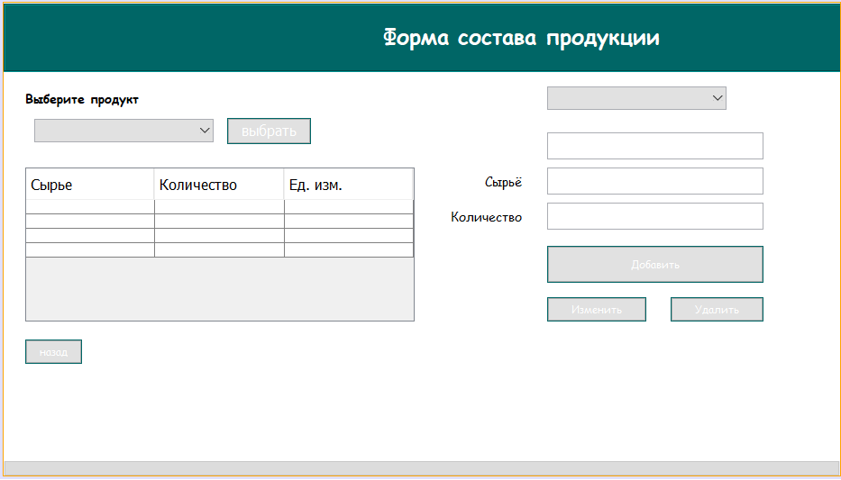

**Код:**

/*

/*

* To change this license header, choose License Headers in Project Properties.

* To change this template file, choose Tools | Templates

* and open the template in the editor.

*/

package bakery;

import java.sql.*;

import java.util.Calendar;

import javax.swing.*;

import javax.swing.table.TableModel;

import net.proteanit.sql.DbUtils;

/**

*

* @author aidin

*/

public class ingredients extends javax.swing.JFrame {

Connection conn = null;

CallableStatement stored_pro = null;

Statement statement = null;

ResultSet rs = null;

/**

* Creates new form measure

*/

public ingredients() {

initComponents();

}

/**

* This method is called from within the constructor to initialize the form.

* WARNING: Do NOT modify this code. The content of this method is always

* regenerated by the Form Editor.

*/

@SuppressWarnings("unchecked")

// <editor-fold defaultstate="collapsed" desc="Generated Code">

private void initComponents() {

jLabel2 = new javax.swing.JLabel();

jPanel1 = new javax.swing.JPanel();

jScrollPane1 = new javax.swing.JScrollPane();

jTable1 = new javax.swing.JTable();

MeasureInsertButton = new javax.swing.JButton();

MeasureUpdateButton = new javax.swing.JButton();

MeasureDeleteButton = new javax.swing.JButton();

IDTxt = new javax.swing.JTextField();

jLabel1 = new javax.swing.JLabel();

back = new javax.swing.JButton();

jPanel2 = new javax.swing.JPanel();

jLabel3 = new javax.swing.JLabel();

AmountTxt = new javax.swing.JTextField();

jLabel7 = new javax.swing.JLabel();

jLabel5 = new javax.swing.JLabel();

jComboBox1 = new javax.swing.JComboBox<>();

jButton3 = new javax.swing.JButton();

jComboBox2 = new javax.swing.JComboBox<>();

IDTxt1 = new javax.swing.JTextField();

jLabel2.setText("jLabel2");

setDefaultCloseOperation(javax.swing.WindowConstants.EXIT_ON_CLOSE);

addWindowListener(new java.awt.event.WindowAdapter() {

public void windowActivated(java.awt.event.WindowEvent evt) {

formWindowActivated(evt);

}

public void windowClosing(java.awt.event.WindowEvent evt) {

formWindowClosing(evt);

}

});

jPanel1.setBackground(new java.awt.Color(255, 255, 255));

jTable1.setFont(new java.awt.Font("Comic Sans MS", 0, 14)); // NOI18N

jTable1.setModel(new javax.swing.table.DefaultTableModel(

new Object [][] {

{null, null, null},

{null, null, null},

{null, null, null},

{null, null, null}

},

new String [] {

"Сырье", "Количество", "Ед. изм."

}

));

jTable1.addMouseListener(new java.awt.event.MouseAdapter() {

public void mouseClicked(java.awt.event.MouseEvent evt) {

jTable1MouseClicked(evt);

}

});

jScrollPane1.setViewportView(jTable1);

MeasureInsertButton.setBackground(new java.awt.Color(0, 102, 102));

MeasureInsertButton.setFont(new java.awt.Font("Comic Sans MS", 0, 12)); // NOI18N

MeasureInsertButton.setForeground(new java.awt.Color(255, 255, 255));

MeasureInsertButton.setText("Добавить");

MeasureInsertButton.addActionListener(new java.awt.event.ActionListener() {

public void actionPerformed(java.awt.event.ActionEvent evt) {

MeasureInsertButtonActionPerformed(evt);

}

});

MeasureUpdateButton.setBackground(new java.awt.Color(0, 102, 102));

MeasureUpdateButton.setFont(new java.awt.Font("Comic Sans MS", 0, 12)); // NOI18N

MeasureUpdateButton.setForeground(new java.awt.Color(255, 255, 255));

MeasureUpdateButton.setText("Изменить");

MeasureUpdateButton.addActionListener(new java.awt.event.ActionListener() {

public void actionPerformed(java.awt.event.ActionEvent evt) {

MeasureUpdateButtonActionPerformed(evt);

}

});

MeasureDeleteButton.setBackground(new java.awt.Color(0, 102, 102));

MeasureDeleteButton.setFont(new java.awt.Font("Comic Sans MS", 0, 12)); // NOI18N

MeasureDeleteButton.setForeground(new java.awt.Color(255, 255, 255));

MeasureDeleteButton.setText("Удалить");

MeasureDeleteButton.addActionListener(new java.awt.event.ActionListener() {

public void actionPerformed(java.awt.event.ActionEvent evt) {

MeasureDeleteButtonActionPerformed(evt);

}

});

jLabel1.setFont(new java.awt.Font("Comic Sans MS", 0, 14)); // NOI18N

jLabel1.setText("Сырьё");

back.setBackground(new java.awt.Color(0, 102, 102));

back.setFont(new java.awt.Font("Comic Sans MS", 0, 12)); // NOI18N

back.setForeground(new java.awt.Color(255, 255, 255));

back.setText("назад");

back.addActionListener(new java.awt.event.ActionListener() {

public void actionPerformed(java.awt.event.ActionEvent evt) {

backActionPerformed(evt);

}

});

jPanel2.setBackground(new java.awt.Color(0, 102, 102));

jPanel2.setBorder(javax.swing.BorderFactory.createEtchedBorder());

jPanel2.setForeground(new java.awt.Color(255, 255, 255));

jLabel3.setFont(new java.awt.Font("Comic Sans MS", 1, 24)); // NOI18N

jLabel3.setForeground(new java.awt.Color(255, 255, 255));

jLabel3.setText("Форма состава продукции");

javax.swing.GroupLayout jPanel2Layout = new javax.swing.GroupLayout(jPanel2);

jPanel2.setLayout(jPanel2Layout);

jPanel2Layout.setHorizontalGroup(

jPanel2Layout.createParallelGroup(javax.swing.GroupLayout.Alignment.LEADING)

.addGroup(javax.swing.GroupLayout.Alignment.TRAILING, jPanel2Layout.createSequentialGroup()

.addContainerGap(javax.swing.GroupLayout.DEFAULT_SIZE, Short.MAX_VALUE)

.addComponent(jLabel3)

.addGap(378, 378, 378))

);

jPanel2Layout.setVerticalGroup(

jPanel2Layout.createParallelGroup(javax.swing.GroupLayout.Alignment.LEADING)

.addGroup(jPanel2Layout.createSequentialGroup()

.addContainerGap()

.addComponent(jLabel3)

.addContainerGap(22, Short.MAX_VALUE))

);

AmountTxt.setToolTipText("");

jLabel7.setFont(new java.awt.Font("Comic Sans MS", 0, 14)); // NOI18N

jLabel7.setText("Количество");

jLabel5.setFont(new java.awt.Font("Comic Sans MS", 1, 14)); // NOI18N

jLabel5.setText("Выберите продукт");

jComboBox1.addMouseListener(new java.awt.event.MouseAdapter() {

public void mouseClicked(java.awt.event.MouseEvent evt) {

jComboBox1MouseClicked(evt);

}

});

jButton3.setBackground(new java.awt.Color(0, 102, 102));

jButton3.setForeground(new java.awt.Color(255, 255, 255));

jButton3.setText("выбрать");

jButton3.addActionListener(new java.awt.event.ActionListener() {

public void actionPerformed(java.awt.event.ActionEvent evt) {

jButton3ActionPerformed(evt);

}

});

jComboBox2.addPopupMenuListener(new javax.swing.event.PopupMenuListener() {

public void popupMenuCanceled(javax.swing.event.PopupMenuEvent evt) {

}

public void popupMenuWillBecomeInvisible(javax.swing.event.PopupMenuEvent evt) {

jComboBox2PopupMenuWillBecomeInvisible(evt);

}

public void popupMenuWillBecomeVisible(javax.swing.event.PopupMenuEvent evt) {

}

});

jComboBox2.addMouseListener(new java.awt.event.MouseAdapter() {

public void mouseClicked(java.awt.event.MouseEvent evt) {

jComboBox2MouseClicked(evt);

}

});

javax.swing.GroupLayout jPanel1Layout = new javax.swing.GroupLayout(jPanel1);

jPanel1.setLayout(jPanel1Layout);

jPanel1Layout.setHorizontalGroup(

jPanel1Layout.createParallelGroup(javax.swing.GroupLayout.Alignment.LEADING)

.addGroup(jPanel1Layout.createSequentialGroup()

.addGap(24, 24, 24)

.addGroup(jPanel1Layout.createParallelGroup(javax.swing.GroupLayout.Alignment.LEADING)

.addGroup(jPanel1Layout.createSequentialGroup()

.addGroup(jPanel1Layout.createParallelGroup(javax.swing.GroupLayout.Alignment.LEADING)

.addGroup(jPanel1Layout.createSequentialGroup()

.addGap(10, 10, 10)

.addComponent(jComboBox1, javax.swing.GroupLayout.PREFERRED_SIZE, 199, javax.swing.GroupLayout.PREFERRED_SIZE)

.addPreferredGap(javax.swing.LayoutStyle.ComponentPlacement.UNRELATED)

.addComponent(jButton3))

.addComponent(jScrollPane1, javax.swing.GroupLayout.PREFERRED_SIZE, 432, javax.swing.GroupLayout.PREFERRED_SIZE))

.addGroup(jPanel1Layout.createParallelGroup(javax.swing.GroupLayout.Alignment.LEADING)

.addGroup(jPanel1Layout.createSequentialGroup()

.addPreferredGap(javax.swing.LayoutStyle.ComponentPlacement.RELATED, javax.swing.GroupLayout.DEFAULT_SIZE, Short.MAX_VALUE)

.addGroup(jPanel1Layout.createParallelGroup(javax.swing.GroupLayout.Alignment.TRAILING)

.addComponent(jLabel1)

.addComponent(jLabel7))

.addGap(28, 28, 28)

.addGroup(jPanel1Layout.createParallelGroup(javax.swing.GroupLayout.Alignment.LEADING)

.addGroup(jPanel1Layout.createParallelGroup(javax.swing.GroupLayout.Alignment.LEADING, false)

.addComponent(AmountTxt, javax.swing.GroupLayout.PREFERRED_SIZE, 240, javax.swing.GroupLayout.PREFERRED_SIZE)

.addComponent(MeasureInsertButton, javax.swing.GroupLayout.PREFERRED_SIZE, 240, javax.swing.GroupLayout.PREFERRED_SIZE)

.addGroup(jPanel1Layout.createSequentialGroup()

.addComponent(MeasureUpdateButton, javax.swing.GroupLayout.PREFERRED_SIZE, 110, javax.swing.GroupLayout.PREFERRED_SIZE)

.addPreferredGap(javax.swing.LayoutStyle.ComponentPlacement.RELATED, javax.swing.GroupLayout.DEFAULT_SIZE, Short.MAX_VALUE)

.addComponent(MeasureDeleteButton, javax.swing.GroupLayout.PREFERRED_SIZE, 103, javax.swing.GroupLayout.PREFERRED_SIZE)))

.addComponent(IDTxt1, javax.swing.GroupLayout.PREFERRED_SIZE, 240, javax.swing.GroupLayout.PREFERRED_SIZE))

.addGap(265, 265, 265))

.addGroup(jPanel1Layout.createSequentialGroup()

.addGap(147, 147, 147)

.addComponent(IDTxt, javax.swing.GroupLayout.PREFERRED_SIZE, 240, javax.swing.GroupLayout.PREFERRED_SIZE)

.addContainerGap(javax.swing.GroupLayout.DEFAULT_SIZE, Short.MAX_VALUE))))

.addGroup(javax.swing.GroupLayout.Alignment.TRAILING, jPanel1Layout.createSequentialGroup()

.addGap(0, 0, Short.MAX_VALUE)

.addComponent(back)

.addGap(1021, 1021, 1021))

.addGroup(jPanel1Layout.createSequentialGroup()

.addComponent(jLabel5)

.addPreferredGap(javax.swing.LayoutStyle.ComponentPlacement.RELATED, javax.swing.GroupLayout.DEFAULT_SIZE, Short.MAX_VALUE)

.addComponent(jComboBox2, javax.swing.GroupLayout.PREFERRED_SIZE, 199, javax.swing.GroupLayout.PREFERRED_SIZE)

.addGap(306, 306, 306))))

.addComponent(jPanel2, javax.swing.GroupLayout.DEFAULT_SIZE, javax.swing.GroupLayout.DEFAULT_SIZE, Short.MAX_VALUE)

);

jPanel1Layout.setVerticalGroup(

jPanel1Layout.createParallelGroup(javax.swing.GroupLayout.Alignment.LEADING)

.addGroup(javax.swing.GroupLayout.Alignment.TRAILING, jPanel1Layout.createSequentialGroup()

.addGap(1, 1, 1)

.addComponent(jPanel2, javax.swing.GroupLayout.PREFERRED_SIZE, javax.swing.GroupLayout.DEFAULT_SIZE, javax.swing.GroupLayout.PREFERRED_SIZE)

.addPreferredGap(javax.swing.LayoutStyle.ComponentPlacement.UNRELATED)

.addGroup(jPanel1Layout.createParallelGroup(javax.swing.GroupLayout.Alignment.BASELINE)

.addComponent(jLabel5)

.addComponent(jComboBox2, javax.swing.GroupLayout.PREFERRED_SIZE, javax.swing.GroupLayout.DEFAULT_SIZE, javax.swing.GroupLayout.PREFERRED_SIZE))

.addGroup(jPanel1Layout.createParallelGroup(javax.swing.GroupLayout.Alignment.LEADING)

.addGroup(jPanel1Layout.createSequentialGroup()

.addPreferredGap(javax.swing.LayoutStyle.ComponentPlacement.RELATED)

.addGroup(jPanel1Layout.createParallelGroup(javax.swing.GroupLayout.Alignment.BASELINE)

.addComponent(jComboBox1, javax.swing.GroupLayout.PREFERRED_SIZE, javax.swing.GroupLayout.DEFAULT_SIZE, javax.swing.GroupLayout.PREFERRED_SIZE)

.addComponent(jButton3)))

.addGroup(jPanel1Layout.createSequentialGroup()

.addGap(25, 25, 25)

.addComponent(IDTxt, javax.swing.GroupLayout.PREFERRED_SIZE, 30, javax.swing.GroupLayout.PREFERRED_SIZE)))

.addPreferredGap(javax.swing.LayoutStyle.ComponentPlacement.RELATED)

.addGroup(jPanel1Layout.createParallelGroup(javax.swing.GroupLayout.Alignment.LEADING, false)

.addGroup(jPanel1Layout.createSequentialGroup()

.addGroup(jPanel1Layout.createParallelGroup(javax.swing.GroupLayout.Alignment.BASELINE)

.addComponent(jLabel1)

.addComponent(IDTxt1, javax.swing.GroupLayout.PREFERRED_SIZE, 30, javax.swing.GroupLayout.PREFERRED_SIZE))

.addGap(9, 9, 9)

.addGroup(jPanel1Layout.createParallelGroup(javax.swing.GroupLayout.Alignment.BASELINE)

.addComponent(jLabel7)

.addComponent(AmountTxt, javax.swing.GroupLayout.PREFERRED_SIZE, 30, javax.swing.GroupLayout.PREFERRED_SIZE))

.addGap(18, 18, 18)

.addComponent(MeasureInsertButton, javax.swing.GroupLayout.DEFAULT_SIZE, javax.swing.GroupLayout.DEFAULT_SIZE, Short.MAX_VALUE)

.addPreferredGap(javax.swing.LayoutStyle.ComponentPlacement.UNRELATED)

.addGroup(jPanel1Layout.createParallelGroup(javax.swing.GroupLayout.Alignment.BASELINE)

.addComponent(MeasureUpdateButton)

.addComponent(MeasureDeleteButton)))

.addComponent(jScrollPane1, javax.swing.GroupLayout.PREFERRED_SIZE, 171, javax.swing.GroupLayout.PREFERRED_SIZE))

.addGap(20, 20, 20)

.addComponent(back)

.addContainerGap(108, Short.MAX_VALUE))

);

javax.swing.GroupLayout layout = new javax.swing.GroupLayout(getContentPane());

getContentPane().setLayout(layout);

layout.setHorizontalGroup(

layout.createParallelGroup(javax.swing.GroupLayout.Alignment.LEADING)

.addComponent(jPanel1, javax.swing.GroupLayout.PREFERRED_SIZE, 928, Short.MAX_VALUE)

);

layout.setVerticalGroup(

layout.createParallelGroup(javax.swing.GroupLayout.Alignment.LEADING)

.addGroup(layout.createSequentialGroup()

.addComponent(jPanel1, javax.swing.GroupLayout.DEFAULT_SIZE, javax.swing.GroupLayout.DEFAULT_SIZE, Short.MAX_VALUE)

.addContainerGap())

);

pack();

}// </editor-fold>

private void formWindowActivated(java.awt.event.WindowEvent evt) {

// TODO add your handling code here:

Fillcombo();

try {

conn = ConnectMsSql.ConnectDB();

Statement st = conn.createStatement();

ResultSet rs = st.executeQuery("select Name_Products from Products");

while (rs.next()) {

String name = rs.getString("Name_Products");

jComboBox1.addItem(name);

}

String test = jComboBox1.getSelectedItem().toString();

int ID = 0;

ResultSet id = st.executeQuery("select ID from Products where Name_Products = '" + test + "'");

while (id.next()) {

ID = Integer.parseInt(id.getString("ID"));

}

String sql = "SELECT Ingridients.ID, RawMaterials.Naimenovaniye_Syrya,Ingridients.Kol_Syrya_prod,Units.Unit FROM Ingridients INNER JOIN RawMaterials ON Ingridients.RawMaterials = RawMaterials.ID INNER JOIN Units ON RawMaterials.Unit = Units.ID WHERE Ingridients.Product ='" + ID + "'";

statement = conn.createStatement();

rs = statement.executeQuery(sql);

this.jTable1.setModel(DbUtils.resultSetToTableModel(rs));

jTable1.getColumnModel().getColumn(0).setHeaderValue("ID");

jTable1.getColumnModel().getColumn(1).setHeaderValue("Сырьё");

jTable1.getColumnModel().getColumn(2).setHeaderValue("Количество");

jTable1.getColumnModel().getColumn(3).setHeaderValue("Ед. изм.");

conn.close();

} catch (Exception e) {

JOptionPane.showMessageDialog(null, e);

}

}

private void jComboBox1MouseClicked(java.awt.event.MouseEvent evt) {

// TODO add your handling code here:

}

private void backActionPerformed(java.awt.event.ActionEvent evt) {

// TODO add your handling code here:

Main111 field = new Main111();

field.setVisible(true);

setVisible(false);

}

private void MeasureDeleteButtonActionPerformed(java.awt.event.ActionEvent evt) {

// TODO add your handling code here:

try {

conn = ConnectMsSql.ConnectDB();

Statement st = conn.createStatement();

// String name = IDTxt.getText();

// int idMaterial = 0;

// ResultSet id = st.executeQuery("select ID from Ingridients where ID = '" + name + "'");

// while (id.next()) {

// idMaterial = id.getInt("ID");

// }

int idMaterial = Integer.parseInt(IDTxt.getText());

JFrame frame = new JFrame("Sure");

if (JOptionPane.showConfirmDialog(frame, "Вы действительно хотите удалить данные?",

"Удаление данных", JOptionPane.YES_NO_OPTION) == JOptionPane.YES_NO_OPTION) {

stored_pro = conn.prepareCall("{call delete_date_about_Ingridients(?)}");

stored_pro.setInt(1, idMaterial);

stored_pro.execute();

JOptionPane.showMessageDialog(null, "Данные успешно удалены.");

IDTxt.setText("");

IDTxt1.setText("");

AmountTxt.setText("");

}

} catch (Exception e) {

JOptionPane.showMessageDialog(null, "Ошибка, что то пошло не так");

}

}

private void MeasureUpdateButtonActionPerformed(java.awt.event.ActionEvent evt) {

// TODO add your handling code here:

try {

int row = jTable1.getSelectedRow();

String name = (jTable1.getModel().getValueAt(row,1).toString());

conn = ConnectMsSql.ConnectDB();

Statement st = conn.createStatement();

String test = jComboBox1.getSelectedItem().toString();

// String name = IDTxt.getText();

int idProduct = 0;

ResultSet id = st.executeQuery("select ID from Products where Name_Products = '" + test + "'");

while (id.next()) {

idProduct = Integer.parseInt(id.getString("ID"));

}

int idMaterial = 0;

ResultSet id1 = st.executeQuery("select ID from RawMaterials where Naimenovaniye_Syrya = '" + name + "'");

while (id1.next()) {

idMaterial = id1.getInt("ID");

}

int ID = 0;

ResultSet krest = st.executeQuery("select ID from Ingridients where Product = '" + idProduct + "' and RawMaterials = '" + idMaterial + "'");

while (krest.next()) {

ID = krest.getInt("ID");

}

double amount = Double.parseDouble(IDTxt1.getText());

stored_pro = conn.prepareCall("{call update_data_about_ingredients (?,?,?)}");

stored_pro.setInt(1, ID);

stored_pro.setInt(2, idMaterial);

stored_pro.setDouble(3, amount);

stored_pro.execute();

JOptionPane.showMessageDialog(null, "Данные успешно обновлены.");

}

catch (Exception e) {

JOptionPane.showMessageDialog(null, "Ошибка, что то пошло не так :(");

}

}

private void MeasureInsertButtonActionPerformed(java.awt.event.ActionEvent evt) {

// TODO add your handling code here:

try {

conn = ConnectMsSql.ConnectDB();

Statement st = conn.createStatement();

String test = jComboBox1.getSelectedItem().toString();

String name = jComboBox2.getSelectedItem().toString();

double amount = Double.parseDouble(IDTxt1.getText());

int idProduct = 0;

ResultSet id = st.executeQuery("select ID from Products where Name_Products = '" + test + "'");

while (id.next()) {

idProduct = Integer.parseInt(id.getString("ID"));

}

int idMaterial = 0;

ResultSet id1 = st.executeQuery("select ID from RawMaterials where Naimenovaniye_Syrya = '" + name + "'");

while (id1.next()) {

idMaterial = id1.getInt("ID");

}

String dobavlenie = "INSERT INTO Ingridients (Product,RawMaterials,Kol_Syrya_prod) VALUES(?,?,?)";

PreparedStatement pst = conn.prepareStatement(dobavlenie);

pst.setInt(1, idProduct);

pst.setInt(2, idMaterial);

pst.setDouble(3, amount);

JOptionPane.showMessageDialog(null, "Данные успешно добавленны.");

pst.executeUpdate();

} catch (Exception e) {

JOptionPane.showMessageDialog(null, "Ошибка, что то пошло не так :(");

}

}

private void Fillcombo(){

try{

conn=ConnectMsSql.ConnectDB();

String sql="select Naimenovaniye_Syrya from RawMaterials";

statement = conn.createStatement();

rs = statement.executeQuery(sql);

while(rs.next()){

String nme=rs.getString("Naimenovaniye_Syrya");

this.jComboBox2.addItem(nme);

}

}

catch(Exception e){

JOptionPane.showMessageDialog(null, "Ошибка, что то пошло не так");

}

}

private void jTable1MouseClicked(java.awt.event.MouseEvent evt) {

int i=jTable1.getSelectedRow();

TableModel model=jTable1.getModel();

IDTxt.setText(model.getValueAt(i,0).toString());

jComboBox2.setSelectedItem(model.getValueAt(i,1).toString());

IDTxt1.setText(model.getValueAt(i,2).toString());

AmountTxt.setText(model.getValueAt(i,3).toString());

}

private void jButton3ActionPerformed(java.awt.event.ActionEvent evt) {

// TODO add your handling code here:

try {

conn = ConnectMsSql.ConnectDB();

String test = jComboBox1.getSelectedItem().toString();

Statement st = conn.createStatement();

int ID = 0;

ResultSet id = st.executeQuery("select ID from Products where Name_Products = '" + test + "'");

while (id.next()) {

ID = Integer.parseInt(id.getString("ID"));

}

String sql = "SELECT Ingridients.ID, RawMaterials.Naimenovaniye_Syrya,Ingridients.Kol_Syrya_prod,Units.Unit FROM Ingridients INNER JOIN RawMaterials ON Ingridients.RawMaterials = RawMaterials.ID INNER JOIN Units ON RawMaterials.Unit = Units.ID WHERE Ingridients.Product ='" + ID + "'";

statement = conn.createStatement();

rs = statement.executeQuery(sql);

this.jTable1.setModel(DbUtils.resultSetToTableModel(rs));

jTable1.getColumnModel().getColumn(0).setHeaderValue("ID");

jTable1.getColumnModel().getColumn(1).setHeaderValue("Сырьё");

jTable1.getColumnModel().getColumn(2).setHeaderValue("Количество");

jTable1.getColumnModel().getColumn(3).setHeaderValue("Ед. изм.");

conn.close();

} catch (Exception e) {

e.printStackTrace();

JOptionPane.showMessageDialog(null, e);

}

}

private void jComboBox2MouseClicked(java.awt.event.MouseEvent evt) {

// TODO add your handling code here:

}

private void jComboBox2PopupMenuWillBecomeInvisible(javax.swing.event.PopupMenuEvent evt) {

// TODO add your handling code here:

// Fillcombo();

String tmp=(String)jComboBox2.getSelectedItem();

String sql = "SELECT RawMaterials.Naimenovaniye_Syrya, Ingridients.Kol_Syrya_prod FROM Ingridients INNER JOIN RawMaterials ON Ingridients.RawMaterials = RawMaterials.ID WHERE Ingridients.RawMaterials =?";

// try {

//

// //String sql = "SELECT RawMaterials.Naimenovaniye_Syrya, Ingridients.Kol_Syrya_prod FROM Ingridients INNER JOIN RawMaterials ON Ingridients.RawMaterials = RawMaterials.ID WHERE Ingridients.RawMaterials ='" + ID + "'";

// PreparedStatement pst = conn.prepareStatement(sql);

// pst.setString(1,tmp);

// rs=pst.executeQuery();

//

// while (rs.next()) {

// String add1= rs.getString("Naimenovaniye_Syrya");

// IDTxt.setText(add1);

// String add2=(rs.getString("Kol_Syrya_prod"));

// // MeasureTxt.setText(rs.getString("meas"));

// AmountTxt.setText(add2);

// }

//

// } catch (Exception e) {

// System.out.println("Error");

// }

}

private void formWindowClosing(java.awt.event.WindowEvent evt) {

// TODO add your handling code here:

new Main111().setVisible(true);

this.dispose();

}

/**

* @param args the command line arguments

*/

public static void main(String args[]) {

/* Set the Nimbus look and feel */

//<editor-fold defaultstate="collapsed" desc=" Look and feel setting code (optional) ">

/* If Nimbus (introduced in Java SE 6) is not available, stay with the default look and feel.

* For details see http://download.oracle.com/javase/tutorial/uiswing/lookandfeel/plaf.html

*/

try {

for (javax.swing.UIManager.LookAndFeelInfo info : javax.swing.UIManager.getInstalledLookAndFeels()) {

if ("Nimbus".equals(info.getName())) {

javax.swing.UIManager.setLookAndFeel(info.getClassName());

break;

}

}

} catch (ClassNotFoundException ex) {

java.util.logging.Logger.getLogger(ingredients.class.getName()).log(java.util.logging.Level.SEVERE, null, ex);

} catch (InstantiationException ex) {

java.util.logging.Logger.getLogger(ingredients.class.getName()).log(java.util.logging.Level.SEVERE, null, ex);

} catch (IllegalAccessException ex) {

java.util.logging.Logger.getLogger(ingredients.class.getName()).log(java.util.logging.Level.SEVERE, null, ex);

} catch (javax.swing.UnsupportedLookAndFeelException ex) {

java.util.logging.Logger.getLogger(ingredients.class.getName()).log(java.util.logging.Level.SEVERE, null, ex);

}

//</editor-fold>

//</editor-fold>

//</editor-fold>

//</editor-fold>

//</editor-fold>

//</editor-fold>

//</editor-fold>

//</editor-fold>

/* Create and display the form */

java.awt.EventQueue.invokeLater(new Runnable() {

public void run() {

new ingredients().setVisible(true);

}

});

}

// Variables declaration - do not modify

private javax.swing.JTextField AmountTxt;

private javax.swing.JTextField IDTxt;

private javax.swing.JTextField IDTxt1;

private javax.swing.JButton MeasureDeleteButton;

private javax.swing.JButton MeasureInsertButton;

private javax.swing.JButton MeasureUpdateButton;

private javax.swing.JButton back;

private javax.swing.JButton jButton3;

private javax.swing.JComboBox<String> jComboBox1;

private javax.swing.JComboBox<String> jComboBox2;

private javax.swing.JLabel jLabel1;

private javax.swing.JLabel jLabel2;

private javax.swing.JLabel jLabel3;

private javax.swing.JLabel jLabel5;

private javax.swing.JLabel jLabel7;

private javax.swing.JPanel jPanel1;

private javax.swing.JPanel jPanel2;

private javax.swing.JScrollPane jScrollPane1;

private javax.swing.JTable jTable1;

// End of variables declaration

}

* Форма **position.java**

Для редактирование, добавление и удалеиие записей в таблице **единицы измерения**.

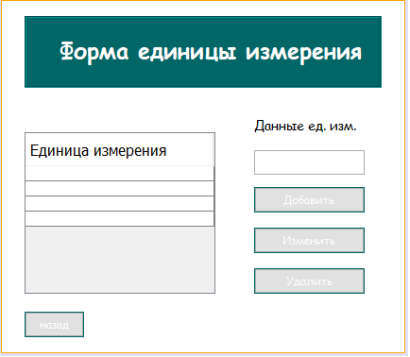

**Код:**

/*

/*

* To change this license header, choose License Headers in Project Properties.

* To change this template file, choose Tools | Templates

* and open the template in the editor.

*/

package bakery;

import java.sql.*;

import java.util.Calendar;

import javax.swing.*;

import net.proteanit.sql.DbUtils;

/**

*

* @author aidin

*/

public class measure extends javax.swing.JFrame {

Connection conn = null;

CallableStatement stored_pro = null;

Statement statement = null;

ResultSet rs = null;

/**

* Creates new form measure

*/

public measure() {

initComponents();

}

/**

* This method is called from within the constructor to initialize the form.

* WARNING: Do NOT modify this code. The content of this method is always

* regenerated by the Form Editor.

*/

@SuppressWarnings("unchecked")

// <editor-fold defaultstate="collapsed" desc="Generated Code">

private void initComponents() {

jLabel2 = new javax.swing.JLabel();

jPanel1 = new javax.swing.JPanel();

jScrollPane1 = new javax.swing.JScrollPane();

jTable1 = new javax.swing.JTable();

MeasureInsertButton = new javax.swing.JButton();

MeasureUpdateButton = new javax.swing.JButton();

MeasureDeleteButton = new javax.swing.JButton();

MeasureName = new javax.swing.JTextField();

jLabel1 = new javax.swing.JLabel();

back = new javax.swing.JButton();

jPanel2 = new javax.swing.JPanel();

jLabel3 = new javax.swing.JLabel();

jLabel2.setText("jLabel2");

setDefaultCloseOperation(javax.swing.WindowConstants.EXIT_ON_CLOSE);

addWindowListener(new java.awt.event.WindowAdapter() {

public void windowActivated(java.awt.event.WindowEvent evt) {

formWindowActivated(evt);

}

});

jPanel1.setBackground(new java.awt.Color(255, 255, 255));

jTable1.setFont(new java.awt.Font("Comic Sans MS", 0, 14)); // NOI18N

jTable1.setModel(new javax.swing.table.DefaultTableModel(

new Object [][] {

{null},

{null},

{null},

{null}

},

new String [] {

"Единица измерения"

}

));

jTable1.addMouseListener(new java.awt.event.MouseAdapter() {

public void mouseClicked(java.awt.event.MouseEvent evt) {

jTable1MouseClicked(evt);

}

});

jScrollPane1.setViewportView(jTable1);

MeasureInsertButton.setBackground(new java.awt.Color(0, 102, 102));

MeasureInsertButton.setFont(new java.awt.Font("Comic Sans MS", 0, 12)); // NOI18N

MeasureInsertButton.setForeground(new java.awt.Color(255, 255, 255));

MeasureInsertButton.setText("Добавить");

MeasureInsertButton.addActionListener(new java.awt.event.ActionListener() {

public void actionPerformed(java.awt.event.ActionEvent evt) {

MeasureInsertButtonActionPerformed(evt);

}

});

MeasureUpdateButton.setBackground(new java.awt.Color(0, 102, 102));

MeasureUpdateButton.setFont(new java.awt.Font("Comic Sans MS", 0, 12)); // NOI18N

MeasureUpdateButton.setForeground(new java.awt.Color(255, 255, 255));

MeasureUpdateButton.setText("Изменить");

MeasureUpdateButton.addActionListener(new java.awt.event.ActionListener() {

public void actionPerformed(java.awt.event.ActionEvent evt) {

MeasureUpdateButtonActionPerformed(evt);

}

});

MeasureDeleteButton.setBackground(new java.awt.Color(0, 102, 102));

MeasureDeleteButton.setFont(new java.awt.Font("Comic Sans MS", 0, 12)); // NOI18N

MeasureDeleteButton.setForeground(new java.awt.Color(255, 255, 255));

MeasureDeleteButton.setText("Удалить");

MeasureDeleteButton.addActionListener(new java.awt.event.ActionListener() {

public void actionPerformed(java.awt.event.ActionEvent evt) {

MeasureDeleteButtonActionPerformed(evt);

}

});

jLabel1.setFont(new java.awt.Font("Comic Sans MS", 0, 14)); // NOI18N

jLabel1.setText("Данные ед. изм.");

back.setBackground(new java.awt.Color(0, 102, 102));

back.setFont(new java.awt.Font("Comic Sans MS", 0, 12)); // NOI18N

back.setForeground(new java.awt.Color(255, 255, 255));

back.setText("назад");

back.addActionListener(new java.awt.event.ActionListener() {

public void actionPerformed(java.awt.event.ActionEvent evt) {

backActionPerformed(evt);

}

});

jPanel2.setBackground(new java.awt.Color(0, 102, 102));

jPanel2.setBorder(javax.swing.BorderFactory.createEtchedBorder());

jLabel3.setBackground(new java.awt.Color(0, 102, 102));

jLabel3.setFont(new java.awt.Font("Comic Sans MS", 1, 24)); // NOI18N

jLabel3.setForeground(new java.awt.Color(255, 255, 255));

jLabel3.setText("Форма единицы измерения");

javax.swing.GroupLayout jPanel2Layout = new javax.swing.GroupLayout(jPanel2);

jPanel2.setLayout(jPanel2Layout);

jPanel2Layout.setHorizontalGroup(

jPanel2Layout.createParallelGroup(javax.swing.GroupLayout.Alignment.LEADING)

.addGroup(jPanel2Layout.createSequentialGroup()

.addGap(35, 35, 35)

.addComponent(jLabel3)

.addContainerGap(19, Short.MAX_VALUE))

);

jPanel2Layout.setVerticalGroup(

jPanel2Layout.createParallelGroup(javax.swing.GroupLayout.Alignment.LEADING)

.addGroup(jPanel2Layout.createSequentialGroup()

.addContainerGap()

.addComponent(jLabel3)

.addContainerGap(22, Short.MAX_VALUE))

);

javax.swing.GroupLayout jPanel1Layout = new javax.swing.GroupLayout(jPanel1);

jPanel1.setLayout(jPanel1Layout);

jPanel1Layout.setHorizontalGroup(

jPanel1Layout.createParallelGroup(javax.swing.GroupLayout.Alignment.LEADING)

.addGroup(jPanel1Layout.createSequentialGroup()

.addGap(24, 24, 24)

.addGroup(jPanel1Layout.createParallelGroup(javax.swing.GroupLayout.Alignment.LEADING)

.addComponent(back)

.addComponent(jPanel2, javax.swing.GroupLayout.PREFERRED_SIZE, javax.swing.GroupLayout.DEFAULT_SIZE, javax.swing.GroupLayout.PREFERRED_SIZE)

.addGroup(jPanel1Layout.createSequentialGroup()

.addComponent(jScrollPane1, javax.swing.GroupLayout.PREFERRED_SIZE, 202, javax.swing.GroupLayout.PREFERRED_SIZE)

.addGap(41, 41, 41)

.addGroup(jPanel1Layout.createParallelGroup(javax.swing.GroupLayout.Alignment.LEADING, false)

.addComponent(MeasureName)

.addComponent(MeasureInsertButton, javax.swing.GroupLayout.DEFAULT_SIZE, javax.swing.GroupLayout.DEFAULT_SIZE, Short.MAX_VALUE)

.addComponent(MeasureUpdateButton, javax.swing.GroupLayout.DEFAULT_SIZE, 117, Short.MAX_VALUE)

.addComponent(MeasureDeleteButton, javax.swing.GroupLayout.DEFAULT_SIZE, javax.swing.GroupLayout.DEFAULT_SIZE, Short.MAX_VALUE)

.addComponent(jLabel1))))

.addContainerGap(24, Short.MAX_VALUE))

);

jPanel1Layout.setVerticalGroup(

jPanel1Layout.createParallelGroup(javax.swing.GroupLayout.Alignment.LEADING)

.addGroup(javax.swing.GroupLayout.Alignment.TRAILING, jPanel1Layout.createSequentialGroup()

.addContainerGap()

.addComponent(jPanel2, javax.swing.GroupLayout.PREFERRED_SIZE, javax.swing.GroupLayout.DEFAULT_SIZE, javax.swing.GroupLayout.PREFERRED_SIZE)

.addGap(29, 29, 29)

.addGroup(jPanel1Layout.createParallelGroup(javax.swing.GroupLayout.Alignment.LEADING)

.addGroup(javax.swing.GroupLayout.Alignment.TRAILING, jPanel1Layout.createSequentialGroup()

.addComponent(jLabel1)

.addPreferredGap(javax.swing.LayoutStyle.ComponentPlacement.UNRELATED)

.addComponent(MeasureName, javax.swing.GroupLayout.PREFERRED_SIZE, javax.swing.GroupLayout.DEFAULT_SIZE, javax.swing.GroupLayout.PREFERRED_SIZE)

.addGap(13, 13, 13)

.addComponent(MeasureInsertButton)

.addPreferredGap(javax.swing.LayoutStyle.ComponentPlacement.UNRELATED)

.addComponent(MeasureUpdateButton)

.addPreferredGap(javax.swing.LayoutStyle.ComponentPlacement.UNRELATED)

.addComponent(MeasureDeleteButton))

.addComponent(jScrollPane1, javax.swing.GroupLayout.Alignment.TRAILING, javax.swing.GroupLayout.PREFERRED_SIZE, 171, javax.swing.GroupLayout.PREFERRED_SIZE))

.addPreferredGap(javax.swing.LayoutStyle.ComponentPlacement.RELATED, 19, Short.MAX_VALUE)

.addComponent(back)

.addContainerGap())

);

javax.swing.GroupLayout layout = new javax.swing.GroupLayout(getContentPane());

getContentPane().setLayout(layout);

layout.setHorizontalGroup(

layout.createParallelGroup(javax.swing.GroupLayout.Alignment.LEADING)

.addComponent(jPanel1, javax.swing.GroupLayout.DEFAULT_SIZE, javax.swing.GroupLayout.DEFAULT_SIZE, Short.MAX_VALUE)

);

layout.setVerticalGroup(

layout.createParallelGroup(javax.swing.GroupLayout.Alignment.LEADING)

.addComponent(jPanel1, javax.swing.GroupLayout.Alignment.TRAILING, javax.swing.GroupLayout.DEFAULT_SIZE, javax.swing.GroupLayout.DEFAULT_SIZE, Short.MAX_VALUE)

);

pack();

}// </editor-fold>

private void jTable1MouseClicked(java.awt.event.MouseEvent evt) {

// TODO add your handling code here:

try{

MeasureName.setText("");

conn = ConnectMsSql.ConnectDB();

int row = jTable1.getSelectedRow();

String name = (jTable1.getModel().getValueAt(row,0).toString());

String sql = "SELECT Unit FROM Units WHERE Unit ='" + name + "'";

PreparedStatement pst=conn.prepareStatement(sql);

ResultSet rs = pst.executeQuery();

statement = conn.createStatement();

rs = statement.executeQuery(sql);

while(rs.next()){

MeasureName.setText(rs.getString("Unit"));

}

}

catch(Exception e){

System.out.println("Error");

}

}

private void formWindowActivated(java.awt.event.WindowEvent evt) {

// TODO add your handling code here:

try{

conn = ConnectMsSql.ConnectDB();

String sql = "SELECT Unit FROM Units";

statement = conn.createStatement();

rs = statement.executeQuery(sql);

this.jTable1.setModel(DbUtils.resultSetToTableModel(rs));

jTable1.getColumnModel().getColumn(0).setHeaderValue("Единица измерения");

conn.close();

}

catch(Exception e){

e.printStackTrace();

JOptionPane.showMessageDialog(null, e);

}

}

private void MeasureInsertButtonActionPerformed(java.awt.event.ActionEvent evt) {

// TODO add your handling code here:

try{

conn = ConnectMsSql.ConnectDB();

String name=MeasureName.getText();

String dobavlenie = "INSERT INTO Units(Unit) VALUES(?)";

PreparedStatement pst1=conn.prepareStatement(dobavlenie);

pst1.setString(1, name);

JOptionPane.showMessageDialog(null, "Данные успешно добавленны.");

pst1.executeUpdate();

}

catch(Exception e){

JOptionPane.showMessageDialog(null, "Ошибка, что то пошло не так :(");

}

}

private void MeasureDeleteButtonActionPerformed(java.awt.event.ActionEvent evt) {

// TODO add your handling code here:

try{

conn = ConnectMsSql.ConnectDB();

JFrame frame = new JFrame("Sure");

if (JOptionPane.showConfirmDialog(frame, "Вы действительно хотите удалить данные?",

"Удаление данных", JOptionPane.YES_NO_OPTION) == JOptionPane.YES_NO_OPTION)

{

stored_pro = conn.prepareCall("{call delete_date_about_Units (?)}");

stored_pro.setString(1, this.MeasureName.getText());

stored_pro.execute();

JOptionPane.showMessageDialog(null, "Данные успешно удалены.");

MeasureName.setText("");

}

}

catch(Exception e){

JOptionPane.showMessageDialog(null, "Ошибка, что то пошло не так :(");

}

}

private void MeasureUpdateButtonActionPerformed(java.awt.event.ActionEvent evt) {

// TODO add your handling code here:

try{

conn = ConnectMsSql.ConnectDB();

int row = jTable1.getSelectedRow();

String id = (jTable1.getModel().getValueAt(row,0).toString());

String sql = "SELECT ID FROM Units WHERE Unit ='" + id + "'";

PreparedStatement pst=conn.prepareStatement(sql);

ResultSet rs = pst.executeQuery();

int ID=0;

while(rs.next()){

ID=Integer.parseInt(rs.getString("ID")) ;

}

stored_pro = conn.prepareCall("{call update_data_about_measure (?,?)}");

stored_pro.setInt(1, ID);

stored_pro.setString(2, this.MeasureName.getText());

stored_pro.execute();

JOptionPane.showMessageDialog(null, "Данные успешно обновлены.");

}

catch(Exception e){

JOptionPane.showMessageDialog(null, "Ошибка, что то пошло не так :(");

}

}

private void backActionPerformed(java.awt.event.ActionEvent evt) {

// TODO add your handling code here:

Main1 field= new Main1();

field.setVisible(true);

setVisible(false);

}

/**

* @param args the command line arguments

*/

public static void main(String args[]) {

/* Set the Nimbus look and feel */

//<editor-fold defaultstate="collapsed" desc=" Look and feel setting code (optional) ">

/* If Nimbus (introduced in Java SE 6) is not available, stay with the default look and feel.

* For details see http://download.oracle.com/javase/tutorial/uiswing/lookandfeel/plaf.html

*/

try {

for (javax.swing.UIManager.LookAndFeelInfo info : javax.swing.UIManager.getInstalledLookAndFeels()) {

if ("Nimbus".equals(info.getName())) {

javax.swing.UIManager.setLookAndFeel(info.getClassName());

break;

}

}

} catch (ClassNotFoundException ex) {

java.util.logging.Logger.getLogger(measure.class.getName()).log(java.util.logging.Level.SEVERE, null, ex);

} catch (InstantiationException ex) {

java.util.logging.Logger.getLogger(measure.class.getName()).log(java.util.logging.Level.SEVERE, null, ex);

} catch (IllegalAccessException ex) {

java.util.logging.Logger.getLogger(measure.class.getName()).log(java.util.logging.Level.SEVERE, null, ex);

} catch (javax.swing.UnsupportedLookAndFeelException ex) {

java.util.logging.Logger.getLogger(measure.class.getName()).log(java.util.logging.Level.SEVERE, null, ex);

}

//</editor-fold>

//</editor-fold>

/* Create and display the form */

java.awt.EventQueue.invokeLater(new Runnable() {

public void run() {

new measure().setVisible(true);

}

});

}

// Variables declaration - do not modify

private javax.swing.JButton MeasureDeleteButton;

private javax.swing.JButton MeasureInsertButton;

private javax.swing.JTextField MeasureName;

private javax.swing.JButton MeasureUpdateButton;

private javax.swing.JButton back;

private javax.swing.JLabel jLabel1;

private javax.swing.JLabel jLabel2;

private javax.swing.JLabel jLabel3;

private javax.swing.JPanel jPanel1;

private javax.swing.JPanel jPanel2;

private javax.swing.JScrollPane jScrollPane1;

private javax.swing.JTable jTable1;

// End of variables declaration

}

* Форма **rawMaterial.java**

Для редактирование, добавление и удалеиие записей в таблице **Сырьё**. 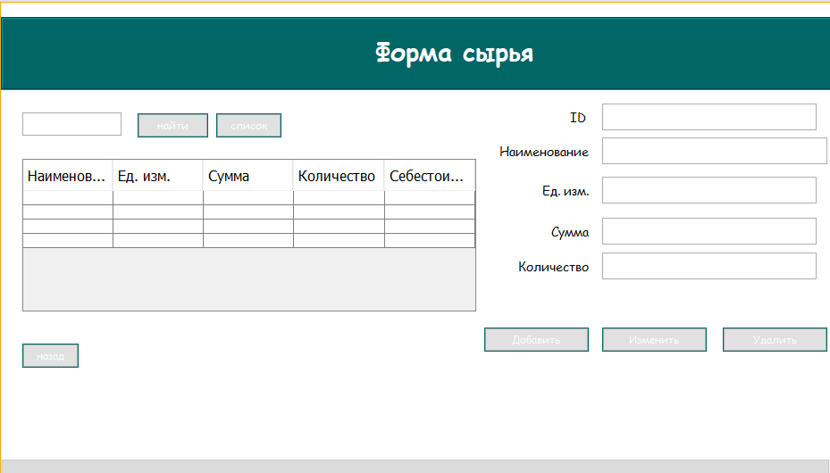

**Код:**

/*

/*

* To change this license header, choose License Headers in Project Properties.

* To change this template file, choose Tools | Templates

* and open the template in the editor.

*/

package bakery;

import java.sql.*;

import java.util.Calendar;

import javax.swing.*;

import javax.swing.table.TableModel;

import net.proteanit.sql.DbUtils;

/**

*

* @author aidin

*/

public class rawMaterial extends javax.swing.JFrame {

Connection conn = null;

CallableStatement stored_pro = null;

Statement statement = null;

ResultSet rs = null;

/**

* Creates new form measure

*/

public rawMaterial() {

initComponents();

}

/**

* This method is called from within the constructor to initialize the form.

* WARNING: Do NOT modify this code. The content of this method is always

* regenerated by the Form Editor.

*/

@SuppressWarnings("unchecked")

// <editor-fold defaultstate="collapsed" desc="Generated Code">

private void initComponents() {

jLabel2 = new javax.swing.JLabel();

jPanel1 = new javax.swing.JPanel();

jScrollPane1 = new javax.swing.JScrollPane();

jTable1 = new javax.swing.JTable();

MeasureInsertButton = new javax.swing.JButton();

MeasureUpdateButton = new javax.swing.JButton();

MeasureDeleteButton = new javax.swing.JButton();

idtxt = new javax.swing.JTextField();

jLabel1 = new javax.swing.JLabel();

back = new javax.swing.JButton();

jPanel2 = new javax.swing.JPanel();

jLabel3 = new javax.swing.JLabel();

jButton1 = new javax.swing.JButton();

SearchTxt = new javax.swing.JTextField();

SumTxt = new javax.swing.JTextField();

AmountTxt = new javax.swing.JTextField();

jLabel4 = new javax.swing.JLabel();

jLabel6 = new javax.swing.JLabel();

MeasureTxt = new javax.swing.JTextField();

jButton2 = new javax.swing.JButton();

jLabel8 = new javax.swing.JLabel();

ProductName12 = new javax.swing.JTextField();

jLabel5 = new javax.swing.JLabel();

jLabel2.setText("jLabel2");

setDefaultCloseOperation(javax.swing.WindowConstants.EXIT_ON_CLOSE);

addWindowListener(new java.awt.event.WindowAdapter() {

public void windowActivated(java.awt.event.WindowEvent evt) {

formWindowActivated(evt);

}

});

jPanel1.setBackground(new java.awt.Color(255, 255, 255));

jTable1.setFont(new java.awt.Font("Comic Sans MS", 0, 14)); // NOI18N

jTable1.setModel(new javax.swing.table.DefaultTableModel(

new Object [][] {

{null, null, null, null, null},

{null, null, null, null, null},

{null, null, null, null, null},

{null, null, null, null, null}

},

new String [] {

"Наименование", "Ед. изм.", "Сумма", "Количество", "Себестоимость"

}

));

jTable1.addMouseListener(new java.awt.event.MouseAdapter() {

public void mouseClicked(java.awt.event.MouseEvent evt) {

jTable1MouseClicked(evt);

}

});

jScrollPane1.setViewportView(jTable1);

MeasureInsertButton.setBackground(new java.awt.Color(0, 102, 102));

MeasureInsertButton.setFont(new java.awt.Font("Comic Sans MS", 0, 12)); // NOI18N

MeasureInsertButton.setForeground(new java.awt.Color(255, 255, 255));

MeasureInsertButton.setText("Добавить");

MeasureInsertButton.addActionListener(new java.awt.event.ActionListener() {

public void actionPerformed(java.awt.event.ActionEvent evt) {

MeasureInsertButtonActionPerformed(evt);

}

});

MeasureUpdateButton.setBackground(new java.awt.Color(0, 102, 102));

MeasureUpdateButton.setFont(new java.awt.Font("Comic Sans MS", 0, 12)); // NOI18N

MeasureUpdateButton.setForeground(new java.awt.Color(255, 255, 255));

MeasureUpdateButton.setText("Изменить");

MeasureUpdateButton.addActionListener(new java.awt.event.ActionListener() {

public void actionPerformed(java.awt.event.ActionEvent evt) {

MeasureUpdateButtonActionPerformed(evt);

}

});

MeasureDeleteButton.setBackground(new java.awt.Color(0, 102, 102));

MeasureDeleteButton.setFont(new java.awt.Font("Comic Sans MS", 0, 12)); // NOI18N

MeasureDeleteButton.setForeground(new java.awt.Color(255, 255, 255));

MeasureDeleteButton.setText("Удалить");

MeasureDeleteButton.addActionListener(new java.awt.event.ActionListener() {

public void actionPerformed(java.awt.event.ActionEvent evt) {

MeasureDeleteButtonActionPerformed(evt);

}

});

jLabel1.setFont(new java.awt.Font("Comic Sans MS", 0, 14)); // NOI18N

jLabel1.setText("Наименование");

back.setBackground(new java.awt.Color(0, 102, 102));

back.setFont(new java.awt.Font("Comic Sans MS", 0, 12)); // NOI18N

back.setForeground(new java.awt.Color(255, 255, 255));

back.setText("назад");

back.addActionListener(new java.awt.event.ActionListener() {

public void actionPerformed(java.awt.event.ActionEvent evt) {

backActionPerformed(evt);

}

});

jPanel2.setBackground(new java.awt.Color(0, 102, 102));

jPanel2.setBorder(javax.swing.BorderFactory.createEtchedBorder());

jLabel3.setFont(new java.awt.Font("Comic Sans MS", 1, 28)); // NOI18N

jLabel3.setForeground(new java.awt.Color(255, 255, 255));

jLabel3.setText("Форма сырья");

javax.swing.GroupLayout jPanel2Layout = new javax.swing.GroupLayout(jPanel2);

jPanel2.setLayout(jPanel2Layout);

jPanel2Layout.setHorizontalGroup(

jPanel2Layout.createParallelGroup(javax.swing.GroupLayout.Alignment.LEADING)

.addGroup(javax.swing.GroupLayout.Alignment.TRAILING, jPanel2Layout.createSequentialGroup()

.addContainerGap(417, Short.MAX_VALUE)

.addComponent(jLabel3)

.addGap(358, 358, 358))

);

jPanel2Layout.setVerticalGroup(

jPanel2Layout.createParallelGroup(javax.swing.GroupLayout.Alignment.LEADING)

.addGroup(jPanel2Layout.createSequentialGroup()

.addContainerGap()

.addComponent(jLabel3)

.addContainerGap(22, Short.MAX_VALUE))

);

jButton1.setBackground(new java.awt.Color(0, 102, 102));

jButton1.setFont(new java.awt.Font("Comic Sans MS", 0, 12)); // NOI18N

jButton1.setForeground(new java.awt.Color(255, 255, 255));

jButton1.setText("найти");

jButton1.addActionListener(new java.awt.event.ActionListener() {

public void actionPerformed(java.awt.event.ActionEvent evt) {

jButton1ActionPerformed(evt);

}

});

SearchTxt.addMouseListener(new java.awt.event.MouseAdapter() {

public void mousePressed(java.awt.event.MouseEvent evt) {

SearchTxtMousePressed(evt);

}

});

AmountTxt.setToolTipText("");

jLabel4.setFont(new java.awt.Font("Comic Sans MS", 0, 14)); // NOI18N

jLabel4.setText("Ед. изм.");

jLabel6.setFont(new java.awt.Font("Comic Sans MS", 0, 14)); // NOI18N

jLabel6.setText("Сумма");

jButton2.setBackground(new java.awt.Color(0, 102, 102));

jButton2.setFont(new java.awt.Font("Comic Sans MS", 0, 12)); // NOI18N

jButton2.setForeground(new java.awt.Color(255, 255, 255));

jButton2.setText("список");

jButton2.addActionListener(new java.awt.event.ActionListener() {

public void actionPerformed(java.awt.event.ActionEvent evt) {

jButton2ActionPerformed(evt);

}

});

jLabel8.setFont(new java.awt.Font("Comic Sans MS", 0, 14)); // NOI18N

jLabel8.setText("Количество");

ProductName12.addActionListener(new java.awt.event.ActionListener() {

public void actionPerformed(java.awt.event.ActionEvent evt) {

ProductName12ActionPerformed(evt);

}

});

jLabel5.setFont(new java.awt.Font("Comic Sans MS", 0, 14)); // NOI18N

jLabel5.setText("ID");

javax.swing.GroupLayout jPanel1Layout = new javax.swing.GroupLayout(jPanel1);

jPanel1.setLayout(jPanel1Layout);

jPanel1Layout.setHorizontalGroup(

jPanel1Layout.createParallelGroup(javax.swing.GroupLayout.Alignment.LEADING)

.addGroup(javax.swing.GroupLayout.Alignment.TRAILING, jPanel1Layout.createSequentialGroup()

.addGap(24, 24, 24)

.addGroup(jPanel1Layout.createParallelGroup(javax.swing.GroupLayout.Alignment.LEADING)

.addGroup(jPanel1Layout.createSequentialGroup()

.addGroup(jPanel1Layout.createParallelGroup(javax.swing.GroupLayout.Alignment.LEADING)

.addComponent(jScrollPane1, javax.swing.GroupLayout.PREFERRED_SIZE, 508, javax.swing.GroupLayout.PREFERRED_SIZE)

.addComponent(back))

.addGroup(jPanel1Layout.createParallelGroup(javax.swing.GroupLayout.Alignment.LEADING)

.addGroup(jPanel1Layout.createSequentialGroup()

.addGap(47, 47, 47)

.addGroup(jPanel1Layout.createParallelGroup(javax.swing.GroupLayout.Alignment.TRAILING)

.addComponent(jLabel6)

.addComponent(jLabel8))

.addPreferredGap(javax.swing.LayoutStyle.ComponentPlacement.RELATED, javax.swing.GroupLayout.DEFAULT_SIZE, Short.MAX_VALUE))

.addGroup(javax.swing.GroupLayout.Alignment.TRAILING, jPanel1Layout.createSequentialGroup()

.addPreferredGap(javax.swing.LayoutStyle.ComponentPlacement.RELATED, javax.swing.GroupLayout.DEFAULT_SIZE, Short.MAX_VALUE)

.addGroup(jPanel1Layout.createParallelGroup(javax.swing.GroupLayout.Alignment.TRAILING)

.addComponent(jLabel4)

.addComponent(jLabel1)

.addComponent(MeasureInsertButton, javax.swing.GroupLayout.PREFERRED_SIZE, 117, javax.swing.GroupLayout.PREFERRED_SIZE))

.addPreferredGap(javax.swing.LayoutStyle.ComponentPlacement.UNRELATED))))

.addGroup(jPanel1Layout.createSequentialGroup()

.addComponent(SearchTxt, javax.swing.GroupLayout.PREFERRED_SIZE, 111, javax.swing.GroupLayout.PREFERRED_SIZE)

.addGap(18, 18, 18)

.addComponent(jButton1, javax.swing.GroupLayout.PREFERRED_SIZE, 79, javax.swing.GroupLayout.PREFERRED_SIZE)

.addPreferredGap(javax.swing.LayoutStyle.ComponentPlacement.RELATED)

.addComponent(jButton2)

.addPreferredGap(javax.swing.LayoutStyle.ComponentPlacement.RELATED, javax.swing.GroupLayout.DEFAULT_SIZE, Short.MAX_VALUE)

.addComponent(jLabel5)

.addGap(18, 18, 18)))

.addGroup(jPanel1Layout.createParallelGroup(javax.swing.GroupLayout.Alignment.LEADING)

.addGroup(jPanel1Layout.createSequentialGroup()

.addGroup(jPanel1Layout.createParallelGroup(javax.swing.GroupLayout.Alignment.LEADING)

.addComponent(ProductName12)

.addGroup(jPanel1Layout.createParallelGroup(javax.swing.GroupLayout.Alignment.LEADING, false)

.addComponent(AmountTxt, javax.swing.GroupLayout.Alignment.TRAILING)

.addComponent(SumTxt)

.addComponent(MeasureTxt, javax.swing.GroupLayout.DEFAULT_SIZE, 240, Short.MAX_VALUE))

.addGroup(jPanel1Layout.createSequentialGroup()

.addComponent(MeasureUpdateButton, javax.swing.GroupLayout.PREFERRED_SIZE, 117, javax.swing.GroupLayout.PREFERRED_SIZE)

.addGap(18, 18, 18)

.addComponent(MeasureDeleteButton, javax.swing.GroupLayout.PREFERRED_SIZE, 117, javax.swing.GroupLayout.PREFERRED_SIZE)))

.addGap(194, 194, 194))

.addGroup(jPanel1Layout.createSequentialGroup()

.addComponent(idtxt, javax.swing.GroupLayout.PREFERRED_SIZE, 240, javax.swing.GroupLayout.PREFERRED_SIZE)

.addContainerGap(javax.swing.GroupLayout.DEFAULT_SIZE, Short.MAX_VALUE))))

.addGroup(jPanel1Layout.createSequentialGroup()

.addComponent(jPanel2, javax.swing.GroupLayout.PREFERRED_SIZE, javax.swing.GroupLayout.DEFAULT_SIZE, javax.swing.GroupLayout.PREFERRED_SIZE)

.addGap(0, 0, Short.MAX_VALUE))

);

jPanel1Layout.setVerticalGroup(

jPanel1Layout.createParallelGroup(javax.swing.GroupLayout.Alignment.LEADING)

.addGroup(jPanel1Layout.createSequentialGroup()

.addContainerGap()

.addComponent(jPanel2, javax.swing.GroupLayout.PREFERRED_SIZE, javax.swing.GroupLayout.DEFAULT_SIZE, javax.swing.GroupLayout.PREFERRED_SIZE)

.addGroup(jPanel1Layout.createParallelGroup(javax.swing.GroupLayout.Alignment.LEADING)

.addGroup(jPanel1Layout.createSequentialGroup()

.addGap(25, 25, 25)

.addGroup(jPanel1Layout.createParallelGroup(javax.swing.GroupLayout.Alignment.BASELINE)

.addComponent(SearchTxt, javax.swing.GroupLayout.PREFERRED_SIZE, javax.swing.GroupLayout.DEFAULT_SIZE, javax.swing.GroupLayout.PREFERRED_SIZE)

.addComponent(jButton1)

.addComponent(jButton2, javax.swing.GroupLayout.PREFERRED_SIZE, 27, javax.swing.GroupLayout.PREFERRED_SIZE)))

.addGroup(javax.swing.GroupLayout.Alignment.TRAILING, jPanel1Layout.createSequentialGroup()

.addPreferredGap(javax.swing.LayoutStyle.ComponentPlacement.RELATED)

.addGroup(jPanel1Layout.createParallelGroup(javax.swing.GroupLayout.Alignment.BASELINE)

.addComponent(idtxt, javax.swing.GroupLayout.PREFERRED_SIZE, 30, javax.swing.GroupLayout.PREFERRED_SIZE)

.addComponent(jLabel5))

.addGap(8, 8, 8)))

.addGroup(jPanel1Layout.createParallelGroup(javax.swing.GroupLayout.Alignment.TRAILING, false)

.addGroup(jPanel1Layout.createSequentialGroup()

.addGroup(jPanel1Layout.createParallelGroup(javax.swing.GroupLayout.Alignment.BASELINE)

.addComponent(ProductName12, javax.swing.GroupLayout.PREFERRED_SIZE, 30, javax.swing.GroupLayout.PREFERRED_SIZE)

.addComponent(jLabel1))

.addPreferredGap(javax.swing.LayoutStyle.ComponentPlacement.RELATED, 14, Short.MAX_VALUE)

.addGroup(jPanel1Layout.createParallelGroup(javax.swing.GroupLayout.Alignment.BASELINE)

.addComponent(jLabel4, javax.swing.GroupLayout.DEFAULT_SIZE, javax.swing.GroupLayout.DEFAULT_SIZE, Short.MAX_VALUE)

.addComponent(MeasureTxt, javax.swing.GroupLayout.PREFERRED_SIZE, 30, javax.swing.GroupLayout.PREFERRED_SIZE))

.addPreferredGap(javax.swing.LayoutStyle.ComponentPlacement.UNRELATED)

.addGroup(jPanel1Layout.createParallelGroup(javax.swing.GroupLayout.Alignment.BASELINE)

.addComponent(SumTxt, javax.swing.GroupLayout.PREFERRED_SIZE, 30, javax.swing.GroupLayout.PREFERRED_SIZE)

.addComponent(jLabel6))

.addPreferredGap(javax.swing.LayoutStyle.ComponentPlacement.RELATED)

.addGroup(jPanel1Layout.createParallelGroup(javax.swing.GroupLayout.Alignment.BASELINE)

.addComponent(AmountTxt, javax.swing.GroupLayout.PREFERRED_SIZE, 30, javax.swing.GroupLayout.PREFERRED_SIZE)

.addComponent(jLabel8))

.addGap(36, 36, 36))

.addComponent(jScrollPane1, javax.swing.GroupLayout.PREFERRED_SIZE, 171, javax.swing.GroupLayout.PREFERRED_SIZE))

.addGroup(jPanel1Layout.createParallelGroup(javax.swing.GroupLayout.Alignment.LEADING)

.addGroup(jPanel1Layout.createSequentialGroup()

.addGap(18, 18, 18)

.addGroup(jPanel1Layout.createParallelGroup(javax.swing.GroupLayout.Alignment.BASELINE)

.addComponent(MeasureUpdateButton)

.addComponent(MeasureInsertButton)

.addComponent(MeasureDeleteButton)))

.addGroup(jPanel1Layout.createSequentialGroup()

.addGap(36, 36, 36)

.addComponent(back)))

.addContainerGap(103, Short.MAX_VALUE))

);

javax.swing.GroupLayout layout = new javax.swing.GroupLayout(getContentPane());

getContentPane().setLayout(layout);

layout.setHorizontalGroup(

layout.createParallelGroup(javax.swing.GroupLayout.Alignment.LEADING)

.addComponent(jPanel1, javax.swing.GroupLayout.PREFERRED_SIZE, 928, Short.MAX_VALUE)

);

layout.setVerticalGroup(

layout.createParallelGroup(javax.swing.GroupLayout.Alignment.LEADING)

.addGroup(layout.createSequentialGroup()

.addComponent(jPanel1, javax.swing.GroupLayout.DEFAULT_SIZE, javax.swing.GroupLayout.DEFAULT_SIZE, Short.MAX_VALUE)

.addContainerGap())

);

pack();

}// </editor-fold>

private void jTable1MouseClicked(java.awt.event.MouseEvent evt) {

// TODO add your handling code here:

// ProductName12.setText("");

try{

//

conn = ConnectMsSql.ConnectDB();

// int row = jTable1.getSelectedRow();

// String name = (jTable1.getModel().getValueAt(row,0).toString());

int i=jTable1.getSelectedRow();

TableModel model=jTable1.getModel();

idtxt.setText(model.getValueAt(i,0).toString());

ProductName12.setText(model.getValueAt(i,1).toString());

MeasureTxt.setText(model.getValueAt(i,2).toString());

// jComboBox1.setSelectedItem(model.getValueAt(i,2).toString());

SumTxt.setText(model.getValueAt(i,3).toString());

AmountTxt.setText(model.getValueAt(i,4).toString());

}

catch(Exception e){

System.out.println("Ошибка обнавления таблицы");

}

}

private void formWindowActivated(java.awt.event.WindowEvent evt) {

// TODO add your handling code here:

try{

conn = ConnectMsSql.ConnectDB();

String sql = "SELECT RawMaterials.ID, RawMaterials.Naimenovaniye_Syrya,Units.Unit,RawMaterials.Amount,RawMaterials.Kol_Syrya,RawMaterials.Self_cost FROM RawMaterials INNER JOIN Units ON RawMaterials.Unit=Units.ID";

statement = conn.createStatement();

rs = statement.executeQuery(sql);

this.jTable1.setModel(DbUtils.resultSetToTableModel(rs));

jTable1.getColumnModel().getColumn(0).setHeaderValue("ID");

jTable1.getColumnModel().getColumn(1).setHeaderValue("Наименование");

jTable1.getColumnModel().getColumn(2).setHeaderValue("Ед. изм.");

jTable1.getColumnModel().getColumn(3).setHeaderValue("Сумма");

jTable1.getColumnModel().getColumn(4).setHeaderValue("Количество");

jTable1.getColumnModel().getColumn(5).setHeaderValue("Себестоимость");

conn.close();

}

catch(Exception e){

e.printStackTrace();

JOptionPane.showMessageDialog(null, e);

}

}

private void MeasureInsertButtonActionPerformed(java.awt.event.ActionEvent evt) {

// TODO add your handling code here:

try{

conn = ConnectMsSql.ConnectDB();

Statement st=conn.createStatement();

String txt = MeasureTxt.getText();

int meas = 0;

ResultSet measure = st.executeQuery("select ID from Units where Unit = '" + txt + "'");

while(measure.next()){

meas = measure.getInt("ID");

}

String name=idtxt.getText();

String name1=ProductName12.getText();

double sum=Double.parseDouble(SumTxt.getText());

double amount=Double.parseDouble(AmountTxt.getText());

String dobavlenie = "INSERT INTO RawMaterials (Naimenovaniye_Syrya,Unit,Amount,Kol_Syrya) VALUES(?,?,?,?)";

PreparedStatement pst=conn.prepareStatement(dobavlenie);

pst.setString(1, name1);

pst.setInt(2, meas);

pst.setDouble(3, sum);

pst.setDouble(4, amount);

JOptionPane.showMessageDialog(null, "Данные успешно добавленны.");

pst.executeUpdate();

}

catch(Exception e){

JOptionPane.showMessageDialog(null, "Ошибка, что то пошло не так :(");

}

}

private void MeasureDeleteButtonActionPerformed(java.awt.event.ActionEvent evt) {

// TODO add your handling code here:

try{

conn = ConnectMsSql.ConnectDB();

JFrame frame = new JFrame("Sure");

if (JOptionPane.showConfirmDialog(frame, "Вы действительно хотите удалить данные?",

"Удаление данных", JOptionPane.YES_NO_OPTION) == JOptionPane.YES_NO_OPTION)

{

stored_pro = conn.prepareCall("{call delete_date_about_RawMaterials (?)}");

stored_pro.setString(1,this.idtxt.getText());

stored_pro.execute();

JOptionPane.showMessageDialog(null, "Данные успешно удалены.");

idtxt.setText("");

ProductName12.setText("");

MeasureTxt.setText("");

SumTxt.setText("");

AmountTxt.setText("");

}

}

catch(Exception e){

JOptionPane.showMessageDialog(null, "Ошибка, Удалении");

}

}

private void MeasureUpdateButtonActionPerformed(java.awt.event.ActionEvent evt) {

// TODO add your handling code here:

try{

conn = ConnectMsSql.ConnectDB();

Statement st=conn.createStatement();

int row = jTable1.getSelectedRow();

String id = (jTable1.getModel().getValueAt(row,0).toString());

String sql = "SELECT ID FROM RawMaterials WHERE Naimenovaniye_Syrya ='" + id + "'";

PreparedStatement pst=conn.prepareStatement(sql);

ResultSet rs = pst.executeQuery();

int ID=0;

while(rs.next()){

ID=Integer.parseInt(rs.getString("ID")) ;

}

String txt = MeasureTxt.getText();

int meas = 0;

ResultSet measure = st.executeQuery("select ID from Units where Unit = '" + txt + "'");

while(measure.next()){

meas = measure.getInt("ID");

}

double ID1=Double.parseDouble(idtxt.getText());

double sum=Double.parseDouble(SumTxt.getText());

double amount=Double.parseDouble(AmountTxt.getText());

String name = ProductName12.getText();

stored_pro = conn.prepareCall("{call update_data_about_raw_material (?,?,?,?,?)}");

stored_pro.setDouble(1, ID1);

stored_pro.setString(2, name);

stored_pro.setInt(3, meas);

stored_pro.setDouble(4, sum);

stored_pro.setDouble(5, amount);

stored_pro.execute();

JOptionPane.showMessageDialog(null, "Данные успешно обновлены.");

}

catch(Exception e){

JOptionPane.showMessageDialog(null, "Ошибка, что то пошло не так :(");

}

}

private void backActionPerformed(java.awt.event.ActionEvent evt) {

// TODO add your handling code here:

Main1 field = new Main1();

field.setVisible(true);

setVisible(false);

}

private void jButton1ActionPerformed(java.awt.event.ActionEvent evt) {

// TODO add your handling code here:

try{

conn = ConnectMsSql.ConnectDB();

String perem = SearchTxt.getText();

String sql = "SELECT RawMaterials.ID, RawMaterials.Naimenovaniye_Syrya,Units.Unit,RawMaterials.Amount,RawMaterials.Kol_Syrya,RawMaterials.Self_cost FROM RawMaterials INNER JOIN Units ON RawMaterials.Unit=Units.id WHERE RawMaterials.Naimenovaniye_Syrya like '%" + perem + "%'";

statement = conn.createStatement();

rs = statement.executeQuery(sql);

this.jTable1.setModel(DbUtils.resultSetToTableModel(rs));

jTable1.getColumnModel().getColumn(0).setHeaderValue("ID");

jTable1.getColumnModel().getColumn(0).setHeaderValue("Наименование");

jTable1.getColumnModel().getColumn(1).setHeaderValue("Ед. изм.");

jTable1.getColumnModel().getColumn(2).setHeaderValue("Сумма");

jTable1.getColumnModel().getColumn(3).setHeaderValue("Количество");

jTable1.getColumnModel().getColumn(4).setHeaderValue("Себестоимость");

}

catch(Exception e){

JOptionPane.showMessageDialog(null, "Ошибка, что то пошло не так :(");

}

}

private void SearchTxtMousePressed(java.awt.event.MouseEvent evt) {

// TODO add your handling code here:

}

private void jButton2ActionPerformed(java.awt.event.ActionEvent evt) {

// TODO add your handling code here:

try{

conn = ConnectMsSql.ConnectDB();

//String sql = "SELECT rawMaterial.name,measure.name,rawMaterial.sum,rawMaterial.amount,rawMaterial.self_cost FROM rawMaterial INNER JOIN measure ON rawMaterial.measure=measure.id";

String sql = "SELECT RawMaterials.ID, RawMaterials.Naimenovaniye_Syrya,Units.Unit,RawMaterials.Amount,RawMaterials.Kol_Syrya,RawMaterials.Self_cost FROM RawMaterials INNER JOIN Units ON RawMaterials.Unit=Units.ID";

statement = conn.createStatement();

rs = statement.executeQuery(sql);

this.jTable1.setModel(DbUtils.resultSetToTableModel(rs));

jTable1.getColumnModel().getColumn(0).setHeaderValue("ID");

jTable1.getColumnModel().getColumn(0).setHeaderValue("Наименование");

jTable1.getColumnModel().getColumn(1).setHeaderValue("Ед. изм.");

jTable1.getColumnModel().getColumn(2).setHeaderValue("Сумма");

jTable1.getColumnModel().getColumn(3).setHeaderValue("Количество");

jTable1.getColumnModel().getColumn(4).setHeaderValue("Себестоимость");

conn.close();

}

catch(Exception e){

e.printStackTrace();

JOptionPane.showMessageDialog(null, e);

}

}

private void ProductName12ActionPerformed(java.awt.event.ActionEvent evt) {

// TODO add your handling code here:

}

/**

* @param args the command line arguments

*/

public static void main(String args[]) {

/* Set the Nimbus look and feel */

//<editor-fold defaultstate="collapsed" desc=" Look and feel setting code (optional) ">

/* If Nimbus (introduced in Java SE 6) is not available, stay with the default look and feel.

* For details see http://download.oracle.com/javase/tutorial/uiswing/lookandfeel/plaf.html

*/

try {

for (javax.swing.UIManager.LookAndFeelInfo info : javax.swing.UIManager.getInstalledLookAndFeels()) {

if ("Nimbus".equals(info.getName())) {

javax.swing.UIManager.setLookAndFeel(info.getClassName());

break;

}

}

} catch (ClassNotFoundException ex) {

java.util.logging.Logger.getLogger(rawMaterial.class.getName()).log(java.util.logging.Level.SEVERE, null, ex);

} catch (InstantiationException ex) {

java.util.logging.Logger.getLogger(rawMaterial.class.getName()).log(java.util.logging.Level.SEVERE, null, ex);

} catch (IllegalAccessException ex) {

java.util.logging.Logger.getLogger(rawMaterial.class.getName()).log(java.util.logging.Level.SEVERE, null, ex);

} catch (javax.swing.UnsupportedLookAndFeelException ex) {

java.util.logging.Logger.getLogger(rawMaterial.class.getName()).log(java.util.logging.Level.SEVERE, null, ex);

}

//</editor-fold>

//</editor-fold>

//</editor-fold>

//</editor-fold>

//</editor-fold>

//</editor-fold>

//</editor-fold>

//</editor-fold>

/* Create and display the form */

java.awt.EventQueue.invokeLater(new Runnable() {

public void run() {

new rawMaterial().setVisible(true);

}

});

}

// Variables declaration - do not modify

private javax.swing.JTextField AmountTxt;

private javax.swing.JButton MeasureDeleteButton;

private javax.swing.JButton MeasureInsertButton;

private javax.swing.JTextField MeasureTxt;

private javax.swing.JButton MeasureUpdateButton;

private javax.swing.JTextField ProductName12;

private javax.swing.JTextField SearchTxt;

private javax.swing.JTextField SumTxt;

private javax.swing.JButton back;

private javax.swing.JTextField idtxt;

private javax.swing.JButton jButton1;

private javax.swing.JButton jButton2;

private javax.swing.JLabel jLabel1;

private javax.swing.JLabel jLabel2;

private javax.swing.JLabel jLabel3;

private javax.swing.JLabel jLabel4;

private javax.swing.JLabel jLabel5;

private javax.swing.JLabel jLabel6;

private javax.swing.JLabel jLabel8;

private javax.swing.JPanel jPanel1;

private javax.swing.JPanel jPanel2;

private javax.swing.JScrollPane jScrollPane1;

private javax.swing.JTable jTable1;

// End of variables declaration

}

Форма **readyProduct.java**

Для редактирование, добавление и удалеиие записей в таблице **Готовая продукция**. 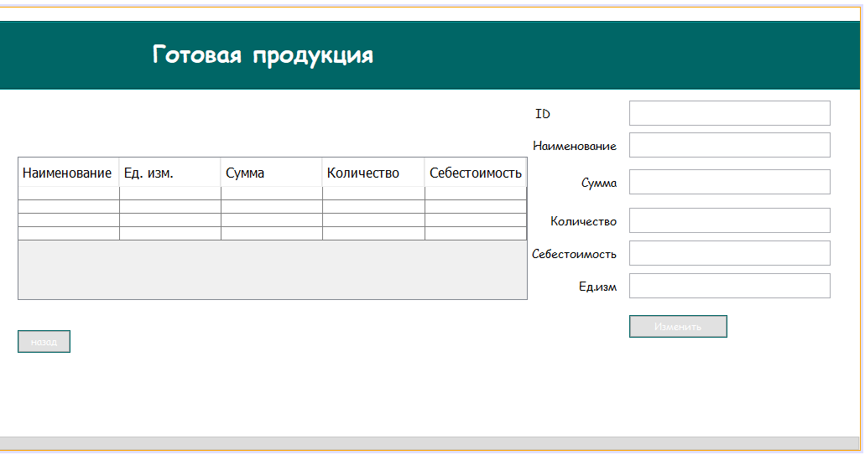

**Код:**

/*

/*

* To change this license header, choose License Headers in Project Properties.

* To change this template file, choose Tools | Templates

* and open the template in the editor.

*/

package bakery;

import java.sql.*;

import java.util.Calendar;

import javax.swing.*;

import javax.swing.table.TableModel;

import net.proteanit.sql.DbUtils;

/**

*

* @author aidin

*/

public class rawMaterial1 extends javax.swing.JFrame {

Connection conn = null;

CallableStatement stored_pro = null;

Statement statement = null;

ResultSet rs = null;

/**

* Creates new form measure

*/

public rawMaterial1() {

initComponents();

}

/**

* This method is called from within the constructor to initialize the form.

* WARNING: Do NOT modify this code. The content of this method is always

* regenerated by the Form Editor.

*/

@SuppressWarnings("unchecked")

// <editor-fold defaultstate="collapsed" desc="Generated Code">

private void initComponents() {

jLabel2 = new javax.swing.JLabel();

jPanel1 = new javax.swing.JPanel();

jScrollPane1 = new javax.swing.JScrollPane();

jTable1 = new javax.swing.JTable();

MeasureUpdateButton = new javax.swing.JButton();

idtxt = new javax.swing.JTextField();

jLabel1 = new javax.swing.JLabel();

back = new javax.swing.JButton();

jPanel2 = new javax.swing.JPanel();

jLabel3 = new javax.swing.JLabel();

AmountTxt1 = new javax.swing.JTextField();

AmountTxt = new javax.swing.JTextField();

jLabel4 = new javax.swing.JLabel();

jLabel6 = new javax.swing.JLabel();

jLabel7 = new javax.swing.JLabel();

SumTxt = new javax.swing.JTextField();

MeasureTxt1 = new javax.swing.JTextField();

jLabel8 = new javax.swing.JLabel();

ProductName12 = new javax.swing.JTextField();

jLabel5 = new javax.swing.JLabel();

jLabel2.setText("jLabel2");

setDefaultCloseOperation(javax.swing.WindowConstants.EXIT_ON_CLOSE);

addWindowListener(new java.awt.event.WindowAdapter() {

public void windowActivated(java.awt.event.WindowEvent evt) {

formWindowActivated(evt);

}

});

jPanel1.setBackground(new java.awt.Color(255, 255, 255));

jTable1.setFont(new java.awt.Font("Comic Sans MS", 0, 14)); // NOI18N

jTable1.setModel(new javax.swing.table.DefaultTableModel(

new Object [][] {

{null, null, null, null, null},

{null, null, null, null, null},

{null, null, null, null, null},

{null, null, null, null, null}

},

new String [] {

"Наименование", "Ед. изм.", "Сумма", "Количество", "Себестоимость"

}

));

jTable1.addMouseListener(new java.awt.event.MouseAdapter() {

public void mouseClicked(java.awt.event.MouseEvent evt) {

jTable1MouseClicked(evt);

}

});

jScrollPane1.setViewportView(jTable1);

MeasureUpdateButton.setBackground(new java.awt.Color(0, 102, 102));

MeasureUpdateButton.setFont(new java.awt.Font("Comic Sans MS", 0, 12)); // NOI18N

MeasureUpdateButton.setForeground(new java.awt.Color(255, 255, 255));

MeasureUpdateButton.setText("Изменить");

MeasureUpdateButton.addActionListener(new java.awt.event.ActionListener() {

public void actionPerformed(java.awt.event.ActionEvent evt) {

MeasureUpdateButtonActionPerformed(evt);

}

});

jLabel1.setFont(new java.awt.Font("Comic Sans MS", 0, 14)); // NOI18N

jLabel1.setText("ID");

back.setBackground(new java.awt.Color(0, 102, 102));

back.setFont(new java.awt.Font("Comic Sans MS", 0, 12)); // NOI18N

back.setForeground(new java.awt.Color(255, 255, 255));

back.setText("назад");

back.addActionListener(new java.awt.event.ActionListener() {

public void actionPerformed(java.awt.event.ActionEvent evt) {

backActionPerformed(evt);

}

});

jPanel2.setBackground(new java.awt.Color(0, 102, 102));

jPanel2.setBorder(javax.swing.BorderFactory.createEtchedBorder());

jLabel3.setFont(new java.awt.Font("Comic Sans MS", 1, 28)); // NOI18N

jLabel3.setForeground(new java.awt.Color(255, 255, 255));

jLabel3.setText("Готовая продукция");

javax.swing.GroupLayout jPanel2Layout = new javax.swing.GroupLayout(jPanel2);

jPanel2.setLayout(jPanel2Layout);

jPanel2Layout.setHorizontalGroup(

jPanel2Layout.createParallelGroup(javax.swing.GroupLayout.Alignment.LEADING)

.addGroup(jPanel2Layout.createSequentialGroup()

.addGap(183, 183, 183)

.addComponent(jLabel3)

.addContainerGap(592, Short.MAX_VALUE))

);

jPanel2Layout.setVerticalGroup(

jPanel2Layout.createParallelGroup(javax.swing.GroupLayout.Alignment.LEADING)

.addGroup(jPanel2Layout.createSequentialGroup()

.addContainerGap()

.addComponent(jLabel3)

.addContainerGap(22, Short.MAX_VALUE))

);

AmountTxt.setToolTipText("");

jLabel4.setFont(new java.awt.Font("Comic Sans MS", 0, 14)); // NOI18N

jLabel4.setText("Сумма");

jLabel6.setFont(new java.awt.Font("Comic Sans MS", 0, 14)); // NOI18N

jLabel6.setText("Количество");

jLabel7.setFont(new java.awt.Font("Comic Sans MS", 0, 14)); // NOI18N

jLabel7.setText("Ед.изм");

MeasureTxt1.setToolTipText("");

jLabel8.setFont(new java.awt.Font("Comic Sans MS", 0, 14)); // NOI18N

jLabel8.setText("Себестоимость");

ProductName12.addActionListener(new java.awt.event.ActionListener() {

public void actionPerformed(java.awt.event.ActionEvent evt) {

ProductName12ActionPerformed(evt);

}

});

jLabel5.setFont(new java.awt.Font("Comic Sans MS", 0, 14)); // NOI18N

jLabel5.setText("Наименование");

javax.swing.GroupLayout jPanel1Layout = new javax.swing.GroupLayout(jPanel1);

jPanel1.setLayout(jPanel1Layout);

jPanel1Layout.setHorizontalGroup(

jPanel1Layout.createParallelGroup(javax.swing.GroupLayout.Alignment.LEADING)

.addGroup(javax.swing.GroupLayout.Alignment.TRAILING, jPanel1Layout.createSequentialGroup()

.addGap(24, 24, 24)

.addGroup(jPanel1Layout.createParallelGroup(javax.swing.GroupLayout.Alignment.LEADING)

.addComponent(back)

.addComponent(jScrollPane1, javax.swing.GroupLayout.PREFERRED_SIZE, 608, javax.swing.GroupLayout.PREFERRED_SIZE))

.addGroup(jPanel1Layout.createParallelGroup(javax.swing.GroupLayout.Alignment.LEADING)

.addGroup(jPanel1Layout.createSequentialGroup()

.addGap(9, 9, 9)

.addComponent(jLabel1)

.addGap(5, 5, 5))

.addGroup(javax.swing.GroupLayout.Alignment.TRAILING, jPanel1Layout.createSequentialGroup()

.addGap(5, 5, 5)

.addGroup(jPanel1Layout.createParallelGroup(javax.swing.GroupLayout.Alignment.TRAILING)

.addComponent(jLabel4)

.addComponent(jLabel7)

.addComponent(jLabel5)

.addComponent(jLabel6)

.addComponent(jLabel8))

.addPreferredGap(javax.swing.LayoutStyle.ComponentPlacement.UNRELATED)))

.addGroup(jPanel1Layout.createParallelGroup(javax.swing.GroupLayout.Alignment.LEADING, false)

.addComponent(AmountTxt, javax.swing.GroupLayout.Alignment.TRAILING)

.addComponent(AmountTxt1)

.addComponent(SumTxt, javax.swing.GroupLayout.DEFAULT_SIZE, 240, Short.MAX_VALUE)

.addComponent(MeasureTxt1, javax.swing.GroupLayout.Alignment.TRAILING)

.addComponent(MeasureUpdateButton, javax.swing.GroupLayout.PREFERRED_SIZE, 117, javax.swing.GroupLayout.PREFERRED_SIZE)

.addComponent(ProductName12)

.addComponent(idtxt, javax.swing.GroupLayout.DEFAULT_SIZE, 240, Short.MAX_VALUE))

.addContainerGap(javax.swing.GroupLayout.DEFAULT_SIZE, Short.MAX_VALUE))

.addGroup(jPanel1Layout.createSequentialGroup()

.addComponent(jPanel2, javax.swing.GroupLayout.PREFERRED_SIZE, javax.swing.GroupLayout.DEFAULT_SIZE, javax.swing.GroupLayout.PREFERRED_SIZE)

.addGap(0, 0, Short.MAX_VALUE))

);

jPanel1Layout.setVerticalGroup(

jPanel1Layout.createParallelGroup(javax.swing.GroupLayout.Alignment.LEADING)

.addGroup(jPanel1Layout.createSequentialGroup()

.addContainerGap()

.addComponent(jPanel2, javax.swing.GroupLayout.PREFERRED_SIZE, javax.swing.GroupLayout.DEFAULT_SIZE, javax.swing.GroupLayout.PREFERRED_SIZE)

.addGap(13, 13, 13)

.addGroup(jPanel1Layout.createParallelGroup(javax.swing.GroupLayout.Alignment.BASELINE)

.addComponent(jLabel1)

.addComponent(idtxt, javax.swing.GroupLayout.PREFERRED_SIZE, 30, javax.swing.GroupLayout.PREFERRED_SIZE))

.addGap(8, 8, 8)

.addGroup(jPanel1Layout.createParallelGroup(javax.swing.GroupLayout.Alignment.TRAILING, false)

.addGroup(jPanel1Layout.createSequentialGroup()

.addGroup(jPanel1Layout.createParallelGroup(javax.swing.GroupLayout.Alignment.BASELINE)

.addComponent(jLabel5)

.addComponent(ProductName12, javax.swing.GroupLayout.PREFERRED_SIZE, 30, javax.swing.GroupLayout.PREFERRED_SIZE))

.addPreferredGap(javax.swing.LayoutStyle.ComponentPlacement.RELATED, 14, Short.MAX_VALUE)

.addGroup(jPanel1Layout.createParallelGroup(javax.swing.GroupLayout.Alignment.BASELINE)

.addComponent(jLabel4, javax.swing.GroupLayout.DEFAULT_SIZE, javax.swing.GroupLayout.DEFAULT_SIZE, Short.MAX_VALUE)

.addComponent(SumTxt, javax.swing.GroupLayout.PREFERRED_SIZE, 30, javax.swing.GroupLayout.PREFERRED_SIZE))

.addPreferredGap(javax.swing.LayoutStyle.ComponentPlacement.UNRELATED)

.addGroup(jPanel1Layout.createParallelGroup(javax.swing.GroupLayout.Alignment.BASELINE)

.addComponent(AmountTxt1, javax.swing.GroupLayout.PREFERRED_SIZE, 30, javax.swing.GroupLayout.PREFERRED_SIZE)

.addComponent(jLabel6))

.addPreferredGap(javax.swing.LayoutStyle.ComponentPlacement.RELATED)

.addGroup(jPanel1Layout.createParallelGroup(javax.swing.GroupLayout.Alignment.BASELINE)

.addComponent(AmountTxt, javax.swing.GroupLayout.PREFERRED_SIZE, 30, javax.swing.GroupLayout.PREFERRED_SIZE)

.addComponent(jLabel8))

.addPreferredGap(javax.swing.LayoutStyle.ComponentPlacement.RELATED)

.addGroup(jPanel1Layout.createParallelGroup(javax.swing.GroupLayout.Alignment.BASELINE)

.addComponent(MeasureTxt1, javax.swing.GroupLayout.PREFERRED_SIZE, 30, javax.swing.GroupLayout.PREFERRED_SIZE)

.addComponent(jLabel7))

.addGap(2, 2, 2))

.addComponent(jScrollPane1, javax.swing.GroupLayout.PREFERRED_SIZE, 171, javax.swing.GroupLayout.PREFERRED_SIZE))

.addGroup(jPanel1Layout.createParallelGroup(javax.swing.GroupLayout.Alignment.LEADING)

.addGroup(jPanel1Layout.createSequentialGroup()

.addGap(18, 18, 18)

.addComponent(MeasureUpdateButton))

.addGroup(jPanel1Layout.createSequentialGroup()

.addGap(36, 36, 36)

.addComponent(back)))

.addContainerGap(100, Short.MAX_VALUE))

);

javax.swing.GroupLayout layout = new javax.swing.GroupLayout(getContentPane());

getContentPane().setLayout(layout);

layout.setHorizontalGroup(

layout.createParallelGroup(javax.swing.GroupLayout.Alignment.LEADING)

.addComponent(jPanel1, javax.swing.GroupLayout.PREFERRED_SIZE, 1028, Short.MAX_VALUE)

);

layout.setVerticalGroup(

layout.createParallelGroup(javax.swing.GroupLayout.Alignment.LEADING)

.addGroup(layout.createSequentialGroup()

.addComponent(jPanel1, javax.swing.GroupLayout.DEFAULT_SIZE, javax.swing.GroupLayout.DEFAULT_SIZE, Short.MAX_VALUE)

.addContainerGap())

);

pack();

}// </editor-fold>

private void jTable1MouseClicked(java.awt.event.MouseEvent evt) {

// TODO add your handling code here:

// ProductName12.setText("");

try{

//

conn = ConnectMsSql.ConnectDB();

// int row = jTable1.getSelectedRow();

// String name = (jTable1.getModel().getValueAt(row,0).toString());

int i=jTable1.getSelectedRow();

TableModel model=jTable1.getModel();

idtxt.setText(model.getValueAt(i,0).toString());

ProductName12.setText(model.getValueAt(i,1).toString());

SumTxt.setText(model.getValueAt(i,2).toString());

AmountTxt1.setText(model.getValueAt(i,3).toString());

AmountTxt.setText(model.getValueAt(i,4).toString());

MeasureTxt1.setText(model.getValueAt(i,5).toString());

}

catch(Exception e){

System.out.println("Ошибка обнавления таблицы");

}

}

private void formWindowActivated(java.awt.event.WindowEvent evt) {

// TODO add your handling code here:

try{

conn = ConnectMsSql.ConnectDB();

String sql = "SELECT\n" +

" Products.\"ID\" AS Products_ID,\n" +

" Products.\"Name_Products\" AS Products_Name_Products,\n" +

" Products.\"Amount\" AS Products_Amount,\n" +

" Products.\"Kol_fin_products\" AS Products_Kol_fin_products,\n" +

" Products.\"self_cost\" AS Products_self_cost,\n" +

" Units.\"Unit\" AS Units_Unit\n" +

"FROM\n" +

" \"dbo\".\"Units\" Units INNER JOIN \"dbo\".\"Products\" Products ON Units.\"ID\" = Products.\"Unit\"";

statement = conn.createStatement();

rs = statement.executeQuery(sql);

this.jTable1.setModel(DbUtils.resultSetToTableModel(rs));

jTable1.getColumnModel().getColumn(0).setHeaderValue("ID");

jTable1.getColumnModel().getColumn(1).setHeaderValue("Наименование");

jTable1.getColumnModel().getColumn(2).setHeaderValue("Сумма");

jTable1.getColumnModel().getColumn(3).setHeaderValue("Количество");

jTable1.getColumnModel().getColumn(4).setHeaderValue("СебестоимостьЕд");

jTable1.getColumnModel().getColumn(5).setHeaderValue("Ед. изм.");

conn.close();

}

catch(Exception e){

e.printStackTrace();

JOptionPane.showMessageDialog(null, e);

}

}

private void MeasureUpdateButtonActionPerformed(java.awt.event.ActionEvent evt) {

// TODO add your handling code here:

try{

conn = ConnectMsSql.ConnectDB();

Statement st=conn.createStatement();

int row = jTable1.getSelectedRow();

String id = (jTable1.getModel().getValueAt(row,0).toString());

String sql = "SELECT ID FROM Products WHERE ID ='" + id + "'";

PreparedStatement pst=conn.prepareStatement(sql);

ResultSet rs = pst.executeQuery();

int ID=0;

while(rs.next()){

ID=Integer.parseInt(rs.getString("ID")) ;

}

String txt = MeasureTxt1.getText();

int meas = 0;

ResultSet measure = st.executeQuery("select ID from Units where Unit = '" + txt + "'");

while(measure.next()){

meas = measure.getInt("ID");

}

int id1=Integer.parseInt(idtxt.getText());

double sum=Double.parseDouble(SumTxt.getText());

double self=Double.parseDouble(AmountTxt1.getText());

double amount=Double.parseDouble(AmountTxt.getText());

String name = ProductName12.getText();

stored_pro = conn.prepareCall("{call update_data_about_products (?,?,?,?,?,?)}");

stored_pro.setDouble(1, id1);

stored_pro.setString(2, name);

stored_pro.setDouble(3, sum);

stored_pro.setDouble(4, amount);

stored_pro.setDouble(5, self);

stored_pro.setInt(6, meas);

stored_pro.execute();

stored_pro.execute();

JOptionPane.showMessageDialog(null, "Данные успешно обновлены.");

}

catch(Exception e){

JOptionPane.showMessageDialog(null, "Ошибка, что то пошло не так :(");

}

}

private void backActionPerformed(java.awt.event.ActionEvent evt) {

// TODO add your handling code here:

Main1 field = new Main1();

field.setVisible(true);

setVisible(false);

}

private void ProductName12ActionPerformed(java.awt.event.ActionEvent evt) {

// TODO add your handling code here:

}

/**

* @param args the command line arguments

*/

public static void main(String args[]) {

/* Set the Nimbus look and feel */

//<editor-fold defaultstate="collapsed" desc=" Look and feel setting code (optional) ">

/* If Nimbus (introduced in Java SE 6) is not available, stay with the default look and feel.

* For details see http://download.oracle.com/javase/tutorial/uiswing/lookandfeel/plaf.html

*/

try {

for (javax.swing.UIManager.LookAndFeelInfo info : javax.swing.UIManager.getInstalledLookAndFeels()) {

if ("Nimbus".equals(info.getName())) {

javax.swing.UIManager.setLookAndFeel(info.getClassName());

break;

}

}

} catch (ClassNotFoundException ex) {

java.util.logging.Logger.getLogger(rawMaterial1.class.getName()).log(java.util.logging.Level.SEVERE, null, ex);

} catch (InstantiationException ex) {

java.util.logging.Logger.getLogger(rawMaterial1.class.getName()).log(java.util.logging.Level.SEVERE, null, ex);

} catch (IllegalAccessException ex) {

java.util.logging.Logger.getLogger(rawMaterial1.class.getName()).log(java.util.logging.Level.SEVERE, null, ex);

} catch (javax.swing.UnsupportedLookAndFeelException ex) {

java.util.logging.Logger.getLogger(rawMaterial1.class.getName()).log(java.util.logging.Level.SEVERE, null, ex);

}

//</editor-fold>

//</editor-fold>

//</editor-fold>

//</editor-fold>

//</editor-fold>

//</editor-fold>

//</editor-fold>

//</editor-fold>

//</editor-fold>

//</editor-fold>

//</editor-fold>

//</editor-fold>

//</editor-fold>

//</editor-fold>

//</editor-fold>

//</editor-fold>

/* Create and display the form */

java.awt.EventQueue.invokeLater(new Runnable() {

public void run() {

new rawMaterial1().setVisible(true);

}

});

}

// Variables declaration - do not modify

private javax.swing.JTextField AmountTxt;

private javax.swing.JTextField AmountTxt1;

private javax.swing.JTextField MeasureTxt1;

private javax.swing.JButton MeasureUpdateButton;

private javax.swing.JTextField ProductName12;

private javax.swing.JTextField SumTxt;

private javax.swing.JButton back;

private javax.swing.JTextField idtxt;

private javax.swing.JLabel jLabel1;

private javax.swing.JLabel jLabel2;

private javax.swing.JLabel jLabel3;

private javax.swing.JLabel jLabel4;

private javax.swing.JLabel jLabel5;

private javax.swing.JLabel jLabel6;

private javax.swing.JLabel jLabel7;

private javax.swing.JLabel jLabel8;

private javax.swing.JPanel jPanel1;

private javax.swing.JPanel jPanel2;

private javax.swing.JScrollPane jScrollPane1;

private javax.swing.JTable jTable1;

// End of variables declaration

}

* Форма **autorization.java**

Форма для авторизации.

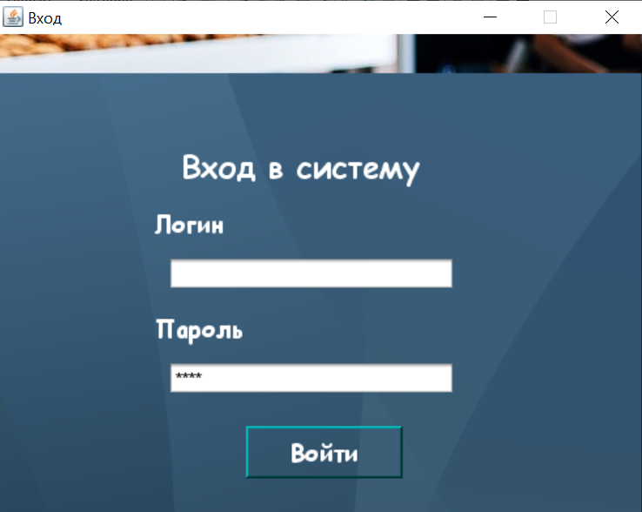

**Код:**

/*

* To change this license header, choose License Headers in Project Properties.

* To change this template file, choose Tools | Templates

* and open the template in the editor.

*/

package plant;

import java.sql.*;

import javax.swing.*;

/**

*

* @author

*/

public class NewJFrame extends javax.swing.JFrame {

String stat="";

String name="";

/**

* Creates new form NewJFrame

*/

public NewJFrame() {

initComponents();

}

/**

* This method is called from within the constructor to initialize the form.

* WARNING: Do NOT modify this code. The content of this method is always

* regenerated by the Form Editor.

*/

@SuppressWarnings("unchecked")

// <editor-fold defaultstate="collapsed" desc="Generated Code">

private void initComponents() {

jSeparator1 = new javax.swing.JSeparator();

jPanel1 = new javax.swing.JPanel();

jButton1 = new javax.swing.JButton();

jLabel1 = new javax.swing.JLabel();

jLabel2 = new javax.swing.JLabel();

jTextField1 = new javax.swing.JTextField();

jTextField2 = new javax.swing.JPasswordField();

jButton2 = new javax.swing.JButton();

jLabel3 = new javax.swing.JLabel();

jLabel4 = new javax.swing.JLabel();

setDefaultCloseOperation(javax.swing.WindowConstants.EXIT_ON_CLOSE);

setBackground(new java.awt.Color(0, 0, 51));

getContentPane().setLayout(new org.netbeans.lib.awtextra.AbsoluteLayout());

getContentPane().add(jSeparator1, new org.netbeans.lib.awtextra.AbsoluteConstraints(700, 1619, 508, -1));

jPanel1.setBackground(new java.awt.Color(0, 0, 51));

jButton1.setBackground(new java.awt.Color(0, 0, 51));

jButton1.setFont(new java.awt.Font("Times New Roman", 0, 24)); // NOI18N

jButton1.setForeground(new java.awt.Color(255, 255, 255));

jButton1.setText("Вход");

jButton1.addActionListener(new java.awt.event.ActionListener() {

public void actionPerformed(java.awt.event.ActionEvent evt) {

jButton1ActionPerformed(evt);

}

});

jLabel1.setFont(new java.awt.Font("Times New Roman", 0, 24)); // NOI18N

jLabel1.setForeground(new java.awt.Color(255, 255, 255));

jLabel1.setText("Логин");

jLabel2.setFont(new java.awt.Font("Times New Roman", 0, 24)); // NOI18N

jLabel2.setForeground(new java.awt.Color(255, 255, 255));

jLabel2.setText("Пароль");

jTextField1.setFont(new java.awt.Font("Times New Roman", 0, 24)); // NOI18N

jTextField2.setFont(new java.awt.Font("Times New Roman", 0, 24)); // NOI18N

jButton2.setBackground(new java.awt.Color(0, 0, 51));

jButton2.setFont(new java.awt.Font("Times New Roman", 0, 18)); // NOI18N

jButton2.setForeground(new java.awt.Color(255, 255, 255));

jButton2.setText("Выход");

jButton2.addActionListener(new java.awt.event.ActionListener() {

public void actionPerformed(java.awt.event.ActionEvent evt) {

jButton2ActionPerformed(evt);

}

});

jLabel3.setFont(new java.awt.Font("Times New Roman", 3, 36)); // NOI18N

jLabel3.setForeground(new java.awt.Color(204, 204, 204));

jLabel3.setText("Авторизация");

javax.swing.GroupLayout jPanel1Layout = new javax.swing.GroupLayout(jPanel1);

jPanel1.setLayout(jPanel1Layout);

jPanel1Layout.setHorizontalGroup(

jPanel1Layout.createParallelGroup(javax.swing.GroupLayout.Alignment.LEADING)

.addGroup(jPanel1Layout.createSequentialGroup()

.addGroup(jPanel1Layout.createParallelGroup(javax.swing.GroupLayout.Alignment.LEADING)

.addGroup(jPanel1Layout.createSequentialGroup()

.addGroup(jPanel1Layout.createParallelGroup(javax.swing.GroupLayout.Alignment.LEADING)

.addGroup(jPanel1Layout.createSequentialGroup()

.addGap(275, 275, 275)

.addComponent(jLabel1, javax.swing.GroupLayout.PREFERRED_SIZE, 89, javax.swing.GroupLayout.PREFERRED_SIZE)

.addGap(38, 38, 38))

.addGroup(javax.swing.GroupLayout.Alignment.TRAILING, jPanel1Layout.createSequentialGroup()

.addContainerGap()

.addComponent(jLabel2, javax.swing.GroupLayout.PREFERRED_SIZE, 89, javax.swing.GroupLayout.PREFERRED_SIZE)

.addGap(49, 49, 49)))

.addGroup(jPanel1Layout.createParallelGroup(javax.swing.GroupLayout.Alignment.LEADING)

.addComponent(jTextField2, javax.swing.GroupLayout.PREFERRED_SIZE, 390, javax.swing.GroupLayout.PREFERRED_SIZE)

.addComponent(jTextField1, javax.swing.GroupLayout.PREFERRED_SIZE, 390, javax.swing.GroupLayout.PREFERRED_SIZE)

.addComponent(jButton1, javax.swing.GroupLayout.PREFERRED_SIZE, 390, javax.swing.GroupLayout.PREFERRED_SIZE)

.addComponent(jButton2, javax.swing.GroupLayout.PREFERRED_SIZE, 390, javax.swing.GroupLayout.PREFERRED_SIZE)))

.addGroup(jPanel1Layout.createSequentialGroup()

.addGap(488, 488, 488)

.addComponent(jLabel3)))

.addContainerGap(408, Short.MAX_VALUE))

);

jPanel1Layout.setVerticalGroup(

jPanel1Layout.createParallelGroup(javax.swing.GroupLayout.Alignment.LEADING)

.addGroup(jPanel1Layout.createSequentialGroup()

.addContainerGap()

.addComponent(jLabel3)

.addGap(18, 18, 18)

.addGroup(jPanel1Layout.createParallelGroup(javax.swing.GroupLayout.Alignment.BASELINE)

.addComponent(jTextField1, javax.swing.GroupLayout.PREFERRED_SIZE, 34, javax.swing.GroupLayout.PREFERRED_SIZE)

.addComponent(jLabel1))

.addGap(18, 18, 18)

.addGroup(jPanel1Layout.createParallelGroup(javax.swing.GroupLayout.Alignment.BASELINE)

.addComponent(jTextField2, javax.swing.GroupLayout.PREFERRED_SIZE, javax.swing.GroupLayout.DEFAULT_SIZE, javax.swing.GroupLayout.PREFERRED_SIZE)

.addComponent(jLabel2))

.addGap(18, 18, 18)

.addComponent(jButton1, javax.swing.GroupLayout.PREFERRED_SIZE, 43, javax.swing.GroupLayout.PREFERRED_SIZE)

.addGap(7, 7, 7)

.addComponent(jButton2, javax.swing.GroupLayout.PREFERRED_SIZE, 37, javax.swing.GroupLayout.PREFERRED_SIZE)

.addContainerGap(23, Short.MAX_VALUE))

);

getContentPane().add(jPanel1, new org.netbeans.lib.awtextra.AbsoluteConstraints(0, 650, -1, -1));

jLabel4.setIcon(new javax.swing.ImageIcon(getClass().getResource("/plant/Chrome_Beauty_1 (1).gif"))); // NOI18N

jLabel4.setText(" ");

getContentPane().add(jLabel4, new org.netbeans.lib.awtextra.AbsoluteConstraints(0, 0, -1, 640));

pack();

setLocationRelativeTo(null);

}// </editor-fold>

private void jButton1ActionPerformed(java.awt.event.ActionEvent evt) {

// TODO add your handling code here:

try{

Class.forName("com.microsoft.sqlserver.jdbc.SQLServerDriver");

String url="jdbc:sqlserver://localhost:1433;databaseName=Завод;user=uzakov;password=123";

Connection con = DriverManager.getConnection(url);

String sql = "Select * from Диспетчеры where login=? and password = ? and Статус=?";

PreparedStatement pst = con.prepareStatement(sql);

pst.setString(1, jTextField1.getText());

pst.setString(2, jTextField2.getText());

pst.setString(3, "admin");

name=jTextField1.getText();

ResultSet rs = pst.executeQuery();

if(rs.next()){

JOptionPane.showMessageDialog(null, "Авторизация успешно выполнено! Добро пожаловать в систему Админ!");

stat="admin";

mainPanel field= new mainPanel();

field.txtUser.setText(name);

field.jPanel9.setVisible(false);

field.setVisible(true);

setVisible(false);

}else{

String sql2 = "Select * from Диспетчеры where login=? and password = ? and Статус=?";

PreparedStatement pst2 = con.prepareStatement(sql2);

pst2.setString(1, jTextField1.getText());

pst2.setString(2, jTextField2.getText());

pst2.setString(3, "user");

ResultSet rs2 = pst2.executeQuery();

if(rs2.next()){

JOptionPane.showMessageDialog(null, "Авторизация успешно выполнено! Добро пожаловать в систему Пользователь!");

stat="user";

mainPanel field= new mainPanel();

field.jPanel6.setVisible(false);

field.jPanel8.setVisible(false);

field.txtUser.setText(name);

field.setVisible(true);

setVisible(false);

}

else{

String sql3 = "Select * from Диспетчеры where login=? and password = ? and Статус=?";

PreparedStatement pst3 = con.prepareStatement(sql2);

pst3.setString(1, jTextField1.getText());

pst3.setString(2, jTextField2.getText());

pst3.setString(3, "accountant");

ResultSet rs3 = pst3.executeQuery();

if(rs3.next()){

JOptionPane.showMessageDialog(null, "Авторизация успешно выполнено! Добро пожаловать в систему!");

stat="accountant";

mainPanelBuh field= new mainPanelBuh();

field.txtUser.setText(name);

field.setVisible(true);

setVisible(false);

} else{

JOptionPane.showMessageDialog(null, "Ошибка! Неверный логин или пароль!");

jTextField1.setText("");

jTextField2.setText("");

}

}

}

con.close();

}

catch(Exception e){

JOptionPane.showMessageDialog(null, e);

}

}

private void jButton2ActionPerformed(java.awt.event.ActionEvent evt) {

// TODO add your handling code here:

System.exit(0);

}

/**

* @param args the command line arguments

*/

public static void main(String args[]) {

/* Set the Nimbus look and feel */

//<editor-fold defaultstate="collapsed" desc=" Look and feel setting code (optional) ">

/* If Nimbus (introduced in Java SE 6) is not available, stay with the default look and feel.

* For details see http://download.oracle.com/javase/tutorial/uiswing/lookandfeel/plaf.html

*/

try {

for (javax.swing.UIManager.LookAndFeelInfo info : javax.swing.UIManager.getInstalledLookAndFeels()) {

if ("Nimbus".equals(info.getName())) {

javax.swing.UIManager.setLookAndFeel(info.getClassName());

break;

}

}

} catch (ClassNotFoundException ex) {

java.util.logging.Logger.getLogger(NewJFrame.class.getName()).log(java.util.logging.Level.SEVERE, null, ex);

} catch (InstantiationException ex) {

java.util.logging.Logger.getLogger(NewJFrame.class.getName()).log(java.util.logging.Level.SEVERE, null, ex);

} catch (IllegalAccessException ex) {

java.util.logging.Logger.getLogger(NewJFrame.class.getName()).log(java.util.logging.Level.SEVERE, null, ex);

} catch (javax.swing.UnsupportedLookAndFeelException ex) {

java.util.logging.Logger.getLogger(NewJFrame.class.getName()).log(java.util.logging.Level.SEVERE, null, ex);

}

//</editor-fold>

//</editor-fold>

/* Create and display the form */

java.awt.EventQueue.invokeLater(new Runnable() {

public void run() {

new NewJFrame().setVisible(true);

}

});

}

// Variables declaration - do not modify

private javax.swing.JButton jButton1;

private javax.swing.JButton jButton2;

private javax.swing.JLabel jLabel1;

private javax.swing.JLabel jLabel2;

private javax.swing.JLabel jLabel3;

private javax.swing.JLabel jLabel4;

private javax.swing.JPanel jPanel1;

private javax.swing.JSeparator jSeparator1;

private javax.swing.JTextField jTextField1;

private javax.swing.JPasswordField jTextField2;

// End of variables declaration

}

* Форма Payments_ex**.java**

Форма для бухгалтера предназначен для выдачи заработной платы соотрудникам и оформление кредита.

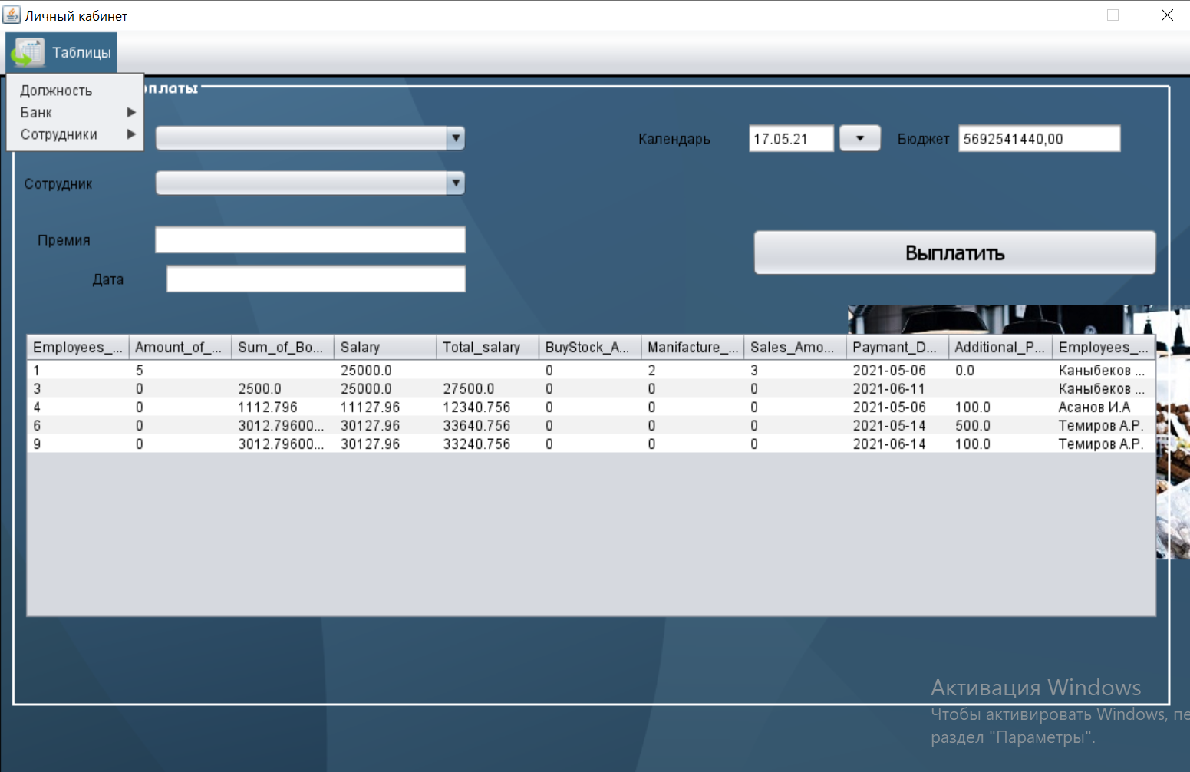

**Код:**

/*

/*

* To change this license header, choose License Headers in Project Properties.

* To change this template file, choose Tools | Templates

* and open the template in the editor.

*/

package bakery;

import javax.swing.table.DefaultTableModel;

//import ketchupproduction.*;

import java.awt.Color;

import java.awt.Font;

import java.awt.Toolkit;

import java.sql.CallableStatement;

import java.sql.Connection;

import java.sql.PreparedStatement;

import java.sql.ResultSet;

import java.sql.Statement;

import java.text.SimpleDateFormat;

import java.time.LocalDate;

import java.util.Date;

import javafx.scene.control.DatePicker;

import javax.swing.ImageIcon;

import javax.swing.JOptionPane;

import javax.swing.table.TableModel;

import net.proteanit.sql.DbUtils;

import net.sf.jasperreports.engine.JasperCompileManager;

import net.sf.jasperreports.engine.JasperFillManager;

import net.sf.jasperreports.engine.JasperPrint;

import net.sf.jasperreports.engine.JasperReport;

import net.sf.jasperreports.engine.design.JRDesignQuery;

import net.sf.jasperreports.engine.design.JasperDesign;

import net.sf.jasperreports.engine.xml.JRXmlLoader;

import net.sf.jasperreports.view.JasperViewer;

/**

*

* @author Mirik

*/

public class Payments_ex extends javax.swing.JFrame {

Connection conn = null;

Statement st = null;

ResultSet rs = null;

String id_buyer = "";

boolean customizeWpnTable = false;

boolean customizeAccountTable = false;

boolean customizeDocumentTable = false;

boolean customizeOrderTable = false;

CallableStatement stored_pro = null;

private void UpdateBudjet(){

try{

conn = ConnectMsSql.ConnectDB();

String insert = "SELECT Kolichestvo_deneg_v_budgete FROM Budget";

PreparedStatement pst = conn.prepareStatement(insert);

ResultSet res = pst.executeQuery();

st = conn.createStatement();

res = st.executeQuery(insert);

while(res.next()){

BudjetTxt.setText(String.format("%.2f", res.getFloat("Kolichestvo_deneg_v_budgete")));

}

conn.close();

}

catch(Exception e){

JOptionPane.showMessageDialog(null, e);

}

}

private void GetEmloyee(){

// try{

// conn = ConnectMsSql.ConnectDB();

// //String query = "SELECT full_name FROM Employees WHERE login=" + KetchupProduction.id;

// // PreparedStatement pst = conn.prepareStatement(query);

// // rs = pst.executeQuery();

//

// while(rs.next()){

// BuhNameTxt.setText(rs.getString("Name"));

// }

//

// conn.close();

// }

// catch(Exception e){

// JOptionPane.showMessageDialog(null, e);

// }

}

private void UpdateJTable(){

}

void DefaultValues(){

LocalDate date = LocalDate.now(); // получаем текущую дату

int year = date.getYear();

// YearTxt.setText(String.valueOf(year));

SimpleDateFormat formatter = new SimpleDateFormat("dd.MM.yyyy");

Date pickerDate = new Date();

JDatePicker.setDate(pickerDate);

conn = ConnectMsSql.ConnectDB();

// String sql = "SELECT full_name FROM employees WHERE id ='"+KetchupProduction.id+"'";

try

{

st = conn.createStatement();

// ResultSet rs = st.executeQuery(sql);

while (rs.next())

{

BuhNameTxt.setText(rs.getString(1));

}

//MonthComboBox.setSelectedIndex(-1);

}

catch (Exception e)

{

e.printStackTrace();

}

}

void ComboboxMonth() {

conn = ConnectMsSql.ConnectDB();

String sql = "SELECT name FROM month";

try {

st = conn.createStatement();

ResultSet rs = st.executeQuery(sql);

while (rs.next())

{

//MonthComboBox.addItem(rs.getString(1));

}

// MonthComboBox.setSelectedIndex(-1);

}

catch (Exception e) {

e.printStackTrace();

}

}

/**

* Creates new form client_main_form

*/

public Payments_ex() {

initComponents();

UpdateBudjet();

GetEmloyee();

ComboboxPos();

ComboboxMonth();

DefaultValues();

//UpdateJTable();

// setIconImage(Toolkit.getDefaultToolkit().getImage(getClass().getResource("tomato-sauce.png")));

}

/**

* This method is called from within the constructor to initialize the form.

* WARNING: Do NOT modify this code. The content of this method is always

* regenerated by the Form Editor.

*/

@SuppressWarnings("unchecked")

// <editor-fold defaultstate="collapsed" desc="Generated Code">

private void initComponents() {

desktopPane = new javax.swing.JDesktopPane();

statusBar = new javax.swing.JLabel();

wpnTableborder = new javax.swing.JPanel();

jLabel3 = new javax.swing.JLabel();

JDatePicker = new org.jdesktop.swingx.JXDatePicker();

PosComboBox = new javax.swing.JComboBox<>();

jLabel5 = new javax.swing.JLabel();

jLabel6 = new javax.swing.JLabel();

EmpComboBox = new javax.swing.JComboBox<>();

jScrollPane1 = new javax.swing.JScrollPane();

EmployeeTable = new javax.swing.JTable();

PaySumTxt = new javax.swing.JTextField();

jLabel8 = new javax.swing.JLabel();

BudjetTxt = new javax.swing.JTextField();

jLabel9 = new javax.swing.JLabel();

jLabel11 = new javax.swing.JLabel();

BuhNameTxt = new javax.swing.JTextField();

PayBtn = new javax.swing.JButton();

background = new javax.swing.JLabel();

jMenuBar1 = new javax.swing.JMenuBar();

jMenu1 = new javax.swing.JMenu();

jMenuItem1 = new javax.swing.JMenuItem();

jMenu4 = new javax.swing.JMenu();

jMenu6 = new javax.swing.JMenu();

setDefaultCloseOperation(javax.swing.WindowConstants.DISPOSE_ON_CLOSE);

setTitle("Личный кабинет");

setResizable(false);

addWindowListener(new java.awt.event.WindowAdapter() {

public void windowActivated(java.awt.event.WindowEvent evt) {

formWindowActivated(evt);

}

public void windowClosing(java.awt.event.WindowEvent evt) {

formWindowClosing(evt);

}

});

desktopPane.setBackground(new java.awt.Color(51, 51, 51));

desktopPane.setBorder(javax.swing.BorderFactory.createLineBorder(new java.awt.Color(0, 0, 0), 2));

statusBar.setFont(new java.awt.Font("Comic Sans MS", 1, 12)); // NOI18N

statusBar.setForeground(new java.awt.Color(255, 0, 0));

statusBar.setBorder(javax.swing.BorderFactory.createLineBorder(new java.awt.Color(0, 0, 0)));

desktopPane.add(statusBar);

statusBar.setBounds(0, 620, 1040, 20);

wpnTableborder.setBorder(javax.swing.BorderFactory.createTitledBorder(new javax.swing.border.LineBorder(new java.awt.Color(255, 255, 255), 2, true), "Начисление зарплаты", javax.swing.border.TitledBorder.LEFT, javax.swing.border.TitledBorder.TOP, new java.awt.Font("Comic Sans MS", 1, 14), new java.awt.Color(255, 255, 255))); // NOI18N

wpnTableborder.setFont(new java.awt.Font("Comic Sans MS", 1, 14)); // NOI18N

wpnTableborder.setOpaque(false);

jLabel3.setText("Календарь");

JDatePicker.addActionListener(new java.awt.event.ActionListener() {

public void actionPerformed(java.awt.event.ActionEvent evt) {

JDatePickerActionPerformed(evt);

}

});

PosComboBox.addActionListener(new java.awt.event.ActionListener() {

public void actionPerformed(java.awt.event.ActionEvent evt) {

PosComboBoxActionPerformed(evt);

}

});

jLabel5.setText("Сотрудник");

jLabel6.setText("Премия");

EmpComboBox.addActionListener(new java.awt.event.ActionListener() {

public void actionPerformed(java.awt.event.ActionEvent evt) {

EmpComboBoxActionPerformed(evt);

}

});

EmployeeTable.addMouseListener(new java.awt.event.MouseAdapter() {

public void mouseClicked(java.awt.event.MouseEvent evt) {

EmployeeTableMouseClicked(evt);

}

});

jScrollPane1.setViewportView(EmployeeTable);

jLabel8.setText("Бюджет");

jLabel9.setText("Должность");

jLabel11.setText("Дата");

PayBtn.setFont(new java.awt.Font("Tahoma", 0, 18)); // NOI18N

PayBtn.setText("Выплатить");

PayBtn.addActionListener(new java.awt.event.ActionListener() {

public void actionPerformed(java.awt.event.ActionEvent evt) {

PayBtnActionPerformed(evt);

}

});

javax.swing.GroupLayout wpnTableborderLayout = new javax.swing.GroupLayout(wpnTableborder);

wpnTableborder.setLayout(wpnTableborderLayout);

wpnTableborderLayout.setHorizontalGroup(

wpnTableborderLayout.createParallelGroup(javax.swing.GroupLayout.Alignment.LEADING)

.addGroup(wpnTableborderLayout.createSequentialGroup()

.addContainerGap()

.addGroup(wpnTableborderLayout.createParallelGroup(javax.swing.GroupLayout.Alignment.LEADING)

.addComponent(jScrollPane1)

.addGroup(wpnTableborderLayout.createSequentialGroup()

.addGroup(wpnTableborderLayout.createParallelGroup(javax.swing.GroupLayout.Alignment.LEADING, false)

.addGroup(wpnTableborderLayout.createSequentialGroup()

.addGap(60, 60, 60)

.addComponent(jLabel11)

.addGap(35, 35, 35)

.addComponent(BuhNameTxt))

.addGroup(wpnTableborderLayout.createSequentialGroup()

.addGroup(wpnTableborderLayout.createParallelGroup(javax.swing.GroupLayout.Alignment.LEADING)

.addComponent(jLabel5)

.addGroup(wpnTableborderLayout.createSequentialGroup()

.addGap(12, 12, 12)

.addComponent(jLabel6))

.addComponent(jLabel9))

.addGap(49, 49, 49)

.addGroup(wpnTableborderLayout.createParallelGroup(javax.swing.GroupLayout.Alignment.LEADING)

.addComponent(PaySumTxt, javax.swing.GroupLayout.Alignment.TRAILING, javax.swing.GroupLayout.PREFERRED_SIZE, 274, javax.swing.GroupLayout.PREFERRED_SIZE)

.addGroup(wpnTableborderLayout.createParallelGroup(javax.swing.GroupLayout.Alignment.TRAILING)

.addComponent(PosComboBox, javax.swing.GroupLayout.PREFERRED_SIZE, 274, javax.swing.GroupLayout.PREFERRED_SIZE)

.addComponent(EmpComboBox, javax.swing.GroupLayout.PREFERRED_SIZE, 274, javax.swing.GroupLayout.PREFERRED_SIZE)))))

.addGroup(wpnTableborderLayout.createParallelGroup(javax.swing.GroupLayout.Alignment.LEADING)

.addGroup(wpnTableborderLayout.createSequentialGroup()

.addPreferredGap(javax.swing.LayoutStyle.ComponentPlacement.RELATED, javax.swing.GroupLayout.DEFAULT_SIZE, Short.MAX_VALUE)

.addComponent(PayBtn, javax.swing.GroupLayout.DEFAULT_SIZE, javax.swing.GroupLayout.DEFAULT_SIZE, Short.MAX_VALUE))

.addGroup(wpnTableborderLayout.createSequentialGroup()

.addGap(148, 148, 148)

.addComponent(jLabel3)

.addPreferredGap(javax.swing.LayoutStyle.ComponentPlacement.RELATED, javax.swing.GroupLayout.DEFAULT_SIZE, Short.MAX_VALUE)

.addComponent(JDatePicker, javax.swing.GroupLayout.PREFERRED_SIZE, 119, javax.swing.GroupLayout.PREFERRED_SIZE)

.addPreferredGap(javax.swing.LayoutStyle.ComponentPlacement.UNRELATED)

.addComponent(jLabel8)

.addPreferredGap(javax.swing.LayoutStyle.ComponentPlacement.RELATED)

.addComponent(BudjetTxt, javax.swing.GroupLayout.PREFERRED_SIZE, 145, javax.swing.GroupLayout.PREFERRED_SIZE)

.addGap(31, 31, 31)))))

.addContainerGap())

);

wpnTableborderLayout.setVerticalGroup(

wpnTableborderLayout.createParallelGroup(javax.swing.GroupLayout.Alignment.LEADING)

.addGroup(wpnTableborderLayout.createSequentialGroup()

.addGap(18, 18, 18)

.addGroup(wpnTableborderLayout.createParallelGroup(javax.swing.GroupLayout.Alignment.BASELINE)

.addComponent(JDatePicker, javax.swing.GroupLayout.PREFERRED_SIZE, javax.swing.GroupLayout.DEFAULT_SIZE, javax.swing.GroupLayout.PREFERRED_SIZE)

.addComponent(jLabel3)

.addComponent(BudjetTxt, javax.swing.GroupLayout.PREFERRED_SIZE, javax.swing.GroupLayout.DEFAULT_SIZE, javax.swing.GroupLayout.PREFERRED_SIZE)

.addComponent(jLabel8)

.addComponent(PosComboBox, javax.swing.GroupLayout.PREFERRED_SIZE, javax.swing.GroupLayout.DEFAULT_SIZE, javax.swing.GroupLayout.PREFERRED_SIZE)

.addComponent(jLabel9))

.addGroup(wpnTableborderLayout.createParallelGroup(javax.swing.GroupLayout.Alignment.LEADING)

.addGroup(wpnTableborderLayout.createSequentialGroup()

.addGap(64, 64, 64)

.addComponent(PayBtn, javax.swing.GroupLayout.PREFERRED_SIZE, 43, javax.swing.GroupLayout.PREFERRED_SIZE))

.addGroup(wpnTableborderLayout.createSequentialGroup()

.addPreferredGap(javax.swing.LayoutStyle.ComponentPlacement.UNRELATED)

.addGroup(wpnTableborderLayout.createParallelGroup(javax.swing.GroupLayout.Alignment.BASELINE)

.addComponent(EmpComboBox, javax.swing.GroupLayout.PREFERRED_SIZE, javax.swing.GroupLayout.DEFAULT_SIZE, javax.swing.GroupLayout.PREFERRED_SIZE)

.addComponent(jLabel5))

.addGap(22, 22, 22)

.addGroup(wpnTableborderLayout.createParallelGroup(javax.swing.GroupLayout.Alignment.BASELINE)

.addComponent(PaySumTxt, javax.swing.GroupLayout.PREFERRED_SIZE, javax.swing.GroupLayout.DEFAULT_SIZE, javax.swing.GroupLayout.PREFERRED_SIZE)

.addComponent(jLabel6))

.addPreferredGap(javax.swing.LayoutStyle.ComponentPlacement.RELATED)

.addGroup(wpnTableborderLayout.createParallelGroup(javax.swing.GroupLayout.Alignment.BASELINE)

.addComponent(jLabel11)

.addComponent(BuhNameTxt, javax.swing.GroupLayout.PREFERRED_SIZE, javax.swing.GroupLayout.DEFAULT_SIZE, javax.swing.GroupLayout.PREFERRED_SIZE))))

.addGap(32, 32, 32)

.addComponent(jScrollPane1, javax.swing.GroupLayout.DEFAULT_SIZE, 249, Short.MAX_VALUE)

.addGap(71, 71, 71))

);

desktopPane.add(wpnTableborder);

wpnTableborder.setBounds(10, 0, 1010, 550);

background.setFont(new java.awt.Font("Comic Sans MS", 1, 14)); // NOI18N

background.setHorizontalAlignment(javax.swing.SwingConstants.RIGHT);

background.setIcon(new javax.swing.ImageIcon(getClass().getResource("/bakery/7badce0e-43e6-4890-a2c1-dc414048b270.jpg"))); // NOI18N

background.setBorder(javax.swing.BorderFactory.createLineBorder(new java.awt.Color(0, 0, 0), 2));

desktopPane.add(background);

background.setBounds(0, 0, 1040, 620);

jMenu1.setIcon(new javax.swing.ImageIcon(getClass().getResource("/bakery/.11111aaaa.png"))); // NOI18N

jMenu1.setText("Таблицы");

jMenuItem1.setText("Должность");

jMenuItem1.addActionListener(new java.awt.event.ActionListener() {

public void actionPerformed(java.awt.event.ActionEvent evt) {

jMenuItem1ActionPerformed(evt);

}

});

jMenu1.add(jMenuItem1);

jMenu4.setText("Банк");

jMenu4.addMouseListener(new java.awt.event.MouseAdapter() {

public void mouseClicked(java.awt.event.MouseEvent evt) {

jMenu4MouseClicked(evt);

}

});

jMenu1.add(jMenu4);

jMenu6.setText("Сотрудники");

jMenu6.addMouseListener(new java.awt.event.MouseAdapter() {

public void mouseClicked(java.awt.event.MouseEvent evt) {

jMenu6MouseClicked(evt);

}

});

jMenu1.add(jMenu6);

jMenuBar1.add(jMenu1);

setJMenuBar(jMenuBar1);

javax.swing.GroupLayout layout = new javax.swing.GroupLayout(getContentPane());

getContentPane().setLayout(layout);

layout.setHorizontalGroup(

layout.createParallelGroup(javax.swing.GroupLayout.Alignment.LEADING)

.addComponent(desktopPane, javax.swing.GroupLayout.DEFAULT_SIZE, 1039, Short.MAX_VALUE)

);

layout.setVerticalGroup(

layout.createParallelGroup(javax.swing.GroupLayout.Alignment.LEADING)

.addComponent(desktopPane, javax.swing.GroupLayout.DEFAULT_SIZE, 641, Short.MAX_VALUE)

);

pack();

setLocationRelativeTo(null);

}// </editor-fold>

private void formWindowClosing(java.awt.event.WindowEvent evt) {

// new Main1().setVisible(true);

// this.dispose();

}

private void PayBtnActionPerformed(java.awt.event.ActionEvent evt) {

// TODO add your handling code here:

try {

conn = ConnectMsSql.ConnectDB();

Statement st = conn.createStatement();

String test = EmpComboBox.getSelectedItem().toString();

double amount = Double.parseDouble(PaySumTxt.getText());

String date=BuhNameTxt.getText();

// phone=JDatePicker.getText();

int idProduct = 0;

ResultSet id = st.executeQuery("select ID from Employees where Name = '" + test + "'");

while (id.next()) {

idProduct = Integer.parseInt(id.getString("ID"));

}

String dobavlenie = "INSERT INTO payments_to_emp (FK_Employer, Additional_Pay, Paymant_Date) VALUES(?,?,?)";

PreparedStatement pst = conn.prepareStatement(dobavlenie);

pst.setInt(1, idProduct);

pst.setDouble(2, amount);

pst.setString(3, date);

JOptionPane.showMessageDialog(null, "Данные успешно добавленны.");

pst.executeUpdate();

} catch (Exception e) {

JOptionPane.showMessageDialog(null, e);

}

/*Регистрация гражданина в БД*/

}

private void EmployeeTableMouseClicked(java.awt.event.MouseEvent evt) {

// TODO add your handling code here:

try{

conn = ConnectMsSql.ConnectDB();

// int row = jTable1.getSelectedRow();

// String name = (jTable1.getModel().getValueAt(row,0).toString());

int i=EmployeeTable.getSelectedRow();

TableModel model=EmployeeTable.getModel();

// NameTxt.setText(model.getValueAt(i,0).toString());

// PositionTxt.setText(model.getValueAt(i,1).toString());

// SalaryTxt.setText(model.getValueAt(i,2).toString());

// adressTxt.setText(model.getValueAt(i,3).toString());

// phoneTxt.setText(model.getValueAt(i,4).toString());

// phoneTxt1.setText(model.getValueAt(i,6).toString());

// String sql = "SELECT Employees.Name,Position.Position as pos,Employees.Final_sallary, Employees.Address, Employees.Phone,Employees.Nadbavka FROM Employees INNER JOIN Position ON Employees.Position = Position.ID WHERE Employees.Name ='" + name + "'";

// PreparedStatement pst=conn.prepareStatement(sql);

// ResultSet rs = pst.executeQuery();

// statement = conn.createStatement();

// rs = statement.executeQuery(sql);

//

// while(rs.next()){

// NameTxt.setText(rs.getString("Name"));

// PositionTxt.setText(rs.getString("pos"));

// SalaryTxt.setText(rs.getString("Final_sallary"));

// adressTxt.setText(rs.getString("Address"));

// phoneTxt.setText(rs.getString("Phone"));

// phoneTxt1.setText(rs.getString("Nadbavka"));

// }

}

catch(Exception e){

System.out.println("Error");

}

}

private void formWindowActivated(java.awt.event.WindowEvent evt) {

// TODO add your handling code here:

try{

conn = ConnectMsSql.ConnectDB();

//String sql = "SELECT Employees.Name,Position.Position as pos,Employees.Final_sallary, Employees.Address, Employees.Phone FROM Employees INNER JOIN Position ON Employees.Position = Position.ID WHERE Employees.Name ='" + name + "'";

String sql = "SELECT\n" +

" payments_to_emp.\"ID_salary\" AS payments_to_emp_ID_salary,\n" +

" payments_to_emp.\"Amount_of_work\" AS payments_to_emp_Amount_of_work,\n" +

" payments_to_emp.\"Sum_of_Bonus\" AS payments_to_emp_Sum_of_Bonus,\n" +

" payments_to_emp.\"Salary\" AS payments_to_emp_Salary,\n" +

" payments_to_emp.\"Total_salary\" AS payments_to_emp_Total_salary,\n" +

" payments_to_emp.\"BuyStock_Amount\" AS payments_to_emp_BuyStock_Amount,\n" +

" payments_to_emp.\"Manifacture_Amount\" AS payments_to_emp_Manifacture_Amount,\n" +

" payments_to_emp.\"Sales_Amount\" AS payments_to_emp_Sales_Amount,\n" +

" payments_to_emp.\"Paymant_Date\" AS payments_to_emp_Paymant_Date,\n" +

" payments_to_emp.\"Additional_Pay\" AS payments_to_emp_Additional_Pay,\n" +

" Employees.\"Name\" AS Employees_Name\n" +

"FROM\n" +

" \"dbo\".\"Employees\" Employees INNER JOIN \"dbo\".\"payments_to_emp\" payments_to_emp ON Employees.\"ID\" = payments_to_emp.\"FK_Employer\"";

Statement statement = conn.createStatement();

rs = statement.executeQuery(sql);

this.EmployeeTable.setModel(DbUtils.resultSetToTableModel(rs));

EmployeeTable.getColumnModel().getColumn(0).setHeaderValue("Employees_Name");

EmployeeTable.getColumnModel().getColumn(1).setHeaderValue("Amount_of_work");

EmployeeTable.getColumnModel().getColumn(2).setHeaderValue("Sum_of_Bonus");

EmployeeTable.getColumnModel().getColumn(3).setHeaderValue("Salary");

EmployeeTable.getColumnModel().getColumn(4).setHeaderValue("Total_salary");

EmployeeTable.getColumnModel().getColumn(5).setHeaderValue("BuyStock_Amount");

EmployeeTable.getColumnModel().getColumn(6).setHeaderValue("Manifacture_Amount");

EmployeeTable.getColumnModel().getColumn(7).setHeaderValue("Sales_Amount");

EmployeeTable.getColumnModel().getColumn(8).setHeaderValue("Paymant_Date");

EmployeeTable.getColumnModel().getColumn(9).setHeaderValue("Additional_Pay");

conn.close();

}

catch(Exception e){

e.printStackTrace();

JOptionPane.showMessageDialog(null, e);

}

}

private void EmpComboBoxActionPerformed(java.awt.event.ActionEvent evt) {

// TODO add your handling code here:

}

void ComboboxPos() {

conn = ConnectMsSql.ConnectDB();

String sql = "SELECT Position FROM Position";

try {

st = conn.createStatement();

ResultSet rs = st.executeQuery(sql);

while (rs.next())

{

PosComboBox.addItem(rs.getString(1));

}

PosComboBox.setSelectedIndex(-1);

}

catch (Exception e) {

e.printStackTrace();

}

}

private void PosComboBoxActionPerformed(java.awt.event.ActionEvent evt) {

// TODO add your handling code here:

EmpComboBox.removeAllItems();

conn = ConnectMsSql.ConnectDB();

try {

String query = "SELECT ID FROM Position WHERE Position = '" + PosComboBox.getSelectedItem() + "'";

PreparedStatement pst = conn.prepareStatement(query);

rs = pst.executeQuery();

int id_pos = 0;

while(rs.next()){

id_pos = rs.getInt("id");

}

String sql = "SELECT Name FROM Employees WHERE Position = '" + id_pos + "'";

st = conn.createStatement();

ResultSet res = st.executeQuery(sql);

while (res.next())

{

EmpComboBox.addItem(res.getString(1));

}

EmpComboBox.setSelectedIndex(-1);

}

catch (Exception e) {

e.printStackTrace();

}

}

private void JDatePickerActionPerformed(java.awt.event.ActionEvent evt) {

// TODO add your handling code here:

}

private void jMenuItem1ActionPerformed(java.awt.event.ActionEvent evt) {

// TODO add your handling code here:

positions field= new positions();

field.setVisible(true);

setVisible(false);

}

private void jMenu4MouseClicked(java.awt.event.MouseEvent evt) {

// TODO add your handling code here:

cred field= new cred();

field.setVisible(true);

setVisible(false);

}

private void jMenu6MouseClicked(java.awt.event.MouseEvent evt) {

// TODO add your handling code here:

employees field= new employees();

field.setVisible(true);

setVisible(false);

}

/**

* @param args the command line arguments

*/

public static void main(String args[]) {

/* Set the Nimbus look and feel */

//<editor-fold defaultstate="collapsed" desc=" Look and feel setting code (optional) ">

/* If Nimbus (introduced in Java SE 6) is not available, stay with the default look and feel.

* For details see http://download.oracle.com/javase/tutorial/uiswing/lookandfeel/plaf.html

*/

try {

for (javax.swing.UIManager.LookAndFeelInfo info : javax.swing.UIManager.getInstalledLookAndFeels()) {

if ("Nimbus".equals(info.getName())) {

javax.swing.UIManager.setLookAndFeel(info.getClassName());

break;

}

}

} catch (ClassNotFoundException ex) {

java.util.logging.Logger.getLogger(Payments_ex.class.getName()).log(java.util.logging.Level.SEVERE, null, ex);

} catch (InstantiationException ex) {

java.util.logging.Logger.getLogger(Payments_ex.class.getName()).log(java.util.logging.Level.SEVERE, null, ex);

} catch (IllegalAccessException ex) {

java.util.logging.Logger.getLogger(Payments_ex.class.getName()).log(java.util.logging.Level.SEVERE, null, ex);

} catch (javax.swing.UnsupportedLookAndFeelException ex) {

java.util.logging.Logger.getLogger(Payments_ex.class.getName()).log(java.util.logging.Level.SEVERE, null, ex);

}

//</editor-fold>

//</editor-fold>

//</editor-fold>

//</editor-fold>

//</editor-fold>

//</editor-fold>

//</editor-fold>

//</editor-fold>

//</editor-fold>

//</editor-fold>

//</editor-fold>

//</editor-fold>

//</editor-fold>

//</editor-fold>

//</editor-fold>

//</editor-fold>

//</editor-fold>

//</editor-fold>

//</editor-fold>

//</editor-fold>

//</editor-fold>

//</editor-fold>

//</editor-fold>

//</editor-fold>

//</editor-fold>

//</editor-fold>

//</editor-fold>

//</editor-fold>

//</editor-fold>

//</editor-fold>

//</editor-fold>

//</editor-fold>

/* Create and display the form */

java.awt.EventQueue.invokeLater(new Runnable() {

public void run() {

new Payments_ex().setVisible(true);

}

});

}

// Variables declaration - do not modify

private javax.swing.JTextField BudjetTxt;

private javax.swing.JTextField BuhNameTxt;

private javax.swing.JComboBox<String> EmpComboBox;

private javax.swing.JTable EmployeeTable;

private org.jdesktop.swingx.JXDatePicker JDatePicker;

private javax.swing.JButton PayBtn;

private javax.swing.JTextField PaySumTxt;

private javax.swing.JComboBox<String> PosComboBox;

private javax.swing.JLabel background;

private javax.swing.JDesktopPane desktopPane;

private javax.swing.JLabel jLabel11;

private javax.swing.JLabel jLabel3;

private javax.swing.JLabel jLabel5;

private javax.swing.JLabel jLabel6;

private javax.swing.JLabel jLabel8;

private javax.swing.JLabel jLabel9;

private javax.swing.JMenu jMenu1;

private javax.swing.JMenu jMenu4;

private javax.swing.JMenu jMenu6;

private javax.swing.JMenuBar jMenuBar1;

private javax.swing.JMenuItem jMenuItem1;

private javax.swing.JScrollPane jScrollPane1;

private javax.swing.JLabel statusBar;

private javax.swing.JPanel wpnTableborder;

// End of variables declaration

}

1. **Реализация защищенного режима рабоыт с БД**

Защищенный режим был реализован способом работы с БД путем вызова только хранимых процедур. То есть операции CRUD выполялись в такой очередности:

* Открытие подключения к БД
* Вызов хранимой процедуры
* Закрытие подключения к БД.

В качестве примера рассмотрим выбор таблицы Сырьё:

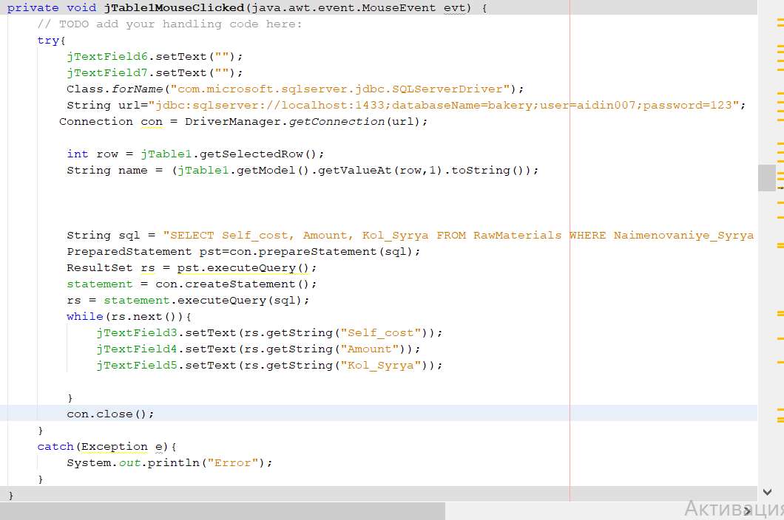

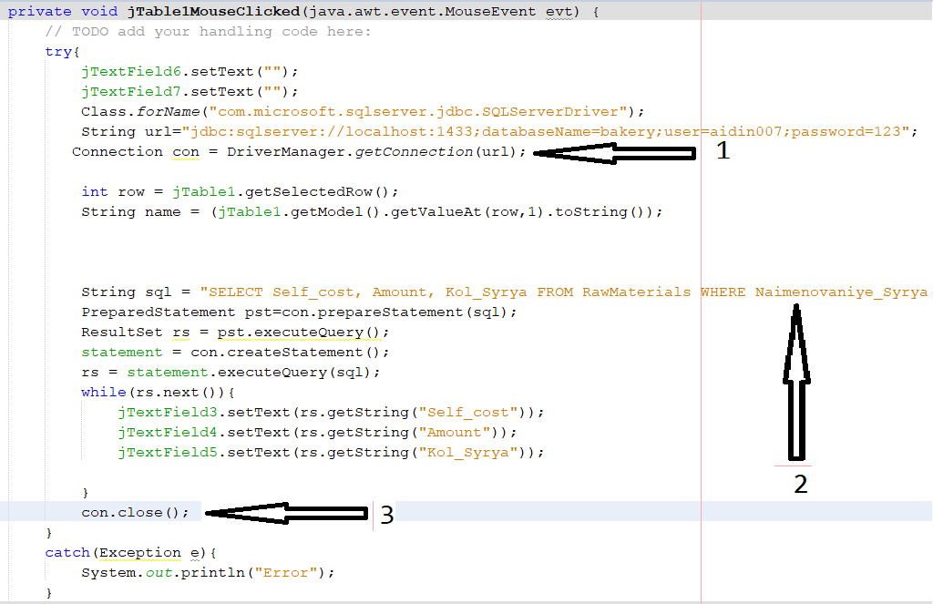

1. – Открытие подключения к БД.
2. – Объявление параметров вызова хранимой процедуры и ее вызов.
3. – Закрытие подключения.
4. **Демонстрация работы программы**

Для начала нужно войти через какого-либо сотрудника, в данном случае заходит как администратор для того что бы посмотреть весь функционал программы. (Рис. 1.1)

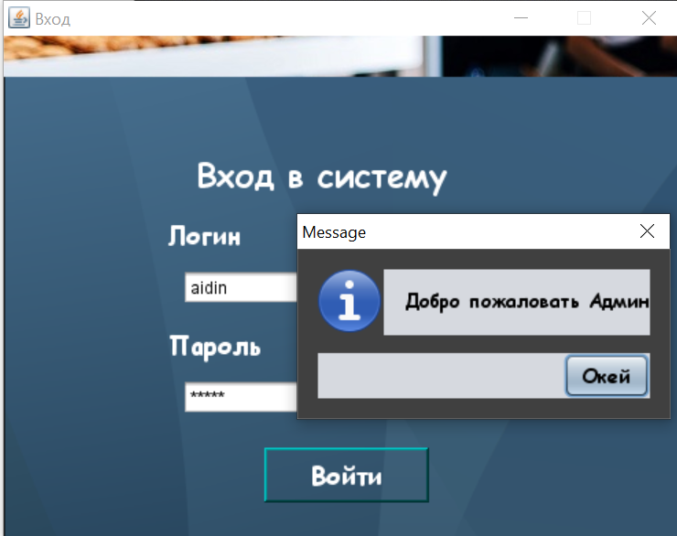

*Рис. 1.1 Форма авторизации Админа*

Затем открывается главная форма через которую можно открывать другие формы для редактирования записей, просмотра отчётов или произведения операций по кредиту, так же на главной форме можно закупить сырье либо произвести продукт, либо продать продукт (Рис. 1.2).

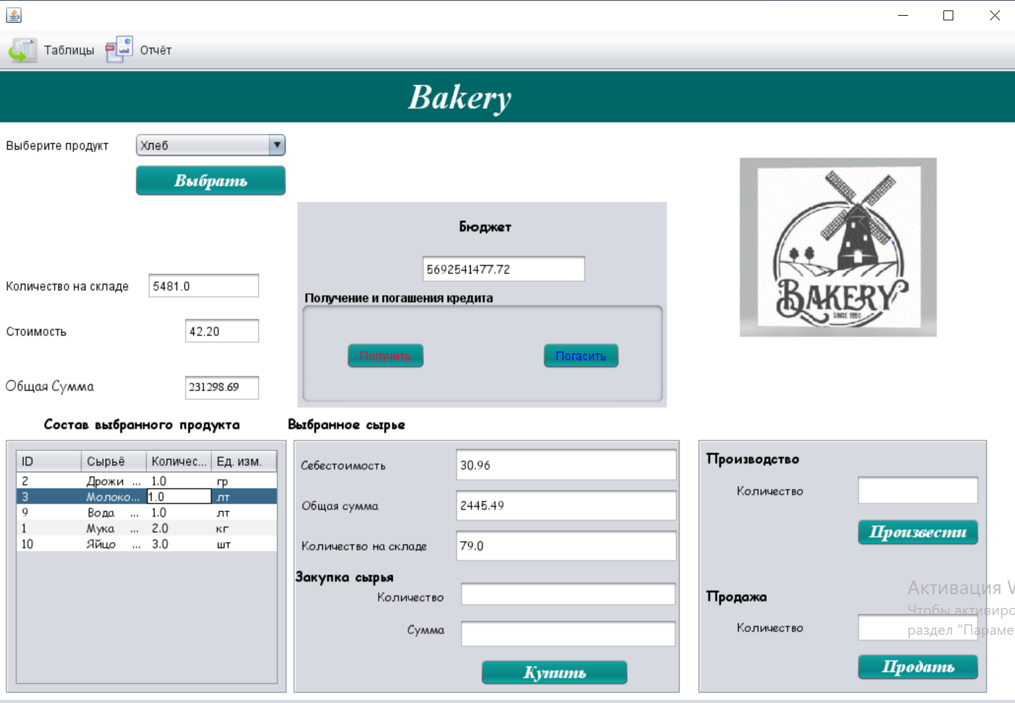

*Рис. 1.2 Главная форма*

Перейдем на форму Сотрудники, для этого в меню среди таблиц нажимаем соответствующую кнопку. И нам откроется форма (Рис.1.3).

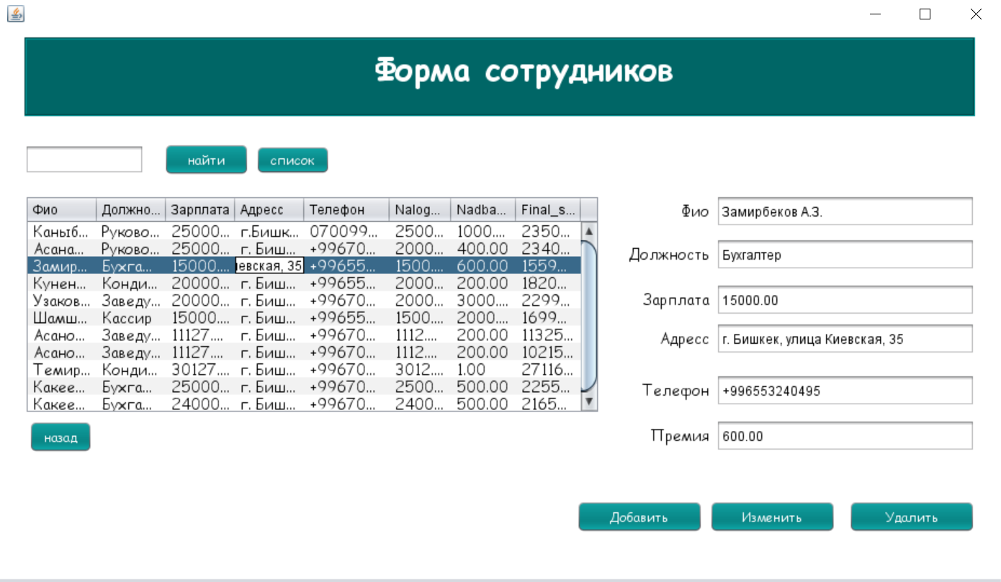

*Рис. 1.3 Форма Сотрудники*

Ниже приведены скриншоты с описание действий на данной форме:

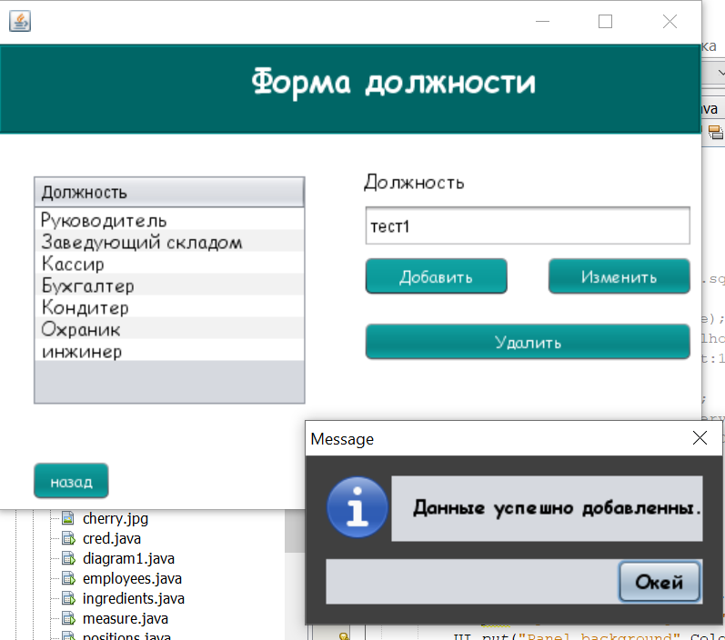

*Рис. 1.3.1 Добавление новой должности*

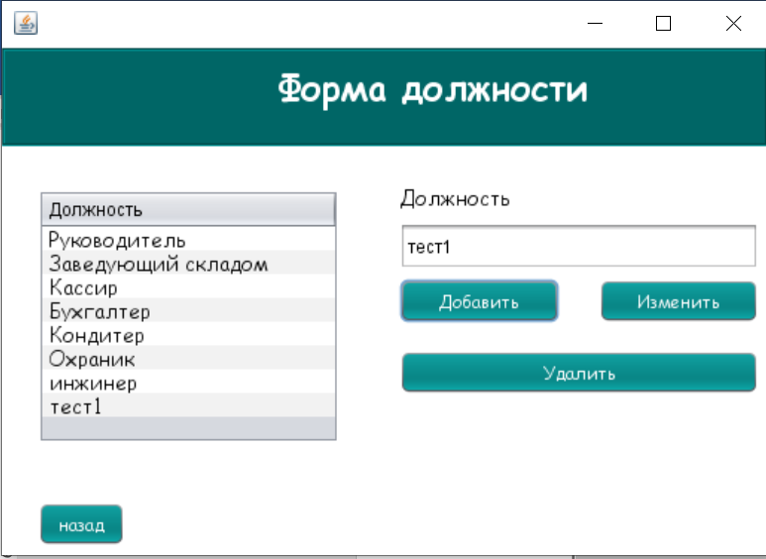

*Рис. 1.3.2 Результат добавления*

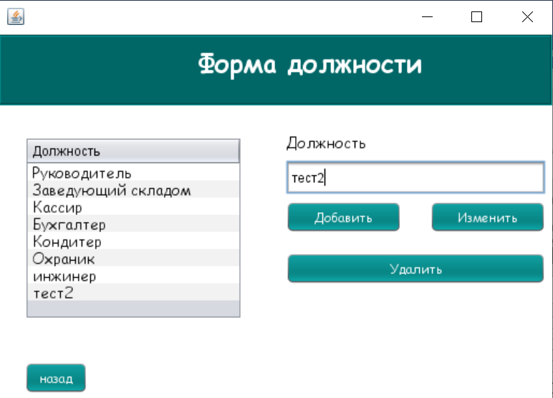

*Рис. 1.3.3 Обновление добавленной должности*

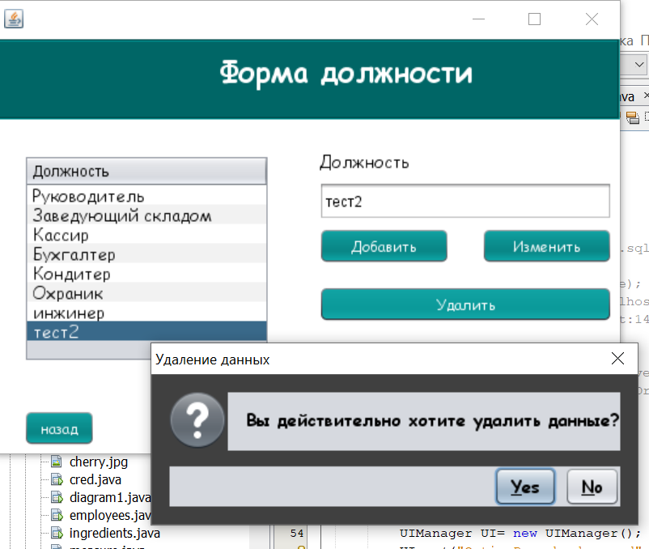

*Рис. 1.3.4 Удаление обновленной должности*

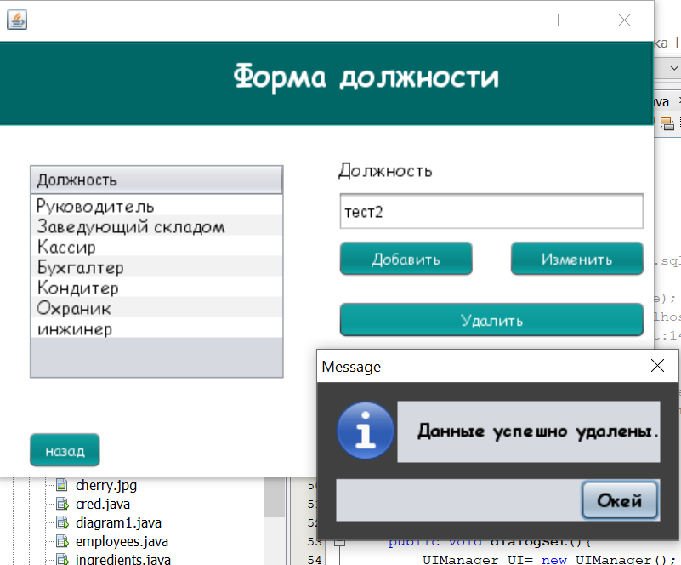

*Рис. 1.3.5 Результат удаления*

**Теперь войдем как бухгалтер**

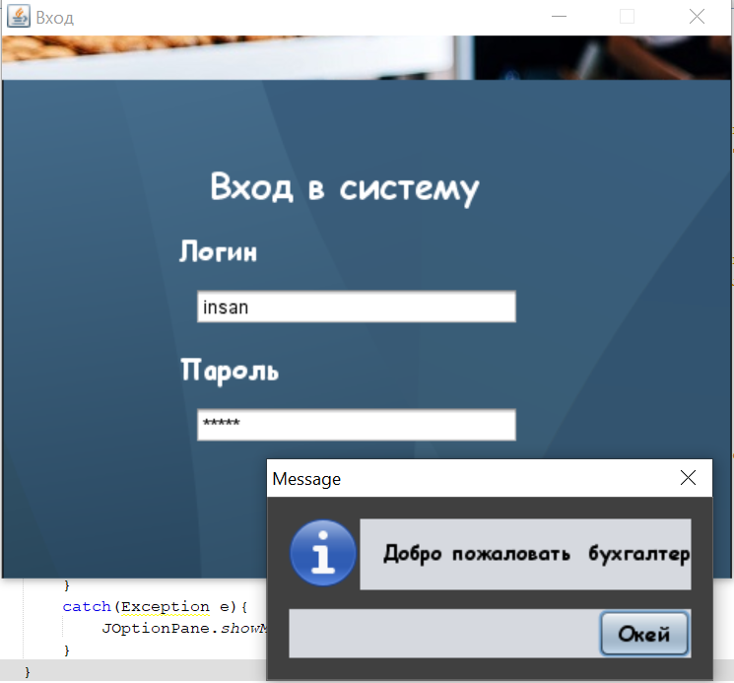

*Рис. 1.3.13 Выдача зарплаты сотрудникам*

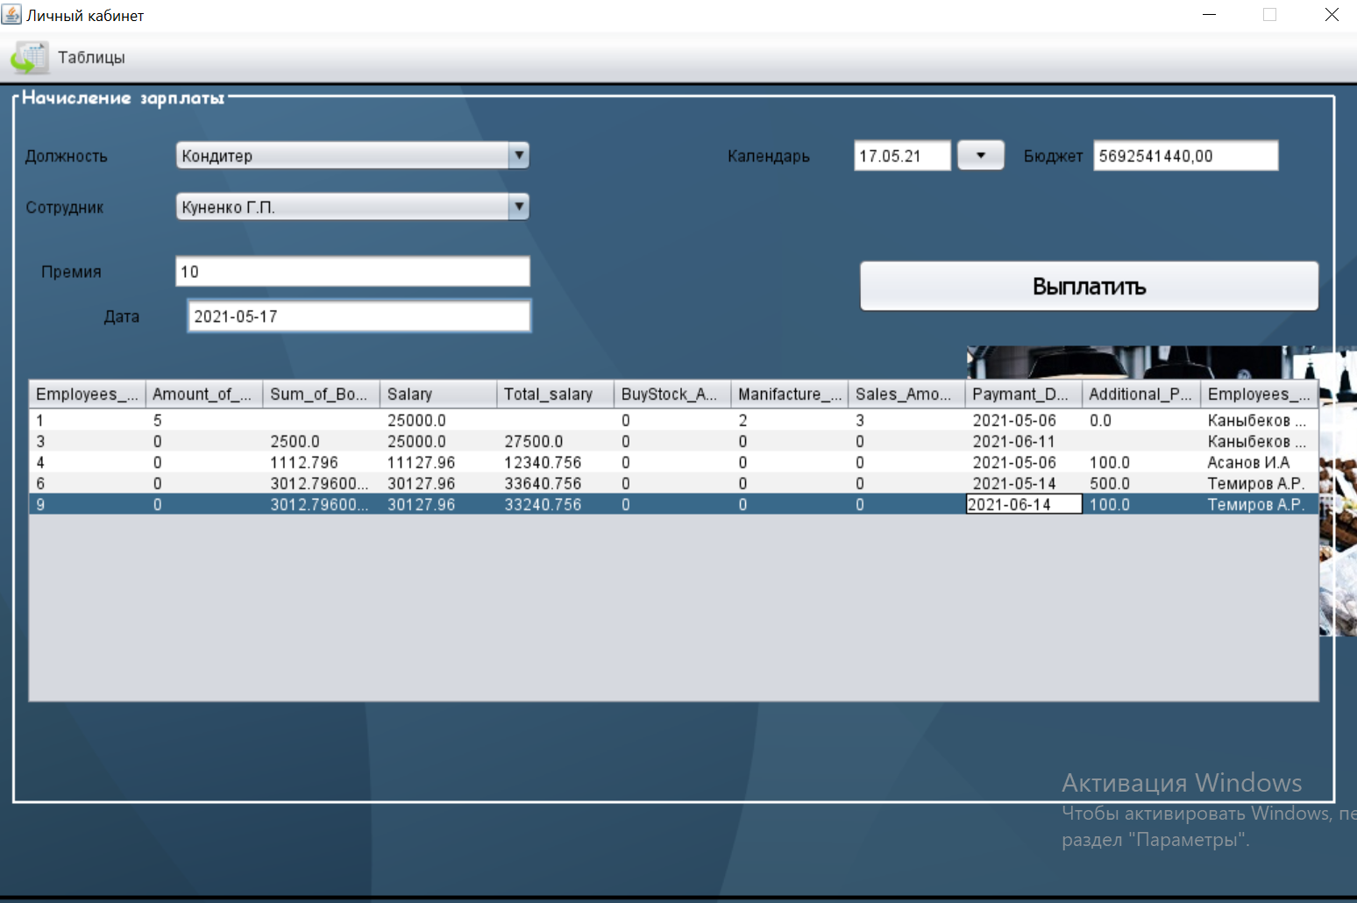

*Рис. 1.3.14 Диалоговое окно о результате выдачи зарплаты.*

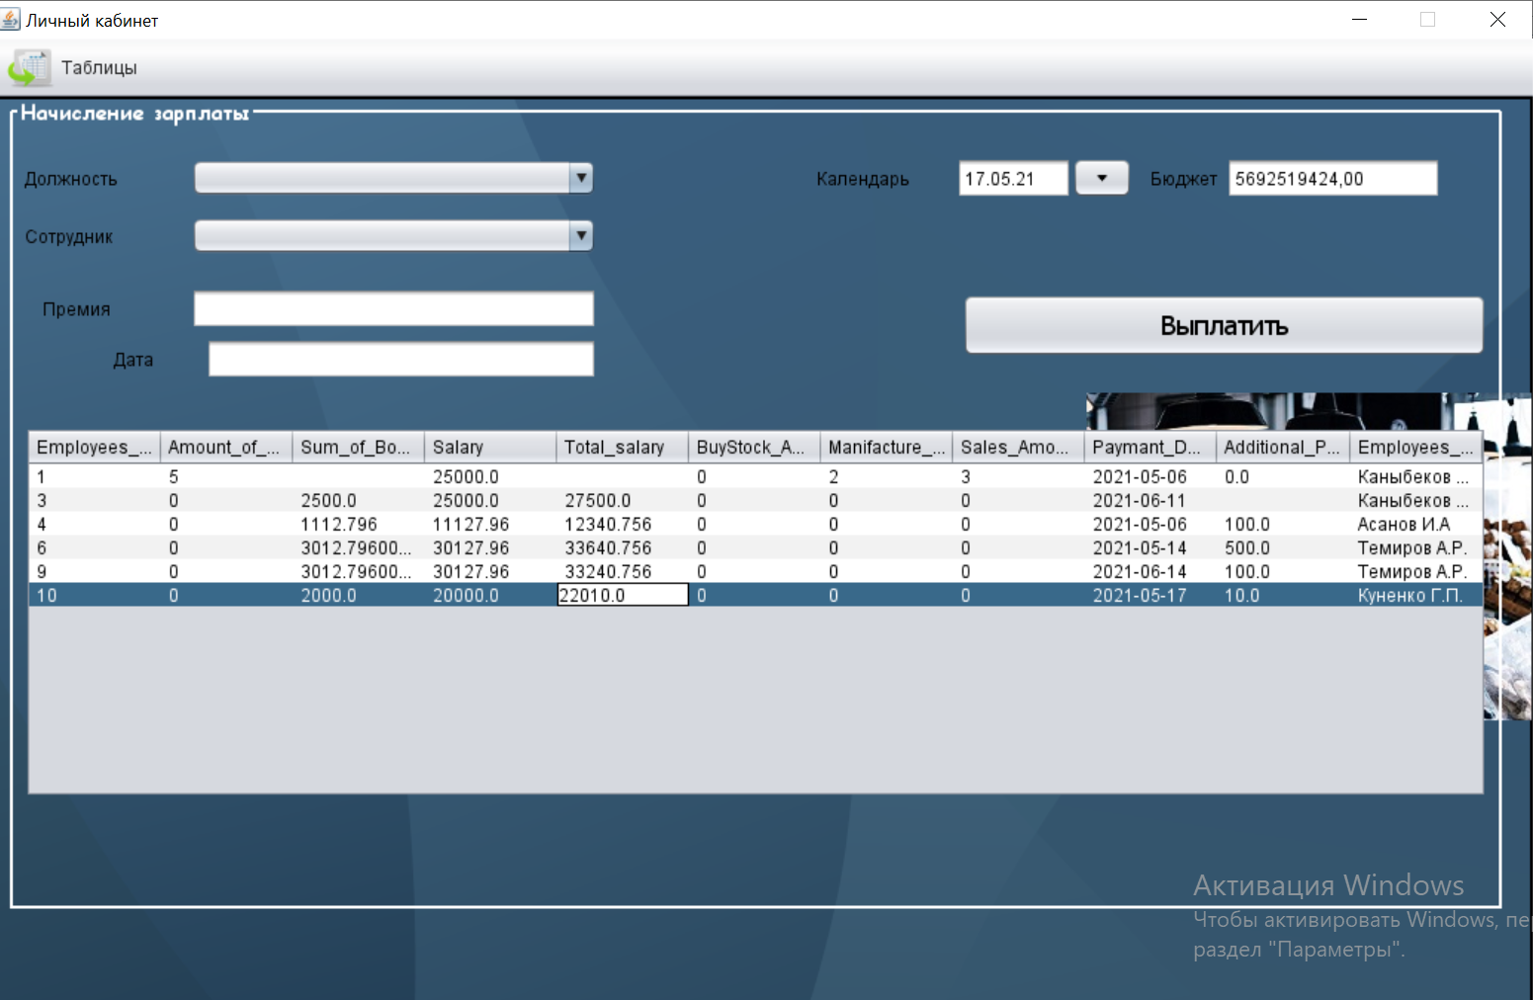

*Рис. 1.3.15 Результат выдачи зарплаты*

*Далее закрываем окну и нажимаем на банк*

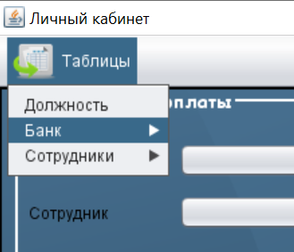

*Рис.1.3.16*

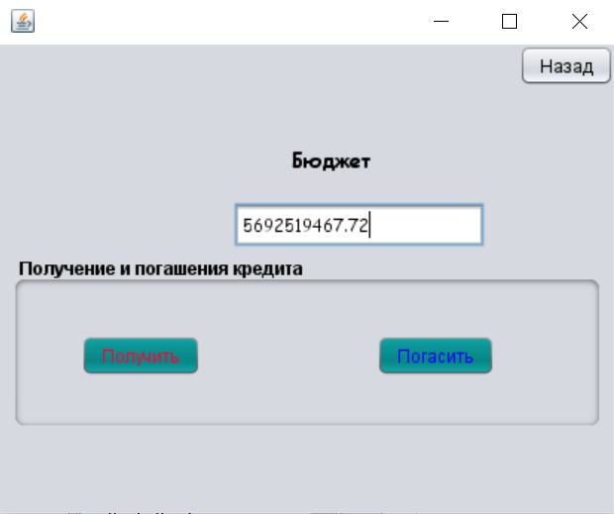

*Рис. 1.3.16*

И у нас открывается Рис. 1.3.16 и здесь мы выбираем получение кредита(Получить) или погашение кредита(Погасить)

Нажимаем на Получить

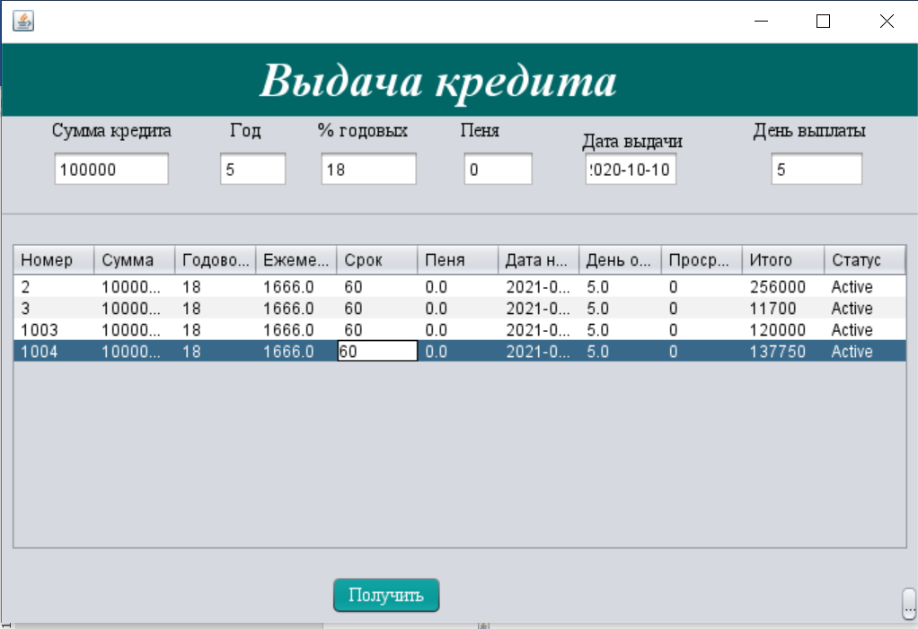

*Рис. 1.3.16 Окно для получения кредита*

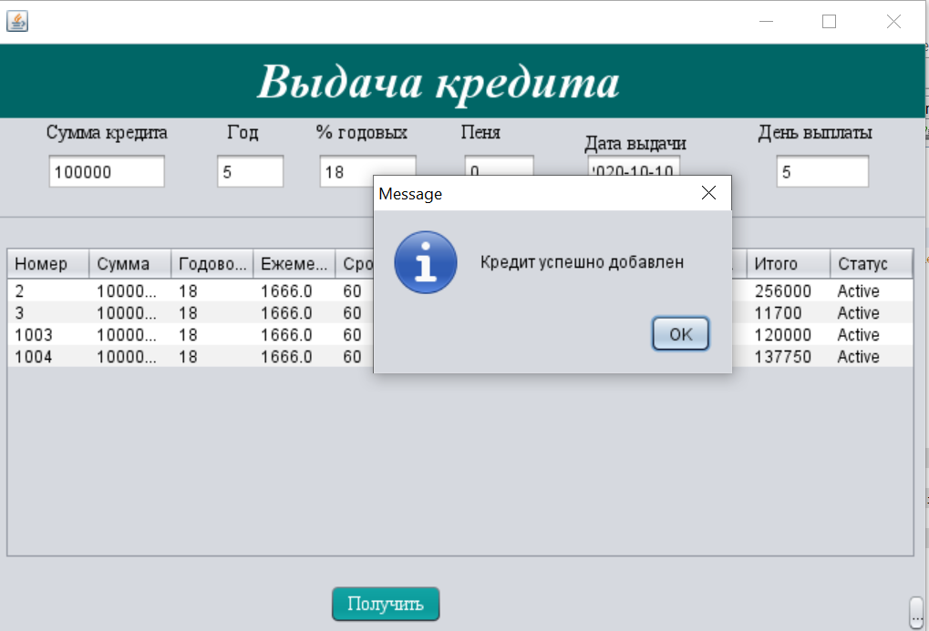

*Рис. 1.3.17 Получение кредита*

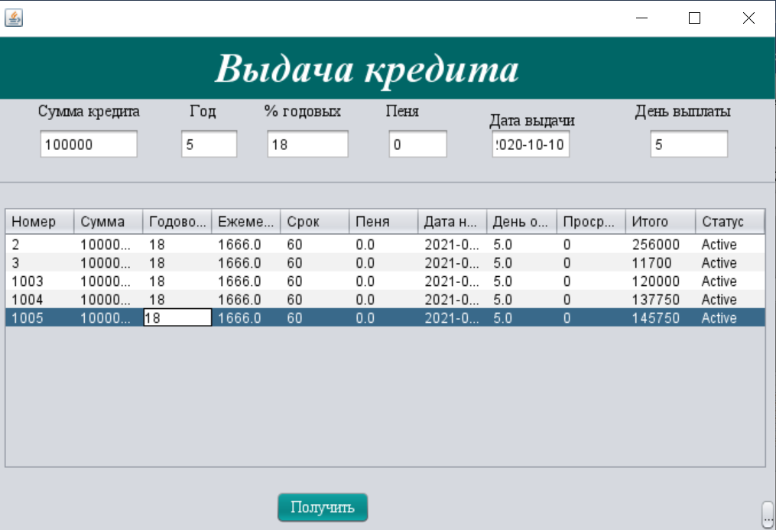

*Рис. 1.3.18 Успешно получили кредит*

Далее нажимаем на кнопку погашение кредита там у нас открывается рисунок «Оплатить кредит», там прописываем нужную ID банка и сумма выплаты нажимаем на кнопку «Оплатить».

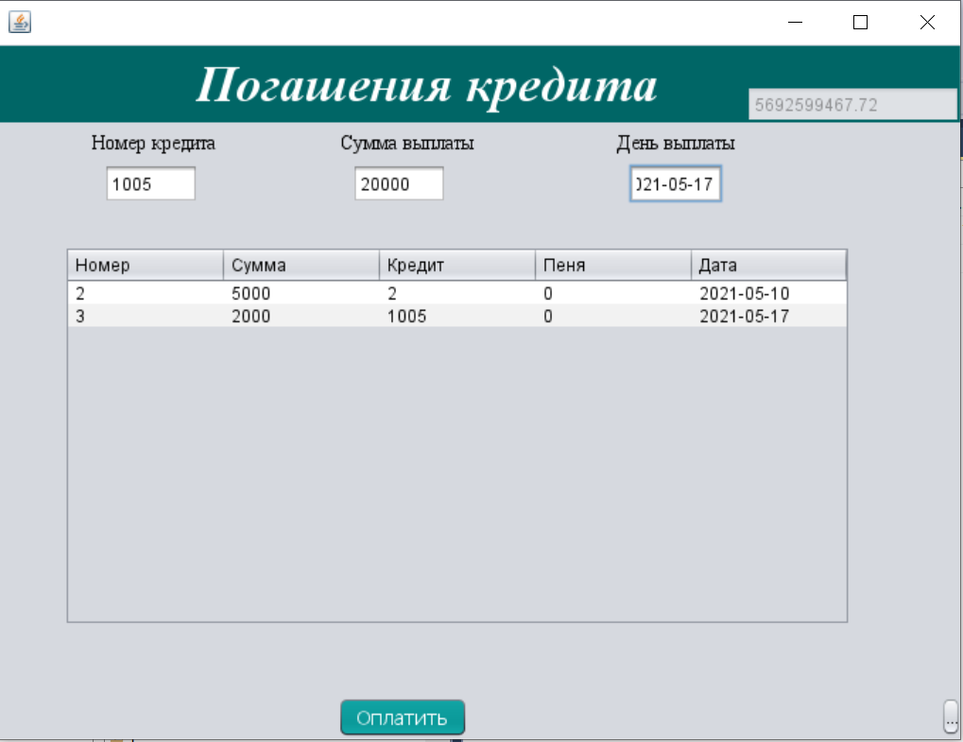

*Рис. 1.3.19 Погашение кредита*

Потом проверяем. Как видете на рисунке *Рис. 1.3.20*  мы успешно оплатили кредит

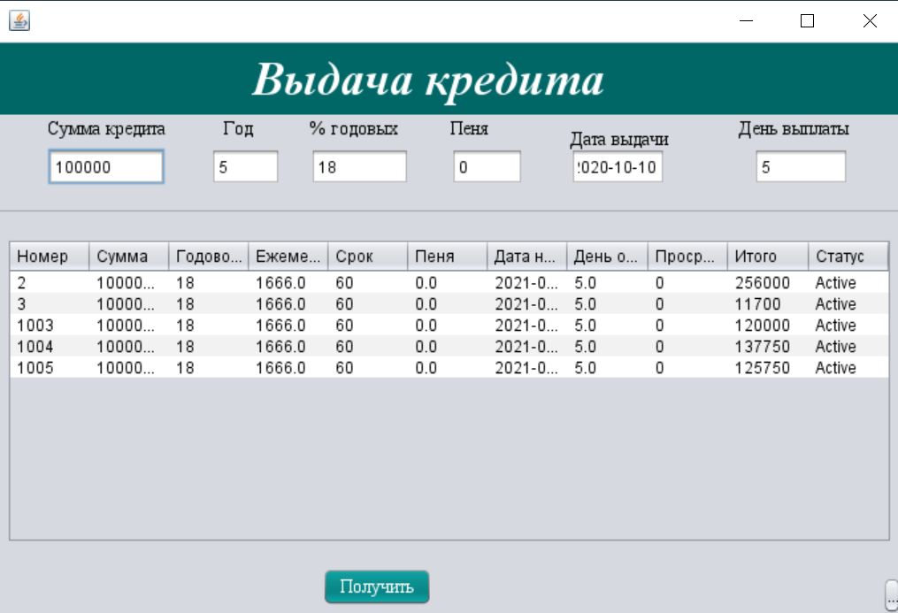

*Рис. 1.3.20*

Затем закрываем данную форму

И заходим как кондитер.

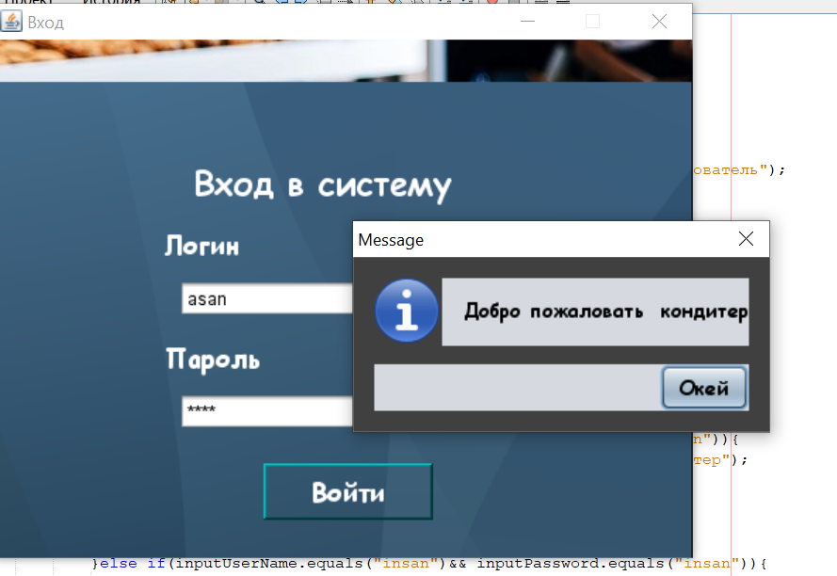

*Рис. 1.3.21 авторизация кондитера*

Кондитер осуществляет производство кондитерских изделий и добавление своих ингрединтов.

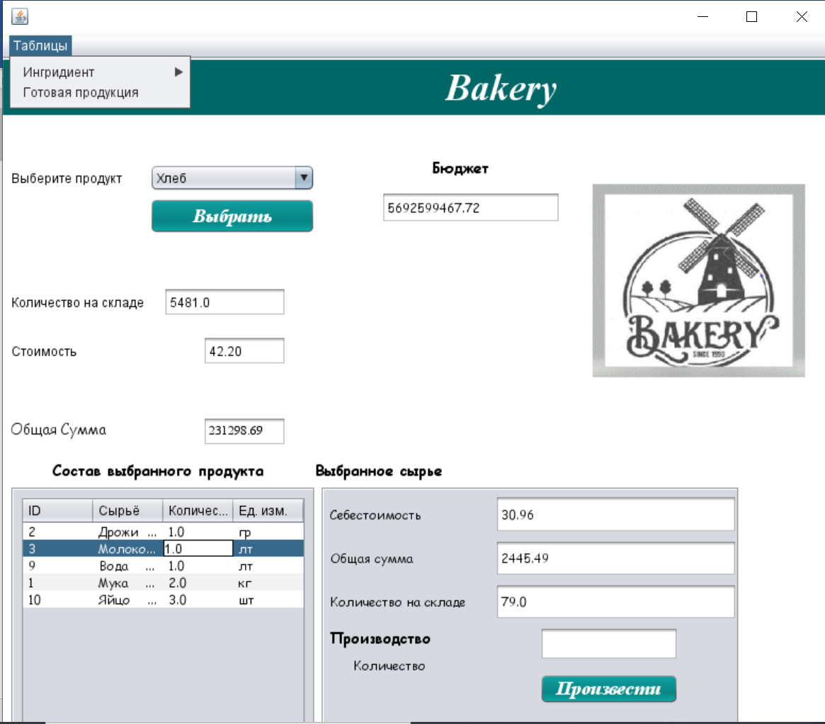

*Рис. 1.3.22* главная форма кондитера

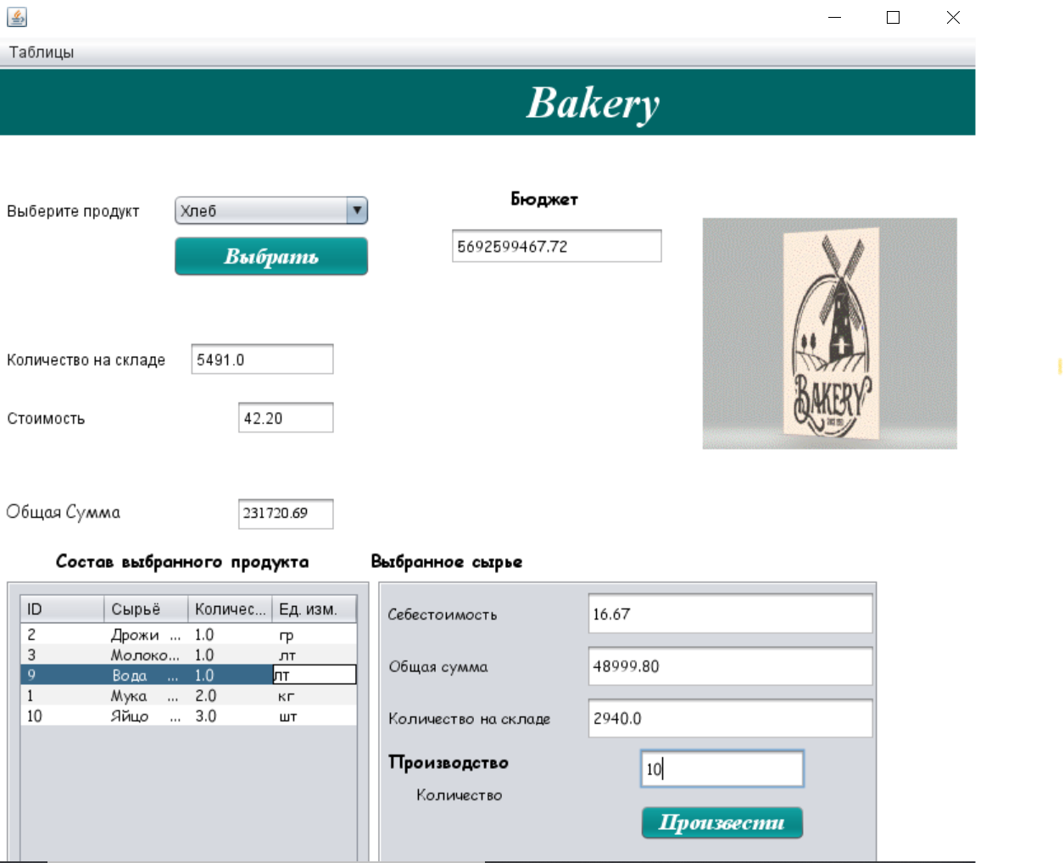

*Рис. 1.3.23 приготовление 10 хлеба*

Как видите на рисунке Рис. 1.3.23 у нас общая сумма и количество количество сырье изменилиз по сравнению Рис. 1.3.22

Потом нажимая на кнопку «**Ингредиенты**», переходим на форму для редактирования данных табилцы:

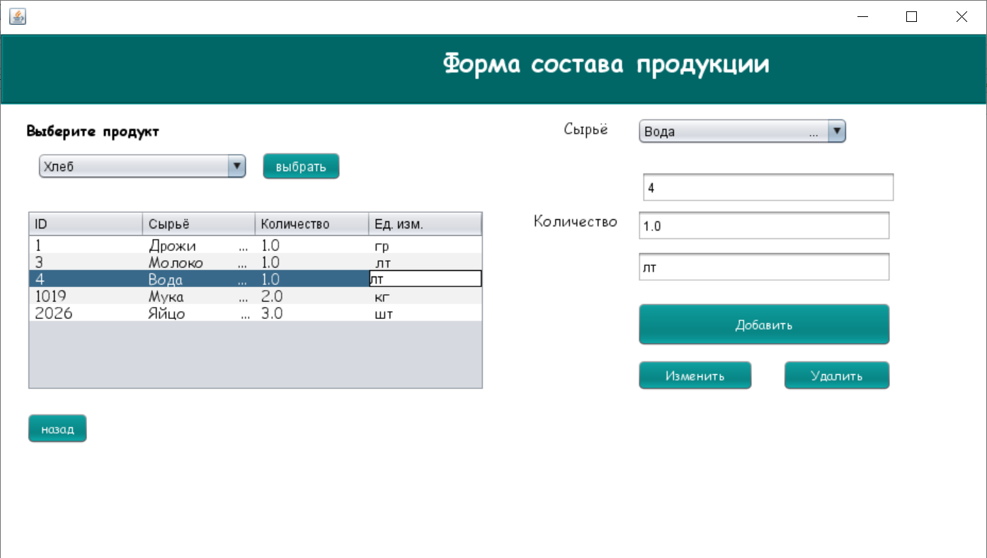

*Рис. 1.4.1 Ингредиенты*

После нажимая на кнопку «**Готовая продукция**», переходим на форму для редактирования:

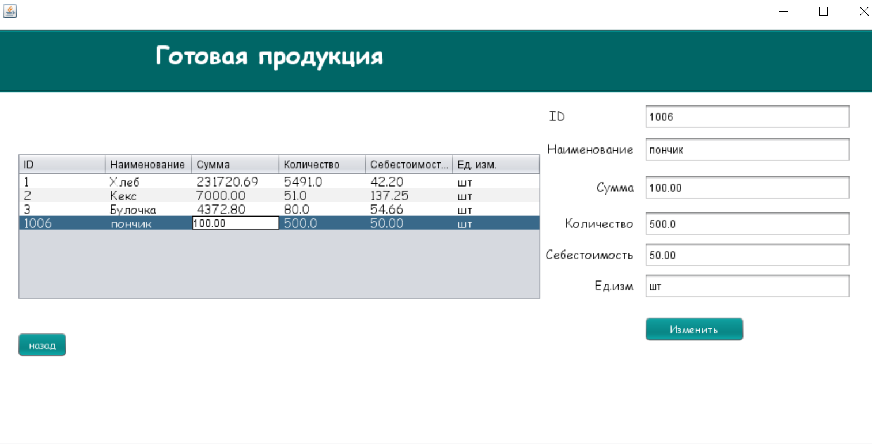

*Рис. 1.4.2 Готовая продукция*

**После закрываем окна и заходим как сотрудник осуществляющий закупок и продажу продукции**

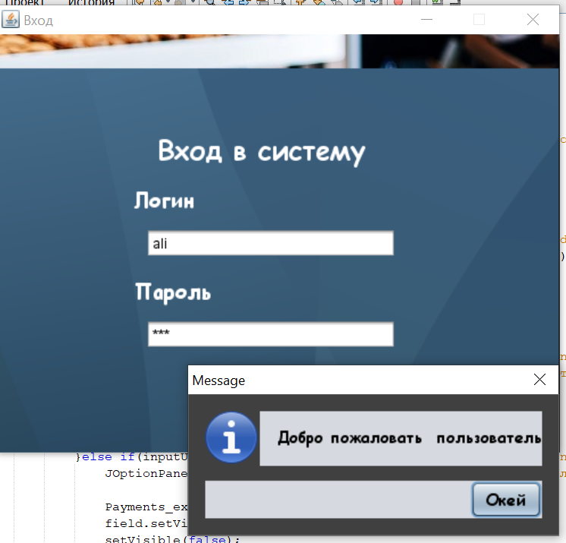

*Рис. 1.4.3*

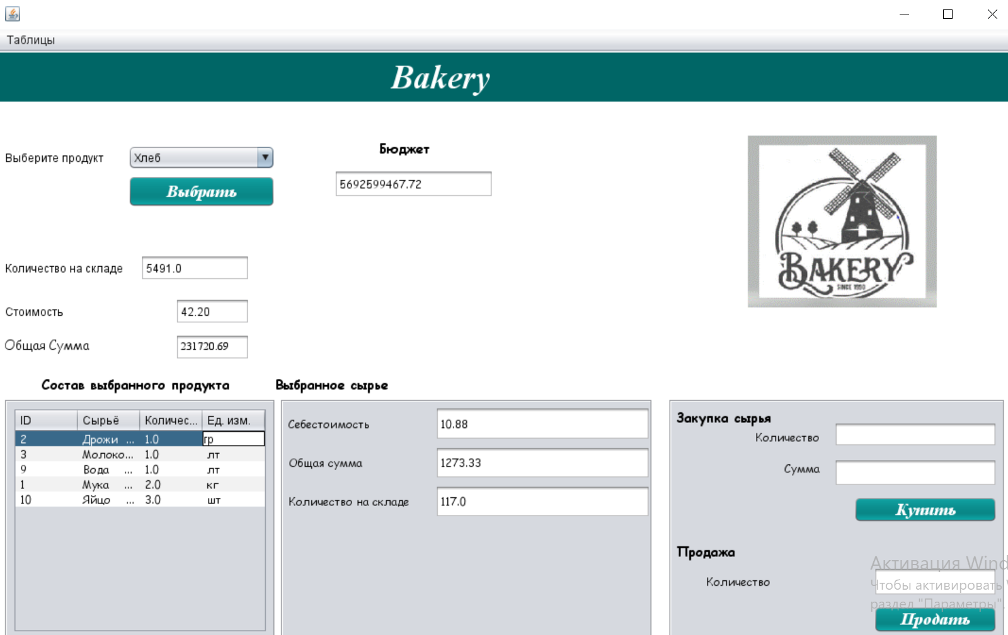

*Рис. 1.4.4*

*Потом осуществляем закупку сырья дрожи*

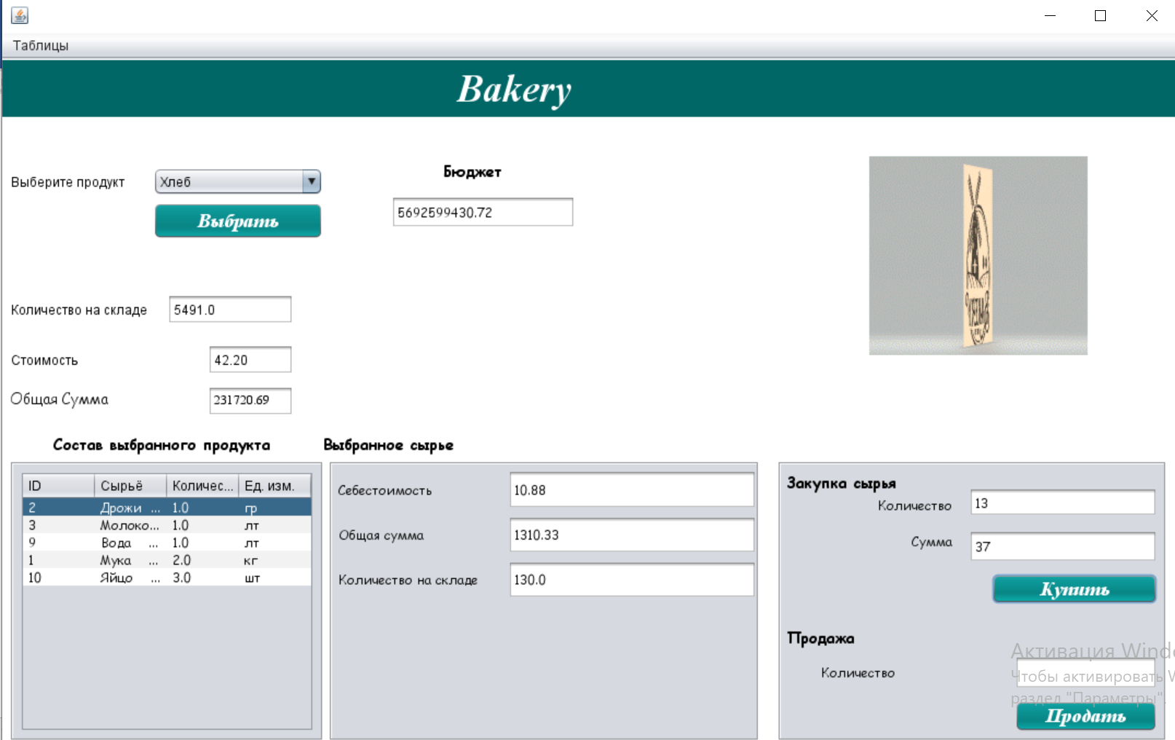

*Рис. 1.4.5 Закуп сырья*

Как видите у нас было количество сырья дрожжей 117(на *Рис. 1.4.4*  ) стало 130(*Рис. 1.4.5*) и в бюджете сумма тоже изменился

Затем осуществляем продажу продукции

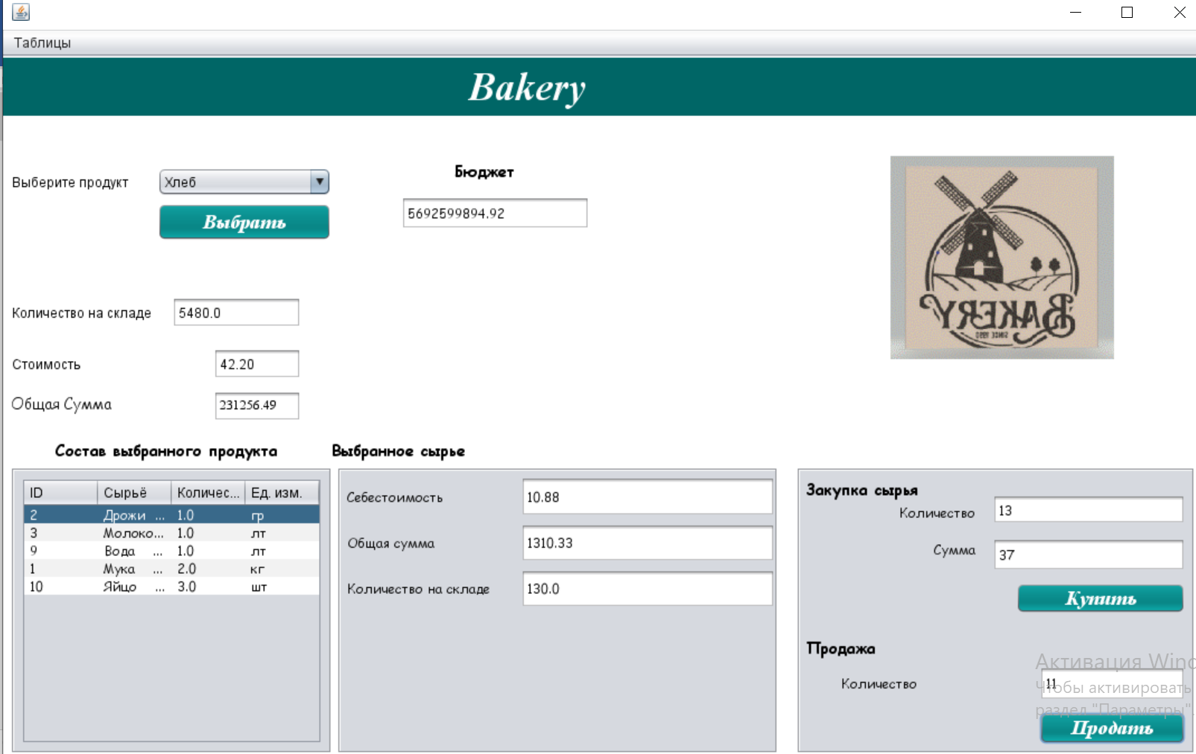

*Рис. 1.4.6 Продажа Продукции*

Как видите на рисунке *Рис. 1.4.6*  при продажах 11 продукции у нас изменился данные в бюджете и количество на складе

**После заходим как админ и выводми отчет**

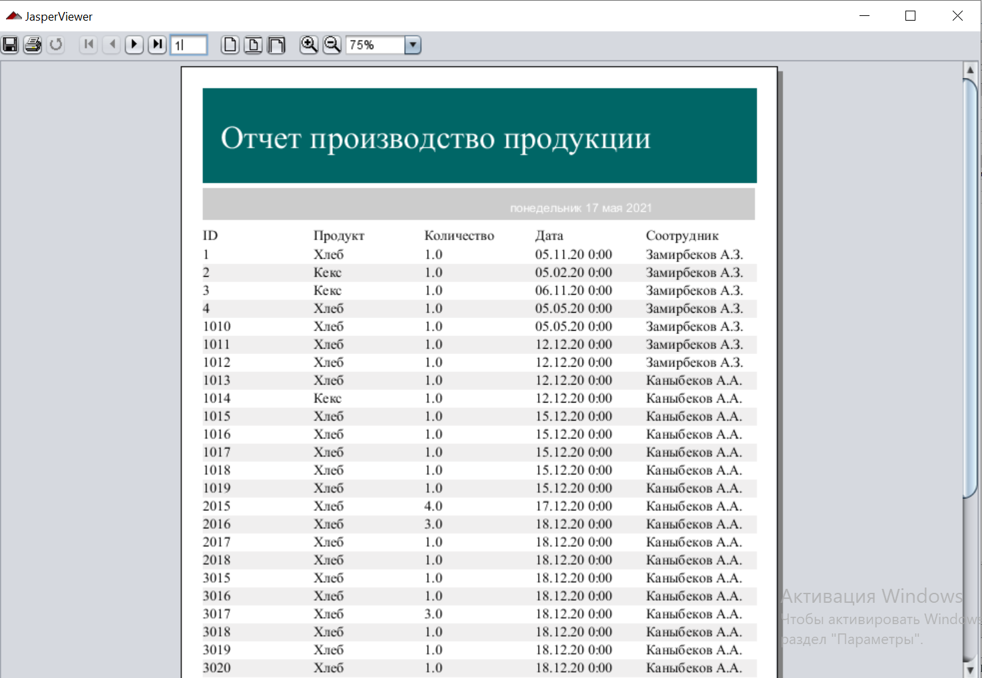

*Рис. 1.4.7 Отчет Производство продукции*

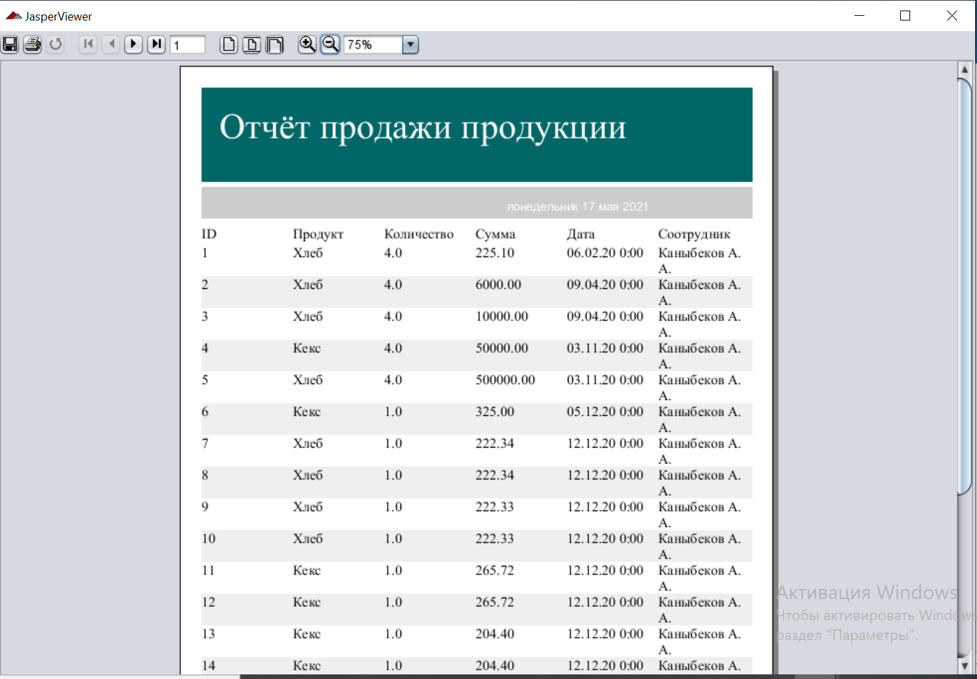

*Рис. 1.4.9 Отчет продажи продукции*

## **Заключение**

Создана требуемая автоматизированная система учёта для производственного предприятия ”*Bakery*”. Реализованы все необходимые функции: ***учет закупок***, ***производства продукции***, ***продаж продукции***, ***работа с персоналом***, ***выдача заработной платы***, ***учёт расходов и доходов предприятия***, ***получение*** и ***выплаты по кредитам***. В ходе выполнения работы были приобретены следующие полезные навыки и опыт:

* Работа в среде **NetBeans** на языке **java**
* Написания полезных алгоритмов на языке **T-SQL**
* Практический опыт создания относительно больших автоматизированных систем, с применением нескольких инструментов для разработки **ПО**.

Серверная часть реализована в **Microsoft SQL Server Management Studio 17**, а клиентская – в **NetBeans** на языке **java**.